Tynewater Primary School

Ready to learn Policy

At Tynewater Primary School we encourage all to ensure that we are ready to learn. In order for our children to be ready to learn we must work together to prepare them for learning. This will take into account the roles of parents, staff and pupils in preparing our children to learn.

Our Vision
Our school Vision is currently under review.

Our Values
Our values are currently under review.

Our Aims
Our school aims are currently under review.

Class Charter
We agree a Class Charter in every class during our Establishment Phase. A class charter is a set of rules, promises or guidelines that children and teachers have all agreed on for the classroom. It ensures all members of the class have a voice in the creation of a mutually agreed set of standards and expectations. Pupils decide on the rights which they think are most relevant to their class and sign the agreement for how they will respect these rights.
We believe that:
Every child has rights “without discrimination of any kind, irrespective of the child’s or his or her parent’s or legal guardian’s race, colour, sex, language, religion, political or other opinion, national, ethnic or social origin, property, disability, birth or other status” (UNCRC Article 2).

Ready to Learn Roles
In order to achieve our vision, values and aims for the children we all have a part to play. We hope that by working together our children will be ready to learn when they come to school. If we all work together, our children can and will achieve.

Expectations And Responsibilities

Parents  - Ensure children are well rested and in bed so that they get a good sleep.  - Encourage children to eat breakfast before they come to school.  - Remind children to wear appropriate clothing for the differing Scottish weather.  - Ensure children are in school on time.  - Communicate any changes in home circumstances, emergency contacts to school.  - Be mindful of screen time. Now that children use screens in school, home is a good time for them to be screen free. | Staff  - Resources are planned, prepared and organised for the class.  - Support and nurture the children through their experiences.  - Highest quality learning, teaching and assessment.  - School values - implement these.  - Responsive to children’s learning, life experiences and circumstances.  - Recognise positive behaviour.  - Communicate progress and learning via parents night, phone calls and Seesaw posts. | Pupils  - Follow the school rules.  - Be kind and try to be a good friend.  - Be resilient and if at first you don’t succeed try and try again.  - Be the best you can be.  - Use our learning qualities.  - Talk to an adult if you need support in or around the building.  - Charge your Chromebook if you are in P4-7.  - Talk respectfully to one another as well as adults.  - Tolerate and accept those who play, work and learn differently.

pri

iSchool practice, policies and procedures

All staff have been training, planning and implementing a variety of strategies and approaches over the years. Below we have outlined the variety of approaches we use. We treat every child as an individual and tailor our approach to suit their individual needs.
_____________________________________________________________________
Positive Praise
At Tynewater Primary School, we value respectful relationships and have high standards of behaviour. We give positive verbal feedback to acknowledge children’s effort and behaviour consistently in classrooms and around the school.

We have a House Points system which rewards pupils for effort and behaviour that goes above and beyond in demonstrating our school values - a Gold Star is worth five House Points and is awarded to whole classes or learners who have demonstrated exceptional standards. Our House Captains collect our House Points each week, organise House Events and plan House Treats twice per year to celebrate our winning Houses.

Children receive Star of the Week (random selection) certificates and Learning Qualities Certificate (teacher selected) which are awarded during our weekly whole school assembly. These certificates recognise and celebrate each learner’s unique strengths and acknowledge individual learners' effort in learning. Every child across the year receives one of each certificate.

We recognise wider achievements through our termly Whole School Achievement Assemblies which share pupil achievements both within and outwith school. These are displayed on our Achievements board in school.

Pupil Leadership

We strive to ensure that children feel valued and listened to by adults during every stage of their school life and experiences. Children are actively involved in making decisions about their play, learning and their day to day life at school. This is achieved through conversation, Focus Groups, questionnaires, a variety of Pupil Leadership Groups including Pupil Council and through MAD (Mixed Age Discussion) Assemblies.
Every child has the right to express their views, feelings and wishes in all matters affecting them, and to have their views considered and taken seriously. (UNCRC Article 12)

Nurture Principles
A Nurturing approach is used to support behaviour, wellbeing, attainment and achievement within Midlothian Council. It complements and is integrated within a suite of policies and the Midlothian Education Service Improvement Priorities. Getting It Right For Every Child (GIRFEC) is the national policy framework aimed at supporting the wellbeing of children and young people. The framework embeds the articles of the United Nations Convention on the rights of the Child (UNCRC) into practice and promotes a nurturing rights-based approach.

At Tynewater a nurturing approach is at the heart of our ethos as this is crucial for learning, wellbeing and ensuring positive relationships are a hallmark of our communities.

Nurture recognises:
∙The importance of early relationships and their link to children and young people’s social and emotional development.
∙It is the responsibility of all to understand and develop nurturing approaches to support and connect with all children, young people and families.
∙ Our relationships reflect our beliefs that everyone should be valued, respected and heard.
∙We model and promote positive relationships through providing a balance of care and challenge, with a focus on achievement and attainment.

Building Resilience
Building Resilience is a whole school approach/resource programme delivered across the whole school through assemblies, class work and family work at home. Building Resilience explores ten tools that promote mental, emotional, social and physical wellbeing. It engages pupils, families and staff in order to raise awareness and understanding of these tools.

Restorative approaches
Restorative approaches are built on values which separate the person from the behaviour. They promote accountability and seek to repair any harm caused in a situation. At Tynewater we use restorative approaches as part of a planned response to relationship and/or discipline difficulties.

Restorative approaches help us to create peaceful learning environments for children to become successful learners, confident individuals, responsible citizens and effective contributors. Restorative approaches can change the emotional atmosphere in a school and lead to more positive relationships between pupils and between pupils and staff. Pupils also accept responsibility for their actions, recognise the harm and upset caused and are supported to find restorative responses to harmful actions. At Tynewater we believe that developing positive, supportive relationships is key.

Zones of Regulation
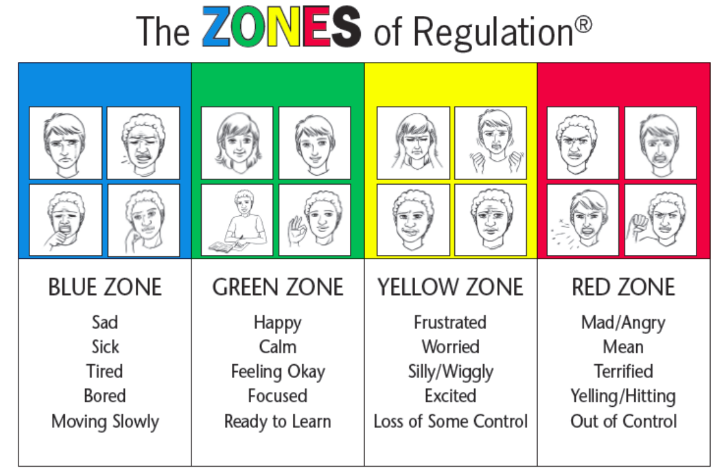
Our team are being trained in using the Zones of Regulation and Team Teach in order to support emotional literacy and wellbeing in the school. Zones of regulation provides a curriculum of lessons and activities used to gain skills in the area of self-regulation and emotional control. The Zones provides a compassionate framework to support positive mental health and social/emotional learning for all, while serving as an inclusion strategy for learners with neurodiversities, those who have experienced trauma, and/or have specific goals related to their social, emotional, and behavioural development. The Zones integrate best practices around Trauma Informed Care and mental health supports. In addition, The Zones incorporate numerous best practices for instruction with learners with neurodiversity.

Our Behaviour Policy
At Tynewater Primary School we want children to be the best that they can be. In school we use the flow chart below to encourage our learners to make good choices and engage in high quality learning, ensuring all our pupils model our school values and are ready to learn.
Learner engages with teacher and re-focuses on their task. Learner is praised for their effort.
Learner engages in high quality learning and demonstrates school values.

Learner does not meet expectations.

Teacher employs a range of strategies to de-escalate, distract and divert.

Teacher employs a small, in class support (e.g. use of nurture nook, move to more advantageous seat, removal of distracting object)
Teacher informs learner of next steps if no improvement

Teacher informs SLT – SLT speaks to learner and supports them to make good choices

Teacher informs learner of next steps if no improvement (e.g. phone call home, reflection time at break)

Where excellence is seen, appropriate praise is given (e.g. verbal, learner quality awards, House Points)
To progress through these stages, the learner will show a lack of willingness to modify behaviour and re-engage with learning. Other class members will be disrupted.

If there is a serious incident or if a child has been to SLT more than once, a phone call will be made to parents/carers.

Additional Support
If a child’s behaviour continues to be a concern after classroom strategies and supports are put into place, the SfL teacher and DHT/HT will arrange a Child Planning meeting with the pupil’s family to agree further steps. Next steps may involve additional planning and referrals. Plans may include:

- A Midlothian Learner Plan
- An Individualised Education Programme
- A Positive Handling Plan
- A Coordinated Support Plan
- A Healthcare Plan

The referrals that may take place involve the following partner agencies:

- Educational Psychologist
- Educational Support Group
- Team Around the Child
- Children and Families
- CAMHS
- The School Nursing Service
- Occupational Therapy
- Speech and Language Therapy

Reviewed – 02.10.23

