

**Language and Literacy**

In writing this term we will be looking at writing instructions. We will think about the key features to include when writing instructions, and then have a go at following each other’s instructions and giving feedback.

In reading lessons we will be engaging with different texts to open our eyes to all the literary possibilities which we have. We will continue our 30 minutes of daily reading time, accompanied by taking tests on Accelerated Reader. We will be focusing on individual targets in group reading lessons.

We are using the Penpals scheme to practise our handwriting joins, which will then be reflected in our work across the week.

P.E kits will be needed on a ***Wednesday*** and ***Thursday***. This should consist of a clean t-shirt, shorts or leggings and indoor footwear. **As we have discussed hygiene and cleanliness issues during puberty, a clean set of clothes for P.E really is necessary.**

All children are required to wear ***indoor shoes*** in school. We appreciate your help with this matter.

Please refer to our Learning at Home policy for guidance on what will be issued each week, and which extra activities are available.

**Social Studies**

Primary 7 will be learning about Democracy as a class topic this term. We will explore how laws are made and the structure of Parliament. The pupils who visit London will have the opportunity to visit Westminster and the pupils remaining in school will be visiting the Scottish Parliament.

We will be exploring the process of an election and some pupils who wish to put themselves forward for Head Boy and Girl, Depute Head Boy and Girl and House Captains will be involved in running their own campaigns.

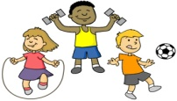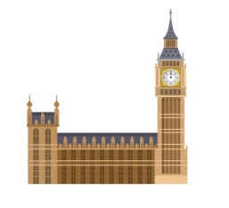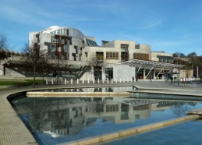

**Technology**

Primary 7 will have the opportunity to take part in film-making this term.

Certain pupils will use the i-Pads and green screen technology to create their campaign videos. All pupils will work in small groups to create documentary style films based on their learning around London, the Scottish or UK parliament or democracy in general.

**Mathematics and numeracy**

This term we will be revising and consolidating our understanding of the 4 mathematical operations and demonstrating them mentally and by using the standard written methods.

P7 will continue to write their own targets to ensure they are always working on something which is relevant and meaningful for them and pushes them to achieve. It is vital that children are also practising their ***times tables at home.***

**Health and Wellbeing**

P7 will be doing fitness and basketball with Mr Watson and

Mrs Thompson for their P.E this term.

P7 will be taking part in Playground Leaders Training this term. This is a session which teaches them a variety of appropriate playground games, which they can then teach the younger children.

We have resumed our Daily Exercise this term, giving pupils a choice of which activity they would like to take part in each week. We have chosen 3 activities which appeal to a range of fitness levels, and we hope that pupils will continue to give 100% to these activities.

Democracy and Parliament