
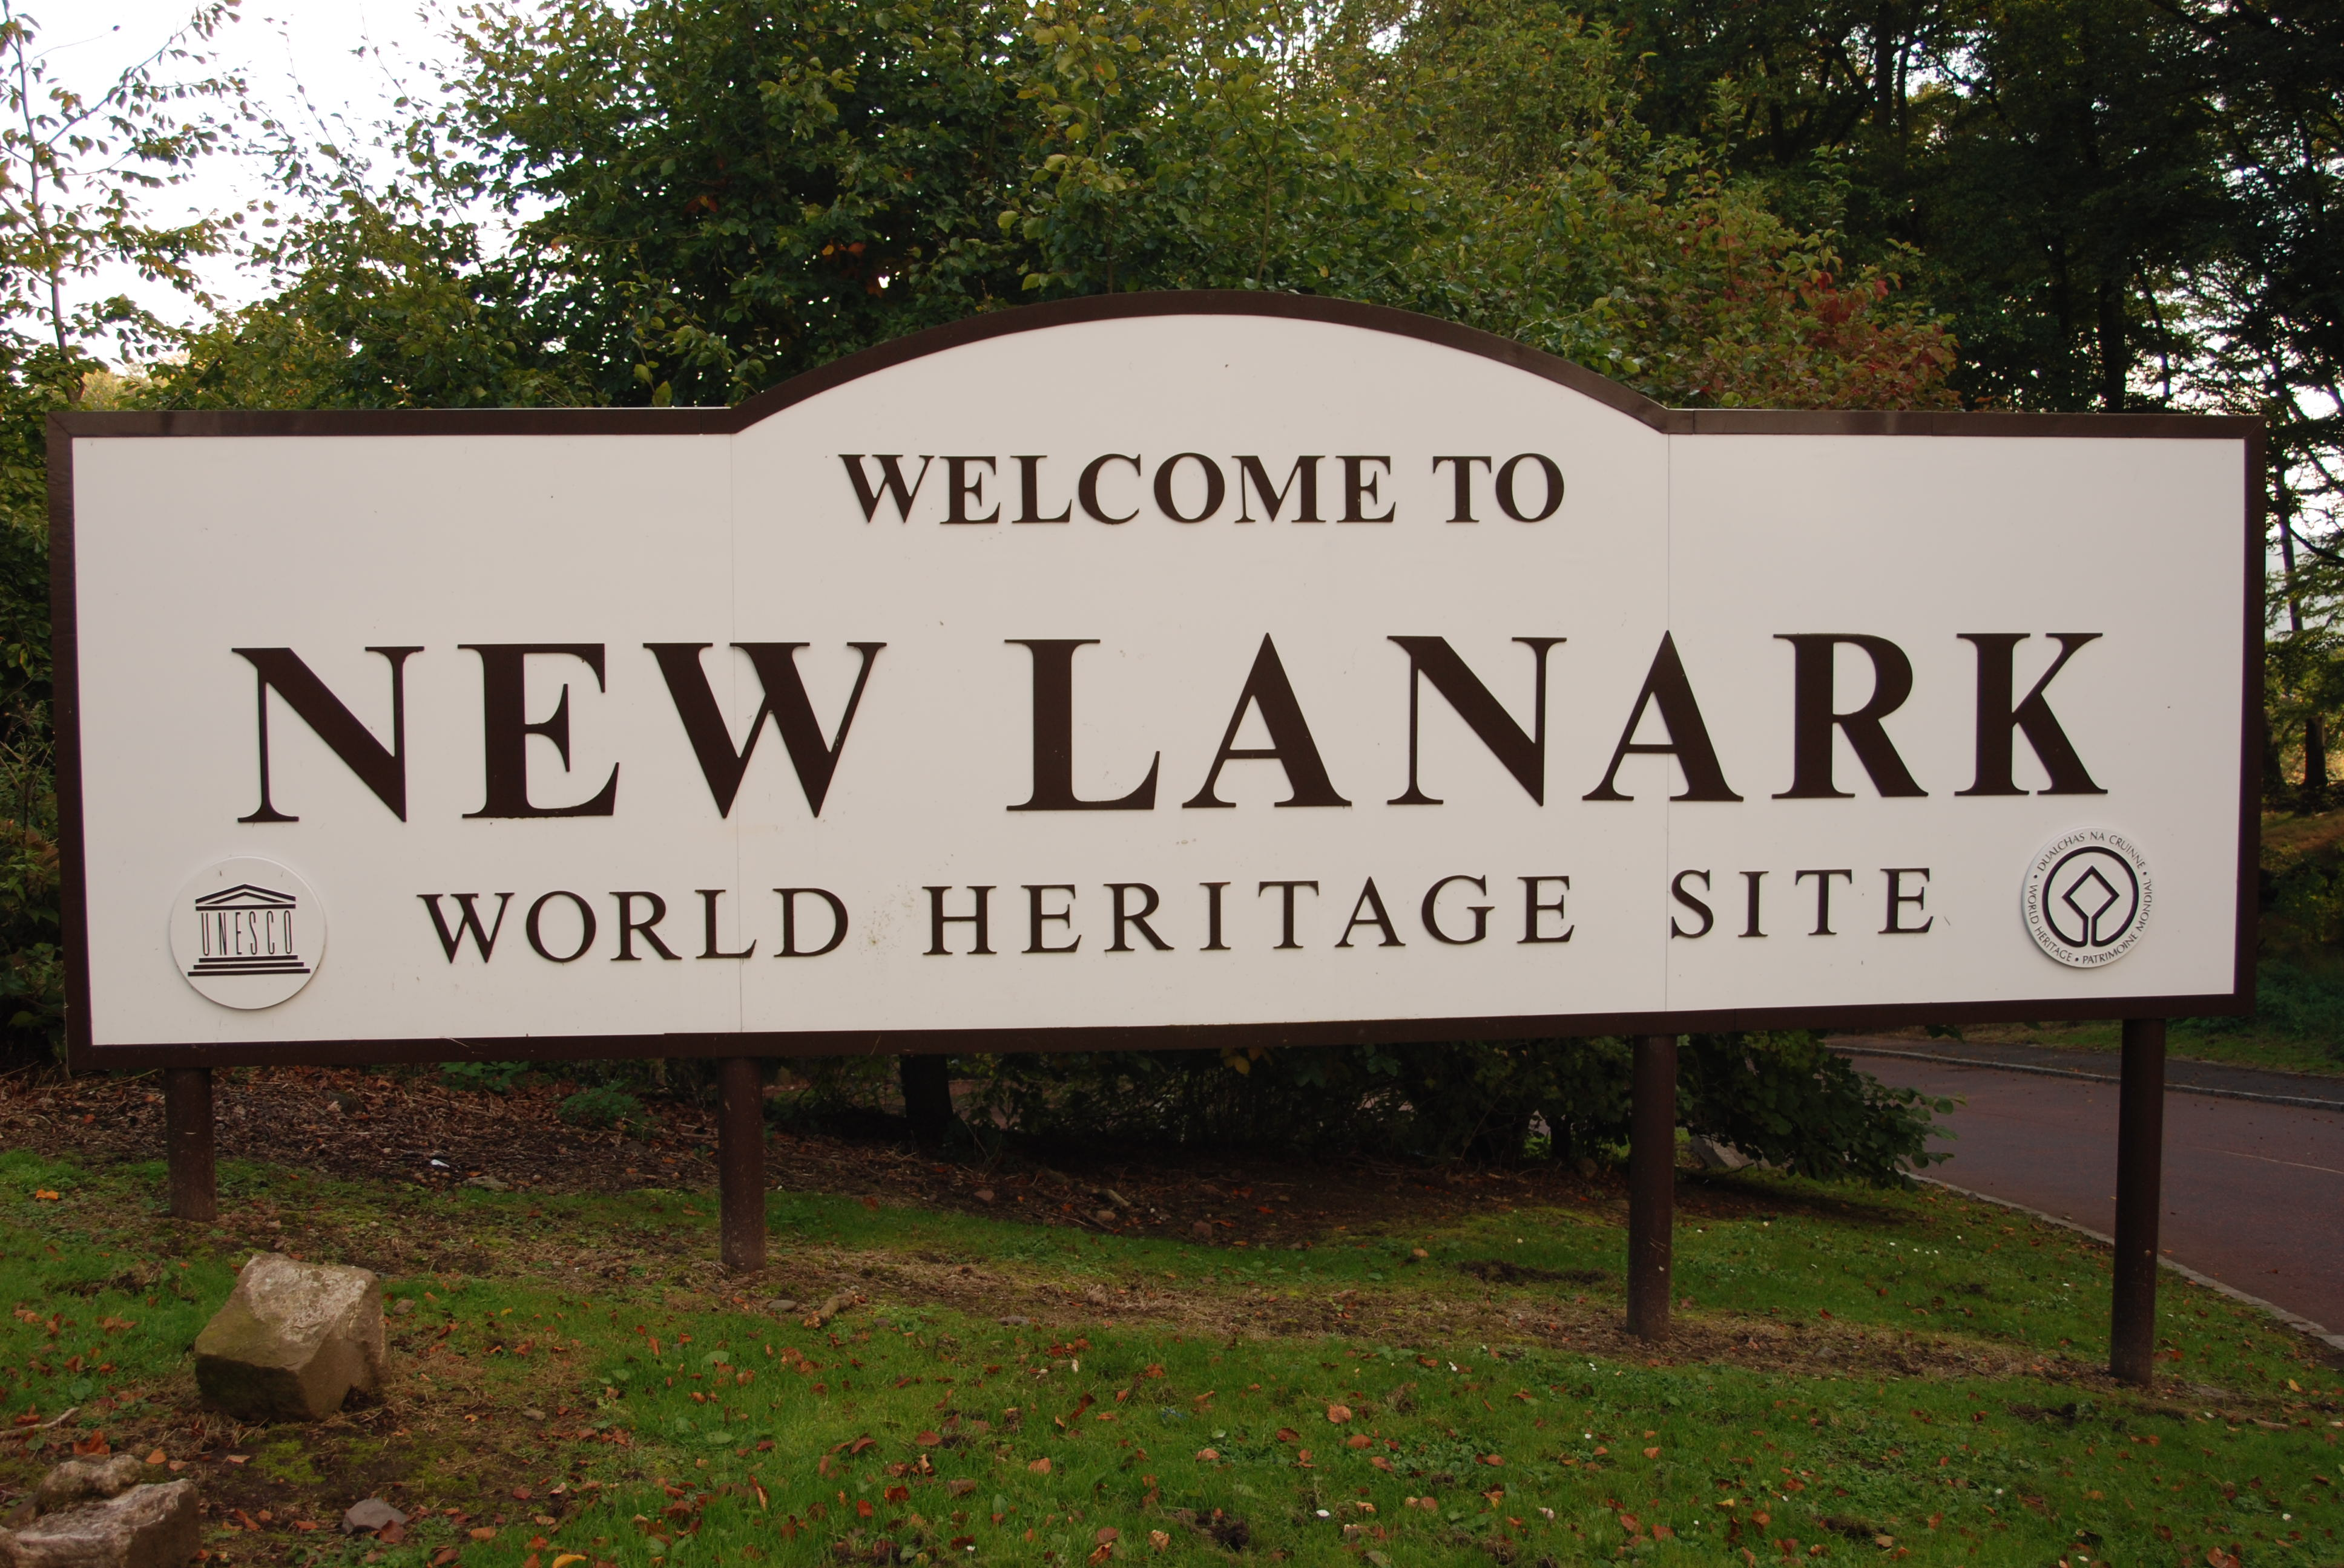
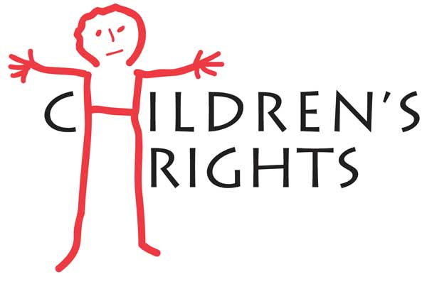
New Lanark
Language and Literacy
We will begin work on a whole class novel after returning from New Lanark. We will use the text to develop our literacy skills during weekly rotations focussing on comprehension, grammar, and talking and listening skills.

In writing we will set individual targets to work on during the period and experience a range of genres linked to our topic and class novel including personal reflective and persuasive writing.
Topic

The pupils will focus on learning more about life in New Lanark and the industrial revolution.
There will be history learning as part of social studies to learn more about children’s life 200 years ago. They will also learn about the world of work which is part of the health and wellbeing curriculum. They will explore the work that children had to complete in the early 1800’s, making links to the rights of the child and making comparisons to the present day. We will explore the rights and reforms that Robert Owen introduced to help improve the lives of people living in New Lanark and how they have impacted on our own lives and the world of work in Britain.

Learning At Home
Children are expected to read daily at home and also have independently selected spelling words to work on. Maths homework will relate to areas being covered in class. Tasks given may
also relate to topic work.
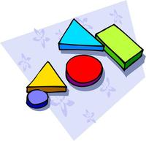


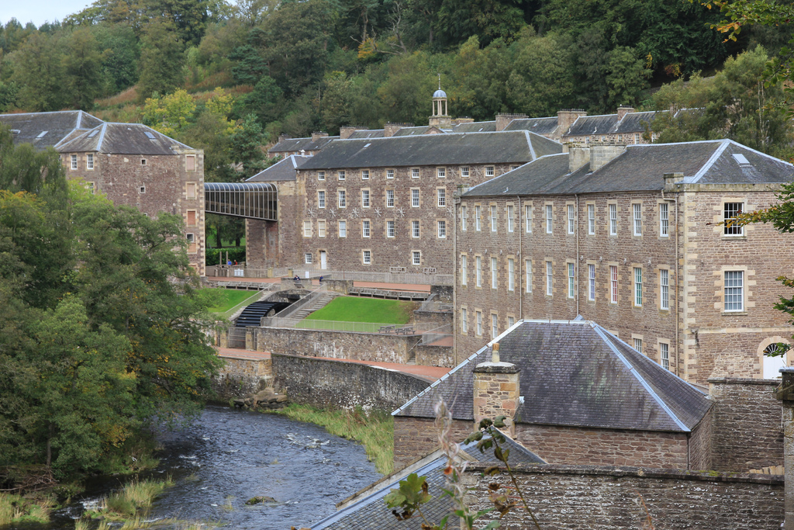


New Lanark
(Industrial Revolution)
Mathematics and Numeracy
Addition, subtraction, multiplication and division strategies will continue to be learned and consolidated this term, and children given the opportunity to apply their understanding in different ways.
Maths facts will be reinforced using the xtra math programme and can also be used at home.
We will continue to regularly reinforce our knowledge of number facts using the basic facts progression and recording and monitoring our progress.

The Midlothian Numeracy programme will be the reference point for all planned work.
Modern Languages

French will continue in P5. We will develop our knowledge of common phrases, write the date in French and follow simple classroom commands.
Health and Wellbeing

PE will focus on developing the ability to adapt and apply skills and strategies across a variety of invasion games as well as developing teamwork and co-operation.
We will continue to take part in daily activity which the children select on a weekly basis.

