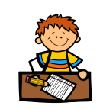

P.E kits will be needed on a ***Tuesday*** and ***Wednesday***. This should consist of a clean t-shirt, shorts or leggings and indoor footwear. **As we discuss hygiene and cleanliness during puberty, a clean set of clothes for P.E really is necessary.**

All children are required to wear ***indoor shoes*** in school. We appreciate your help with this matter.

Spelling and Maths homework will be issued on a **Monday** and due in on **Friday**. We will read in class on a **Thursday** and I will set pages for the following **Thursday**.

**Language and Literacy**

In writing this term we will be studying imaginative writing, particularly creating realistic and interesting character and settings. The focus will be ghost stories.

In reading lessons we will be looking at how to take effective notes from texts, both orally and written. We will then create new texts from these notes. In group reading sessions we will be focusing on our individual targets. We will continue our 30 minutes of daily reading time, accompanied by taking tests on Accelerated Reader.

We are using the Penpals scheme to practise our handwriting joins, which will then be reflected in our work across the week.

**Science and Health and Wellbeing**

Primary 6 will be learning about many aspects of the Human Body, including the skeleton muscular-system, the digestive system and the circulatory system.

We will be carrying out practical activities and experiments to fully understand the way our bodies work.

We will also be exploring sex and relationships education through the FPA’s ‘Growing up with Yasmine and Tom’ interactive programme. We will be looking at topics such as **the body, feelings, relationships, family life and online safety.**

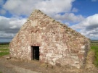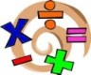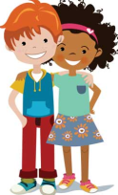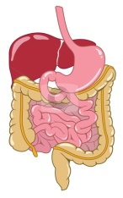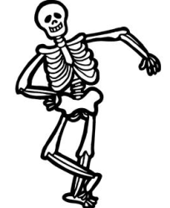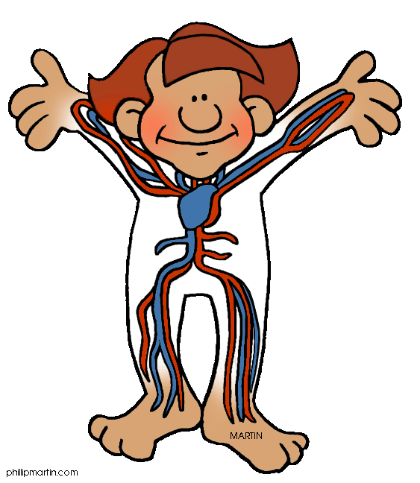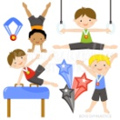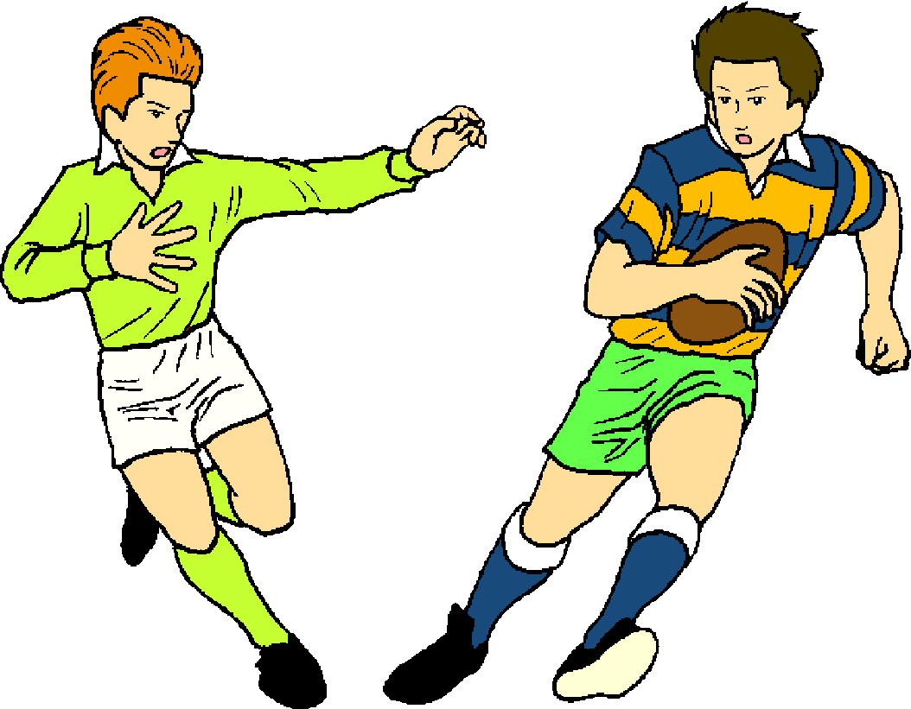

**Social Studies**

As part of Tynewater’s 10th Anniversary celebrations, each class is researching an aspect of the Tynewater area’s heritage. We will be investigating the medieval hospital at Soutra Aisle, linked to our Human Body topic.

The Human Body

**Health and Wellbeing** – P.E

In P.E we will be looking at Gymnastics this term. We will be

practising jumps and rolls, using different equipment.

We will be performing handstands and cartwheels and linking our movements together. We will perform rhythmic sequences to the class, and practise giving peer feedback based on co-constructed criteria.

We will be resuming our Daily Exercise, giving pupils a choice of which activity they would like to take part in each day.

**Mathematics and numeracy**

P6 will be continuing with the Basic Maths Facts programme this term and working on their targets to progress their learning in numeracy. It is vital that children are also practising their ***times tables at home.***

In numeracy we will be looking at mental strategies for addition, subtraction, multiplication and division, as well as the standard written methods.

For maths we will be working with quantities of money, as well as budgeting and comparing costs.