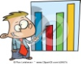

**Science**

We will be learning about living and non-living things, describing characteristics of livings things and how they depend on each other, for example, animals which depend on plants for food.

We will plant our own plants to explore, observe and discuss the basic needs of plants to learn about what they need to grow including water, heat, sunlight and soil.

We will visit Edinburgh Butterfly and Insect Farm to observes living things in their natural environment and learn about how they depend on each other.

**Language and Literacy**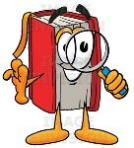

We are continuing to blend the sounds that we have learned together to read and build words and sentences, focusing on capital letters, finger spaces and full stops. We will continue to focus this period on common and tricky words, as well as our ORT scheme to develop our reading skills.

We will explore characters, plot and events in stories to help us create our own imaginative texts. We will be asking questions about texts that we read to help our understanding and share our likes/dislikes of these and others stories.

Pupil Voice: Pupils have decided they would like to learn about living things and help renovate the Learning Garden.

RRSA: Article 13

You have the right to find out things and share what you think with others, by talking, drawing, writing or in any other way unless it harms or offends other people.

 

**Primary 1**

Period 7

Living Things

[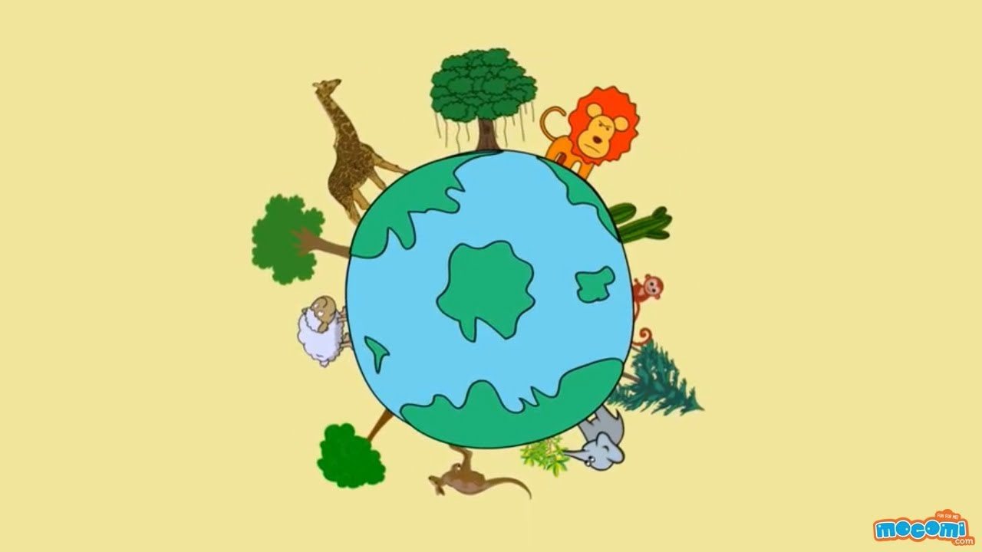](https://www.google.co.uk/url?sa=i&rct=j&q=&esrc=s&source=images&cd=&cad=rja&uact=8&ved=2ahUKEwiAtZbT-LHaAhWI1xQKHXqYCOgQjRx6BAgAEAU&url=https://www.youtube.com/watch?v=ErATB1aMiSU&psig=AOvVaw2gQFaGcBB6RabnGJtmQr35&ust=1523526489313685)

**Mathematics and Numeracy**

In Numeracy, we are continuing to learn to recognise, say and write the numbers within 100 focusing on starting at any number. We will continue to explore counting accurately, ordering and sequencing numbers. We will continue to learn to count in 1s, 2s, 3’s, 5s and 10s to help our problem-solving skills and counting strategies. We are also continuing to learn our number bonds to 10 and doubles to 20 to help our mental strategies for addition and subtraction.

In Mathematics we are going to be learning about money.

**Development of beliefs and values**

As we play and learn, we will be developing our understanding of what is fair and unfair and the importance of caring for, sharing and cooperating with others. [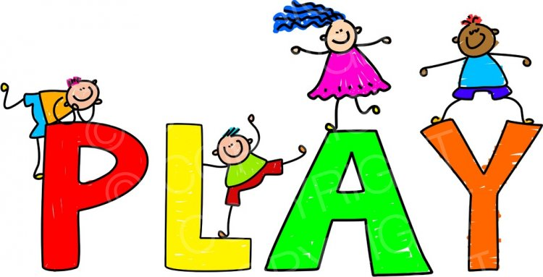](http://www.google.co.uk/url?sa=i&rct=j&q=&esrc=s&source=images&cd=&cad=rja&uact=8&ved=2ahUKEwj1xr63v7LaAhXIWhQKHWysDicQjRx6BAgAEAU&url=http://www.prawny.me.uk/media.details.php?mediaID=NzM4MWM3ZDM1ZGJiZWI=&psig=AOvVaw0FoY47AUx7sInpKIl5l8oF&ust=1523545499441612)

**Health and Wellbeing**

In Health and Wellbeing, we will learn how to link movements together to create and coordinate a dance.

We will be learning to describe how it feels to take part in energetic play, and the effects on our body.

We will also learn about being active as a healthy way to be, as well as discovering ways in which eating and drinking may help us to grow and keep healthy.