Thursday 10 May 2018

Dear Parent(s)/Carer(s),

This year P1-7 pupils are invited to take part in ‘Walk to School Week’ from Monday 14th May- Friday 18th May, an event which is celebrated annually across many schools in Scotland.

On Tuesday 15th May children are invited to participate in ‘Happy Shoesday’, where they can wear their happiest shoes to walk to school! These can be spotty, stripy, colourful, sparkly or odd shoes!

The Junior Road Safety Officer Pupil Voice Leadership Group have been working hard to promote this in school by creating and displaying posters to celebrate ‘Walk to School Week’ which will be displayed next week.
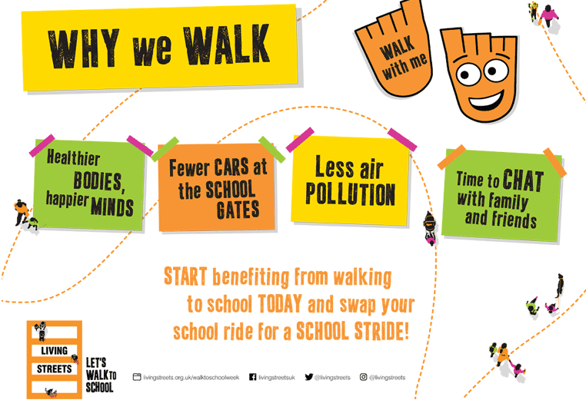

Thank you for your continued support,

Jessica Seaton Douglas Lawson JRSO Pupil Voice Group
Class Teacher Head Teacher

