**Homework**

Literacy and maths homework will be issued on Mondays.

Spelling homework will continue to be handed out and

returned on Wednesdays.

P7 must bring in an appropriate change of clothing for P.E. on Mondays and

Wednesdays.

**Social Studies**

Our WW2 topic continues this period, looking at the Blitz and Rationing on the Home Front. We will also begin to think about life on the Western Front.

**Language and Literacy**

Our reading skill focus this term is contrast and compare. We will finish reading the novel ‘The Boy in the Striped Pyjamas’ and examine and discuss elements of the novel in comparison to the film (parental permission required).

Our weekly literacy rotation will continue to develop our comprehension, grammar and knowledge of literary devices.

Our writing focus this term will involve a number of functional pieces and will continue to use our topic as a stimulus. We will write recipes which could have been used during rationing and create an informative leaflet to avoid the dangers of the Blitz!

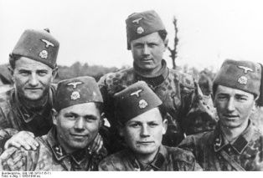

**Learning Visits and Transition Events**

P7 will attend the Risk Factory on Tuesday the 27th February. At The Risk Factory pupils are put into scenarios that they could face in everyday life and asked to identify risks and are taught strategies that could help save not only their own lives but other peoples'.

P7 will visit Dalkeith High School Library on the 7th March as part of the transition programme.

We will also attend a Language 1+2 transition event at the end of March where we will share our learning about a French speaking country with other P7’s from the ASG.

**Health and Wellbeing**

P7 will take part in the ASG athletics competition this term and will focus on developing our ability to effectively run, jump and throw and applying the skills used in the different events.

**Expressive Arts**

P7 will be learning about popular dance styles from the WW2 period and attempting to learn and perform a Charleston routine.

**Mathematics and numeracy**

We continue with math rotations this term ensuring broad coverage of the main skills – addition, subtraction, multiplication and division using the basic facts progression.

We will explore the language of probability and link these to real life events. We will continue to consolidate and revise our learning so far and set individual numeracy and maths targets throughout the term.

We will continue to strengthen our mental math skills using Big Math and Xtra Math each week.

**WWII**