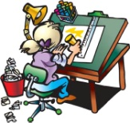



**Language and Literacy**

In writing this term we will be writing a letter to accompany the product we have designed, to persuade engineers that it is a useful project. We will be creating eye catching posters to present our learning about bridges.

In reading lessons we will be looking at the credibility and reliability of texts. In group reading sessions we will be focusing on our individual targets.

We are using the Penpals scheme to practise our handwriting joins, which will then be reflected in our work across the week.

**Science, Technology**

**and Engineering**

We will be continuing our learning around bridges, bridge building and engineering. We will be designing our own product to fit the brief, ‘if you were an engineer, what would you do?’ As well as dreaming up an idea, we will be creating annotated drawings and writing a cover letter to pitch our inventions.

When we visit WSP Parsons Brinckerhoff engineering firm on Wednesday 28th February, we will be taking part in team building challenges based around engineering, as well as finding out about different engineering disciplines. We will have the opportunity to share our designs with ‘real-life’ engineers.

P.E kits will be needed on a ***Tuesday*** and ***Wednesday***. This should consist of a clean t-shirt, shorts or leggings and indoor footwear. All children are required to wear ***indoor shoes*** in school. We appreciate your help with this matter.

Spelling and Maths homework will be issued on a **Monday** and due in on **Friday**. We will read in class on a **Thursday** and I will set pages for the following **Thursday**.

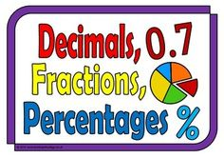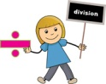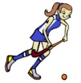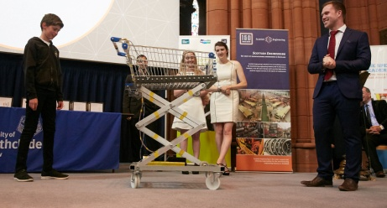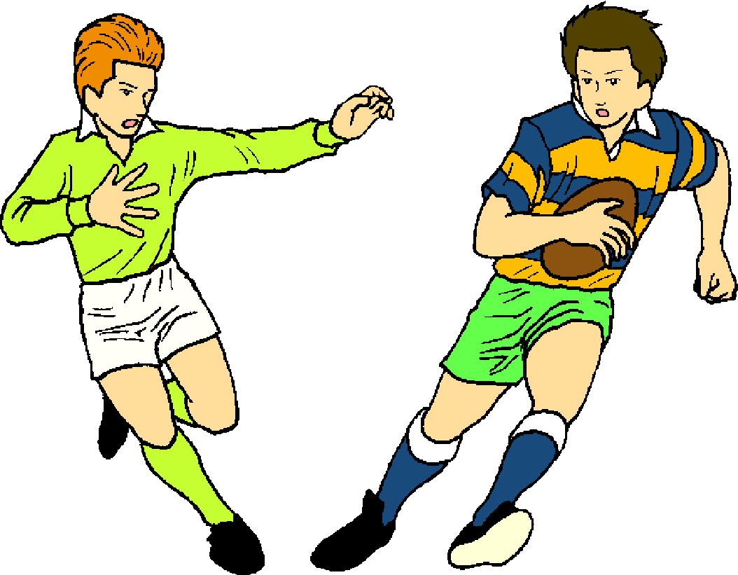

**Mathematics and numeracy**

We will continue our learning of times tables this period, as well as mental maths skills. We will be undertaking standardised assessments in maths and mental maths this term.

We will play Basic Facts games regularly in order to achieve our mental maths targets, and undertake Big Maths once a week. In numeracy lessons we will be learning about the standard written method of multiplication, percentages, length and negative numbers.

**Health and Wellbeing**

In P.E we will be looking at Hockey this term. We will cover the fundamental skills of passing and receiving, moving with the ball, tackling and shooting, and bring these skills together to play small games.

We will continue to learn about food and nutritional needs and cleanliness and hygiene techniques this term.

**Technology**

We will be continuing our game design and systems thinking learning using the Game Star Mechanic online community.