**Language and Literacy**

**Reading** – Time will be given at the start of the day to read for enjoyment from our reading box and reading groups will be heard throughout the week. We will continue to use strategies to help us with the understanding of text.

**Writing** – We will be focussing on imaginative writing, looking at creating characters. We will continue to develop the use of interesting vocabulary.

**Listening and Talking** – Circle time will be every Friday. This will give the children an opportunity to share something of interest to them with the class.

**Spelling and Grammar-** Children will continue to develop and use phonics and spelling rules to spell unfamiliar words.

**French –** We will be learning how to use greetings and say the days of the week and colours in French. .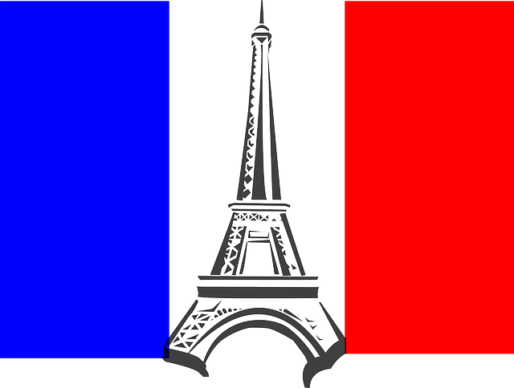

**Expressive Arts**

We will be working with the art specialist on a Monday afternoon to develop our drawing and creative skills.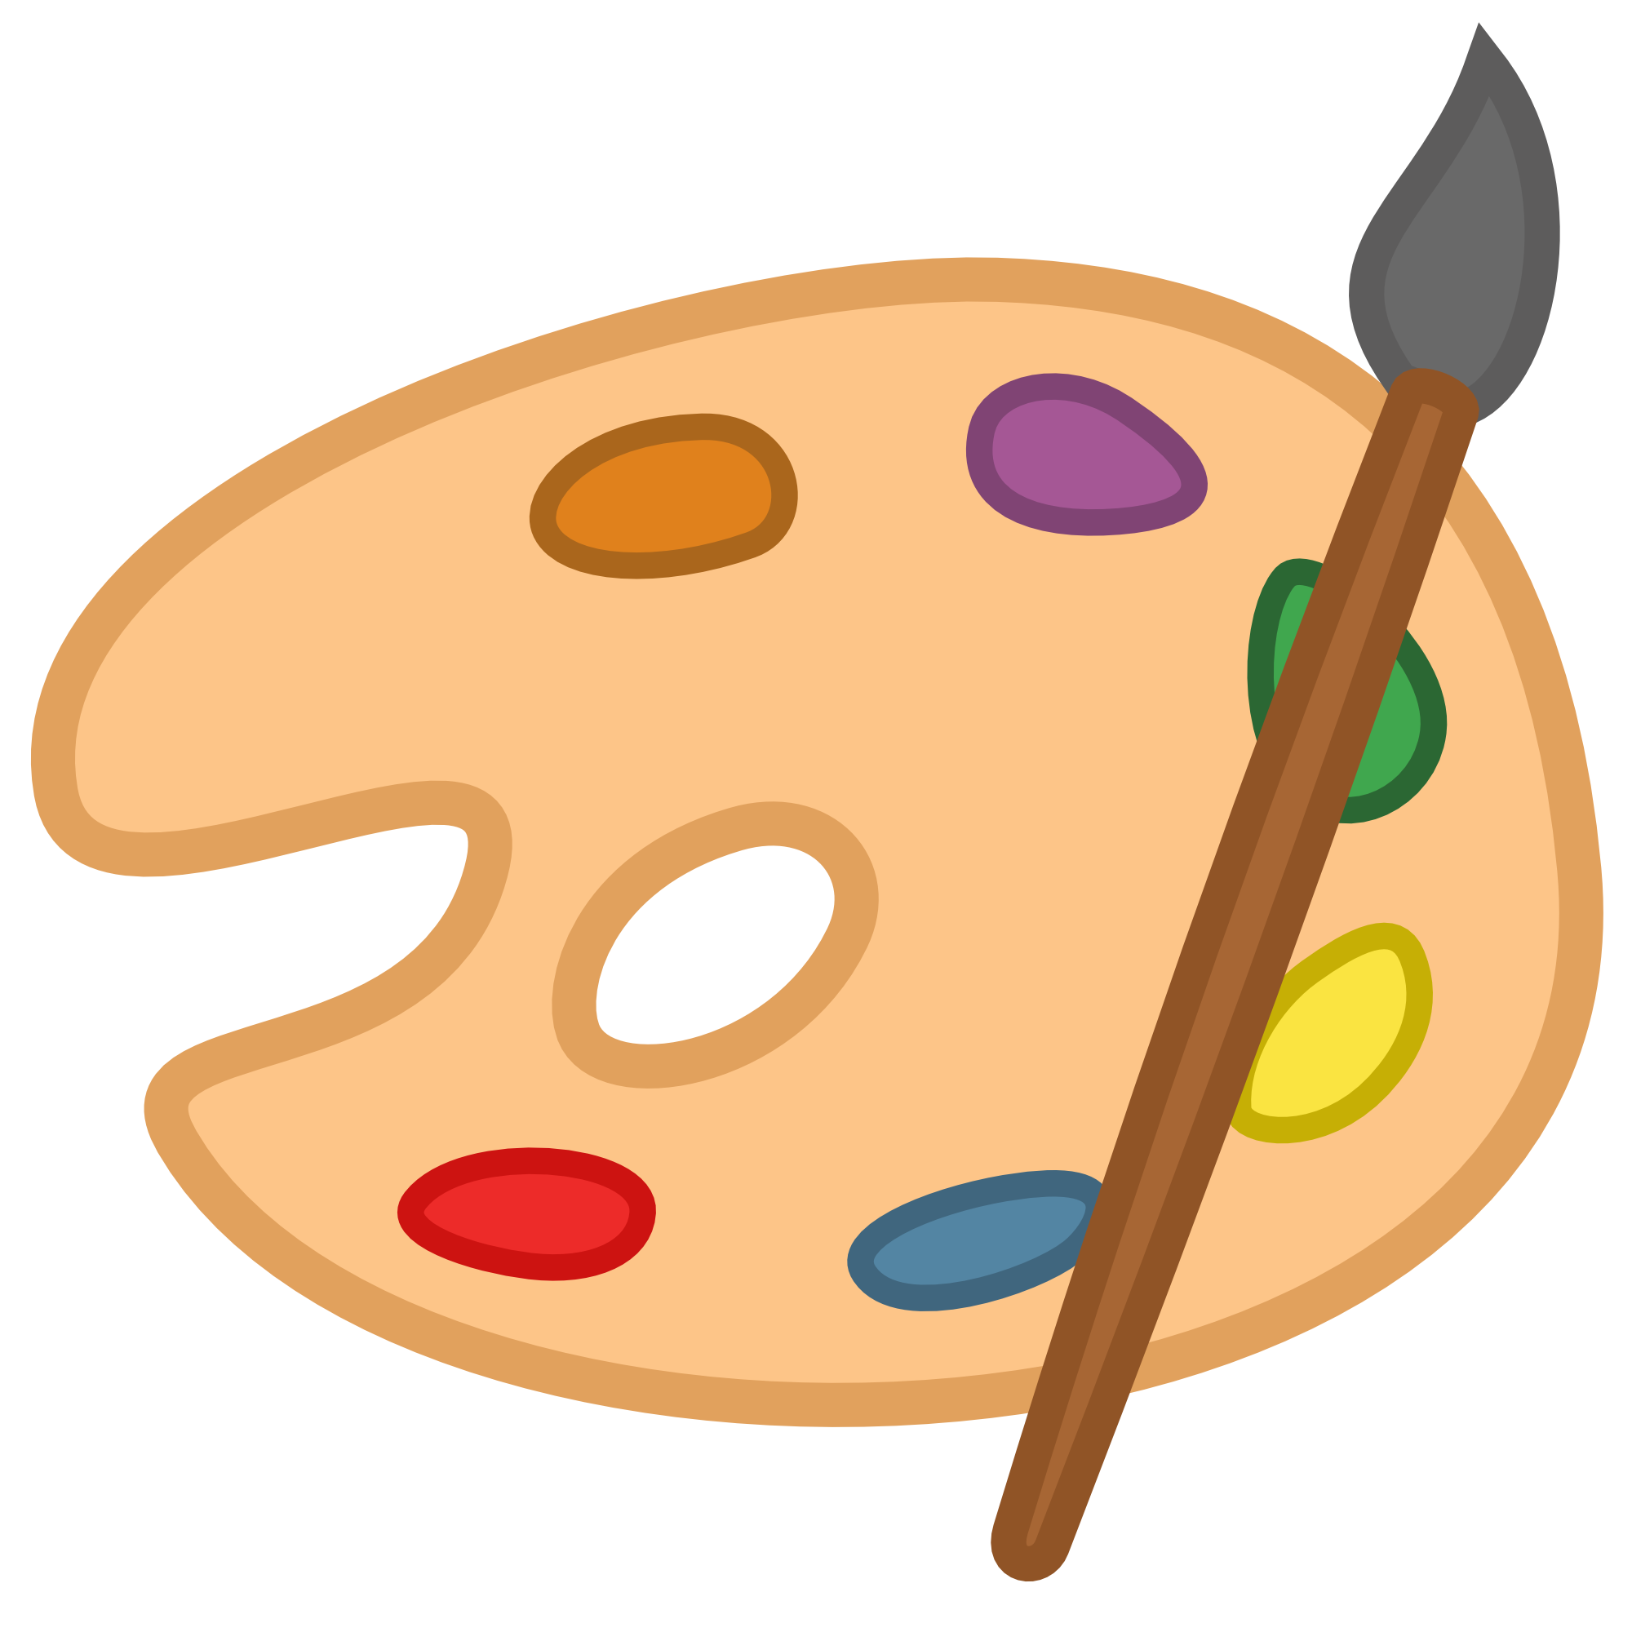

[](http://www.google.co.uk/url?sa=i&rct=j&q=&esrc=s&source=images&cd=&cad=rja&uact=8&ved=0ahUKEwio8eTxmfvOAhVGUhQKHXWBCsQQjRwIBw&url=http://www.freeclipartnow.com/recreation/sports/fitness/&psig=AFQjCNEtBpn-b9fXgooh9aHc3hD0tSfctg&ust=1473267108349464)

**Topic - Health**

We will discuss:

* People who help us
* Safe medicines and when to take them
* Items that are in a first aid kit
* How to apply a bandage
* Diabetes and asthma
* Personal hygiene
* How to make a 999 call

Children will work collaboratively during their topic to enhance their learning. They will produce informative posters and complete role play activities to share with others.

**Religious and Moral Education**

We will look at the Easter Story and work in groups to sequence events.

**Health and Wellbeing**

-We have a right to choose our own beliefs.

-Children will continue to use their healthy snack charts and have the opportunity to use the fruit trolley daily.

-We will continue to focus on developing our skills and techniques to improve our level of performance and fitness.

**Mathematics & Numeracy**

**Maths**- Children will use counters and squared paper to calculate the area of 2D shapes. Children will work in groups outside drawing shapes using chalk and calculating the area of shapes.

**Numeracy**- We will be working on division using sharing. We will also be focusing on adding and subtracting 2 digit numbers.

**Healthy Lifestyles**

