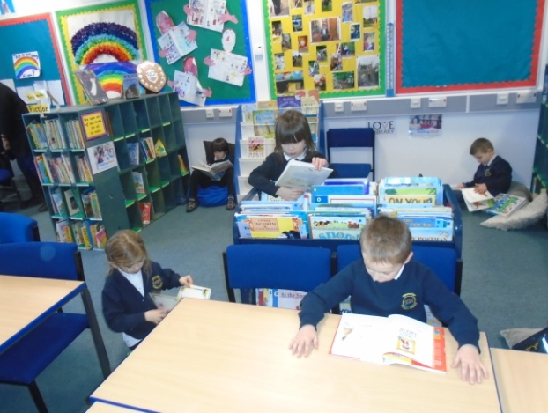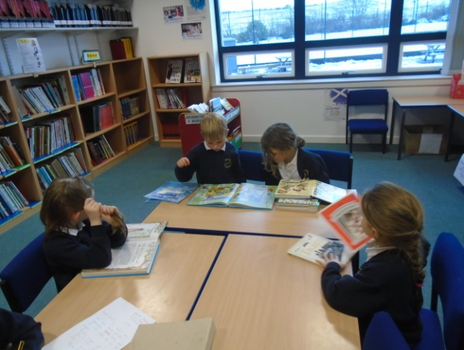 |  | The Nativity – we all worked hard during our nativity rehearsals and delivered an excellent performance of ‘A Little Bird Told Me’.  We also learned about the Christmas story. |  | Literacy-We have been working on our imaginative writing. We enjoyed making up our own adventures and sharing them with others.
Library-We go to the library each week and enjoy choosing and sharing books with others.  We have also had a focus on reading for enjoyment and we spend time each class reading fiction and non-fiction books. |  |  |  | 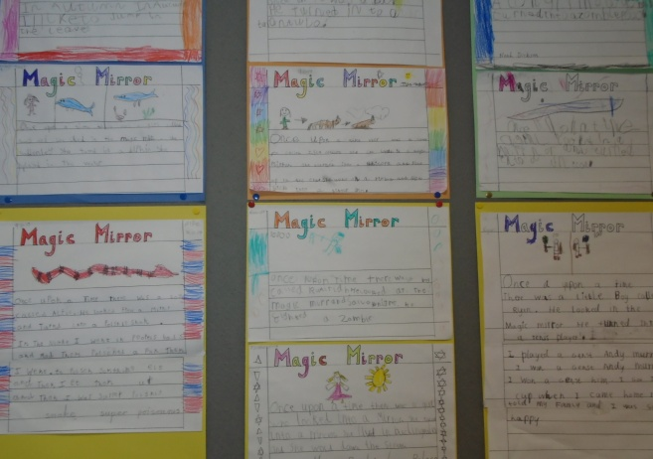y
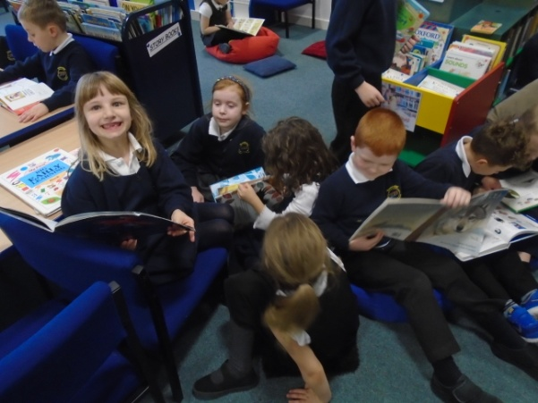 |  | Senses-We have been learning all about the different senses. We carried out experiments to test our senses including smelling and identifying different foods. We also blindfolded ourselves and tried to draw and write. |  | 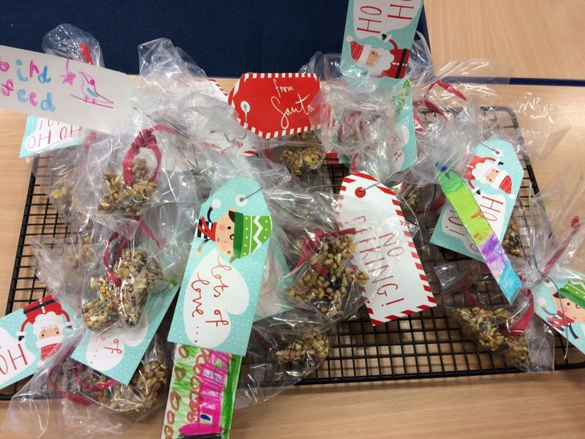  Our bird feeders for the Christmas Fair.

