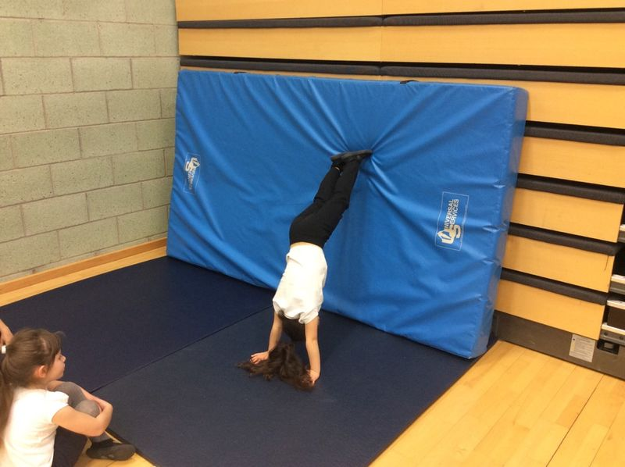 |  | Gymnastics – We have had 8 weeks of gymnastics with coaches from Lasswade gymnastics clubs. The pupils have made huge amounts of progress and develop their skills for jumping, balancing and rolling, |  | 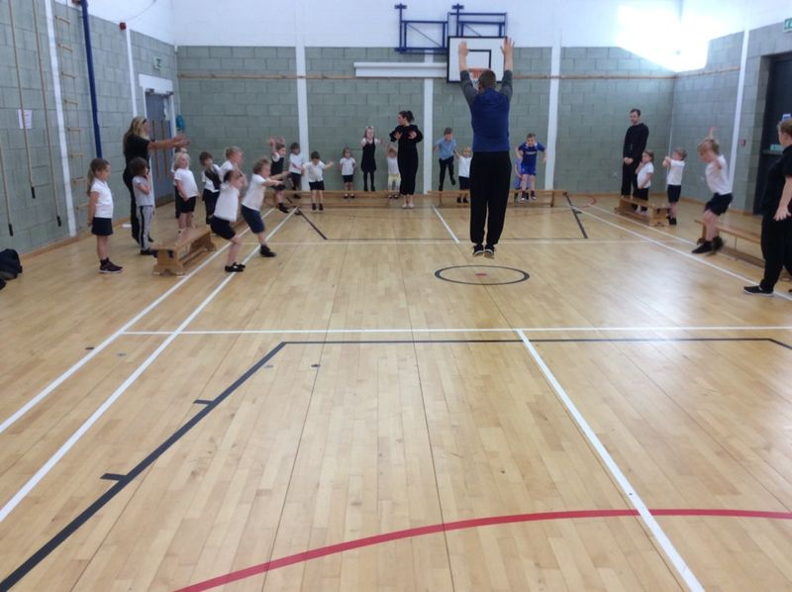
Katie Morag – This period we have been learning about our local environment and Scotland through our topic, Katie Morag. We have enjoyed exploring our local area, main land Scotland and the islands. We hope you enjoyed our assembly. |  | 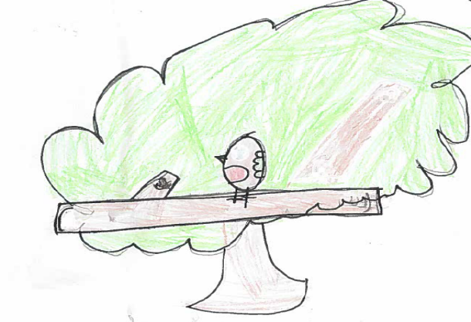 |  | The Elf and the Shoemaker - We all participated in a drama workshop and re told the story of The Elf and the Shoemaker. The children were all very engaged and loved taking part in the story. Every child has a role in retelling the story.
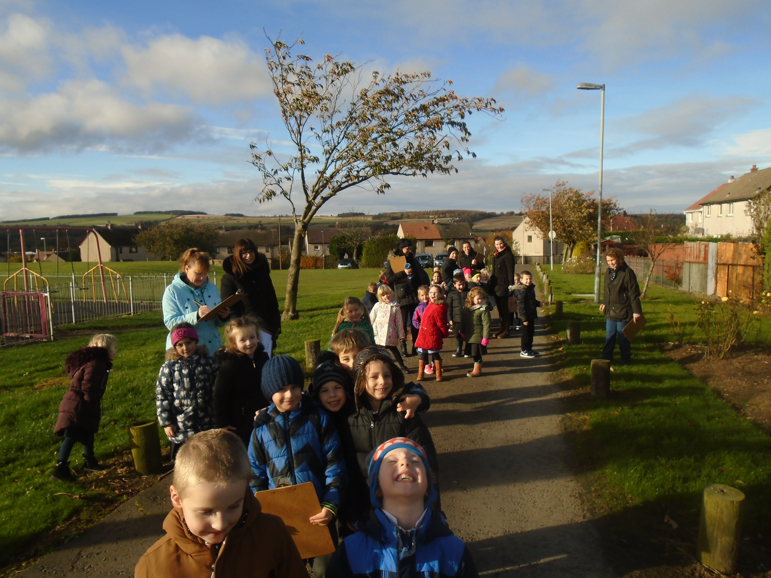 |  | The Nativity – we all worked so hard during our nativity rehearsals and delivered an excellent performance of ‘A Little Bird Told Me’. We also learned about the Christmas story and Christmas traditions from around the World. |  | 

