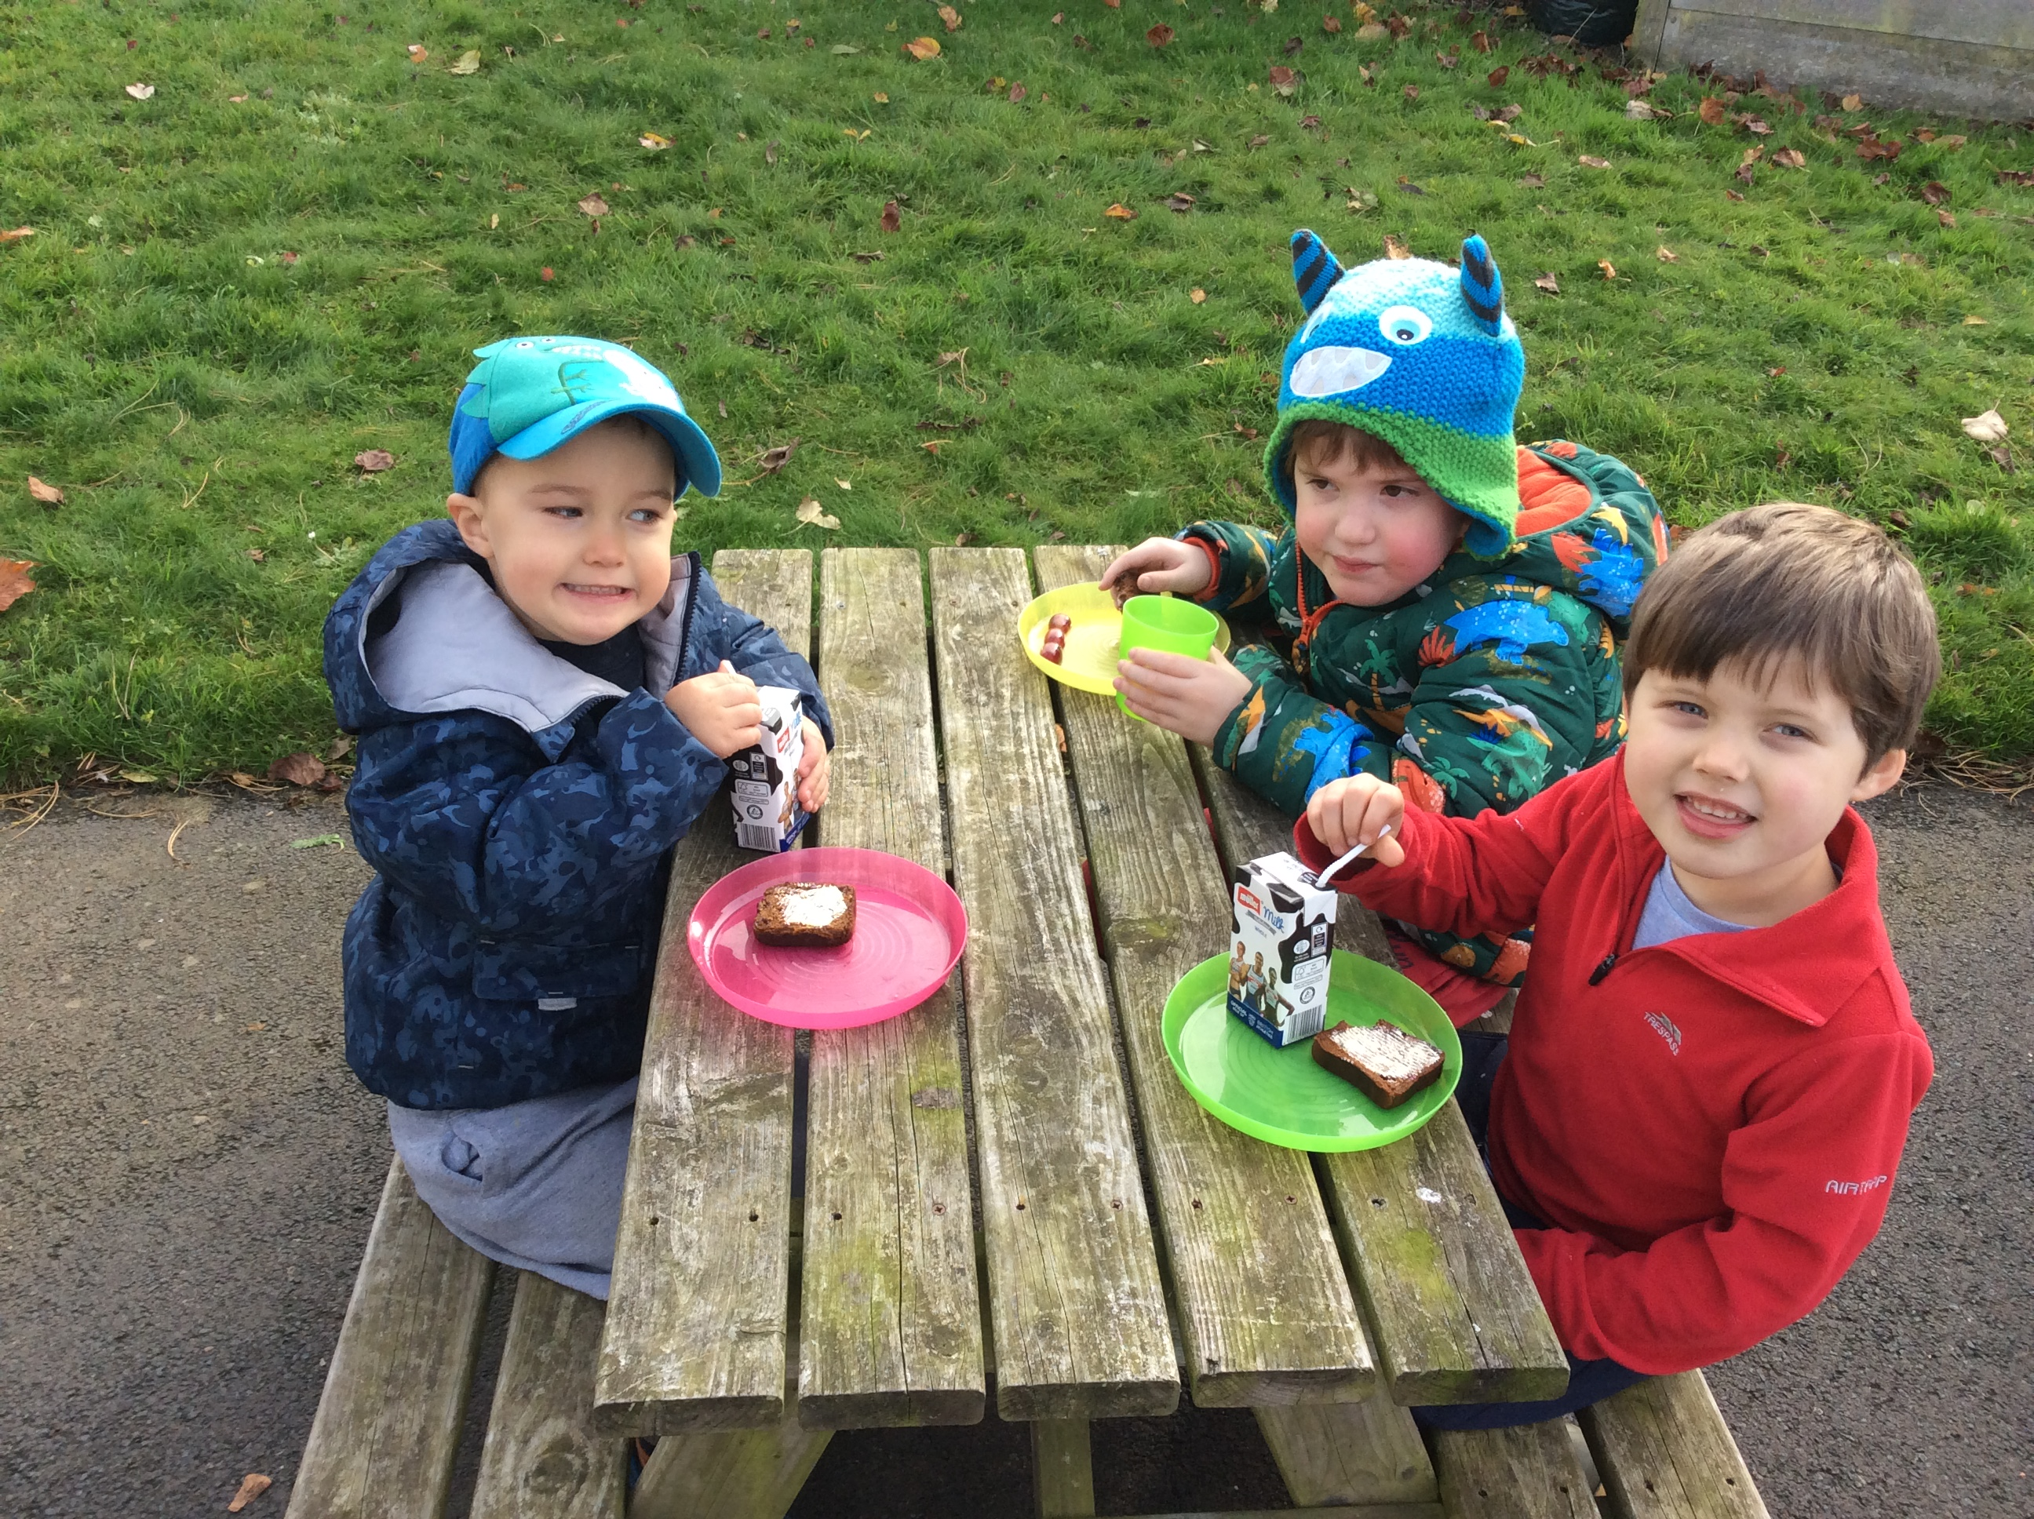 |  | 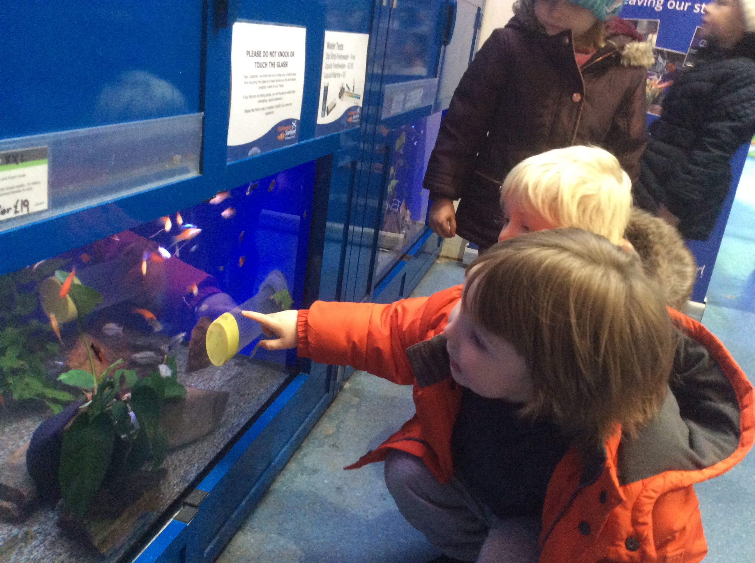 |  | 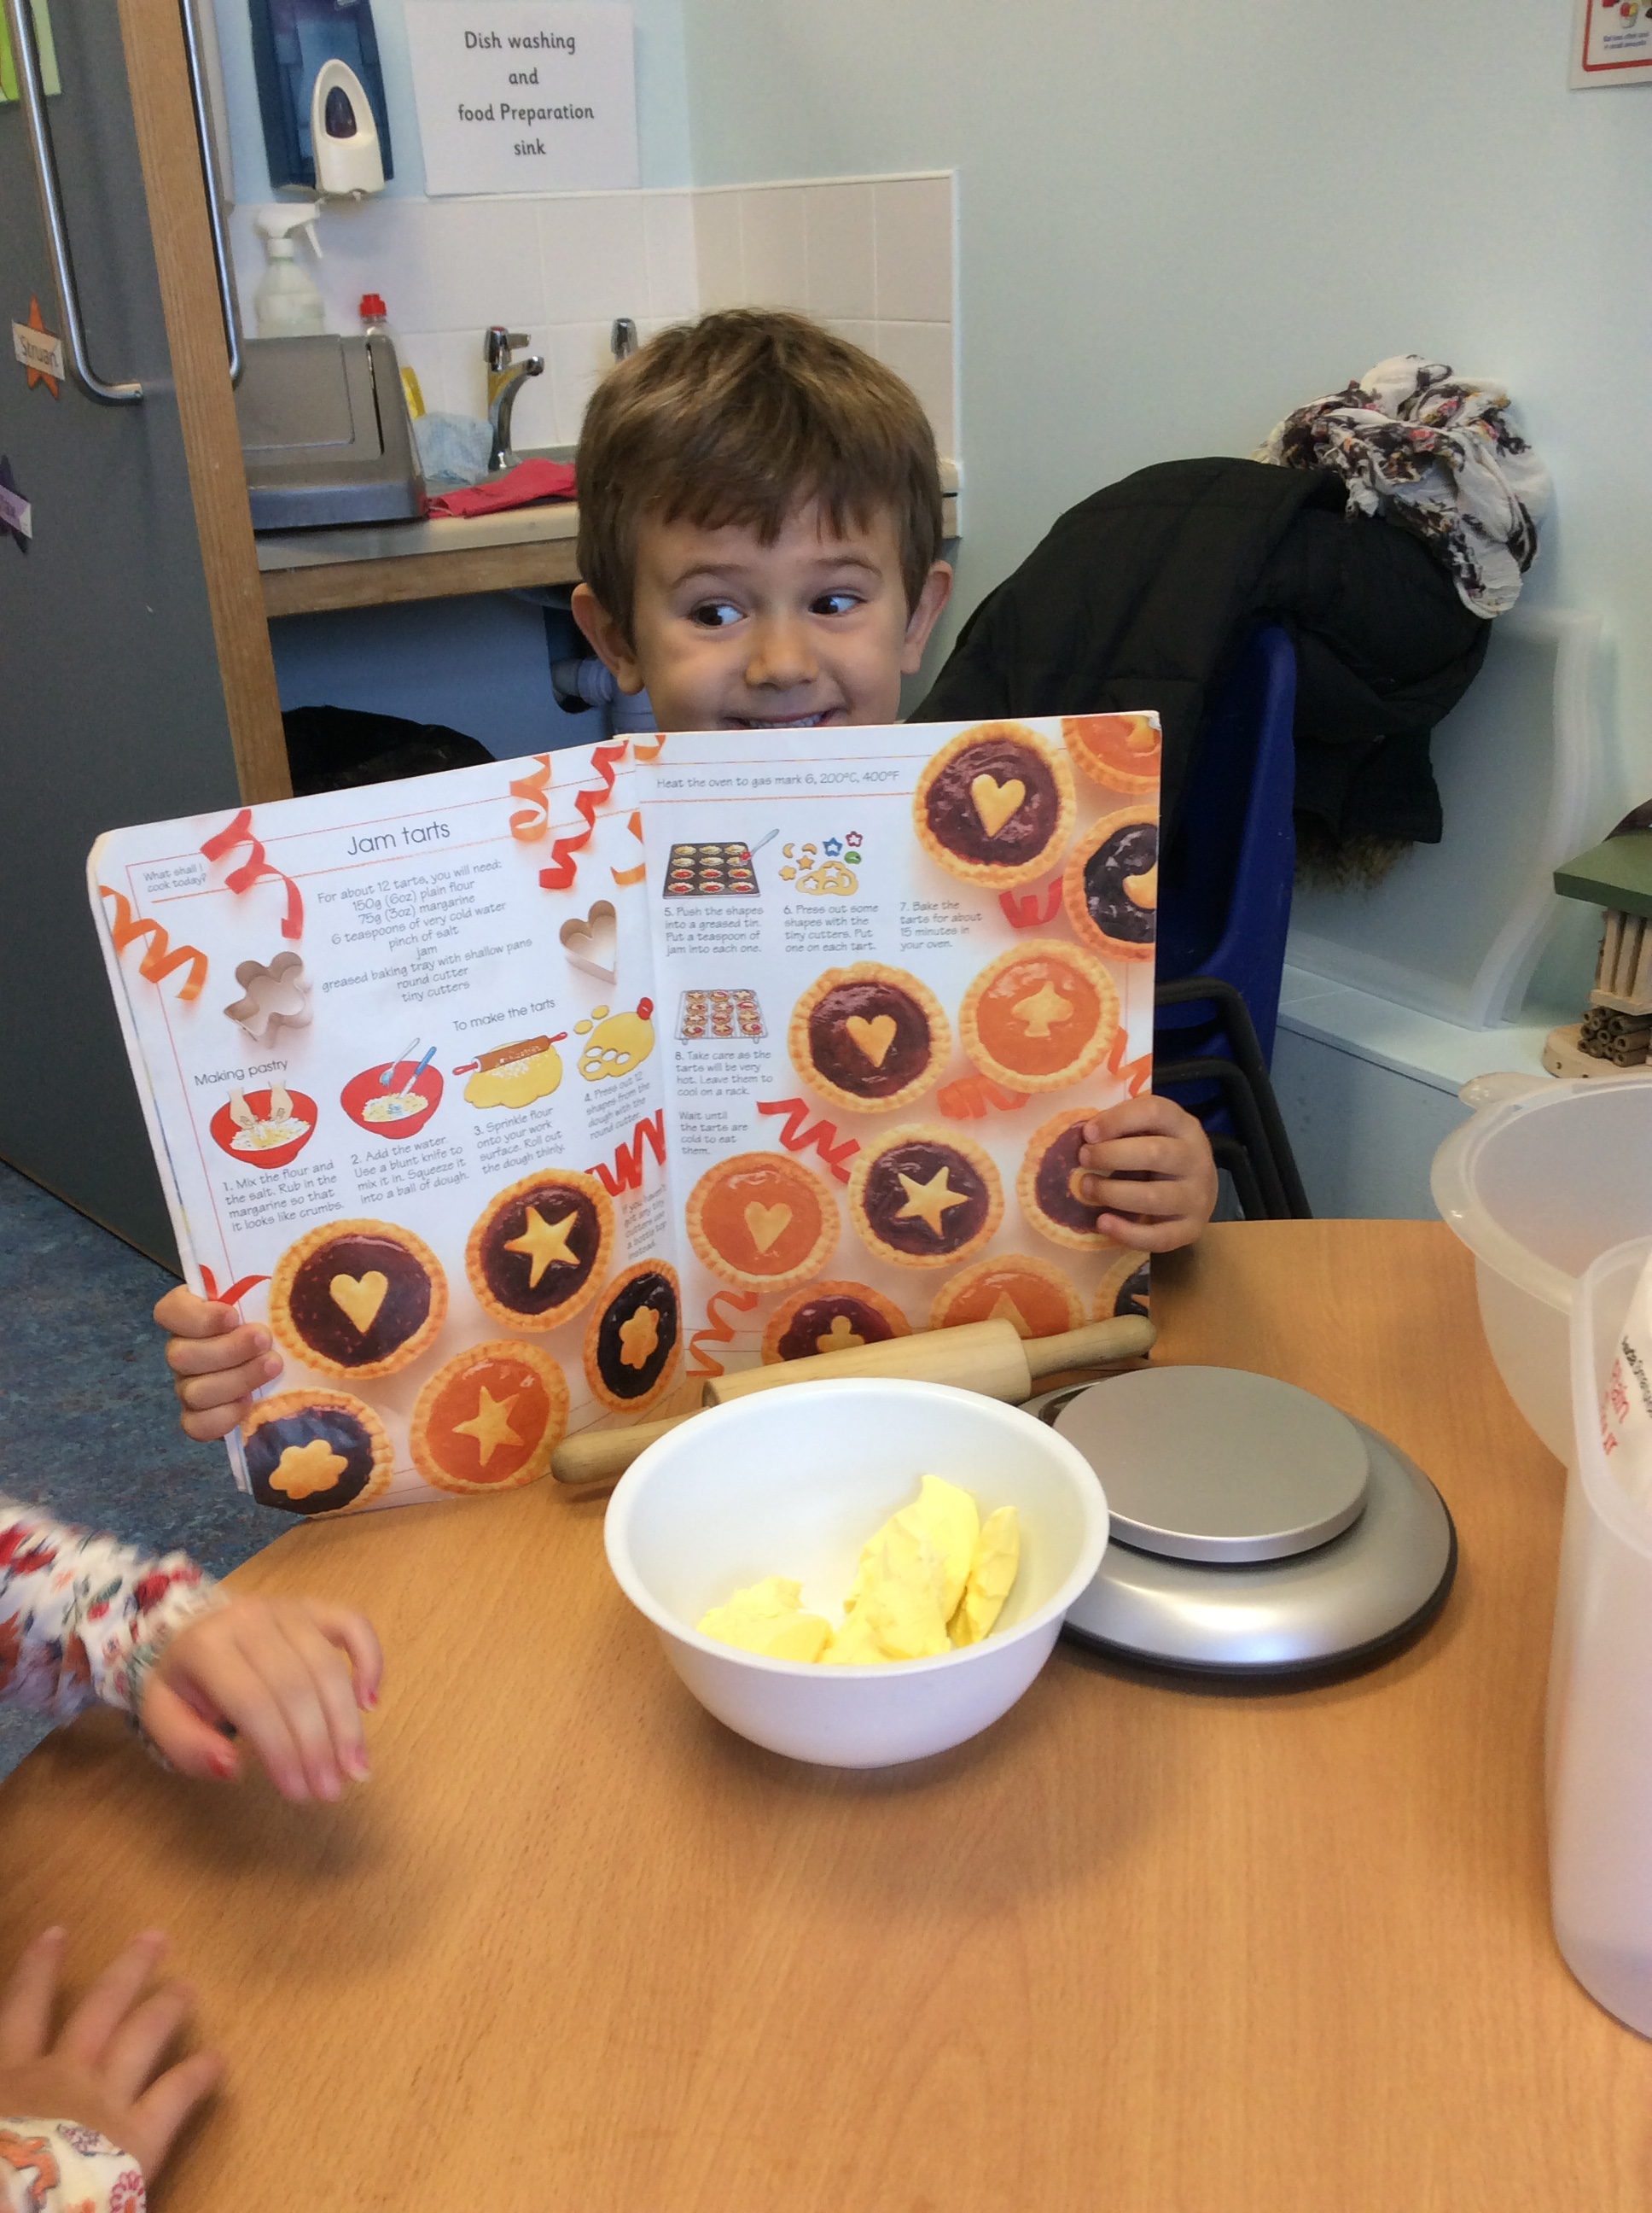
Outdoors!- We continue to enjoy opportunities for outdoor learning regardless of the Weather. One of the children`s favourite things to do is have an outdoor snack. Everyone likes to play in the mud, even the adults sometimes |  | Dobbies Trip- Both classes enjoyed a visit to Dobbies to feed the fish and look at plants. Whilst we were there we had a walk around to see what lovely things we could buy for our nursery. He boys and girls think we should have pet fish in nursery. |  | Freddy the star Baker- Freddy has been very interesting to try our various recipes and make lots of goodies for his friends. Whilst taking part in Baking activities he has encouraged his friends to join in.
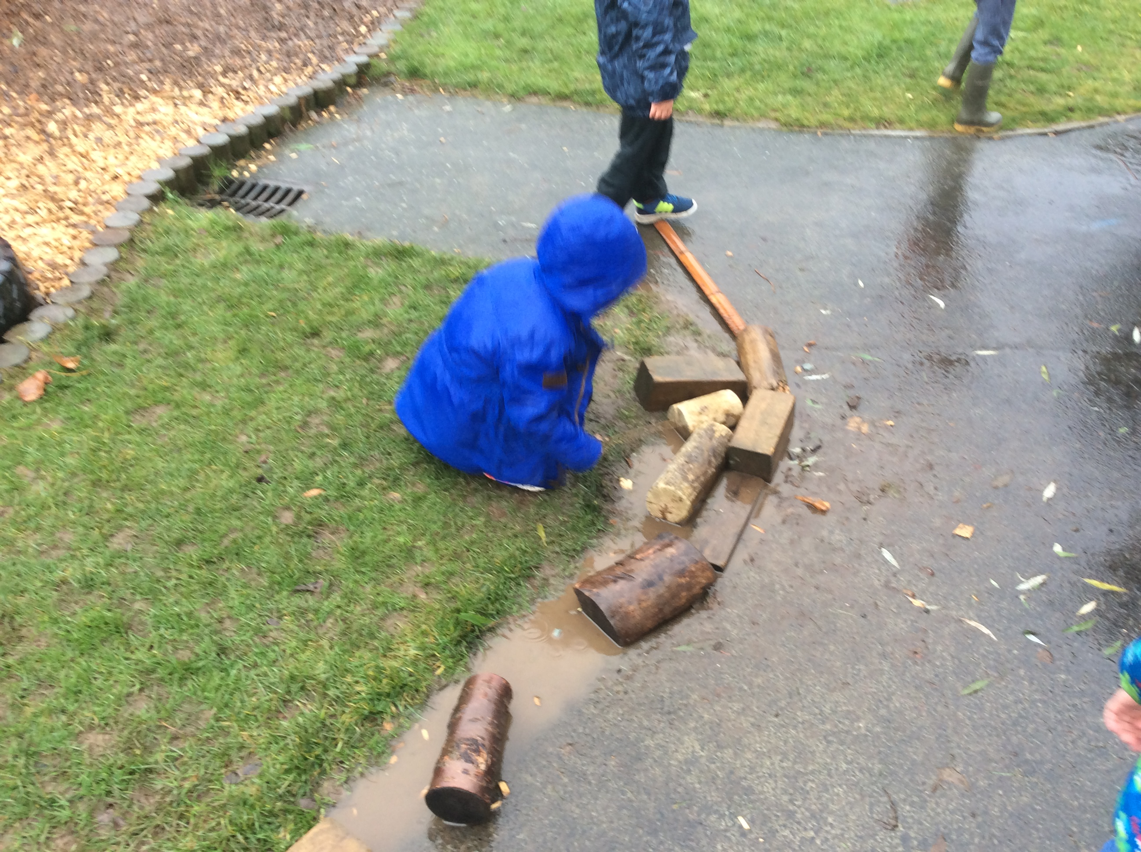 |  | 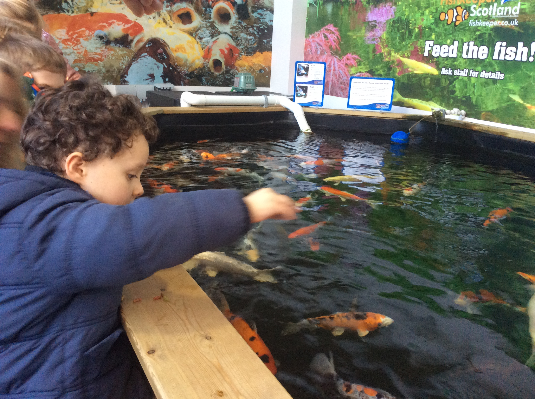 |  | 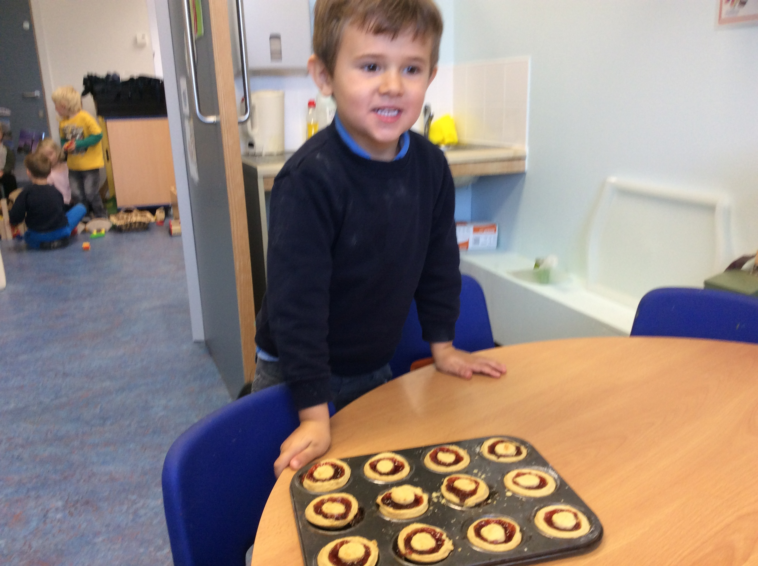
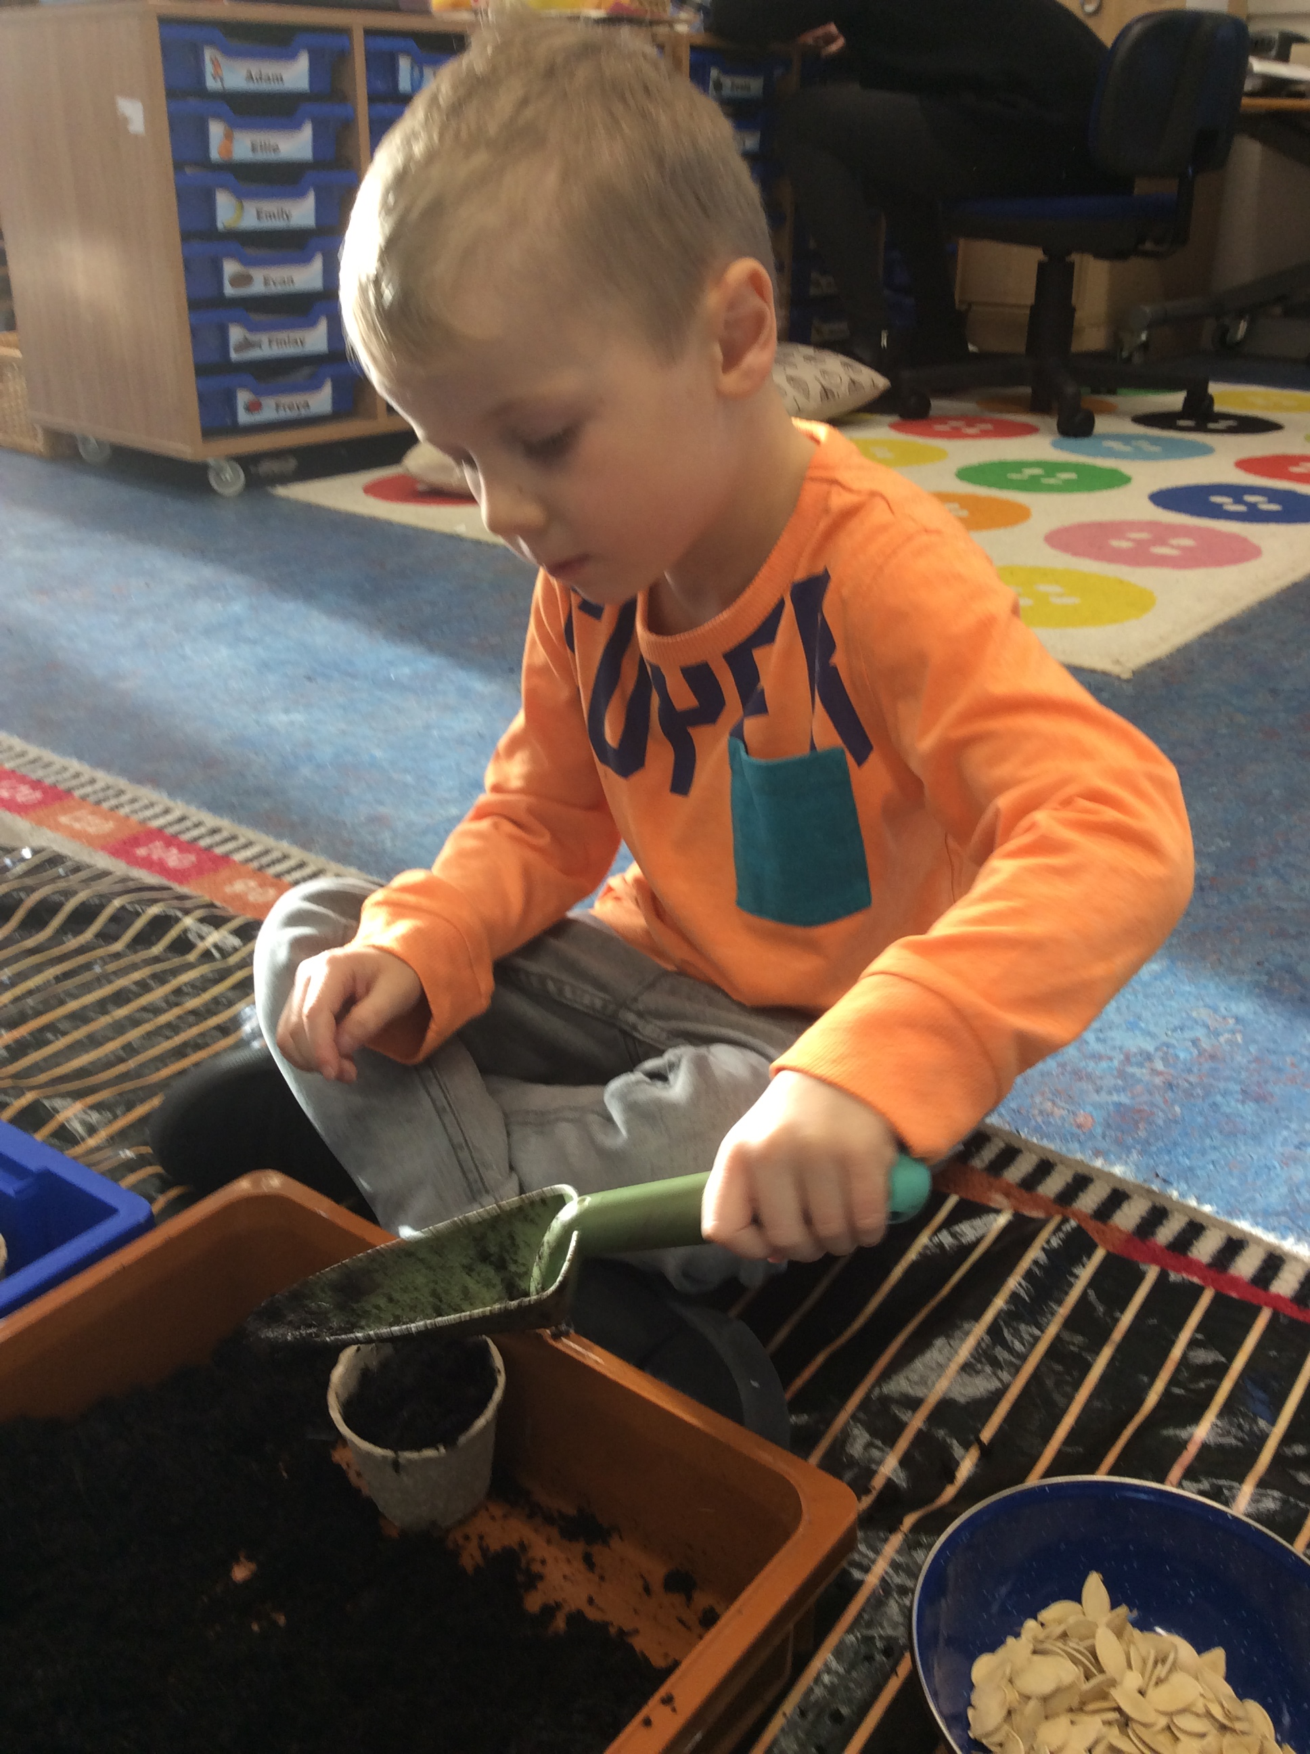 |  | 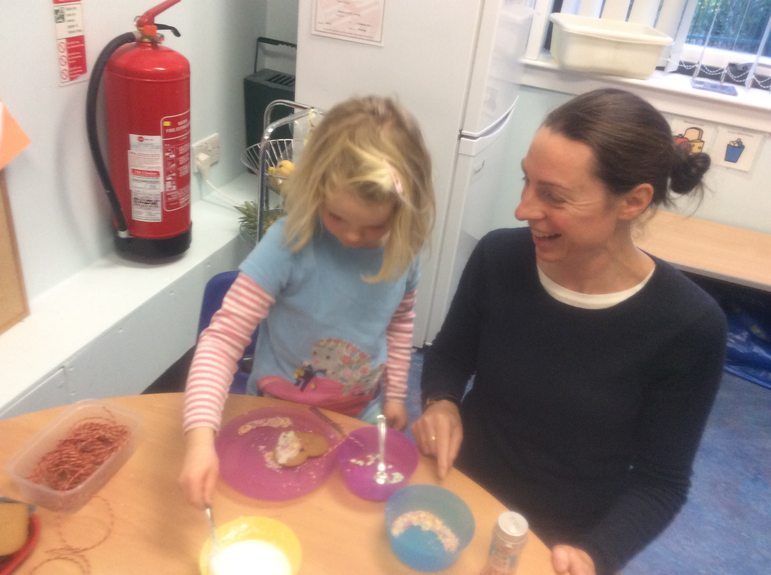 |  | 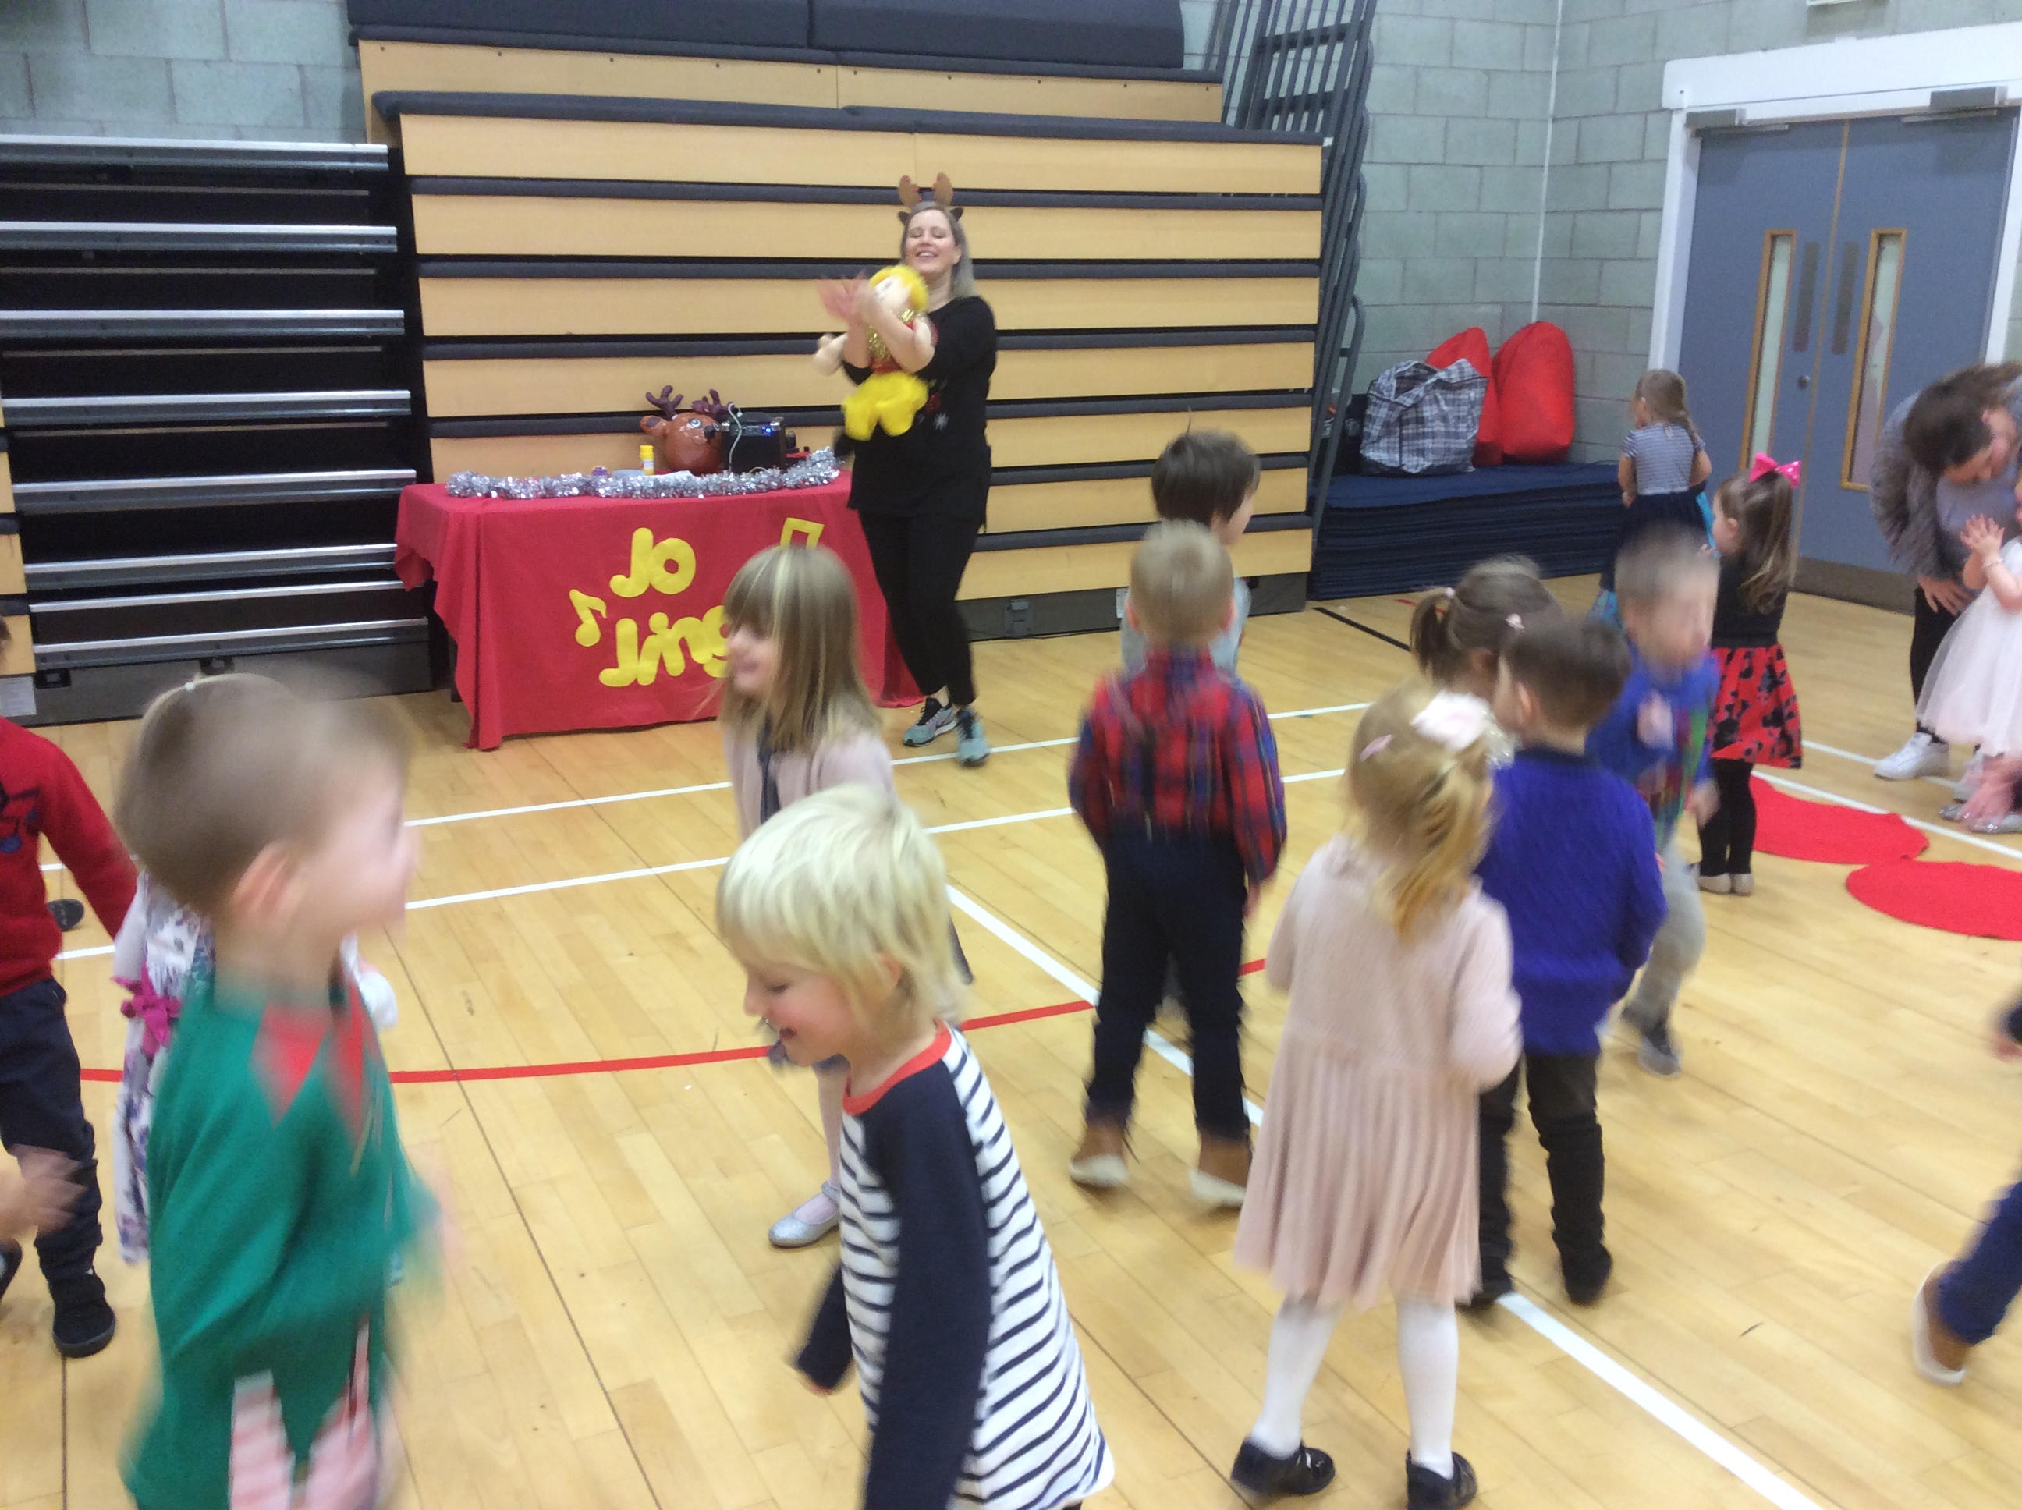
What Can we grow? – This term we have been interested in trying to grow foods that we eat for snack. We planted pumpkin seeds and a pineapple, our pineapple is continuing to grow!!  The children are continually coming up with ideas of what we could try to grow next. |  | Christmas Craft Day- We invited parents and carers in join us for some Christmas crafts, mince pies and Carols.  Everyone enjoyed having the opportunity to socialise with one another and gave the children the opportunity to share their learning. |  | Party time! – Both classes joined together for a morning of dancing and games at our Christmas party led by Jo jingles. All the children showed lots of enjoyment and then enjoyed some delicious party food.
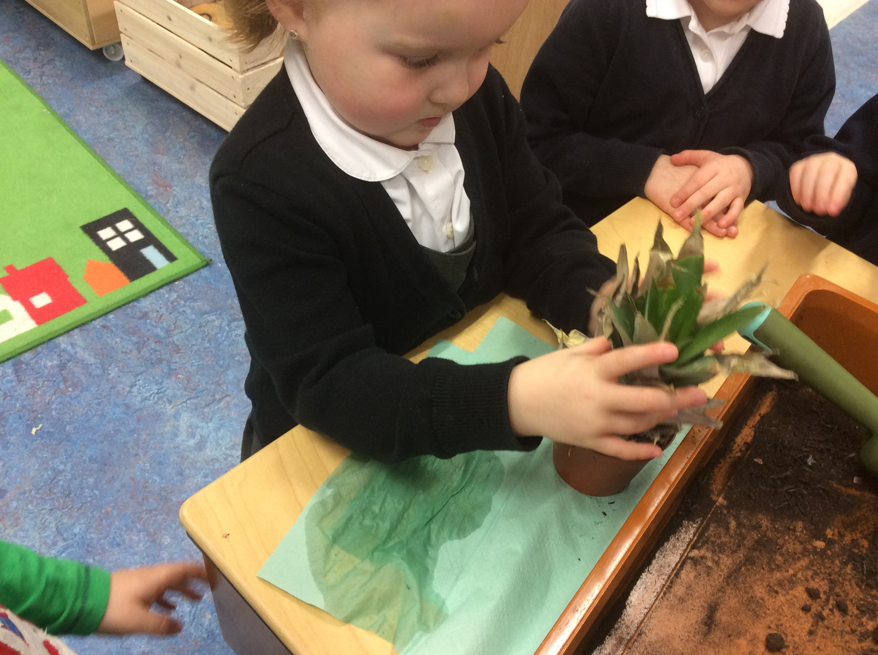 |  | 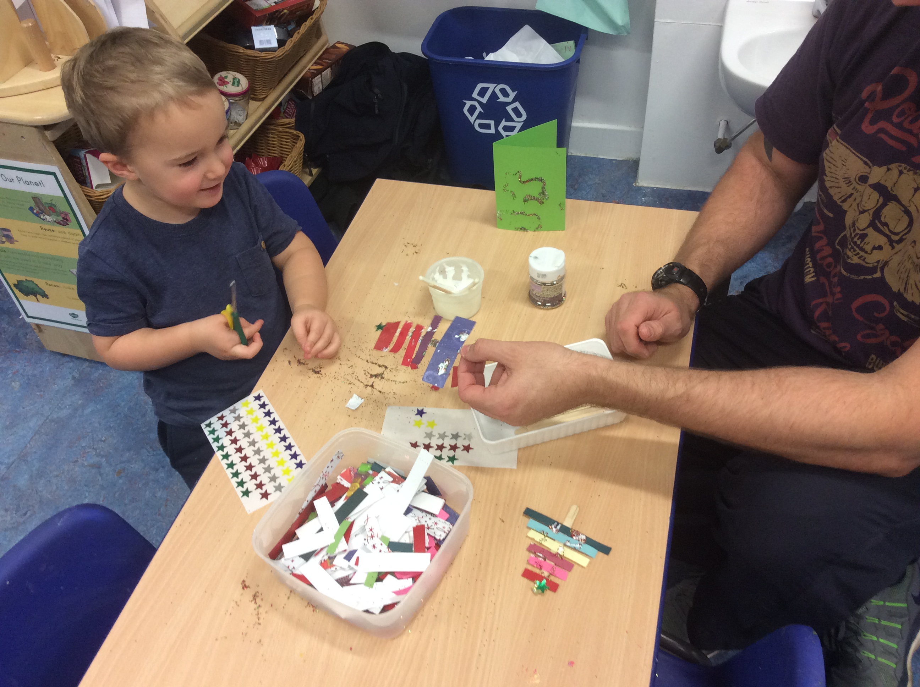 |  | 

