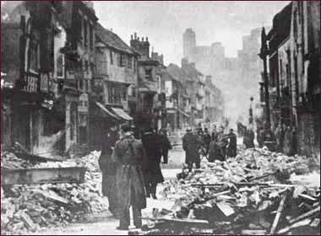

**Social Studies**

Our WW2 topic will focus on:

The Blitz, Evacuees and Rationing.

We will begin our topic by exploring sources of evidence and developing our ability to understand and discuss reliability.

We will conduct research using a number of sources to build a picture of what evacuation was really like and share our findings with each other to develop our talking

and listening skills.

**Language and Literacy**

Our reading skill focus this term is questioning. We will explore the novel ‘The Boy in the Striped Pyjamas’ and examine and discuss elements of the novel in connection to real historical events, allowing us to analyze and discuss, both individually and as a class, the important ideas and themes within the story.

We will also speak and write with insight about the

moral implications of the story and themes in the novel.

Our writing focus this term is poetry and we will

explore the work of a number of WW2 poets as a

stimulus for our own work.

**Homework**

Literacy and maths homework will be issued on Mondays.

Spelling homework will continue to be

handed out and

returned on

Wednesdays.

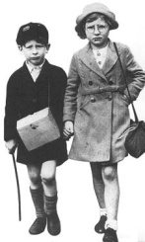[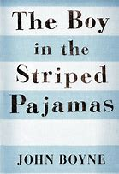](https://www.bing.com/images/search?view=detailV2&ccid=AKcmR3Wl&id=F4F63F12CCAE3EB35AFFC2BA9BF4CBD958259000&thid=OIP.AKcmR3WljSrS3nZc_zwuTgHaLh&q=the+boy+in+the+striped+pyjamas+novel+study&simid=607996955451328315&selectedIndex=3)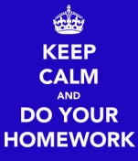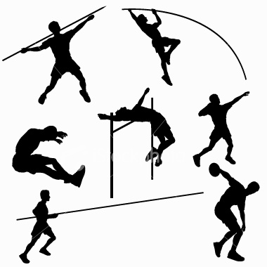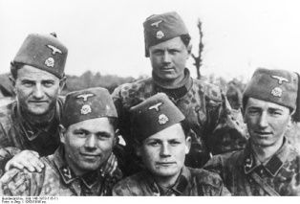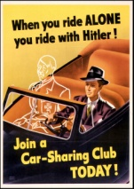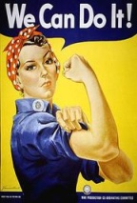

**UNCRC**

We will be exploring the following rights through discussion and practical activities:

Article 2 (non-discrimination)

The Convention applies to every child without discrimination, whatever their ethnicity, gender, religion, language, abilities or any other status.

We will link our work on rights to our topic and research in more detail some of the groups who have been discriminated against during the war and also throughout history.

We will also make links to our own rights and ways that we can effectively manage conflict within our own lives.

**Health and Wellbeing**

P7 will take part in the ASG athletics competition this term and will focus on developing our ability to effectively run, jump and throw and applying the skills used in the different events. P7 must bring in an appropriate change

of clothing for P.E.

on Mondays and

Wednesdays.

**Expressive Arts**

We will create our own propaganda posters, recreate

an image of a WW2 soldier and learn some war

time songs by famous wartime singers.

**Mathematics and numeracy**

We continue with math rotations this term ensuring broad coverage of the main skills – addition, subtraction, multiplication and division using the basic facts progression.

We will explore the properties of circles and develop our knowledge of volume and units of measurement. We will continue to consolidate and revise our learning so far and set individual numeracy and maths targets throughout the term.

We will continue to strengthen our mental math skills using Big Math and Xtra Math each week.

**WWII**