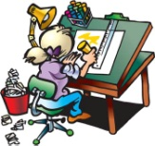

**Science, Technology**

**and Engineering**

Primary 6 have entered the Scottish

Engineering Leaders Award 2018. As part of this project they have to contact and interview an engineer about what their job entails. We are hoping to visit an engineering firm to see the real life practicalities of this job. They will then have to identify a ‘problem’, draw and annotate a solution and write a cover letter to engineers explaining why they should make their invention.

We will also be visiting the Forth Replacement Crossing Contact and Education Centre. This will allow us to see the 3 Forth bridges up close and find out which types of bridges they are. We will also take part in Bridge Building Challenges. The purpose of this topic is to let children experience what it is like to be an engineer in a fun and engaging environment. Through the activities, they learn about the various skills required to be an engineer and may be inspired to consider pursuing a career in this industry.

P.E kits will be needed on a ***Tuesday*** and ***Wednesday***. This should consist of a clean t-shirt, shorts or leggings and indoor footwear. All children are required to wear ***indoor shoes*** in school. We appreciate your help with this matter.

Spelling and Maths homework will be issued on a **Monday** and due in on **Friday**. We will read in class on a **Thursday** and I will set pages for the following **Thursday**.

**Language and Literacy**

In writing this term we will be looking at formal and informal letters. We will be writing letters of complaint, letters of application and persuasive letters.

In reading lessons we will be using a range of questioning techniques, from simple recall questions to higher order evaluative questions. In group reading sessions we will be focusing on our individual targets.

We are using the Penpals scheme to practise our handwriting joins, which will then be reflected in our work across the week.

For listening and talking we will be giving presentations to the rest of the class.



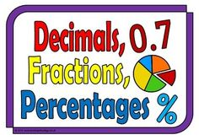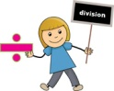

**Technology**

We are hoping to use the i-pads to look at the basics of coding this term. We will also be using technologies to create presentations which we will share with the rest of the class.

**Mathematics and numeracy**

It is still of paramount importance that we increase our mental maths capacity and knowledge of times table facts, and reinforcement and help from home is the only way we can fully achieve this. In class we will complete mental maths booklets. We will play Basic Facts games regularly in order to achieve our mental maths targets, and undertake Big Maths once a week. In numeracy lessons we will be learning about division, decimals and comparing fractions, decimals and percentages

**Health and Wellbeing**

In P.E we will be undertaking Athletics this term, primarily runs, jumps and throws. Some pupils will take part in an inter-school Sportshall Athletics tournament at the end of January.

We will be learning about food and nutritional needs and cleanliness and hygiene techniques this term.