

**Social Subjects** 

We will be learning about people and toys from the past and making connections with today and our own lives.

Through our reading, discussions and exploration of toys and people, we will look closer at how our lives compare and contrast to our own.

The children have also asked to learn about toys from around the world. We will look at toys that are popular around the world, and compare these with our own toys.

Pupil Voice: Pupils have decided they would like to learn about toys from the past and toys from around the world.

RRSA: **Article 13**

You have the right to find out things and share

what you think with others, by talking, drawing, writing or in any other way unless it harms or offends other people.

**Language and Literacy**

We are continuing to blend the sounds that we have learned together to read and make words. We will be focusing this period on common and tricky words, as well as our ORT scheme to continue to develop our reading skills. We will also use nonfiction texts to read for information and use this for a purpose. We are going to be completing personal writing about our toys and delivering a talk on our favourite toys. We will be creating posters to share information about toys from the past.

 

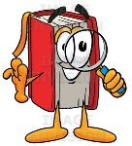

**Primary 1** Period 5

Toys

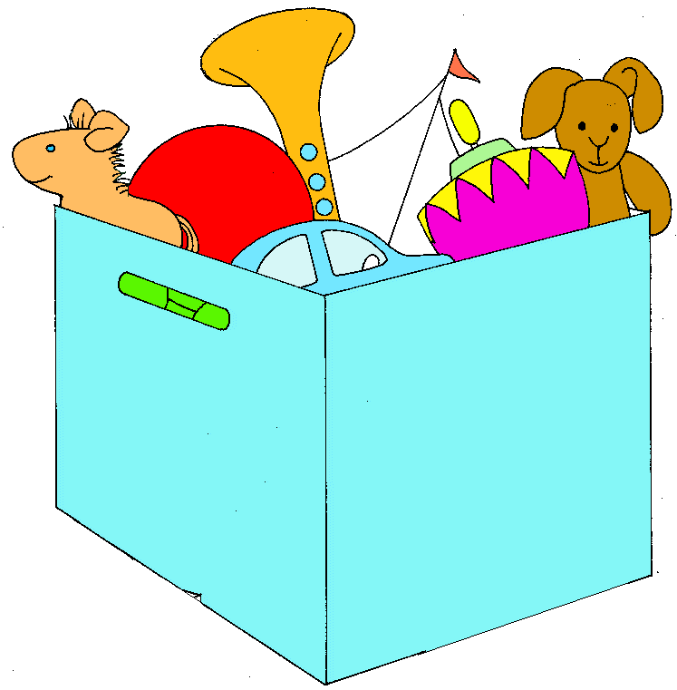

**Mathematics and Numeracy**

In Numeracy, we are continuing to learn to recognise, say and write the numbers within 100 focusing on starting at different numbers. We will continue to explore counting accurately, ordering and sequencing numbers, practising giving the number before and after and in between. We are also learning our number bonds to 10 and doubles to 20.

In Mathematics we are going to be learning how to tell the time, about seasons and months of the year to build our understanding of the world around us.

**Health and Wellbeing**

In Health and Wellbeing, we will be learning about keeping fit and healthy as well as developing our determination, spatial awareness, co-ordination and balance skills through basic moves. We are focusing on throwing and catching skills. We will use our skills in a range of games to show our ability to apply our skills.