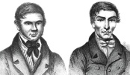

**Literacy**

Our reading skills will be predicting, analysing and evaluating. We will carry out some Christmas themed comprehension activities.

We will develop our oral communication and listening skills through sharing our learning with others and in preparation for our final assembly.

**Social Studies**

Our performance of Burke and Hare is on Monday 11th December, so we will still be fitting in many rehearsals during the first week of December! This will round off our learning well, and we hope that you are able to make the final performance to see our many skills coming together!

Primary 5, 6 and 7 will be utilising our Spanish trainee teachers to teach us about how Christmas is celebrated in their country. We will also be learning about French Christmas celebrations. We will be celebrating Christmas with a whole atrium party during the last week of term.



Spelling and maths Learning at Home activities may be Christmas themed during this period.

P.E kits will not be required during our Social Dance block.

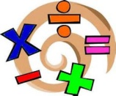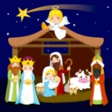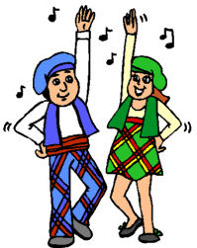

**Mathematics and numeracy**

We will continue to practise our times tables and basic facts targets this term, as well as increasing our speed and accuracy of mental maths through Big Maths and math rotations.

We will assess our knowledge of what we have learned so far using MUNP Assessments and consolidation sheets to identify new targets.

**Religious and Moral Education**

P5-7 will be looking at the meaning of

Christmas and thinking of others before themselves. They will be comparing and contrasting Christian religious traditions and beliefs in Scotland with Spain and France.

**Physical Education**

Primary 5, 6 and 7 will be learning

the steps involved in traditional

Scottish country dancing, in preparation for our Christmas Party. Participation, enthusiasm and good manners will be expected from all.

**Modern Language**

In line with 1+2 languages guidance we will be immersing ourselves in both French and Spanish Christmas themed language. We will sing a carol from each country at our final assembly.

