

**Literacy**

P5 will continue to work on their poster writing this period. As well as using the Christmas party as a context to assess their poster writing skills, children will also be designing anti-bullying posters linked to our Health and Wellbeing learning.

We will be working on our own reading and writing targets- your child should know these off by heart- so feel free to test them.

Children will be looking to find and show sufficient evidence of meeting their own personal learning goals, as spoken about at parents’ night.

Children are welcome to take jotters home to show and work with you and let you know how they are doing.



**Physical Education**

Primary 5, 6 and 7 will be learning the steps involved in traditional Scottish country dancing, in preparation for their Christmas Party. Participation, enthusiasm and good manners will be expected from all.

**EXA- Expressive arts**

P4-7 will be continuing to produce and practice their Burke and Hare performance. We look forward to seeing you on the 11th of December at our revised performance evening. P5 will also be learning some of the dramatic conventions to help them showcase their understanding of the Burke and Hare topic.

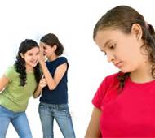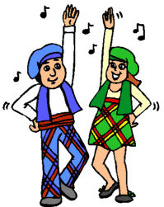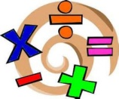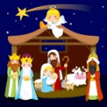

**Modern Languages** 

In line with 1+2 languages guidance we will be immersing ourselves in both French and Spanish Christmas themed language. We will even be singing a French, Spanish and German Christmas Carol.

**Mathematics and numeracy**

In maths we will continue to revise our basic facts. As much practise at home on Xtra Math as possible can help our key concepts of addition, subtractions multiplication and division. As a class we will also be looking at mathematical reasoning to solve mathematical puzzles; handling data, including using a computer to present their data and more complex multiplication, building on their basic times tables knowledge.

**Religious and Moral Education**

P5-7 will be looking at the meaning of

Christmas and thinking of others before themselves. They will be comparing and contrasting Christian religious traditions and beliefs in Scotland with Spain and France.

**Health and Wellbeing**

We will be learning more about bullying and what we can do to support positive relationships in the class and school.

**Christmas**

*Spelling Learning at Home activities will be Christmas themed during this period. (Christmas word unit will start 11th Dec and will be due 22nd Dec.) Reading homework will continue as normal this period. Maths will be online- all children are to try and complete Xtra math revision at least twice a week at home and Sumdog challenges will continue to be set to combat any holiday boredom!* ☺