Tynewater Primary School | 2017-2018 Period 4 |  | 4 to 22 December 2017 | Teacher: Miss Seaton | P3
Information for Parents - Outline Plan for Learning and Teaching
Topic / Project Title: |  | Nativity
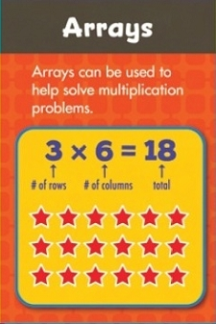
RME
The children will revisit the Christian Christmas story when participating in the Nativity.
Expressive Arts
During our nativity, the children will be developing many skills through Expressive Arts. We will be covering drama, music and dance.
HWB
This period for PE, Primary 3 will be taking part in social dance with Primary 4. So far the children have learned the ‘Gay Gordons’ and the ‘Military Two Step!’
Nativity

Our nativity performance this year is called ‘A Little Bird Told Me’ which we will be performing with Primary 1 and 2. Our nativity will be our topic focus for this period. Primary 3 are enjoying rehearsals and are developing their confidence and fluency when reading their parts aloud.

Primary 3
Literacy
This period we will continue to engage
with Literacy through covering:

Reading
- Engaging with a range of non-fiction texts
- Continue focussing on developing prediction skills

Grammar
- We will continue identifying speech in different types of texts

Writing
- Weekend news using comic strips
Numeracy

This period in numeracy we will be covering:
- Continue to develop knowledge and confidence with
numbers to 100/1,000/10,000
- Continue to work on Basic Maths Facts Target games
- Begin looking at multiplication through arrays

Maths
Primary 3 will be learning about angles and symmetry this
period.

