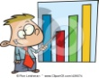

**Expressive Arts**

During drama experiences we will explore the Nativity story, help children to understand the world around them and build their children’s confidence through performing to an audience. .

**Language and Literacy**

We are continuing to recognise, say and write sounds following our Jolly Phonics programme. We are also learning how to blend the sounds together to read and make words. This period we are focussing on common and tricky words, as well as our ORT characters to begin to read. We are also learning how to share information in different ways by making invitations and posters to our school Nativity, School Fair and school Dance.

**Social Subjects**

We have begun our Nativity practice, learning about the story, the songs, and musical instruments.

Through our reading, discussion and exploration of the nativity and Christianity, we have begun to have a closer look at our own and other people’s lives and the world around us. We are looking forward to our Lyceum visit.

The children will discuss the story and different people’s beliefs and learn about the importance of celebrations, festivals and customs in people’s lives.

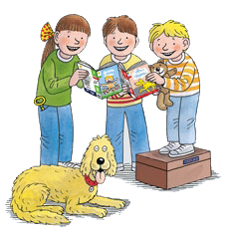 

**Primary 1** Period 4

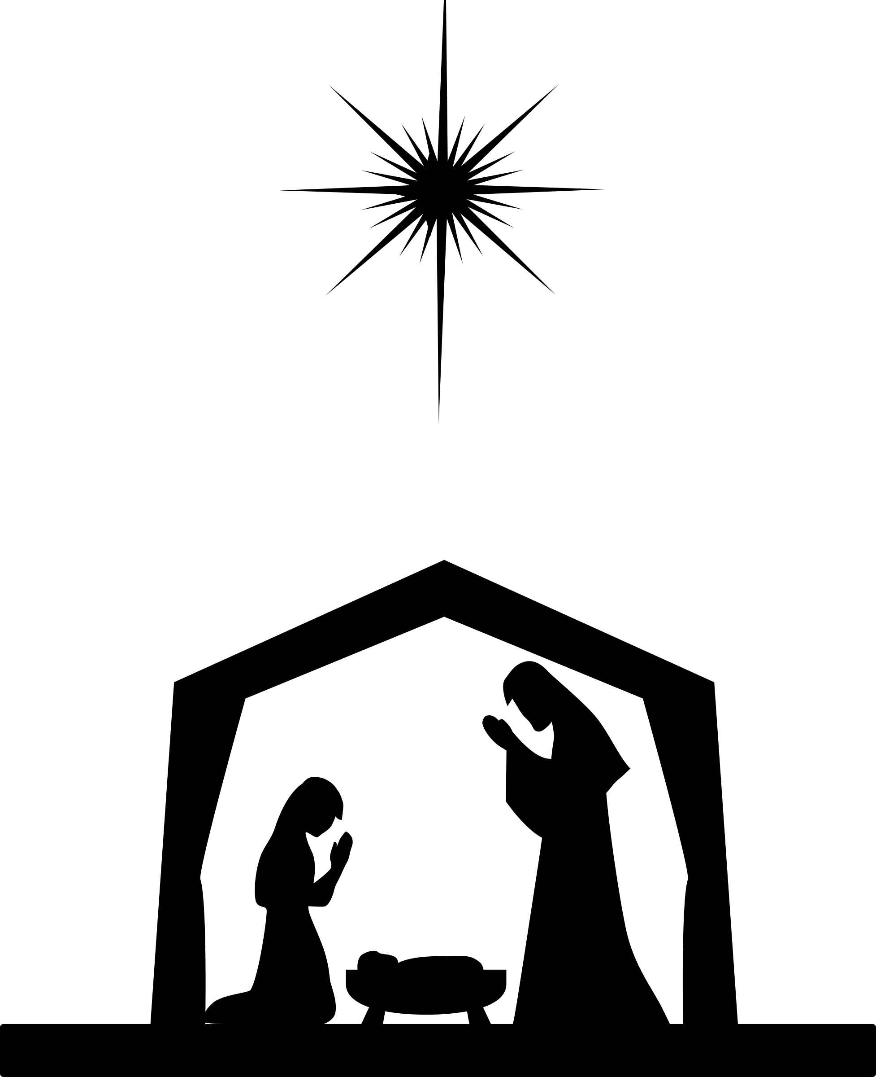

**The Nativity**

**Mathematics and Numeracy**

In Numeracy, we are learning to recognise, say and write the numbers within 30 focusing on starting at different numbers. We will continue to explore counting accurately and ordering and sequencing numbers, practising giving the number before and after. We are also building on our ‘Show Me’ game to start to add and subtract within 5/`0.

In Mathematics we are going to be exploring direction through Scottish Country dancing, and learning how to tell the time. We will also be exploring different ways of making patterns. 



Learning visits; Lyceum to watch Arabian Nights

Pupil Voice: Pupils will decide what part of the Nativity they will be responsible for.

RRSA: Article 14

You have the right to think and believe

what you want and to practise your religion,

as long as you are not stopping other people

from enjoying their rights.

**Health and Wellbeing**

In Health and Wellbeing, we will be learning about keeping fit and healthy through the enjoyment of dance. We will be continuing to develop our balance, coordination and determination through gymnastics.