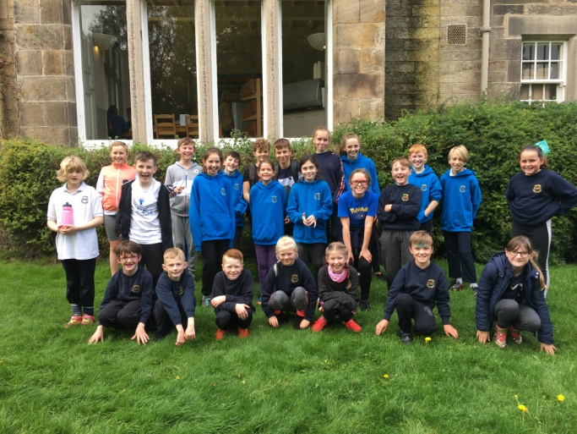 |  | 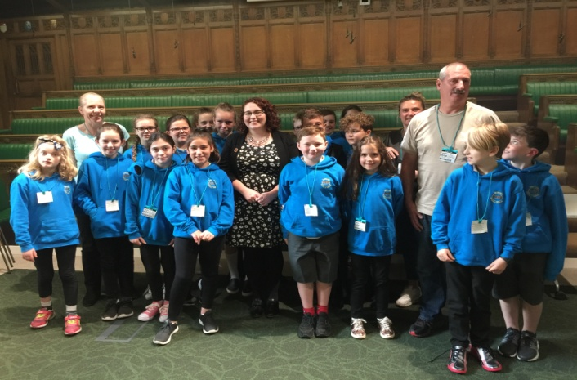
P6 and P7 girls and boys took part in football festivals this term, at Dalkeith High School. There was a great sense of sportsmanship, some goals were scored but most importantly they all had fun!  Some of P6 and P7 were selected to represent the school at a Cross Country event at Vogrie Park. A great effort from everyone involved. |  | This year marked the 9th Year of learning visits to London. P7 experienced a fantastic week, jam packed with learning experiences and were even lucky enough to meet our local MP at the Houses of Parliament.  The remaining P7’s had a great time at the Scottish Parliament and were thrilled to meet ‘Nevada’ the hawk!
