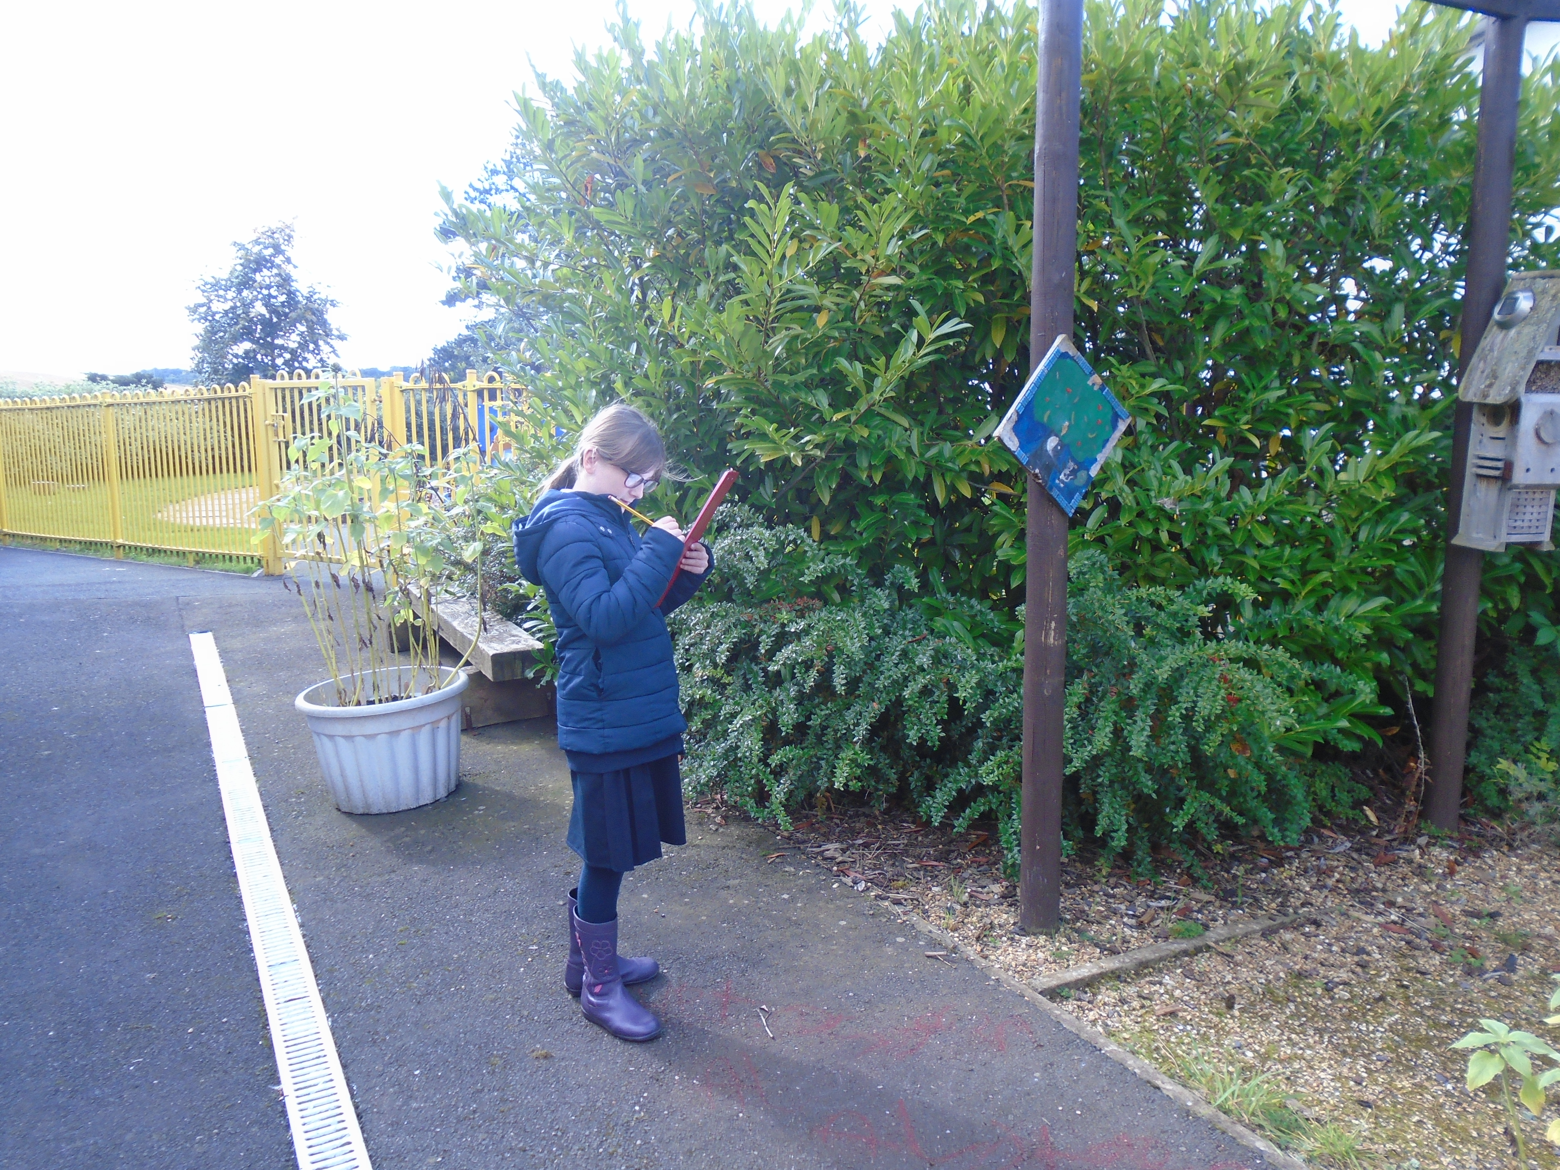 |  | 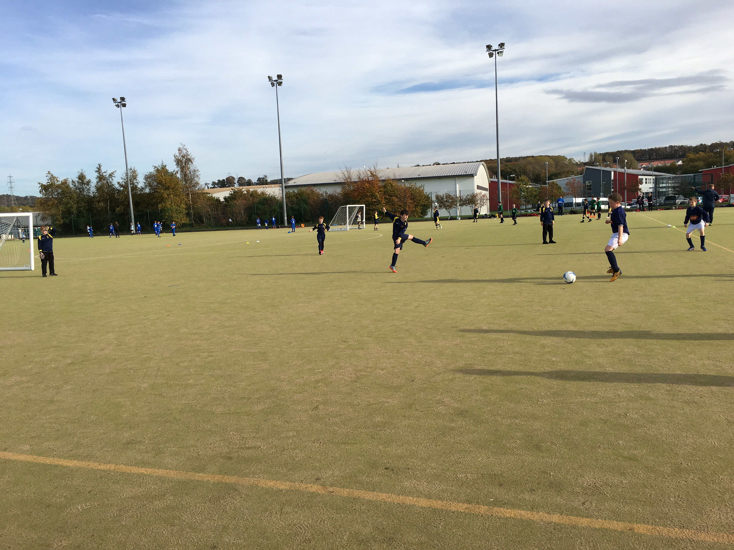 |  | 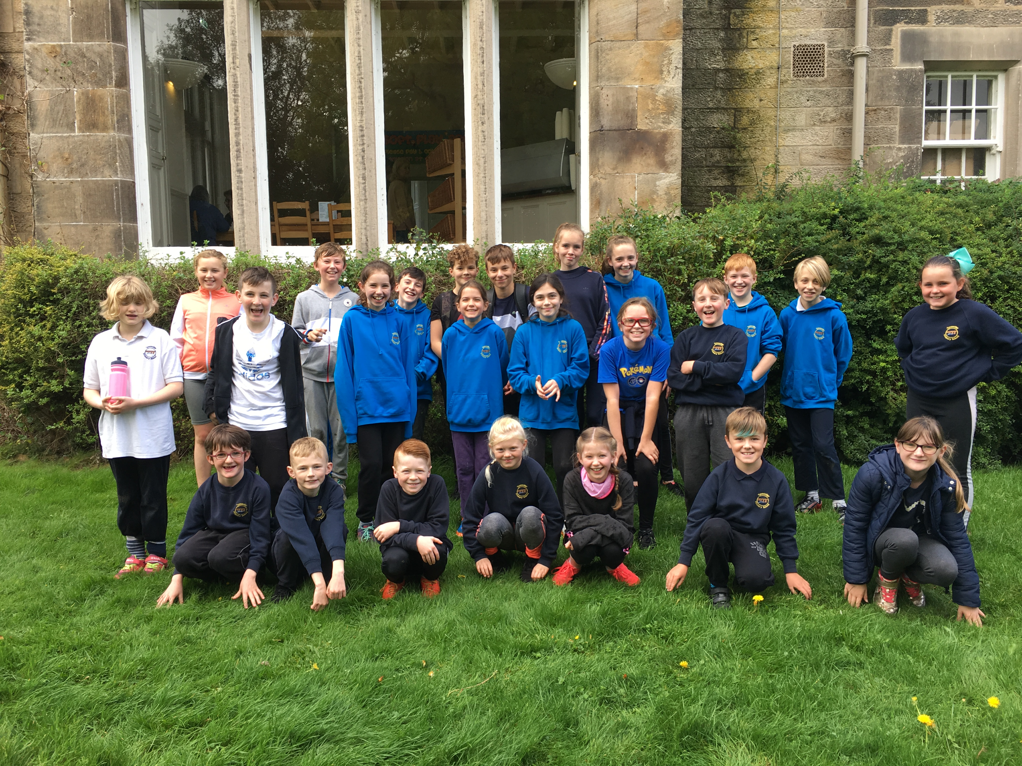
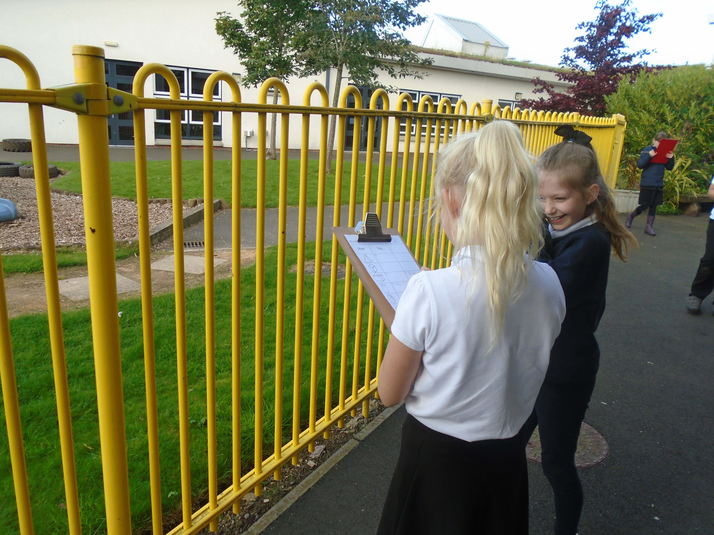 |  | P6 and P7 girls and boys took part in football festivals this term, at Dalkeith High School. There was a great sense of sportsmanship, some goals were scored but most importantly they all had fun! |  | Some of P6 and P7 were selected to represent the school at a Cross Country event at Vogrie Park. The course was around 1 mile, but was slippery underfoot and had a nasty hill at the beginning!  A great effort from everyone involved.
This term we were learning about 2D and 3D shapes and their properties. We conducted a 3D shape hunt in the playground. We found many cuboids and cylinders, but struggled to find many triangular prisms! |  | 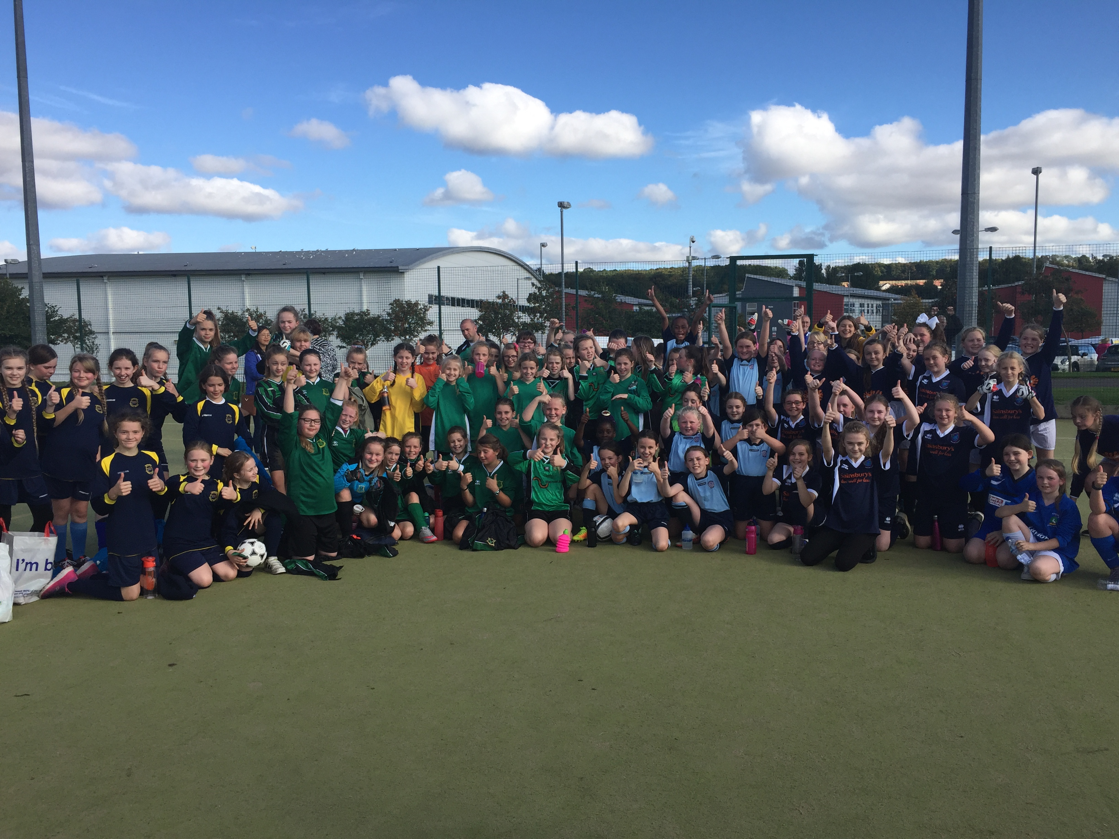 |  | 

