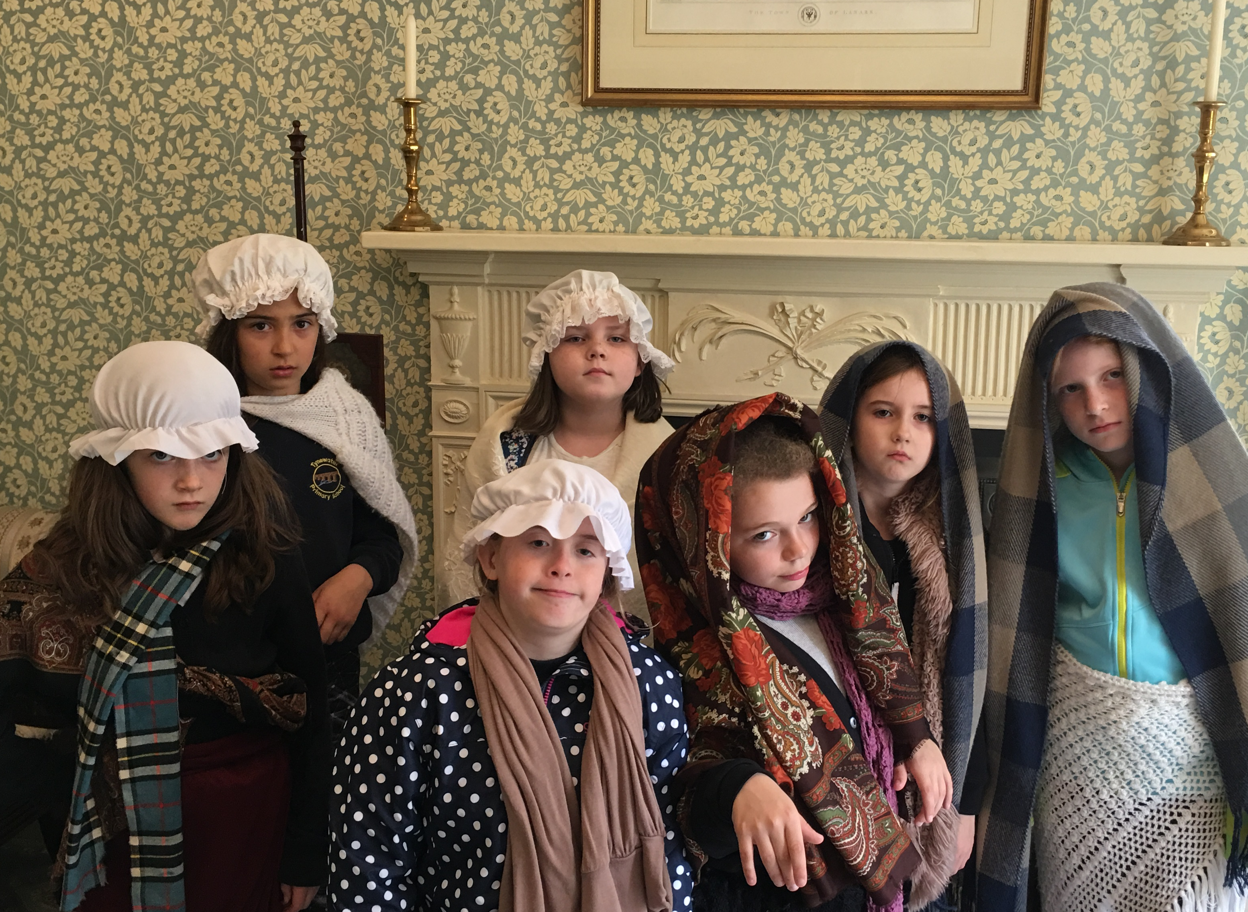 |  | In September the class performed an important assembly to the rest of the school. They compared their rights now, outlined in the United Nations Convention of Rights of Children that we have studied in class with the Child Labour expected of children back in the days the New Lanark Mills. |  | 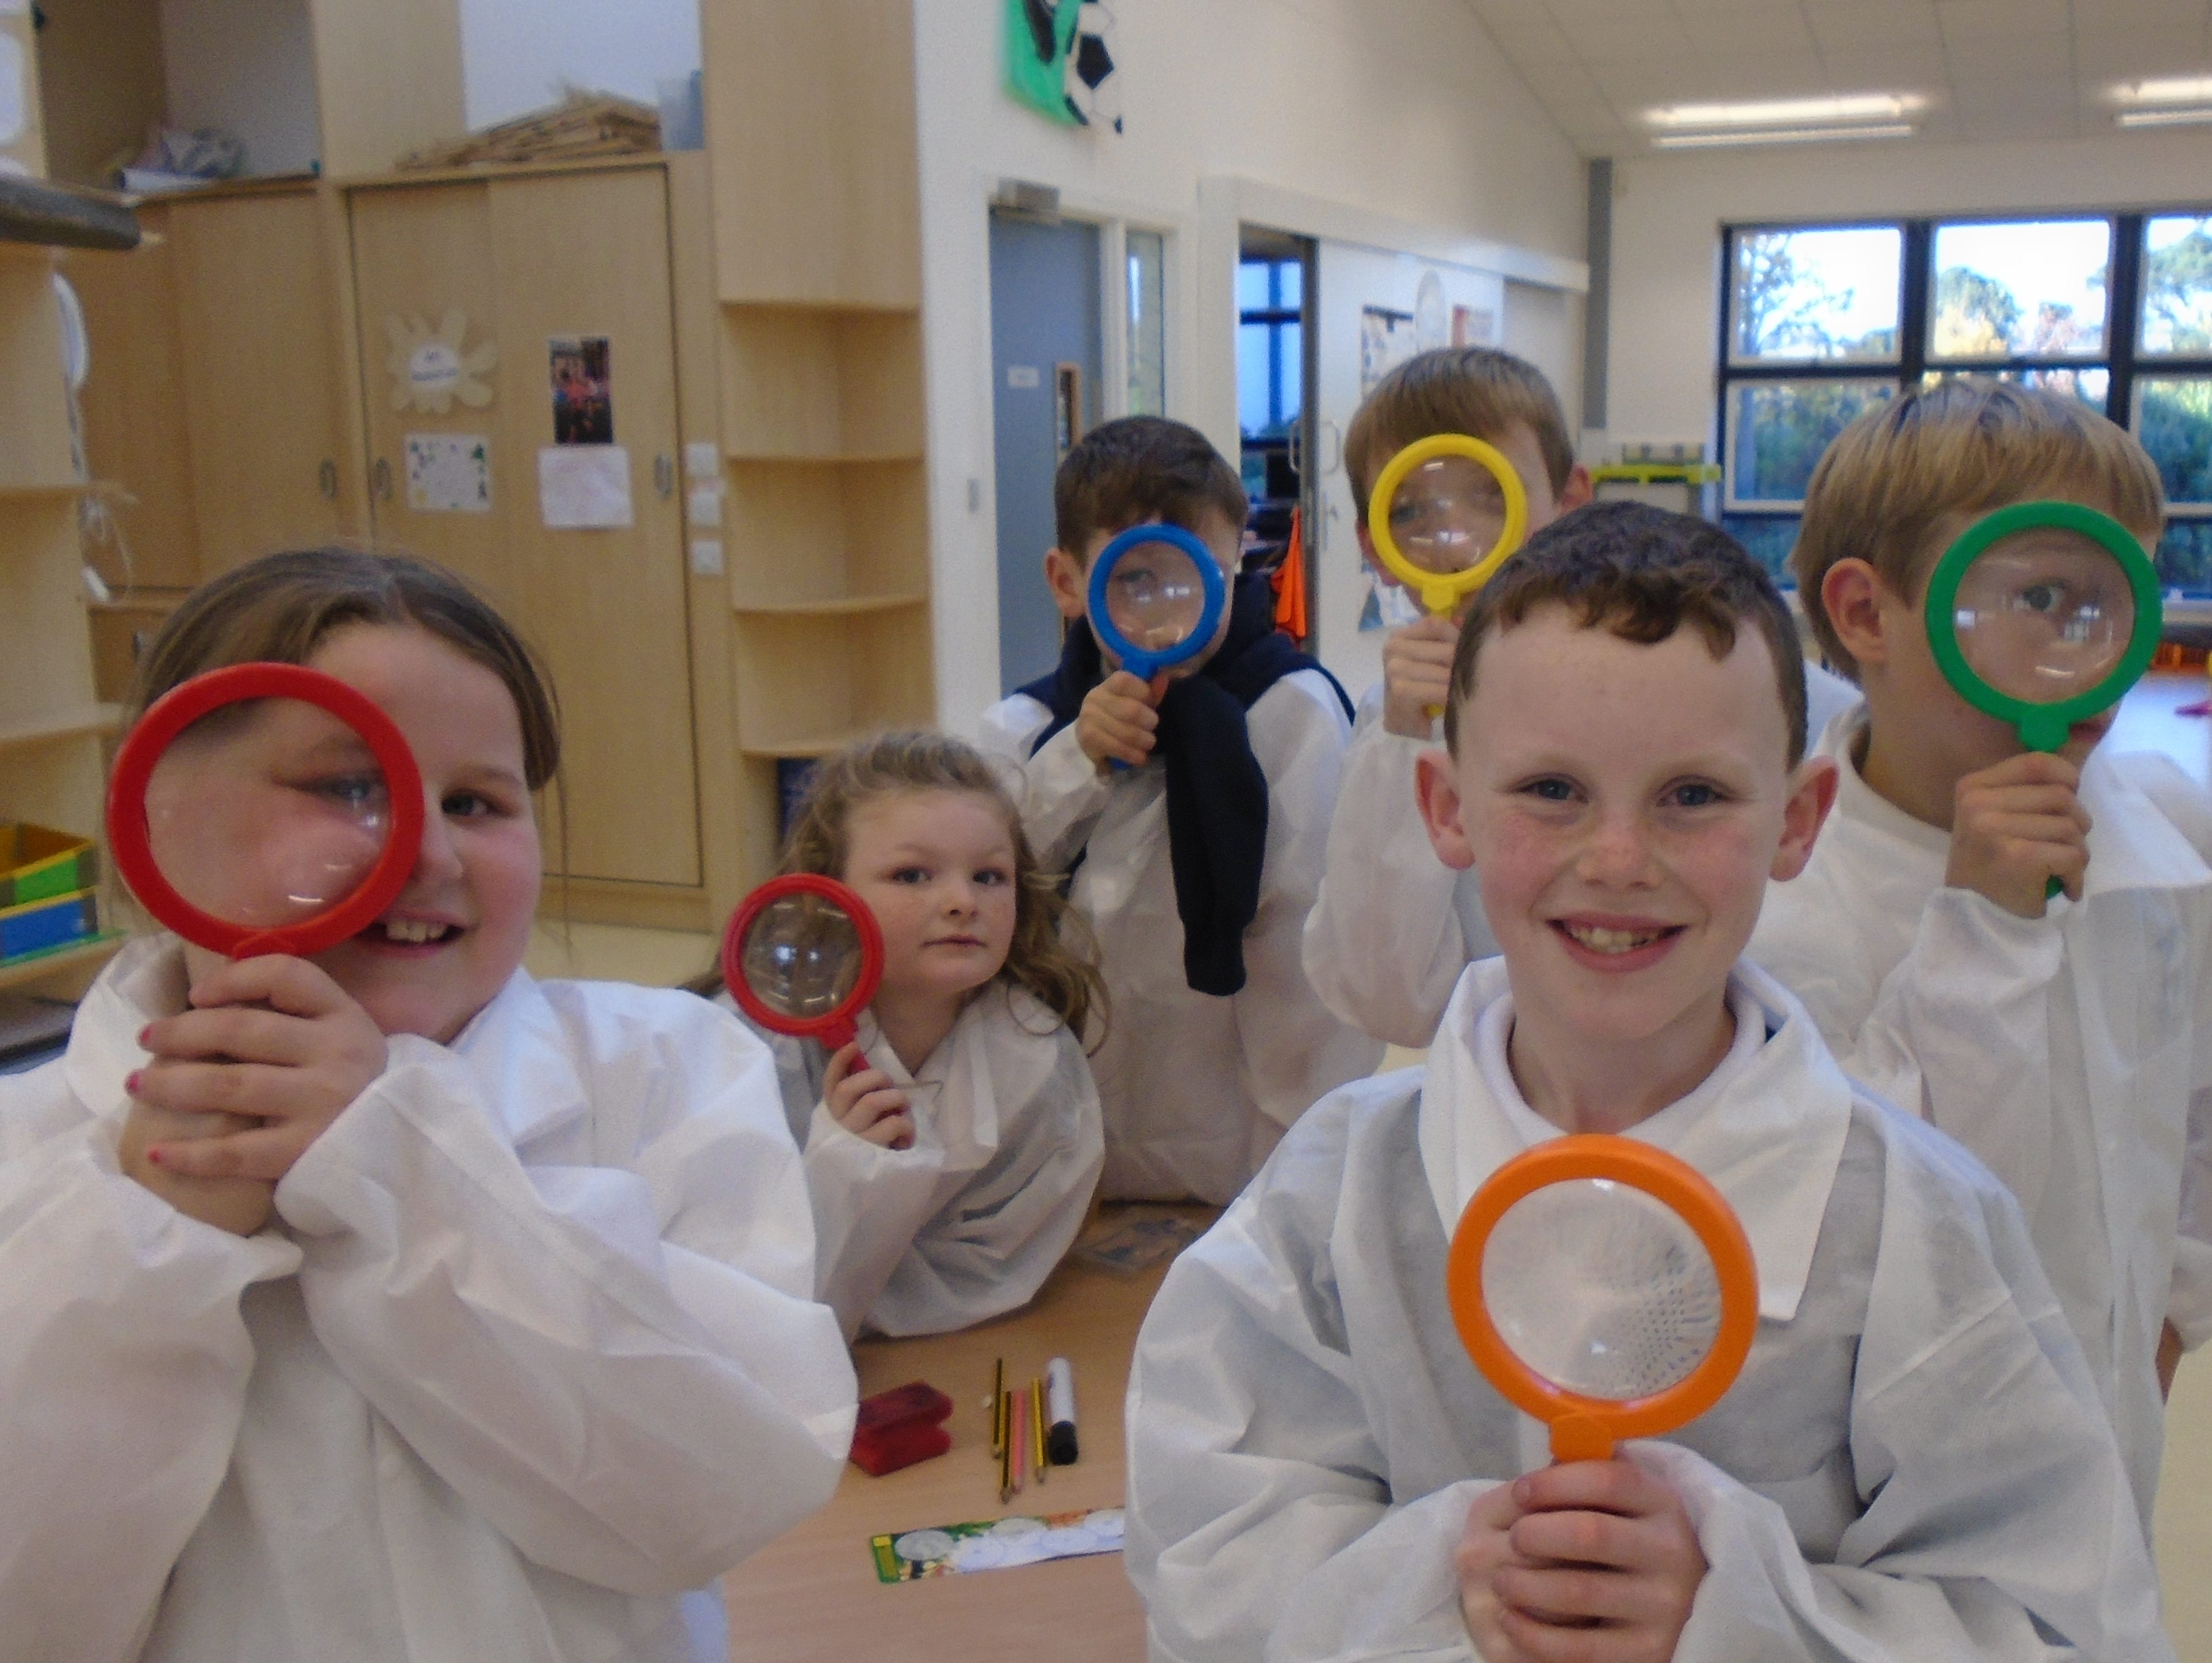The
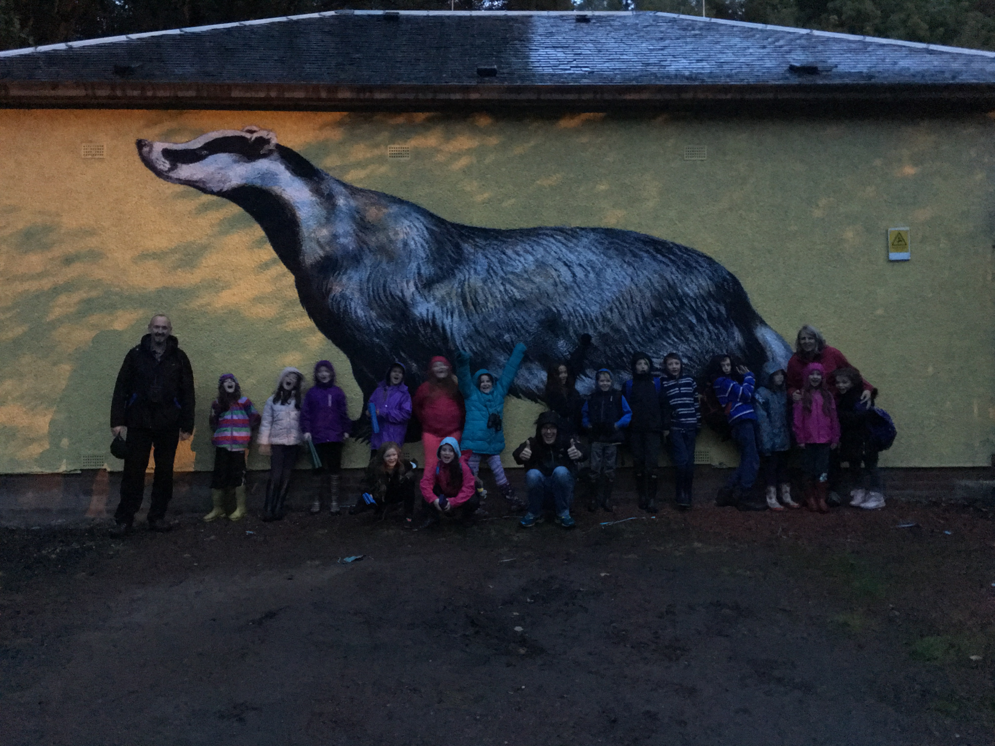 |  | 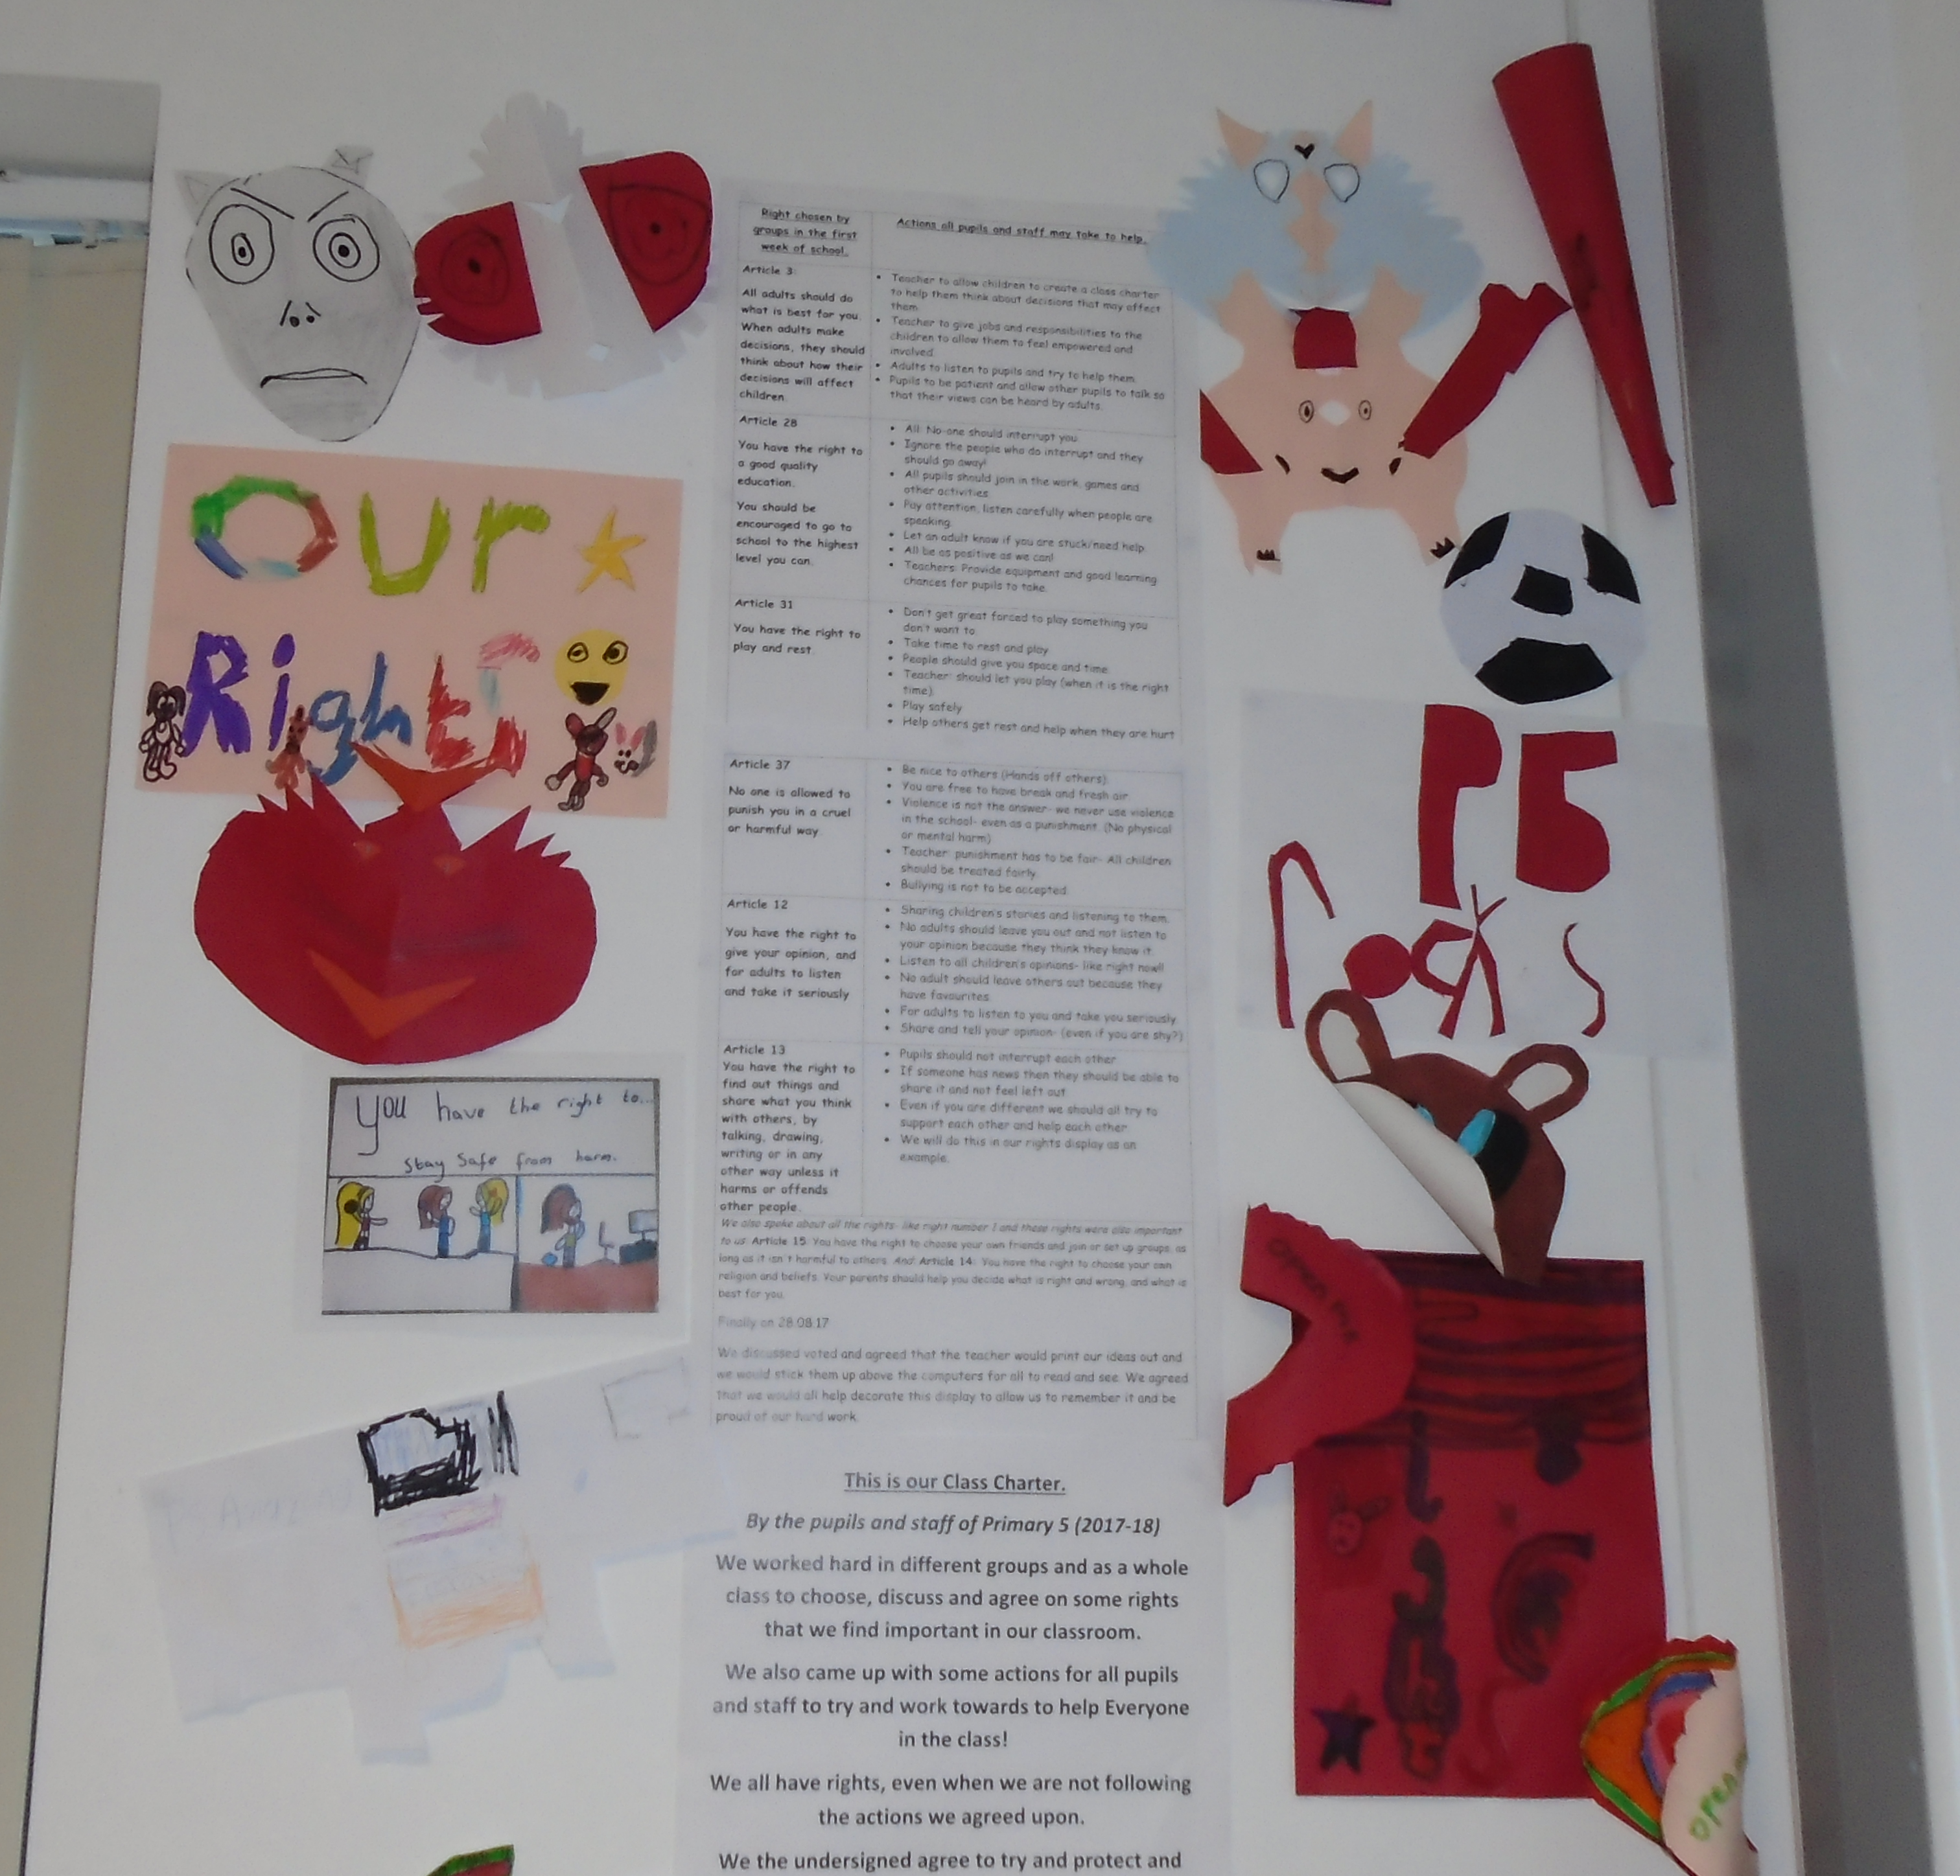 |  | 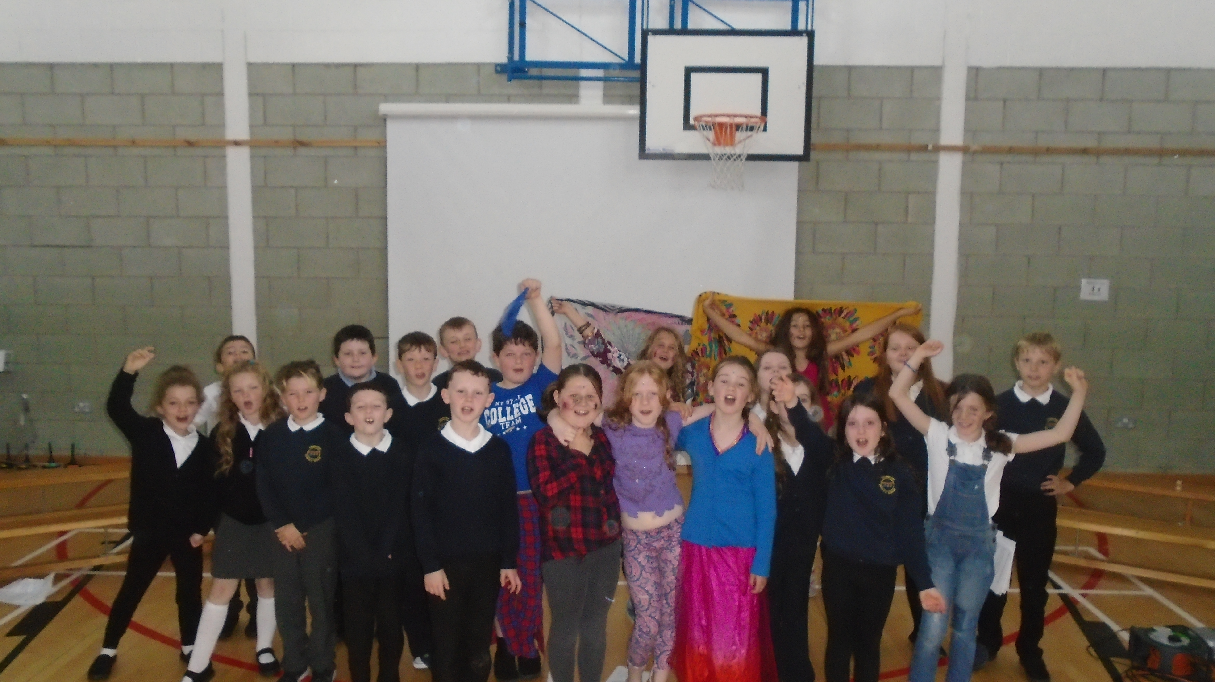
Our P5 residential trip this year took most of the class to the early 19th century Mills at New Lanark. Activities included visiting a Victorian classroom, badger ‘watching’ (we didn’t actually see any!) and lots of learning about Robert Owen and the improvements he brought to the mills and the children at the mills. |  | We are now a rights respecting school! Ask your child about rights!  This is our class charter. |  | Please remember to keep an eye out for regular updates and videos on SeeSaw. Recent additions include some recorded reading aloud and some handwriting to be proud of  

