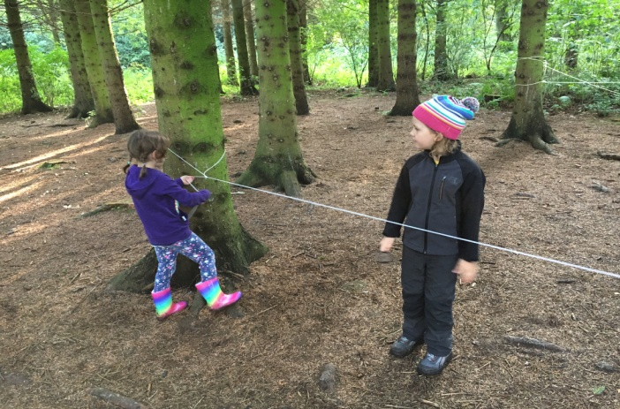 |  | Drumming – We have been involved in drumming workshops. We created our own rhythms using our topic and used the drums and instruments to create these rhythms. We then enjoyed performing to the school. |  | 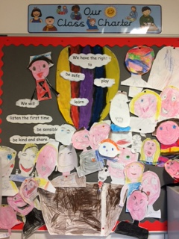
Forest Schools –A group of us have been learning outdoors. We have been hunting for minibeasts, building shelters, creating clay faces and developing our knot tying skills. We are going to finish with a campfire. |  | 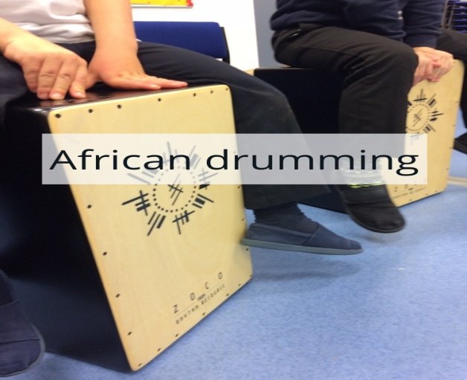 |  | Rights Respecting Schools (RRS) We created our Class Charter using the UN Convention on the Rights of a Child. We have been learning about our playground charter too. We were thrilled to be awarded or Level 1 RRS.
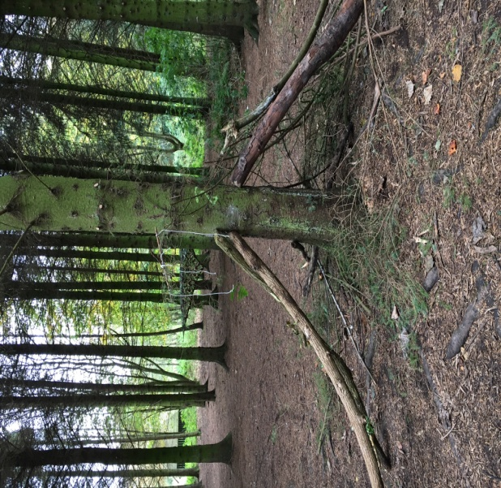 |  | Super Learners – Throughout this term we have been learning about our senses and how to use them effectively. We have been working together on various experiments using our senses. |  | 