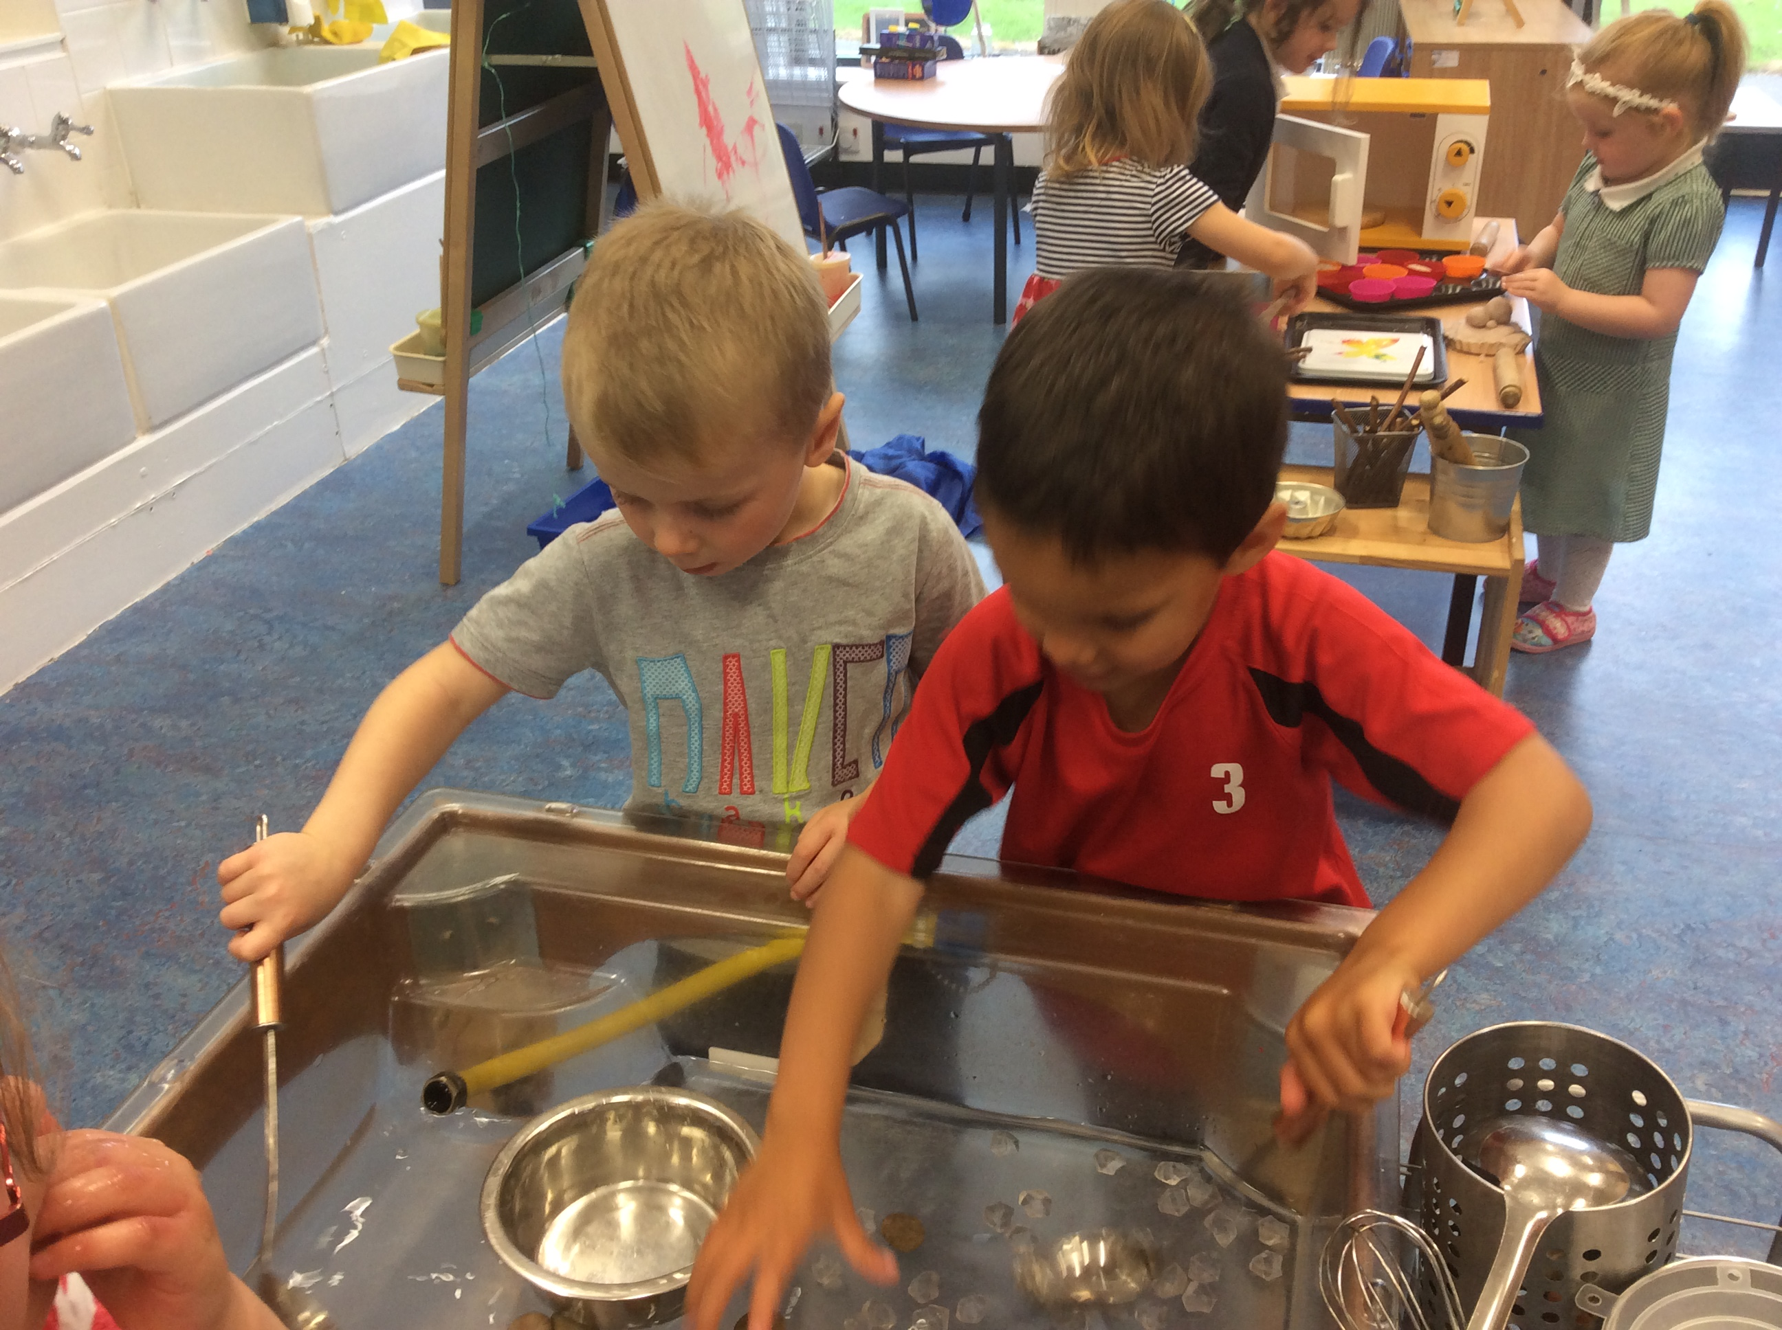 |  | Down at the Farm  We got a lovely new farm yard to add to our small world collection.  This has provided lots of opportunities for us to play together and come up with role play scenarios. |  | 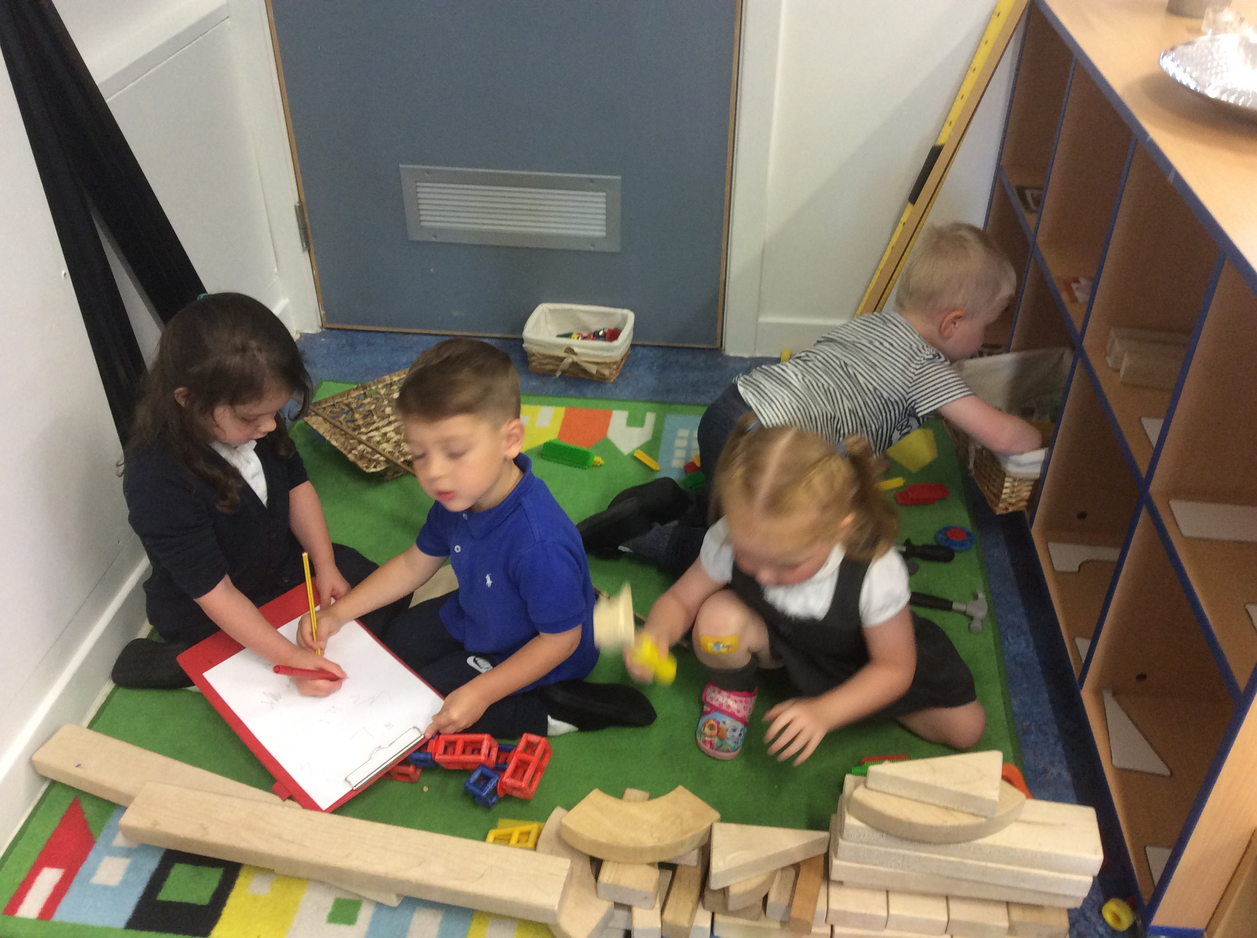Photograph
Lots of new friends!  Everyone settled into the new term with ease, lots of new friendships are continuing to develop in both classes. |  | 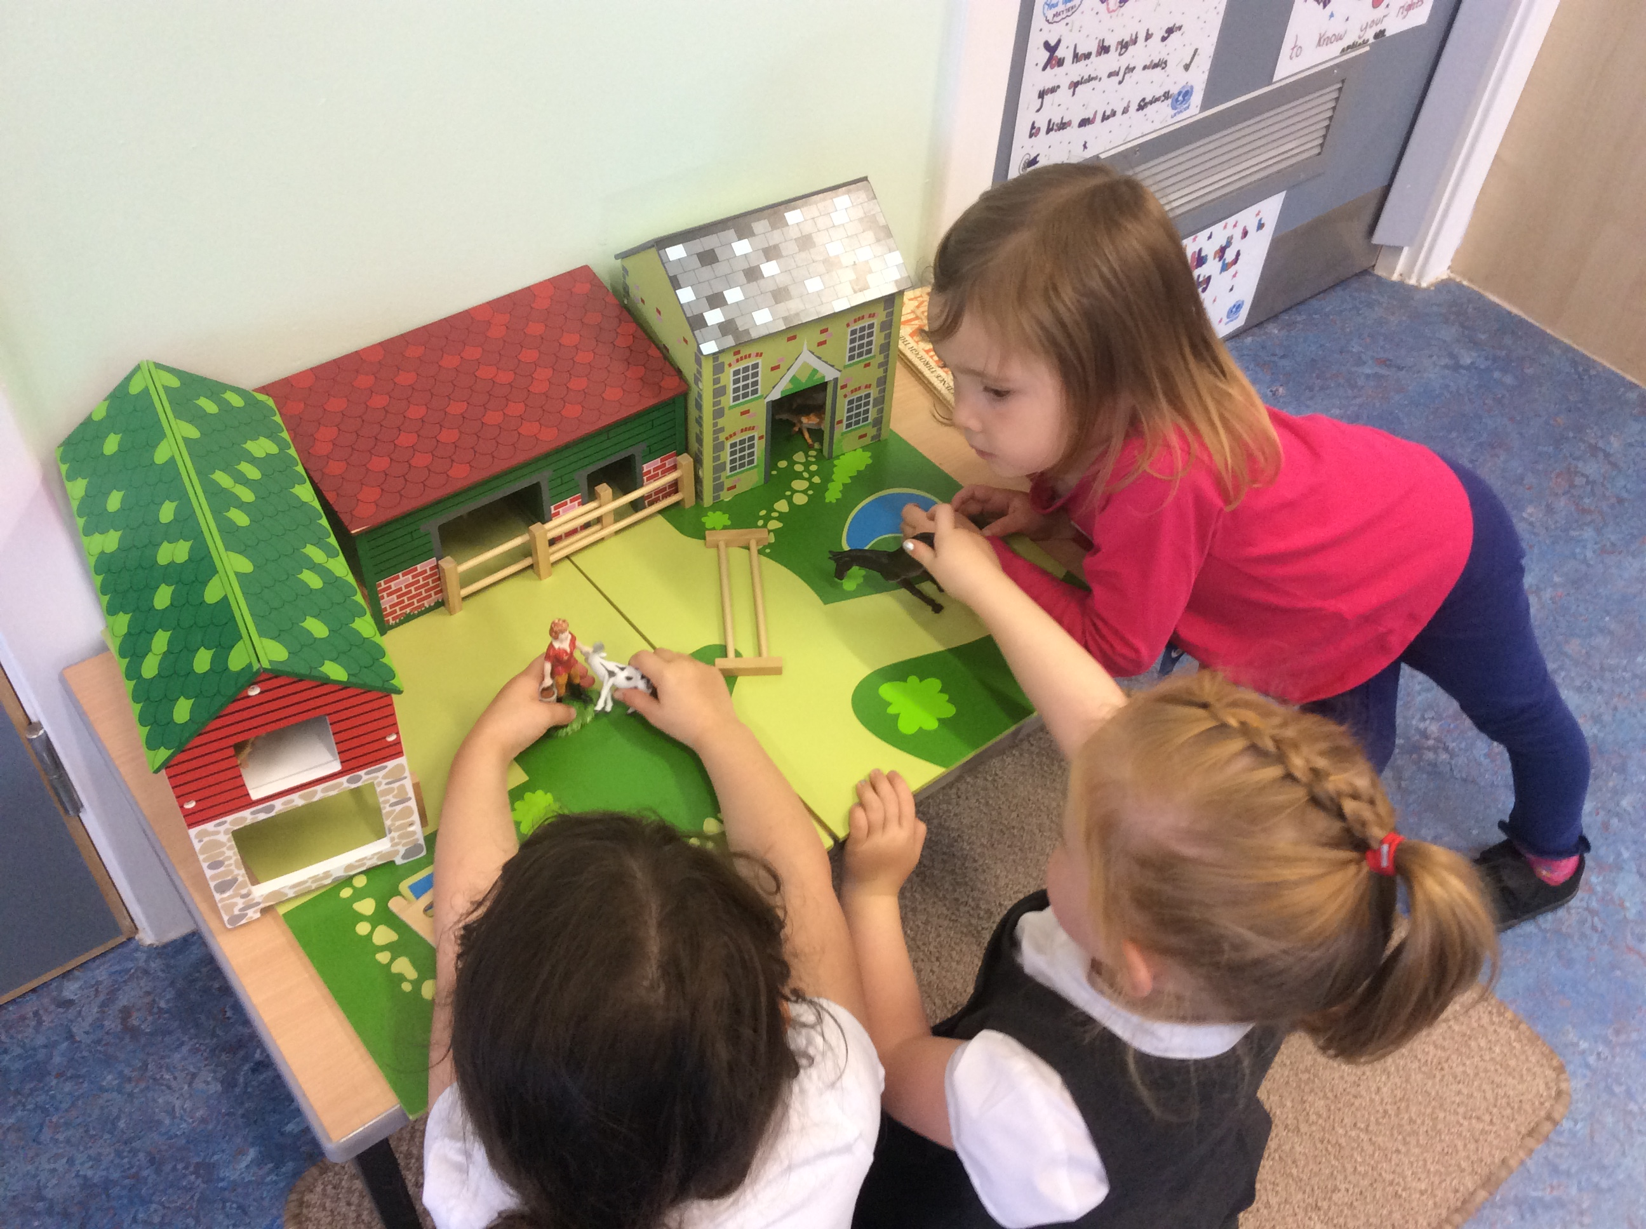 |  | Keeping busy with lots of learning.  We are enjoying taking part in lots of different activities which require us to use many of our different skills. Having fun and learning at the same time!
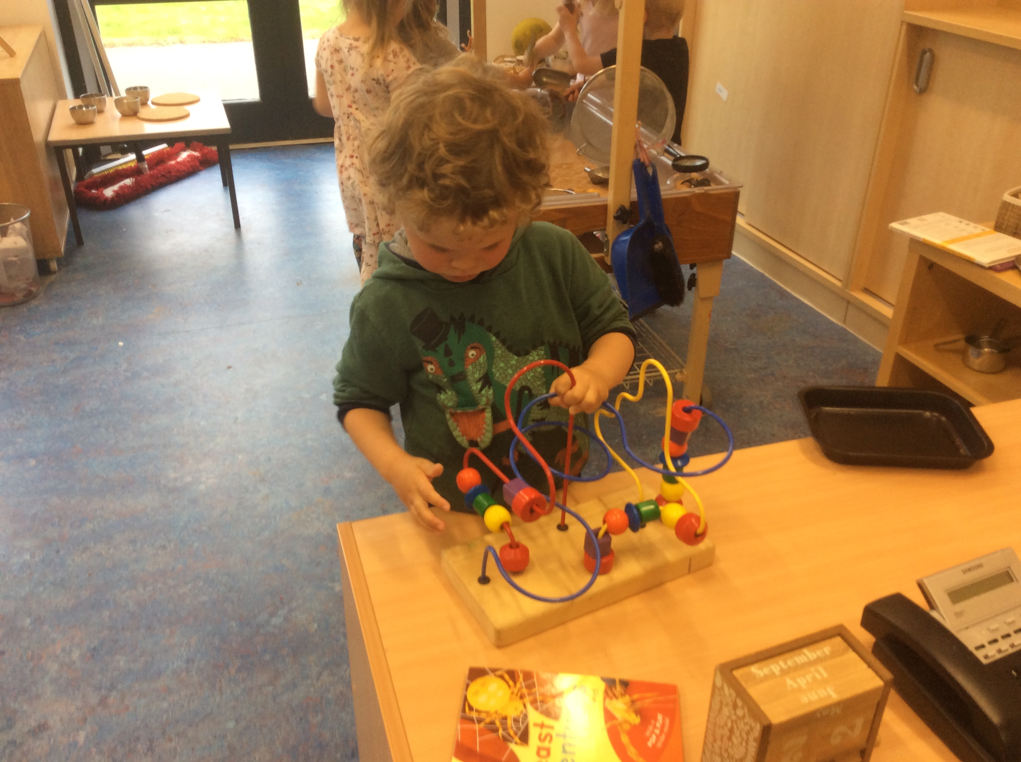 |  | Lots of energy to burn!  Our afternoon class have been enjoying the use of the hall on a Friday afternoon to use up some of their energy, we have enjoyed playing basketball and using the hoops, balls and beanbags too. |  | 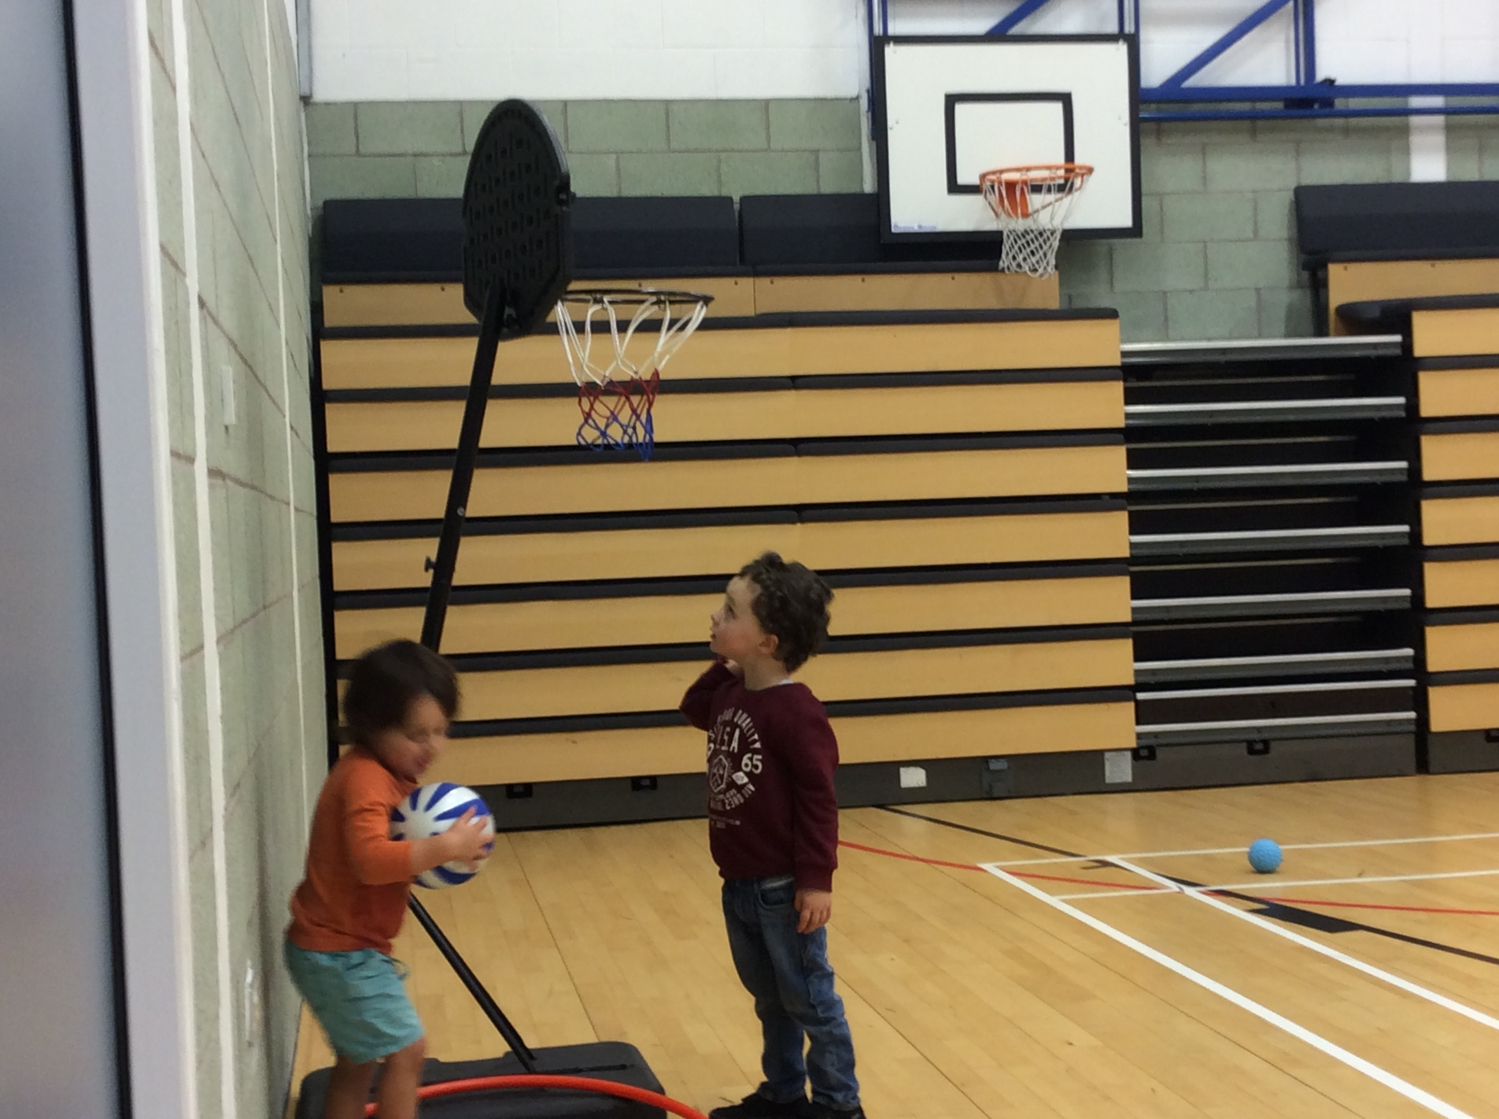
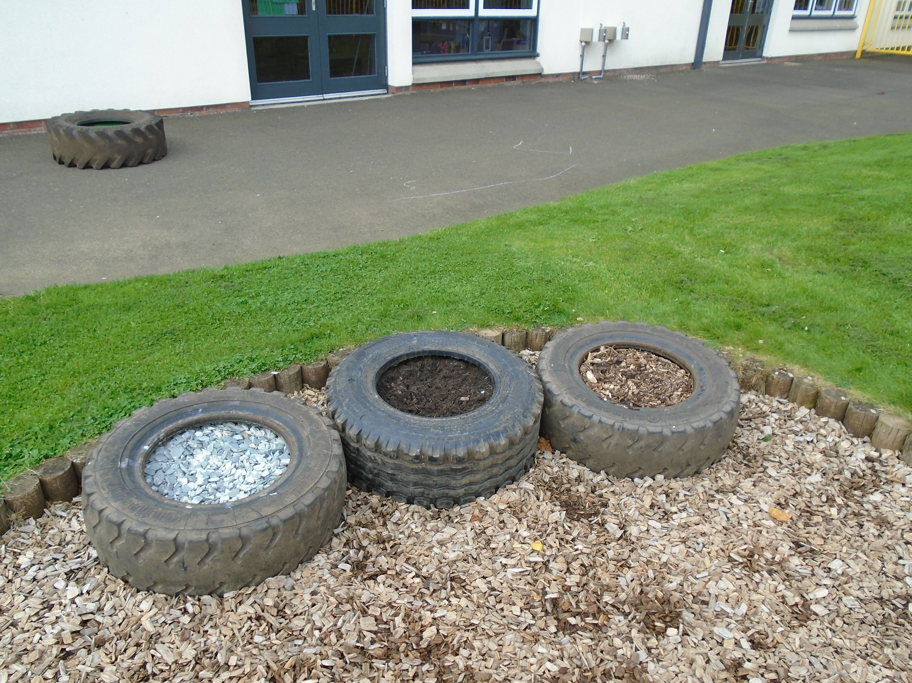 |  | A visit from our friend Minty  Minty came to visit us, his friend Susan read us a lovely story then showed us how to care for our teeth properly. We all then practiced cleaning Mintys teeth then we all got a sticker. |  | 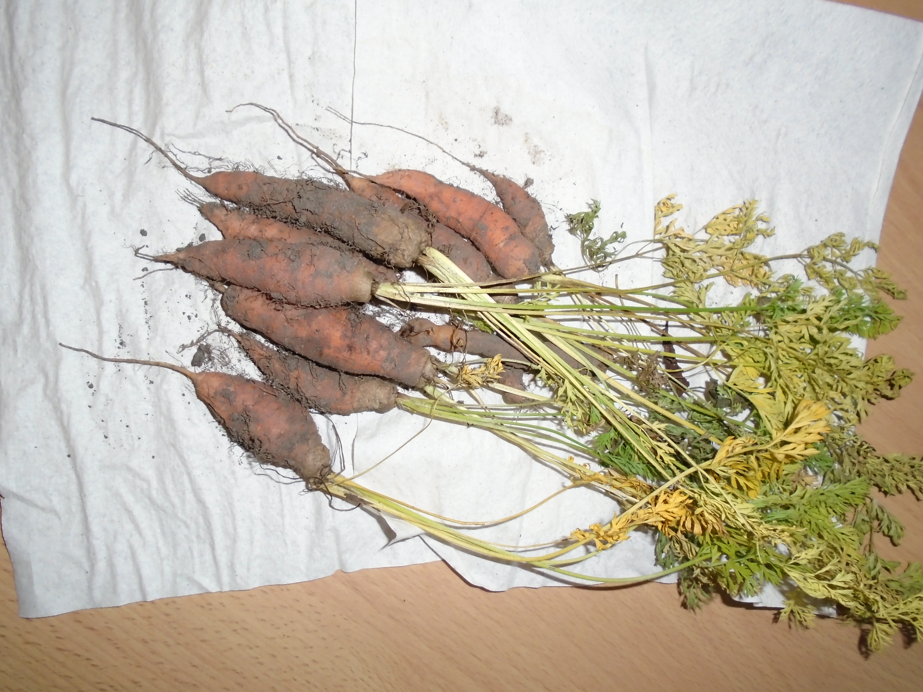
Developing our outdoor area  Mrs Smith, Miss Beattie and all the children have been working hard to think of ideas to develop our outdoor learning environment.  We are now beginning to see small changes happening! |  | 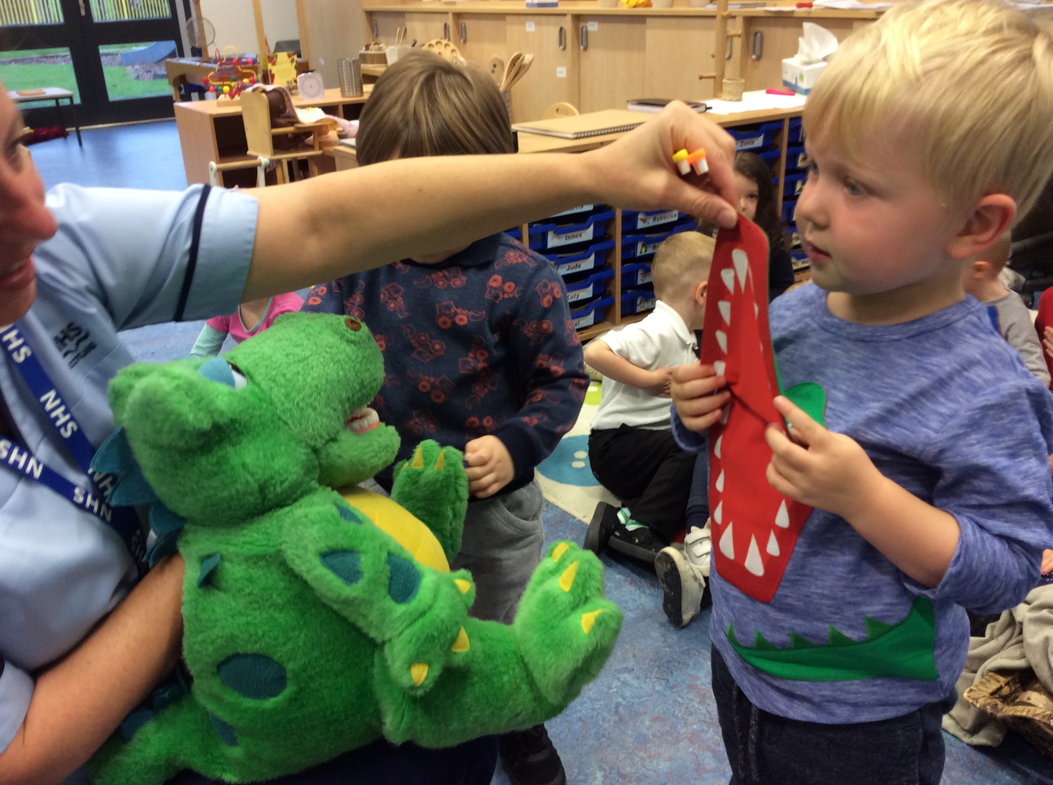 |  | Harvest Time!  Both classes have enjoyed harvesting our carrots and potatoes. We then weeded the raised bed ready for our next project of planting of growing.
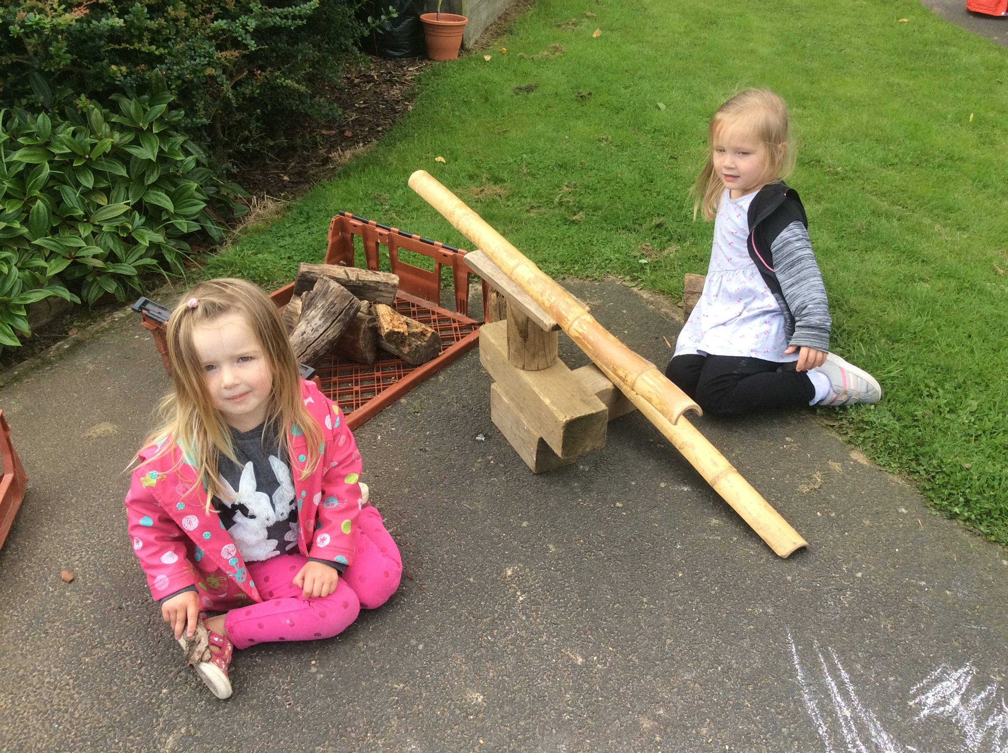 |  | Loose parts!  What can we do with logs, tyres and other loose parts? You would be amazed how creative we are at Tynewater Nursery, we like to use our imagination to come up with lots of different ideas every day. |  | 

