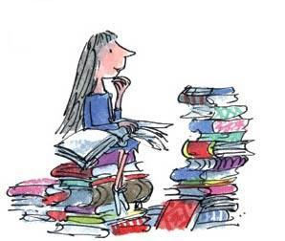
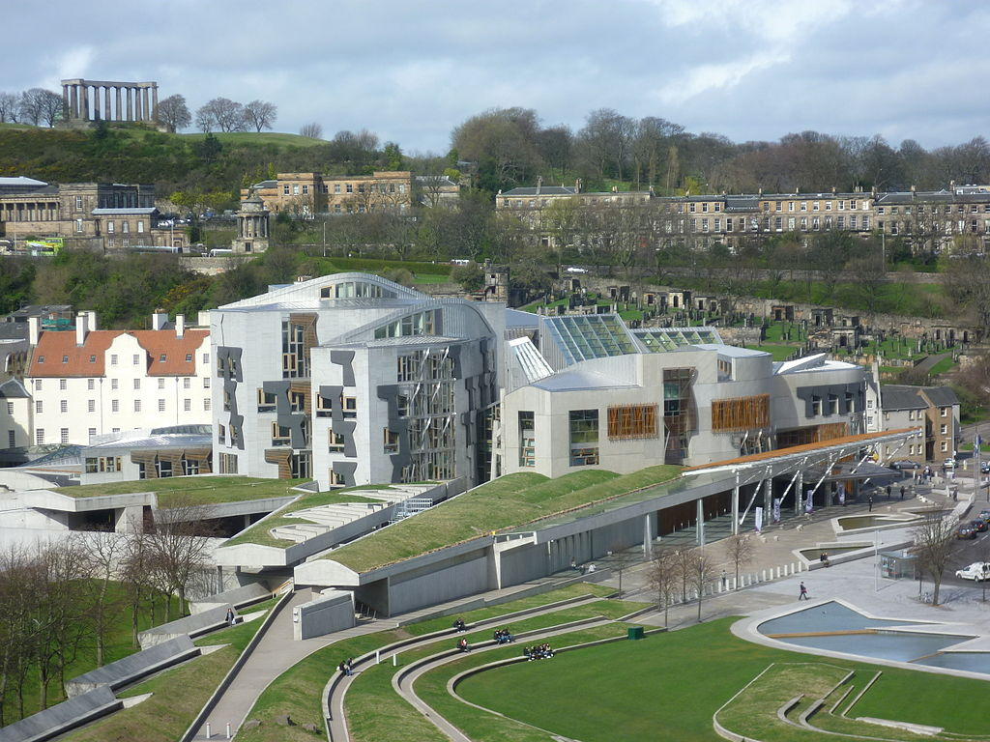
Language and Literacy
Our novel study this term will examine
the text ‘Matilda’ and allow the children
to make comparisons between the stage production and the book.

Our writing will also be linked to our novel study where we will develop characters and examine themes within the book. We will revisit instructional writing and script writing.
As part of our class election we will develop our talking and listening skills by holding a mini class election and creating our own campaign videos.
Social Studies
Linked to our learning visits
earlier in the term, we will develop our understanding of the Scottish and English parliament by examining the process of an election and also how bills become law.
We will hold a mini election in class and give pupils the opportunity to think about the issues that are important to them.
They will then prepare their own campaigns for the pupil council elections.

Expressive Arts
We will use our novel study as a stimulus to develop our ‘hot seating’ skills.
Our performance skills will be developed using mime and dramatic performances of specific scenes from the novel/stage production.

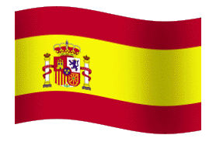
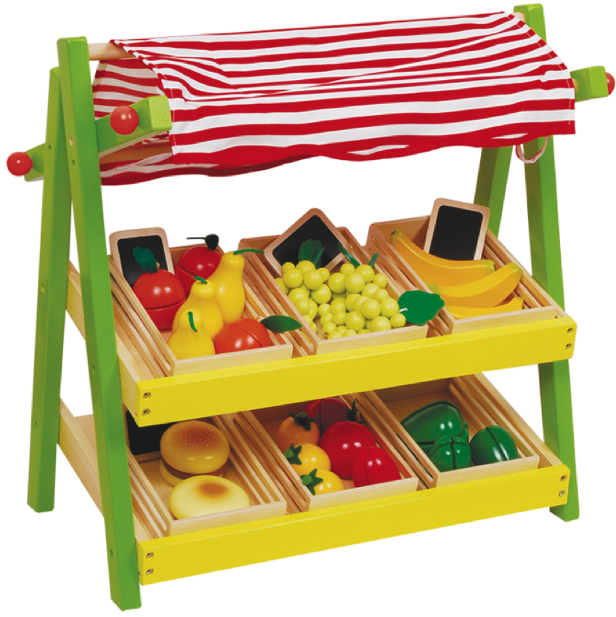



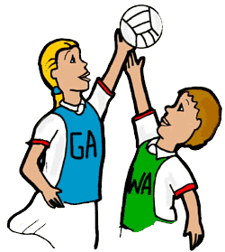
London/Scottish Parliament

Mathematics and numeracy
We continue with math rotations this term ensuring broad coverage of the main skills – addition, subtraction, multiplication and division using the basic facts progression.

We will also cover aspects of data handling, examining assessment data to identify personal and group targets.
We will continue to strengthen our mental math skills using Big Math and Xtra Math each week.

Health and Wellbeing
Weather permitting, we will continue to
take part in the Daily Mile and continue to promote and record healthy eating by completing the daily healthy snack chart.
We will continue to run the fruit trolley to gain enterprise experience and to develop our maths skills in a real life context.
P.E.
P7 boys and girls will participate in the cross country event this term and P7 girls will be involved in the girls football tournament.

Language

In line with 1+2 languages we will continue to develop our knowledge of Spanish as well as French language.

