**RME**

With Mr Watson children will be exposed to a range of learning covering the basics of Islam. Children will also be linking some of the moral education to their own ideas and beliefs and will be challenged to think about the rights of children.

**UNCRC (HWB)**

We have created a class charter which states all of the things we have a right to in the classroom. This has led to lots of good conversations and understanding. A copy of this has been posted to See Saw. This learning really links well to RME, and to our topic, as Robert Owen helped establish children’s rights o education at the Mills in 1805. Children have been comparing child labour of 200 years ago to thast which sadly still continues today...

**Language and Literacy (LIT)**

**Reading** – Most pupils will read or be supported to read our class Novel: ‘Spindle River’. Although very challenging- it gives children a full and rich account of some of the experiences they saw or researched in connection to New Lanark.

**Writing** – Pupils will be looking at instructional writing- at home looking at recipes, instructions for toys or helping with Ikea furniture is to be encouraged! Please feel free to post items to See Saw or share with class.

**Grammar** – Pupils are learning about tenses- past, present and future.

**Handwriting** –Pupils will revise joins, and have undertook a challenge to extend their handwriting into other learning using their ‘everything jotter’

**Spelling** – Pupils will continue to work through increasingly challenging words and will practice these at home.

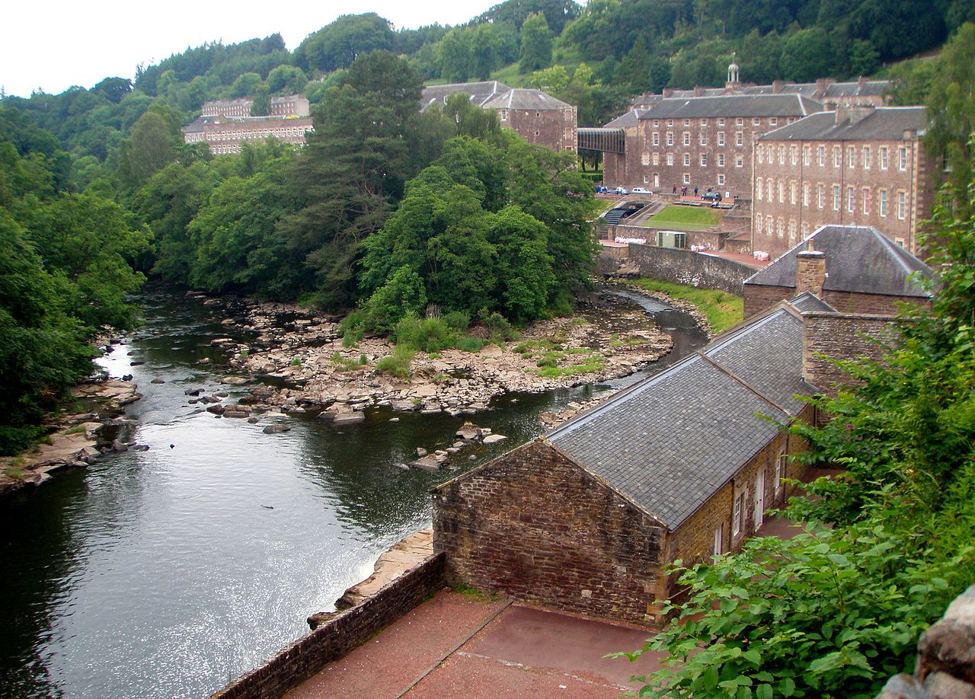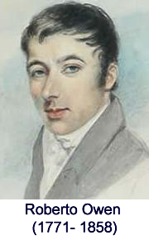C:\Program Files (x86)\Microsoft Office\MEDIA\CAGCAT10\j0301050.wmf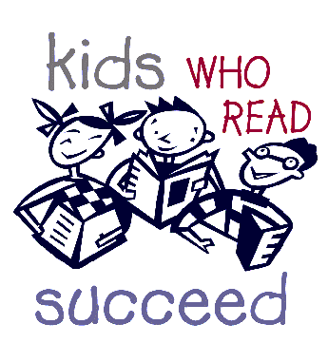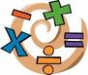

**Topic- SOC and HWB**

The pupils have all focussed on learning more about life in New Lanark.

There will be history learning as part of social studies (SOC) to learn more about children’s life 200 years ago. They will also learn about the world of work which is part of health and wellbeing curriculum (HWB). They will explore the work that children had to complete in the early 1800’s.

SOC: Children will be able to plot some key events into a timeline.

SOC: Children will compare work 200 years ago to work now. They will look at the rights and reforms that Robert Owen introduced to help improve the lives of people living in New Lanark, some still very relevant to today.

HWB: Children have applied for jobs in the class and now carry out their work. They will be looking at skills needed for work and rights as part of HWB.

**New Lanark- Work, Education and Rights: Then and Now.**

**Health and Wellbeing**

In P.E. pupils will be focussing on speed, body awareness and fine/gross motor skills. We are learning these skills through a variety of Invasion Games (including a healthy mix of rugby, football, hockey and netball).

This will allow children to test out their learning in a variety of different contexts and situations- and I hope they can see some benefits in favourite sports.

**Mathematics and Numeracy (MNU)**

Pupils have set themselves individual maths targets at the start of term. Please ask your child about their own specific maths targets. Please be in touch if I can support you in any way here. Lots of children have highlighted times tables and multiplication skills as their target area, however we will also be learning more about place value, shape, the language of maths. They will be trialling more flexible maths groups to allow children to challenge themselves and get the support they need in maths.

At home maths can be done everyday- even just for 4 minutes using Xtra Maths. They can also use Sumdog to play and LEARN at the same time. Any problems with this or internet access issues please just let me know and I can offer alternative arrangements to allow your child to practice and improve in math.