Tynewater Primary School | 2017-2018 Period 1 & 2 |  | 4/9/17 to 13/10/17 | Teacher: Miss Seaton | P3
Information for Parents - Outline Plan for Learning and Teaching
Topic / Project Title: |  | The Egyptians
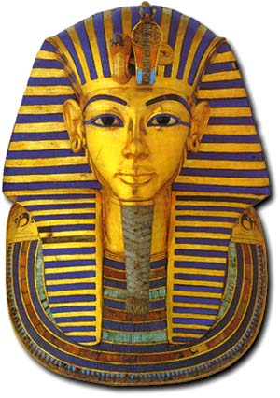
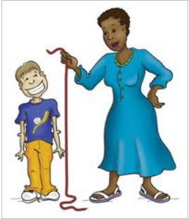
Primary 3
Egyptians
In Primary 3 we have began learning about the Egyptians, which the children are very enthusiastic about! The children will be engaging with different areas of the curriculum during our topic such as Expressive Arts, Literacy and Social Studies, whilst they learn about:
- The river Nile
- Pyramids
- Tombs
- Pharaohs
- Hieroglyphics
- And more!!
Health and Wellbeing
In PE children will be developing their balance, coordination and sequencing skills as they engage with gymnastics this period. They will be given the opportunity to use a number of different equipment in our gym hall to develop their skills.
Numeracy & Maths
Numeracy
We will be continuing with our work on the Basic Maths Facts, whereby children play independent games to achieve their target. We will also be revising place value of numbers and numbers to 100/1,000/10,000.

Maths
In Maths this period we will be
learning about measure.

French
We have begun revising our colours in French by playing games, listening to songs and doing different tasks in class!
Literacy
Reading- We will continue to engage with reading through weekly reading rotations where the children have the opportunity to read aloud and apply their knowledge of the book in comprehension tasks. This period as a whole school, children will have experience engaging in a range of different texts such as non-fiction, blogs and web clips.
Writing- This period we will be focussing on imaginative writing.
Listening and Talking- We will be continuing with our ‘5 to share’ whereby 5 children have the opportunity to share something with the class each day. This gives children the opportunity to practice their presenting and listening skills.

Rights Respecting School
Article 15
You have the right to choose your own friends
and join or set up groups, as long as it isn't
harmful to others.
Expressive Arts
Drama- The children have been engaging in Drama lessons which will continue into Period 2. The class have been learning about how to use their bodies and voices to show their feelings and will have the opportunity to create their own short drama.
Music- The class are receiving a 6 week block of drumming from Infectious Grooves.
Art- Primary 3 are receiving art lessons once a week by Miss Goodwin. So far, they have created yummy ice cream pictures and are beginning to create Egyptian art work based on our topic!

