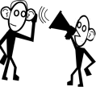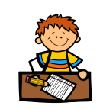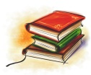

Spelling and maths Learning at Home will be issued on a ***Monday*** and due in on a ***Friday***. Every child will also have reading pages from week to week. Please ensure that the reading is done as this affects the whole reading lesson.

P.E kits will be required on a ***Tuesday*** and ***Wednesday***. This should consist of a clean t-shirt, shorts or leggings and indoor footwear. All children are required to wear ***indoor shoes*** in school. We appreciate your help with this matter.

**Literacy**

P6 will be studying Discursive Writing this term. We will look at a range of mildly controversial issues and practise writing a balanced argument, taking both sides into account.

During reading we will be focusing on our own personal targets. We will be looking at both fiction texts at group reading time, and non-fiction texts linked to our writing topic.

We will be building our listening and talking skills through many group work challenges, linked to our topic.

**Science and Health and Wellbeing**

Primary 6 will be learning about many aspects of the Human Body, including the skeleton muscular-system, the digestive system and the circulatory system. We will also look at the brain related to how we learn and how we can learn better.

We will be carrying out practical activities and experiments to fully understand the way our bodies work.

We will also be exploring sex and relationships education through the FPA’s ‘Growing up with Yasmine and Tom’ interactive programme. We will be looking at topics such as **the body, feelings, relationships, family life and online safety.**

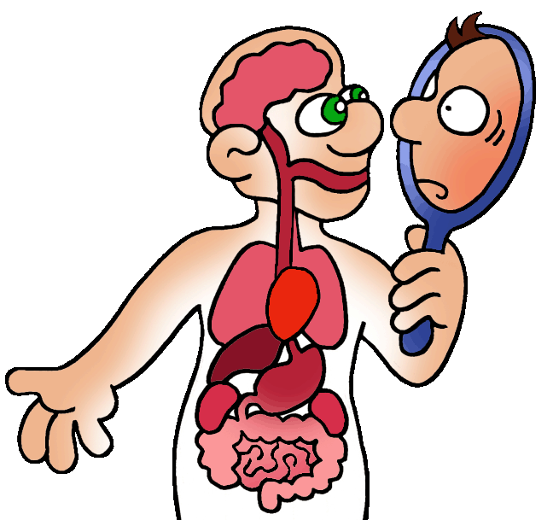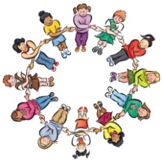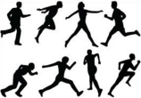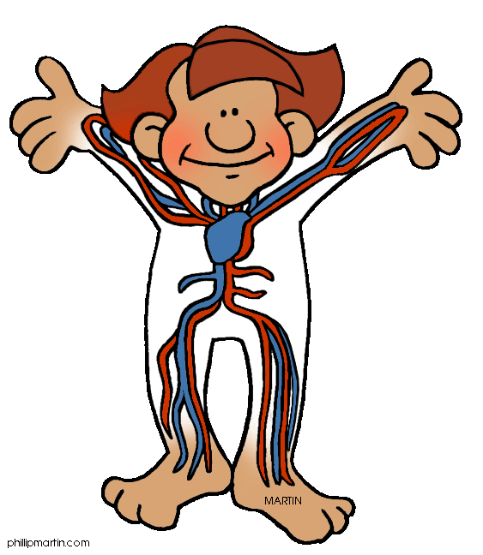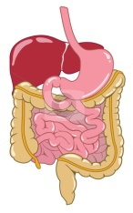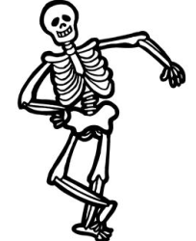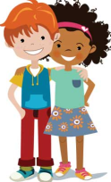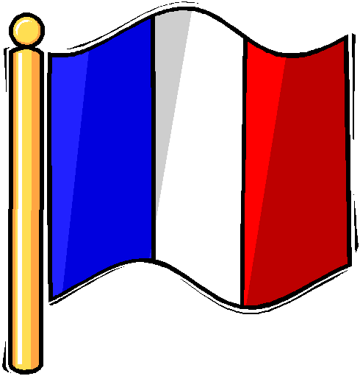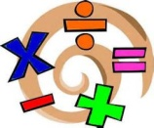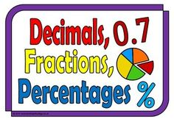

**Mathematics and numeracy**

P6 will be continuing with the Basic Maths Facts programme this term and working on their targets to progress their learning in numeracy. It is vital that children are also practising their ***times tables at home.***

This session we will be identifying areas where we would like to improve and working on these in fluid mixed groupings.

**The Human Body, including sex and relationships education**

**Health and Wellbeing**

Mrs MacInnes will continue to teach Drugs, Alcohol and Smoking Education with the class.

**Physical Education**

Primary 6 will be revising their creativity, flexibility and balance through a block on Parkour. We will then move onto Athletics, in order to practise for Sports Day and an Athletics competition.

**Modern Languages**

In line with 1+2 languages guidance we will be continuing to learn French this term. In French we are working towards creating an extended piece of writing about ourselves, including personal details, our families and pets and our likes and dislikes.