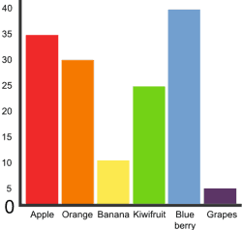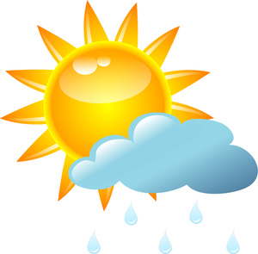

**Language and Literacy**

**Reading**: Children will continue to receive reading books as homework which will also be read in class. Children will also experience reading non-fiction books this period linking to our new topic of The Weather. Reading comprehension activities will continue in class to develop children’s reading skills and test their understanding of texts.

**Writing**: Our focus this term will be **report writing.** This will be an interdisciplinary focus as it will also link to our topic where children will have the opportunity to write weather reports.

**Spelling**: Primary 2 will continue to work through their spelling words for this period. Children will learn their ‘spelling rule’ on a Monday and practice writing their words at home.

**Mathematics & Numeracy**

**Numeracy:** This period for numeracy children will continue to develop counting to 100/1000 and counting up in 2s/5s/10. We will also be looking at place value of numbers and doubles and halves.

**Maths:** Following on from Period 6, our maths focus this period will be **data** **handling**. Primary 2 have learned about bar graphs, pictograms and tally charts so far. We will continue to look at the other ways to collect and display data. After this our maths focus will move on to learn about **money**.

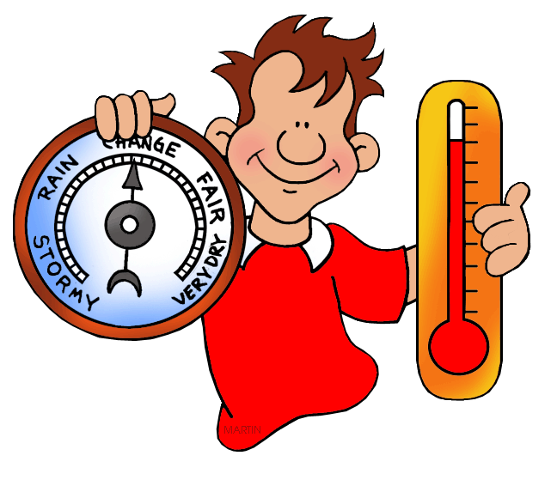

**Health and Wellbeing**

This period in PE our focus will be basketball. Children will have the opportunity to develop skills in travelling, dribbling and passing the ball. They will have the chance to put these skills into practice by taking part in different basketball games and activities.

**Topic: The Weather**

This period for our topic we will be learning about The Weather. In class so far we have learned about the different seasons and what trees look like during these seasons. Throughout this period we will also be learning about different weather conditions and how these change in other countries and climates. The class will have the opportunities to act as weather reports by predicting the forecast and presenting to the class!

**Rights Respecting School**

We respect the rights of all of the children in the school. This period we will be focussing on Article 15 of the UN Convention on the Rights of the Child which states: ‘You have the right to choose your friends as long as it does not harm others.’

**The Weather**