

**Literacy**

P6 will be continuing to study types of poetry this term and writing their own examples. They will also be writing a letter which forms part of their competition entry. They will need to write and re-draft this several time to ensure that it is the best work they can produce.

During reading we will be focusing on our own personal targets. We will be looking at the theme of the text and the author’s message.

We will develop our oral communication and listening skills through discussing our design ideas with others. We will be working with mixed age groupings as part of our Puppet Festival.

**Social Studies, Technologies and**

**Expressive Arts**

Primary 6 are continuing to work on the

Scottish Engineering Leaders Award 2017. As part of this project we have interviewed many engineers about what their job entails. As part of their homework P6 were asked to identify a ‘problem’, and we will work on drawing and annotating a solution to this problem. They will then write a cover letter to engineers explaining why they should make their invention. As part of the programme, engineering students will choose the winning invention to build!

For the last two weeks of term Tynewater will be hosting a ‘Puppet Festival’. Children will be split into mixed age groupings and asked to write a script for their puppet show. They will then have to create backdrops and make their puppets in order to perform their play and perform it to the rest of the school.

Spelling and maths Learning at Home activities will be issued on a ***Monday*** and due in on a ***Friday***. Please also remind your child to read the novel pages set for homework.

P.E kits will be needed on a ***Tuesday*** and ***Thursday***. This should consist of a clean t-shirt, shorts or leggings and indoor footwear. All children are required to wear ***indoor shoes*** in school. We appreciate your help with this matter.

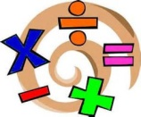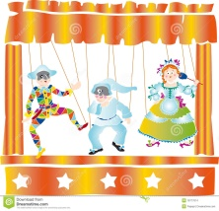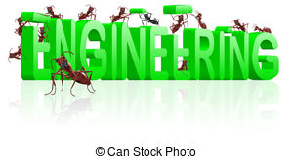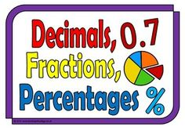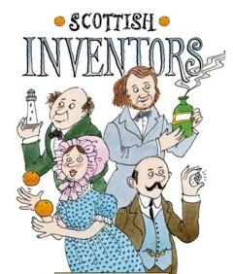

**Mathematics and numeracy**

P6 will be undertaking their Mental Maths and

Progress in Maths assessment papers this session. We will continue to look at decimals and percentages, as well as a focus on using money. Each child will continue to work on an individual target taken from the ‘basic facts’ programme, which will help them to consolidate basic number facts and help them move forwards in their numeracy learning.

We will continue our ‘Big Maths’ mental maths programme this term.

**Physical Education**

Primary 6 will be continuing to work on their creativity,

Flexibility and balance through completing a dance block, then learning some yoga and parkour.

**Modern Languages**

In line with 1+2 languages guidance we will be continuing to learn French and Spanish this term. In French we are working towards creating an extended piece of writing about ourselves, including personal details, our families and pets and our likes and dislikes.

**And Engineers**