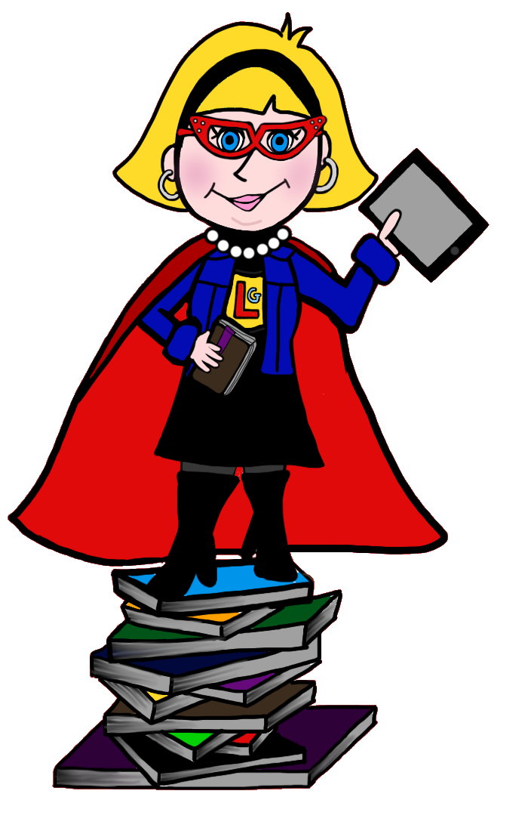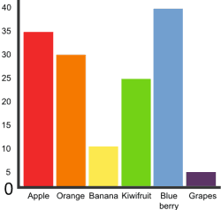

**Learning Powers**

We have begun using our special Learning Powers in class which have been introduced through our Learning Superhero stories. So far we have learned about ‘*Colin Concentration’* who teaches us that we will do our very best work when we concentrate, ‘*Tough Tina’* who teaches us that it is really important to persevere even if we are finding it really tricky and ‘*Tim the Team Player’* who teaches us the importance of working together. We will continue to learn about the other Learning Superheroes this period.

**Mathematics & Numeracy**

**Numeracy:** Children will be continuing to work towards their agreed target for Numeracy this period following the Basic Maths Facts programme. P2 have responded really well to this programme as it meets their individual needs. They are enjoying playing the games which link to their targets both independently and with a partner.

**Maths:** We will be continuing our work on Data Handling this period where we will learn about different ways to create and read data.

**Language and Literacy**

Children will have the opportunity to engage with range of fiction and non-fiction texts, focussing on different skills for reading such as fluency and expression. In class we will continue to engage with Spelling Words (given out as homework) by learning the spelling patterns and doing different activities. We are continuing to write instructions as our writing focus for this period. Pupils will also have the opportunity to develop their writing skills in other areas such as topic work.

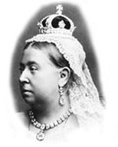

**Rights Respecting School**

This period we will make links to Article 28 of the UN Convention on the Rights of a Child which states that children have the right to a high quality education. This will link to our topic work as we discuss what education was like for children during the Victorian Times.

**The Victorians**

We will be continuing on with our topic of The Victorians this period. The children have thoroughly enjoyed learning about Queen Victoria, children during the Victorian times and different Victorian inventions! We are now looking forward to learning about different Victorian toys and schools.

**Learning Partners**

Primary 2 are continuing to work each week with a different learning partner at a different table! Primary 2 are very positive about working with each other in the class and are developing their communication skills excellently through tasks and discussions.

**Health and Wellbeing**

Primary 2 are currently thoroughly enjoying Football on a Wednesday morning, led by two SFA coaches. Children are learning many Football skills such as passing, travelling and team work games. These sessions will continue until 8th March.

For our other PE slot, we will begin a block of lessons on athletics where children will learn about skills for running, jumping and throwing.