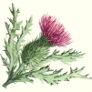

**Literacy**

P6 will be looking at poetry and Scots language this term, which is linked to the Scottish aspect of our topic. We are learning a Doric poem called ‘The Whistle’ and we will be performing this at the Scots Assembly. We will be looking at a variety of different poems and trying to replicate these.

During reading we will be focusing on our own personal targets. We will be looking at the theme of the text and the author’s message

We will develop our oral communication and listening skills through giving a personal talk related to our topic.

**Social Studies and Technologies**

Primary 6 have entered the Scottish

Engineering Leaders Award 2017. As part of this project they have to contact and interview an engineer about what their job entails. We are hoping to visit an engineering firm to see the real life practicalities of this job. They will then have to identify a ‘problem’, draw and annotate a solution and write a cover letter to engineers explaining why they should make their invention. As part of the programme, engineering students will choose the winning invention to build!

We will also be visiting Newtongrange Mining Museum to take part in a Bridges to Schools Building Project. This shows children the basic principles of engineering in building a bridge and the pupils will get a hands-on opportunity to experience what it is like to be a civil engineer in a fun and engaging environment. Through the activities, they learn about the various skills required to be an engineer and may be inspired to consider pursuing a career in this industry.

Spelling and maths Learning at Home activities will be issued on a ***Monday*** and due in on a ***Friday***. Please also remind your child to read the novel pages set for homework.

P.E kits will be needed on a ***Tuesday*** and ***Wednesday***. This should consist of a clean t-shirt, shorts or leggings and indoor footwear. All children are required to wear ***indoor shoes*** in school. We appreciate your help with this matter.

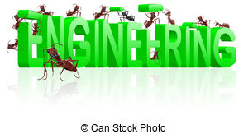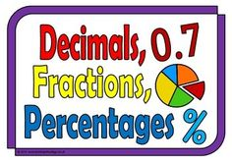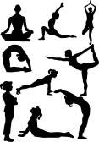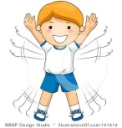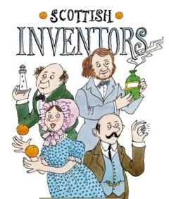 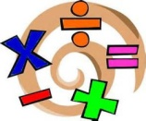

**Modern Language**

In line with 1+2 languages guidance we will be continuing to learn French and Spanish this term. We are fortunate enough to have a French Language Assistant, Miss Dubois, who works with us each Tuesday afternoon. In French we are learning to say what we like and dislike.

**Physical Education**

Primary 6 will be trying to raise their personal fitness

through working on a number of activities to improve speed, agility, stamina and coordination. We will move onto flexibility and balance through yoga and gymnastics.

**And Engineers**

**Mathematics and numeracy**

We will be focusing on fractions, decimals

and percentages in maths this term. Each child will be working on an individual target taken from the ‘basic facts’ programme, which will help them to consolidate basic number facts and help them move forwards in their numeracy learning.

We will continue our ‘Big Maths’ mental maths programme this term.