Health and Wellbeing
Physical Education
We will continue with our sessions once a week at Lasswade Swimming Pool. The children are learning a huge amount from this and enjoying their sessions hugely.
Link to Learning Aims:* I can find ways to improve my physical performance and technique in swimming. * I can recognise my progress in swimming through listening to feedback and discussing my own feelings. .

Relationships, Sexual Health and Parenthood
We will spend time focussing on friendship, as our project leads us through a look at ourselves, our personalities and what makes us happy.
Link to Learning Aims:* I aware how friendships are formed, * I understand how my behaviour, likes, dislikes, wants and needs impact on relationships. * I understand that we must respect people’s boundaries, both physical and emotional.
Planned context: Linking our emotions with happiness and friendships.

Mental and Emotional Well-being
We will look at our emotions and how we all feel/experience a range of emotions.
Link to Learning Aims: * I can express my feelings and talk about how I am feeling * I understand that my feelings can change depending on what is happening. * I understand this in other people too. * I know that friendship, caring, sharing, fairness, equality and love are important in building positive relationships * I



Social Studies
Linked to our exploration of friendship and our emotions.
Link to Learning Aims: * I can contribute to a discussion about my needs and wants and those around me.
Planned context: As part of a discussion about the needs and wants we have in the school environment and how they meet our emotional needs. We will also look at wants and needs in relation to friendships. Pupils will be given time to discuss, plan and create a ‘reflection’ space in the classroom to use in times of emotional sensitivity.

Science
Body Systems and Cells
We will spend time looking at our brains and how it works.
Link to Learning Aims: I have explored my senses and can name and describe them. * I can discuss how reliable they are and explore their limitations. *I can describe the position and function of my brain. * I can discuss what I need to do to keep it healthy.

Planned context: Pupils will undertake scientific investigations into their senses and the limitations of those senses. Learning about the physiology of the brain and its role in making our bodies work. Also a look at how we can grow and keep our brain healthy.

understand that mental wellbeing is important. * I understand that sometimes it is good to share a worry or problem with someone who can help.

Class News:
Primary 4 will continue to have Mme Dubois visiting for 5 weeks after Christmas.. She will lead the class in French games relating to our French topic.
My mindboggling brain.
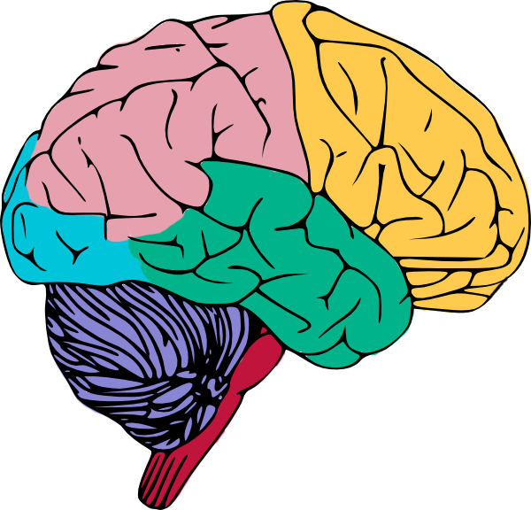
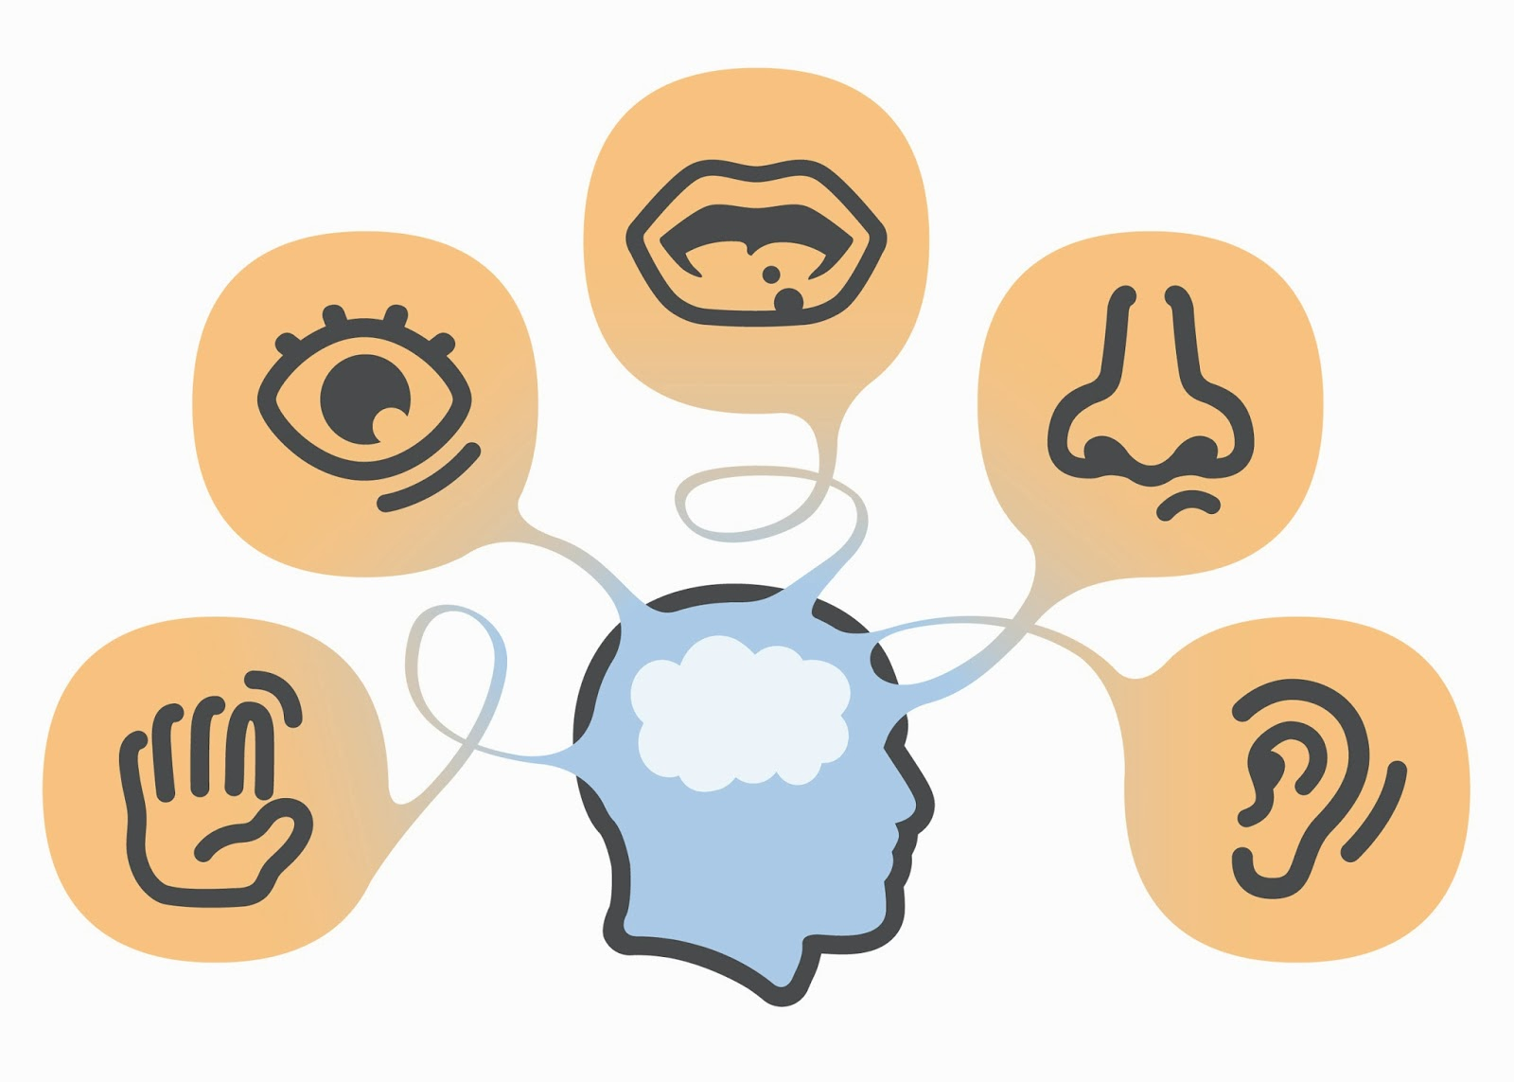


Modern Languages
I explore simple songs and rhymes and I enjoy learning with others as we talk and listen together
Planned Activities: Pupils will be using everyday language and will
Look at the topic of family. Reinforce French vocabulary
for members of our family and be able to describe our family to others. Es&Os: MNU 1-02a

Numeracy + Mathematics
Numeracy
Focus on addition and subtraction as well as improving our rapid recall of a range of number facts.
Benchmarks: Applies a range of strategies to solve addition and subtraction problems with up to 3 digit whole numbers and justifying choice of strategy. * Recognises, explains and uses the connections between addition and subtraction and multiplication and division to complete mental and written calculations. *Checks answers routinely using inverse operations in
both mental and written calculations.
Shape position and Movement
Es&Os: MTH 1-17a
I can describe, follow and record journeys using signs, words and
Angles associated with direction and turning.

Literacy and English
Reading:
We will use our topic work to consolidate our previous work with non-fiction texts.
Benchmarks: * Identifies the key features of fiction and non-fiction texts. * Uses contents, index, headings, sub-headings and diagrams to help locate information. * Finds key information from a text using different strategies. * Makes notes under given headings for different purposes.

We will also continue with our fiction readers.
Benchmarks: Identifies the main ideas of texts. • Makes appropriate suggestions about the purpose of a text.• Asks and answers literal and inferential questions about texts.• Recognises the difference between fact and opinion.• Offers own ideas about characters, writer’s use of language, structure and/or setting.• Offers own ideas about the writer’s message and theme and, when appropriate, relates these to personal experiences.

Listening and Talking:
Benchmarks: Takes turns and contributes at the appropriate time when engaging with others in a
variety of contexts.
• Listens and responds appropriately to the views of others, for example, by nodding
or agreeing, asking and answering questions in a respectful way.
Planned Context: Focus during classroom discussions + small group work.
Writing:
We will set individual targets and explore these through personal and persuasive writing.
Benchmarks: Writes independently, punctuating most sentences accurately using a capital letter, full stop, question mark or exclamation mark. • Links sentences using common conjunctions, for example, and, because, but or so.• Starts sentences in a variety of ways to engage the reader.• Presents writing in a clear and legible way. • Checks writing to ensure it makes sense.

Benchmarks: Uses appropriate vocabulary and language for specific purposes. • Shares own viewpoint and makes use of vocabulary and language to persuade the reader. • Writes about personal experiences in a logical sequence, using appropriate vocabulary to describe feelings, thoughts and events.
• Creates texts with evidence of structure.
My mindboggling brain.





