**Mathematics & Numeracy**

**Numeracy**

This term we will focus on developing children’s ‘Basic Facts’ in their numeracy. Each child will have a different focus for the period i.e. number bonds, skip counting or finding halves and doubles. As a whole class, we will also begin a block on multiplication.

**Maths**

Our maths focus this period will be on data handling.

**Language and Literacy**

Children will continue to receive reading books on a weekly basis for homework where they will develop their skills for reading. Children will also continue to read for enjoyment and choice during weekly visits to the class library. Our writing focus for the period will be instructional writing. We will continue to work through the Jolly Grammar spelling book for spelling words.

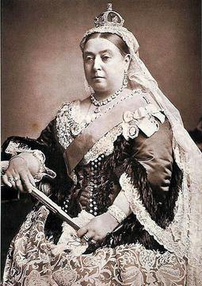

**Health and Wellbeing**

This period our PE focus will be on rugby. Children will have the opportunity to develop skills such as throwing, passing and travelling with the ball.

**Expressive arts**

This period children will have the opportunity to develop their skills and knowledge in Drama. Children will develop skills in voice, characterisation and movement. This strand of Expressive Arts will also link to our topic of the Victorians.

**Topic- The Victorians**

Our next topic we will be studying is The Victorians. We will be learning a lot about life during the Victorian times and will cover many different areas such as: schools, clothing, food, toys and Queen Victoria! Children will have the opportunity to engage with many areas of the curriculum during this topic such as Literacy, Art and Technologies.