**Language and Literacy**

**Reading** – Children will continue take home their reading books for homework each week. The children will also have the opportunity to read for enjoyment and choice at different points in the day during quiet reading time.

**Writing** – For our writing focus this period we will be continuing with our work on writing a formal letter.

**Spelling** – We will continue to work through the Jolly Grammar spelling book for spelling words.

**Mathematics & Numeracy**

**Numeracy**

This period in Numeracy and Maths we will continue to focus on:

* Counting in 2s, 5s and 10s
* Addition and subtraction
* Division by ‘grouping’

Using a range of different strategies and resources.

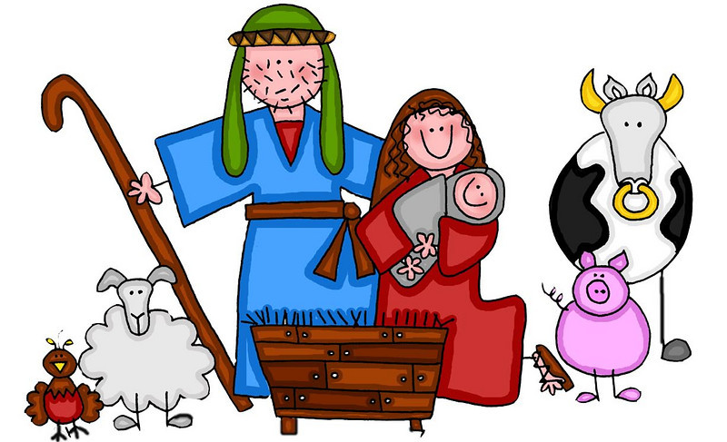

**Expressive arts**

Primary 2 will have the opportunity to develop their skills and confidence in the expressive arts during our preparation for our nativity this period! We will cover:

* *Music*: through singing our songs & some developing skills in playing percussion instruments
* *Drama*
* *Art:* children will be selected to create different costumes and props to contribute to our show
* *Dance:* we are busy learning dance moves to go alongside our songs!

**Nativity**

Our topic focus this period will be our nativity: **‘Rock the Baby’**. We have begun our rehearsals which the children have been very enthusiastic about so far! Primary 2 will be our animals in our nativity as well as being part of the choir or percussion ensemble!

**Health and Wellbeing**

This period we will spend our PE time learning some Scottish country dances alongside Primary 1 to prepare for our Christmas party!