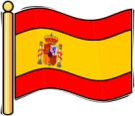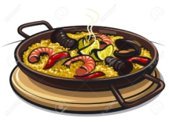

**Literacy**

P6 will be writing non-chronological reports this term. They will be drawing on their drugs education knowledge, as well as learning about Spain or Spanish speaking countries.

Our reading skills will be skimming and scanning, to find information for our writing.

We will develop our oral communication and listening skills through debating. We will have to clarify our thinking and build on contributions of others.

Maths and Spelling homework will be issued on a **Monday** and due in on a **Friday**. Reading will be set pages for the following week.

We will be continuing skiing until **Wednesday 30th November.**

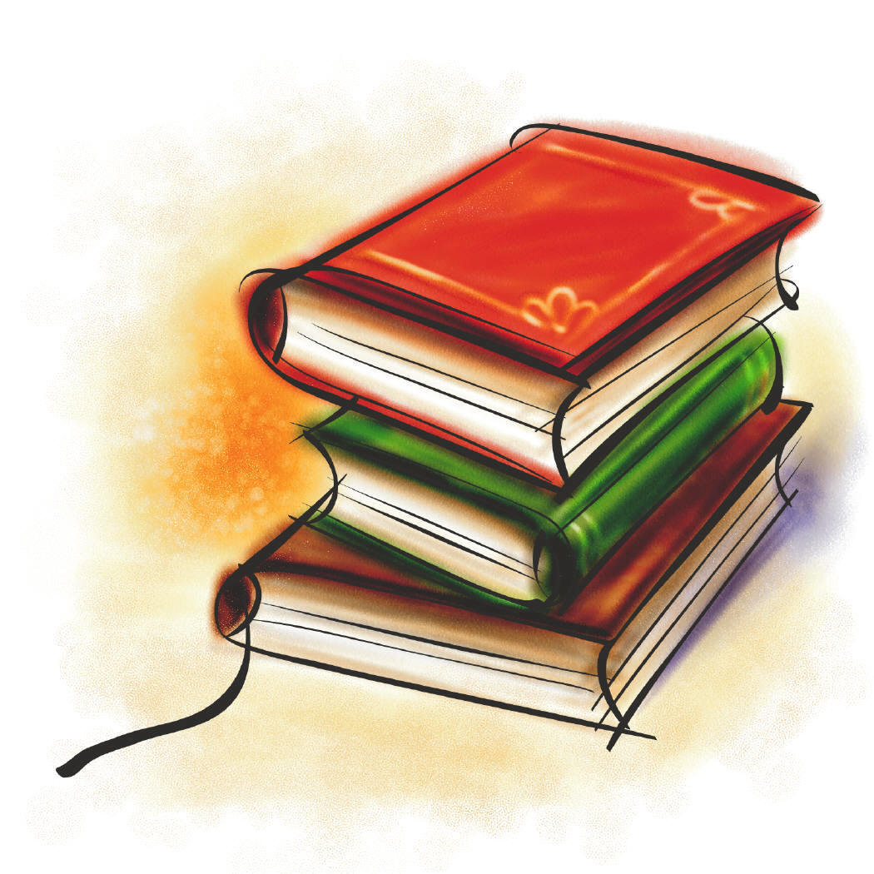

**Social Studies**

P5-7 will be making use of our

excellent Spanish trainee teachers. We are lucky enough to have Miss Ferré and Miss Moncusi, to draw on their knowledge and experience of Spain. This will allow us to have an in depth look at comparative cultural studies, and is one of the reasons why we are undertaking this topic. As well as looking at Spanish culture around the globe, the children will learn about various foods and traditions.

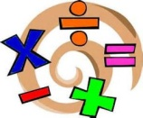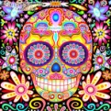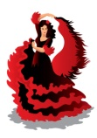

**Religious and Moral Education**

P5-7 will be learning about Catholic festivals which are celebrated in Spain. We will be comparing and contrasting these with Scottish traditions. We will begin the topic with the triduum festival of Allhallowtide.

**Mathematics and numeracy**

We will be continuing our maths rotation this term. We will continue to practise our times tables, and look at key skills of addition, subtraction, multiplication and division. We will practise calculating these in written and mental ways.

Each week we will do ‘Big Maths’, a mental maths programme.

**Expressive Arts**

P5-7 will be exposed to, and taking

part in, a variety of Spanish music and dance. We will be looking at Spanish artists, and using them as an inspiration for our own arts and crafts.

**Language**

In line with 1+2 languages guidance we will be immersing ourselves in Spanish language, as well as our French language.

**Español**

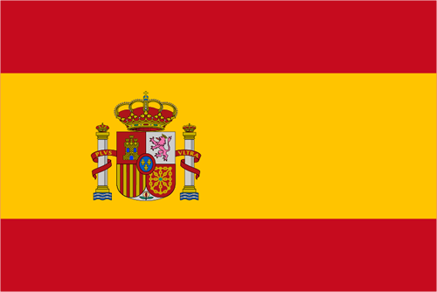

**Technologies - ICT**

P5-7 will be learning to research, create and publish a document related to learning in our topic. This will help them gain the confidence and skills to use and embrace technologies independently, both in school and at home.