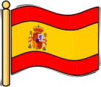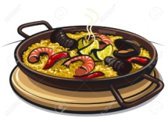

**Literacy**

P7’s reading skills will be focussed to best meet the needs of each individual child- Please ask your child about their reading target and challenge them to improve. (Please also see me if you would like more help to do this.)

We will develop our oral communication and listening skills through debates of bullfighting and the learning of foreign languages.

In writing we will be continuing to look at scriptwriting and looking at the punctuation, layout and different writing

Maths and Spelling homework will be issued on a **Monday** and due in on a **Friday**. Reading will be set pages for the following week.

We will be continuing skiing until **Wednesday 30th November.**



**Social Studies**

P7 will be making use of our

excellent Spanish trainee teachers. We are lucky enough to have Miss Ferré and Miss Moncusi, to draw on their knowledge and experience of Spain. This will allow us to have an in depth look at comparative cultural studies, and is one of the reasons why we are undertaking this topic. As well as looking at Spanish culture around the globe, the children will learn about various foods and traditions.

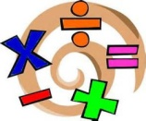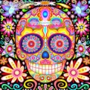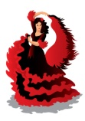

**Technologies - ICT**

P7 will be learning to research, create and publish a document related to learning in our topic. This will help them gain the confidence and skills to use and embrace technologies independently, both in school and at home.

**Mathematics and numeracy**

We will be continuing our maths rotations this term. This term they will be focussing on their specific maths target and working in small groups to improve on this area. Their target was chosen based on their last maths assessment and the hope is they will improve in this area at our next assessment. We have also been looking at varied consolidation work to try and keep ALL of our maths concepts up to date.

**Religious and Moral Education**

P5-7 will be learning about Catholic festivals which are celebrated in Spain. We will be comparing and contrasting these with Scottish traditions. We will begin the topic with the triduum festival of Allhallowtide.

**Language**

In line with 1+2 languages guidance we will be immersing ourselves in Spanish language, as well as continuing our French language.

**Expressive Arts**

P7 will be exposed to, and taking

part in, a variety of Spanish music and dance. We will be looking at Spanish artists, and using them as an inspiration for our own arts and crafts.

**Español**

