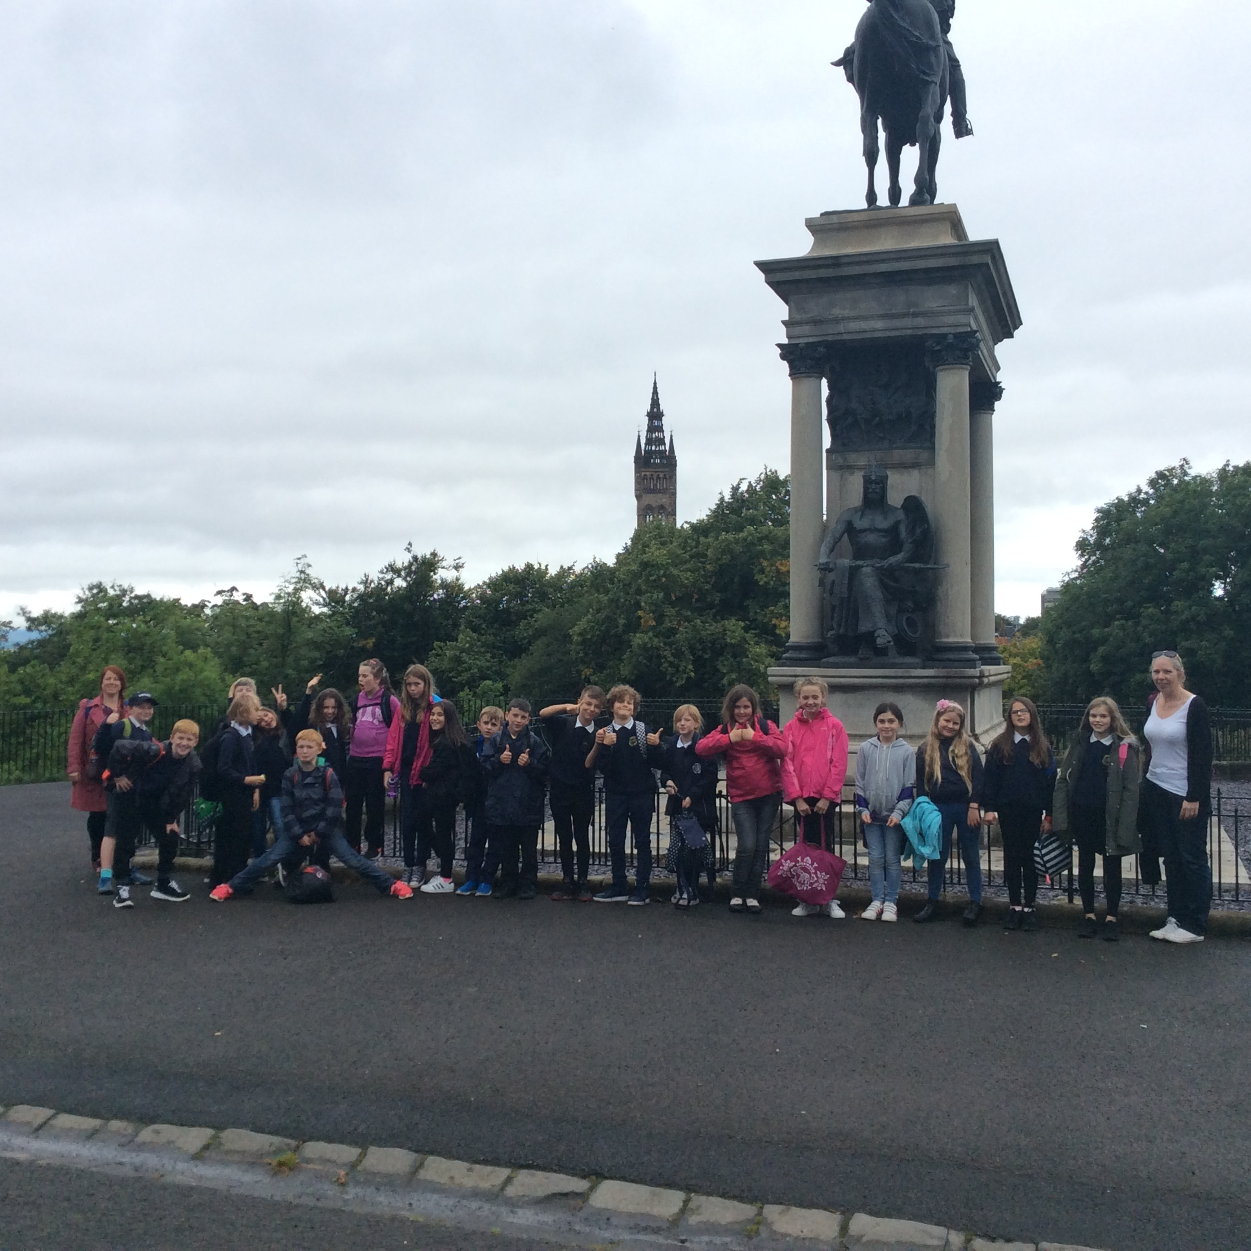 |  | Some of P6 and 7 took part in a Cross Country event at Vogrie Park on the 27th September. It was a cold and windy day but they all did themselves proud by running the course in quick times, and persevering when it felt difficult. |  | 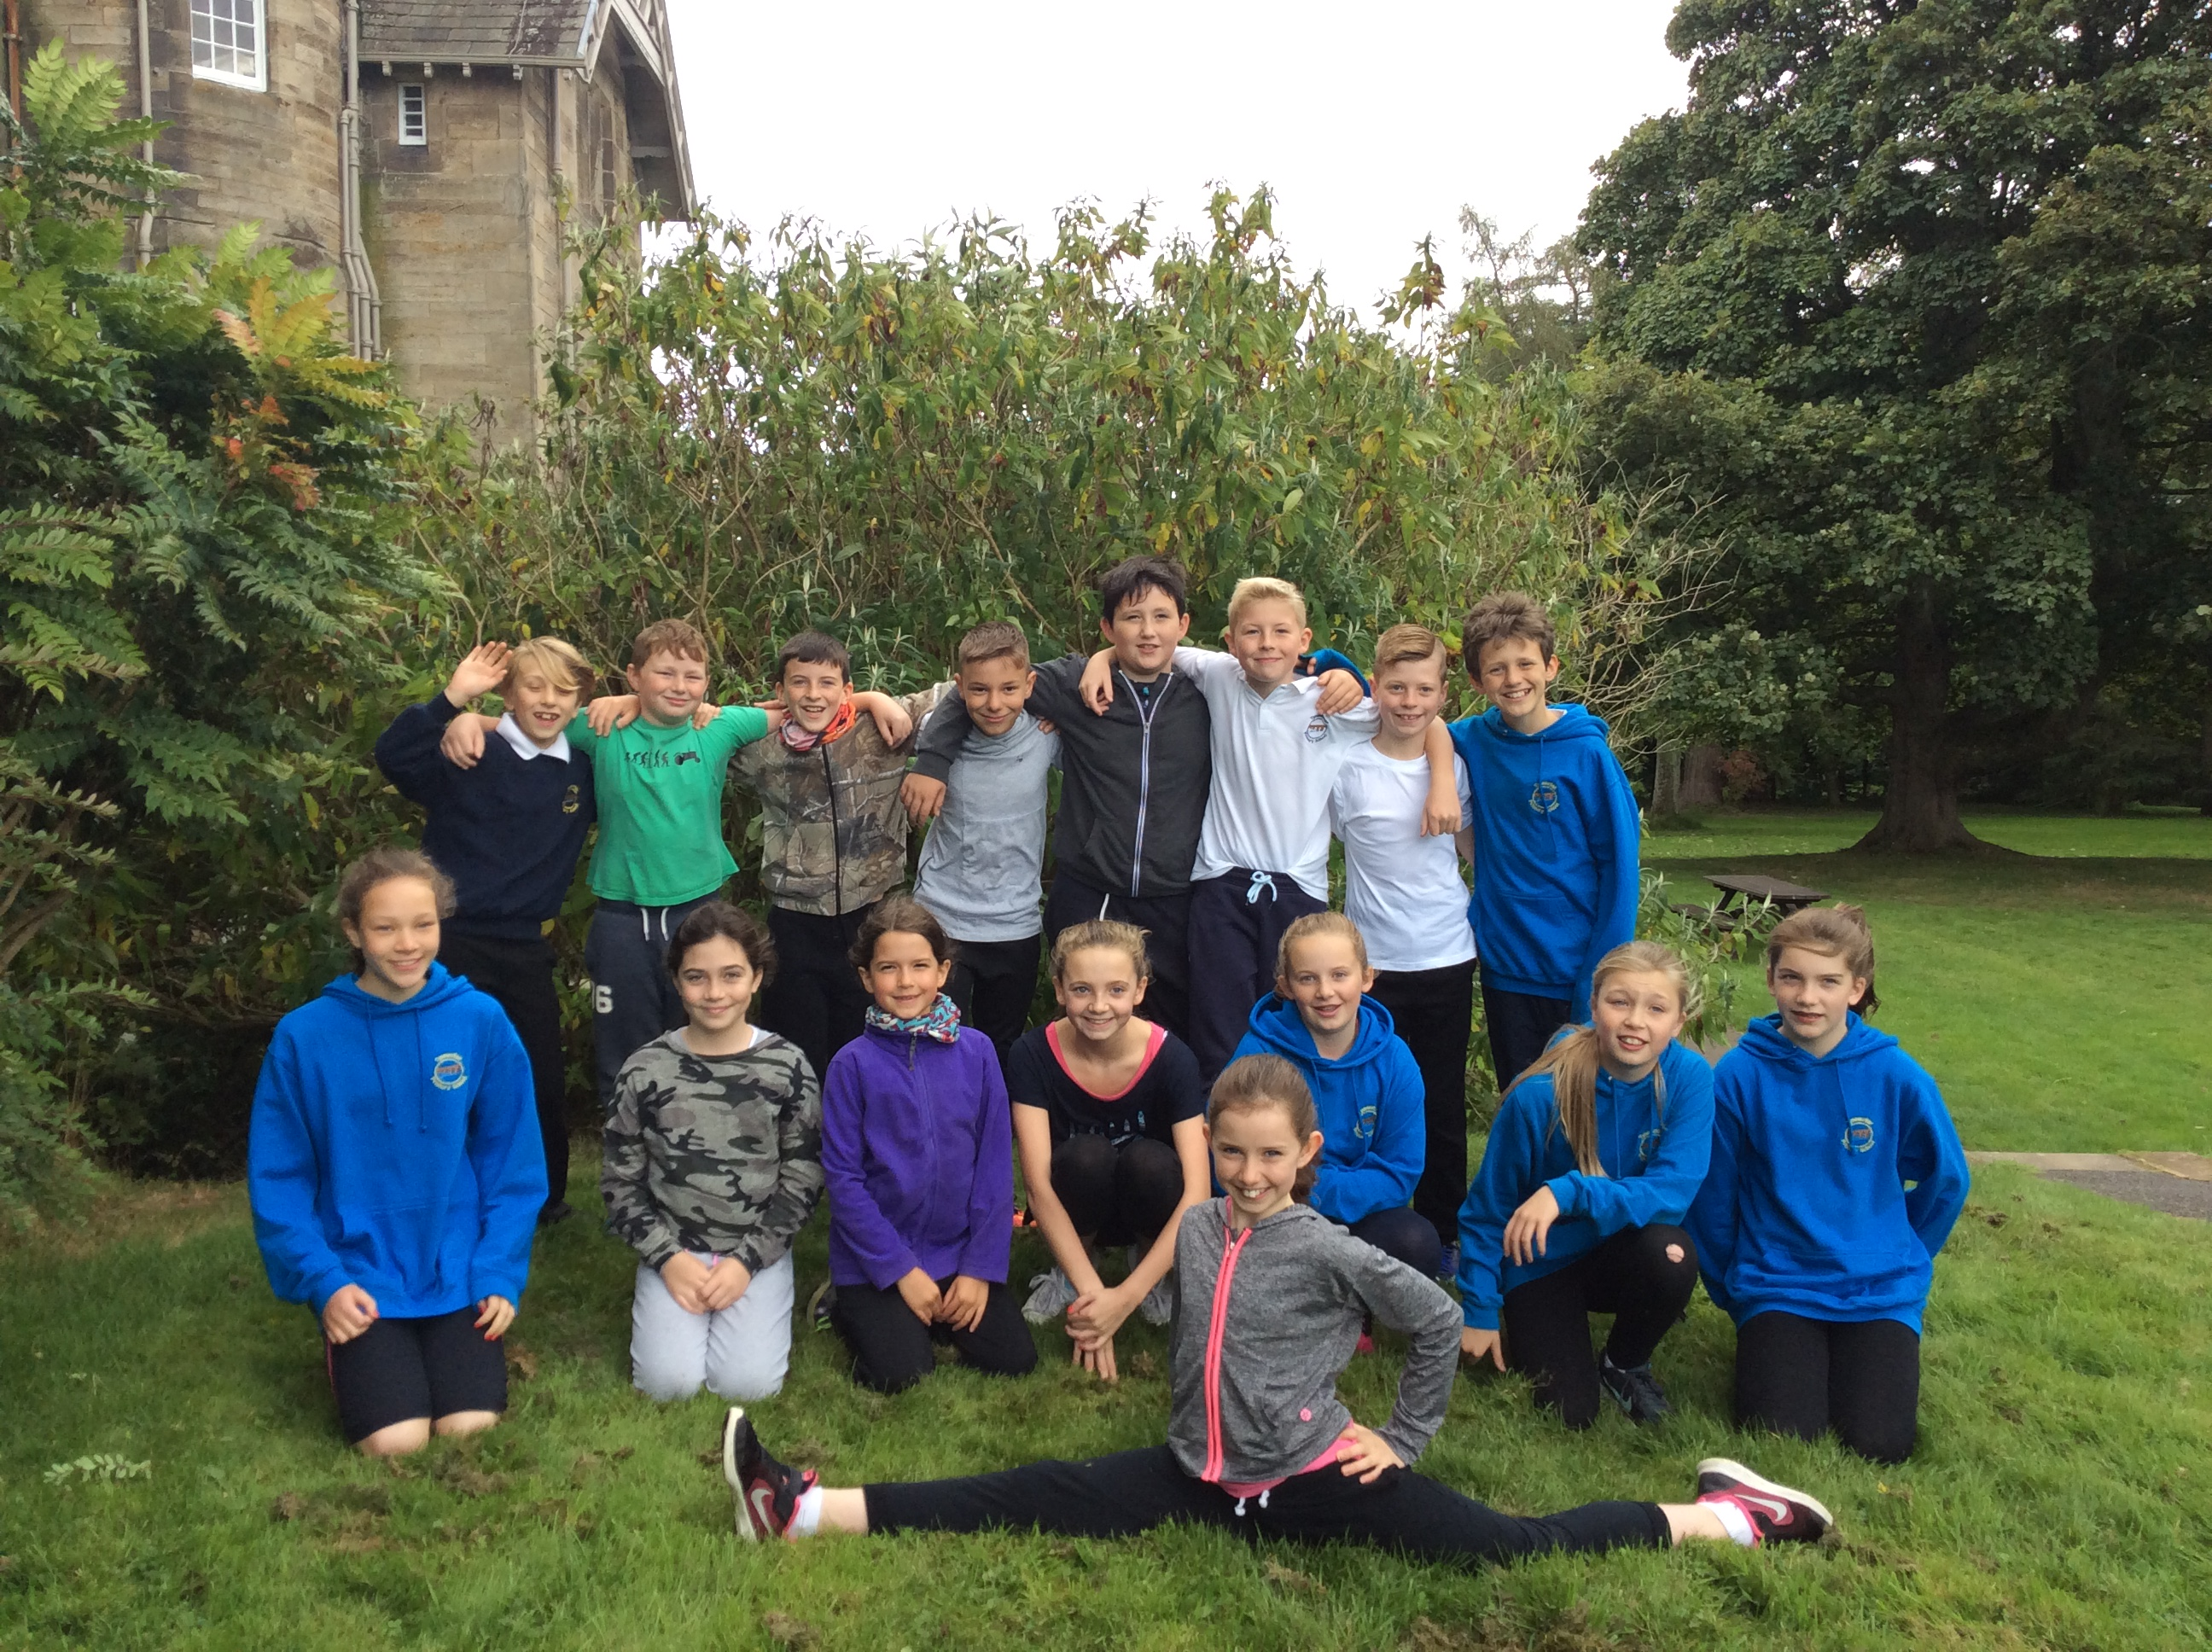
P6 had a brilliant time on our Glasgow Residential! We enjoyed learning about a variety of topics during our trips to the Kelvingrove Museum, Transport Museum and Glasgow Science Centre. The hostel was great and we enjoyed each other’s company, playing games and watching a DVD in the evenings. |  | P6 enjoyed the Science Centre so much that they decided they wanted to find out a bit more about Chemistry. Here they are learning about the properties of liquids and solids and making sticky gloop to play with! |  | 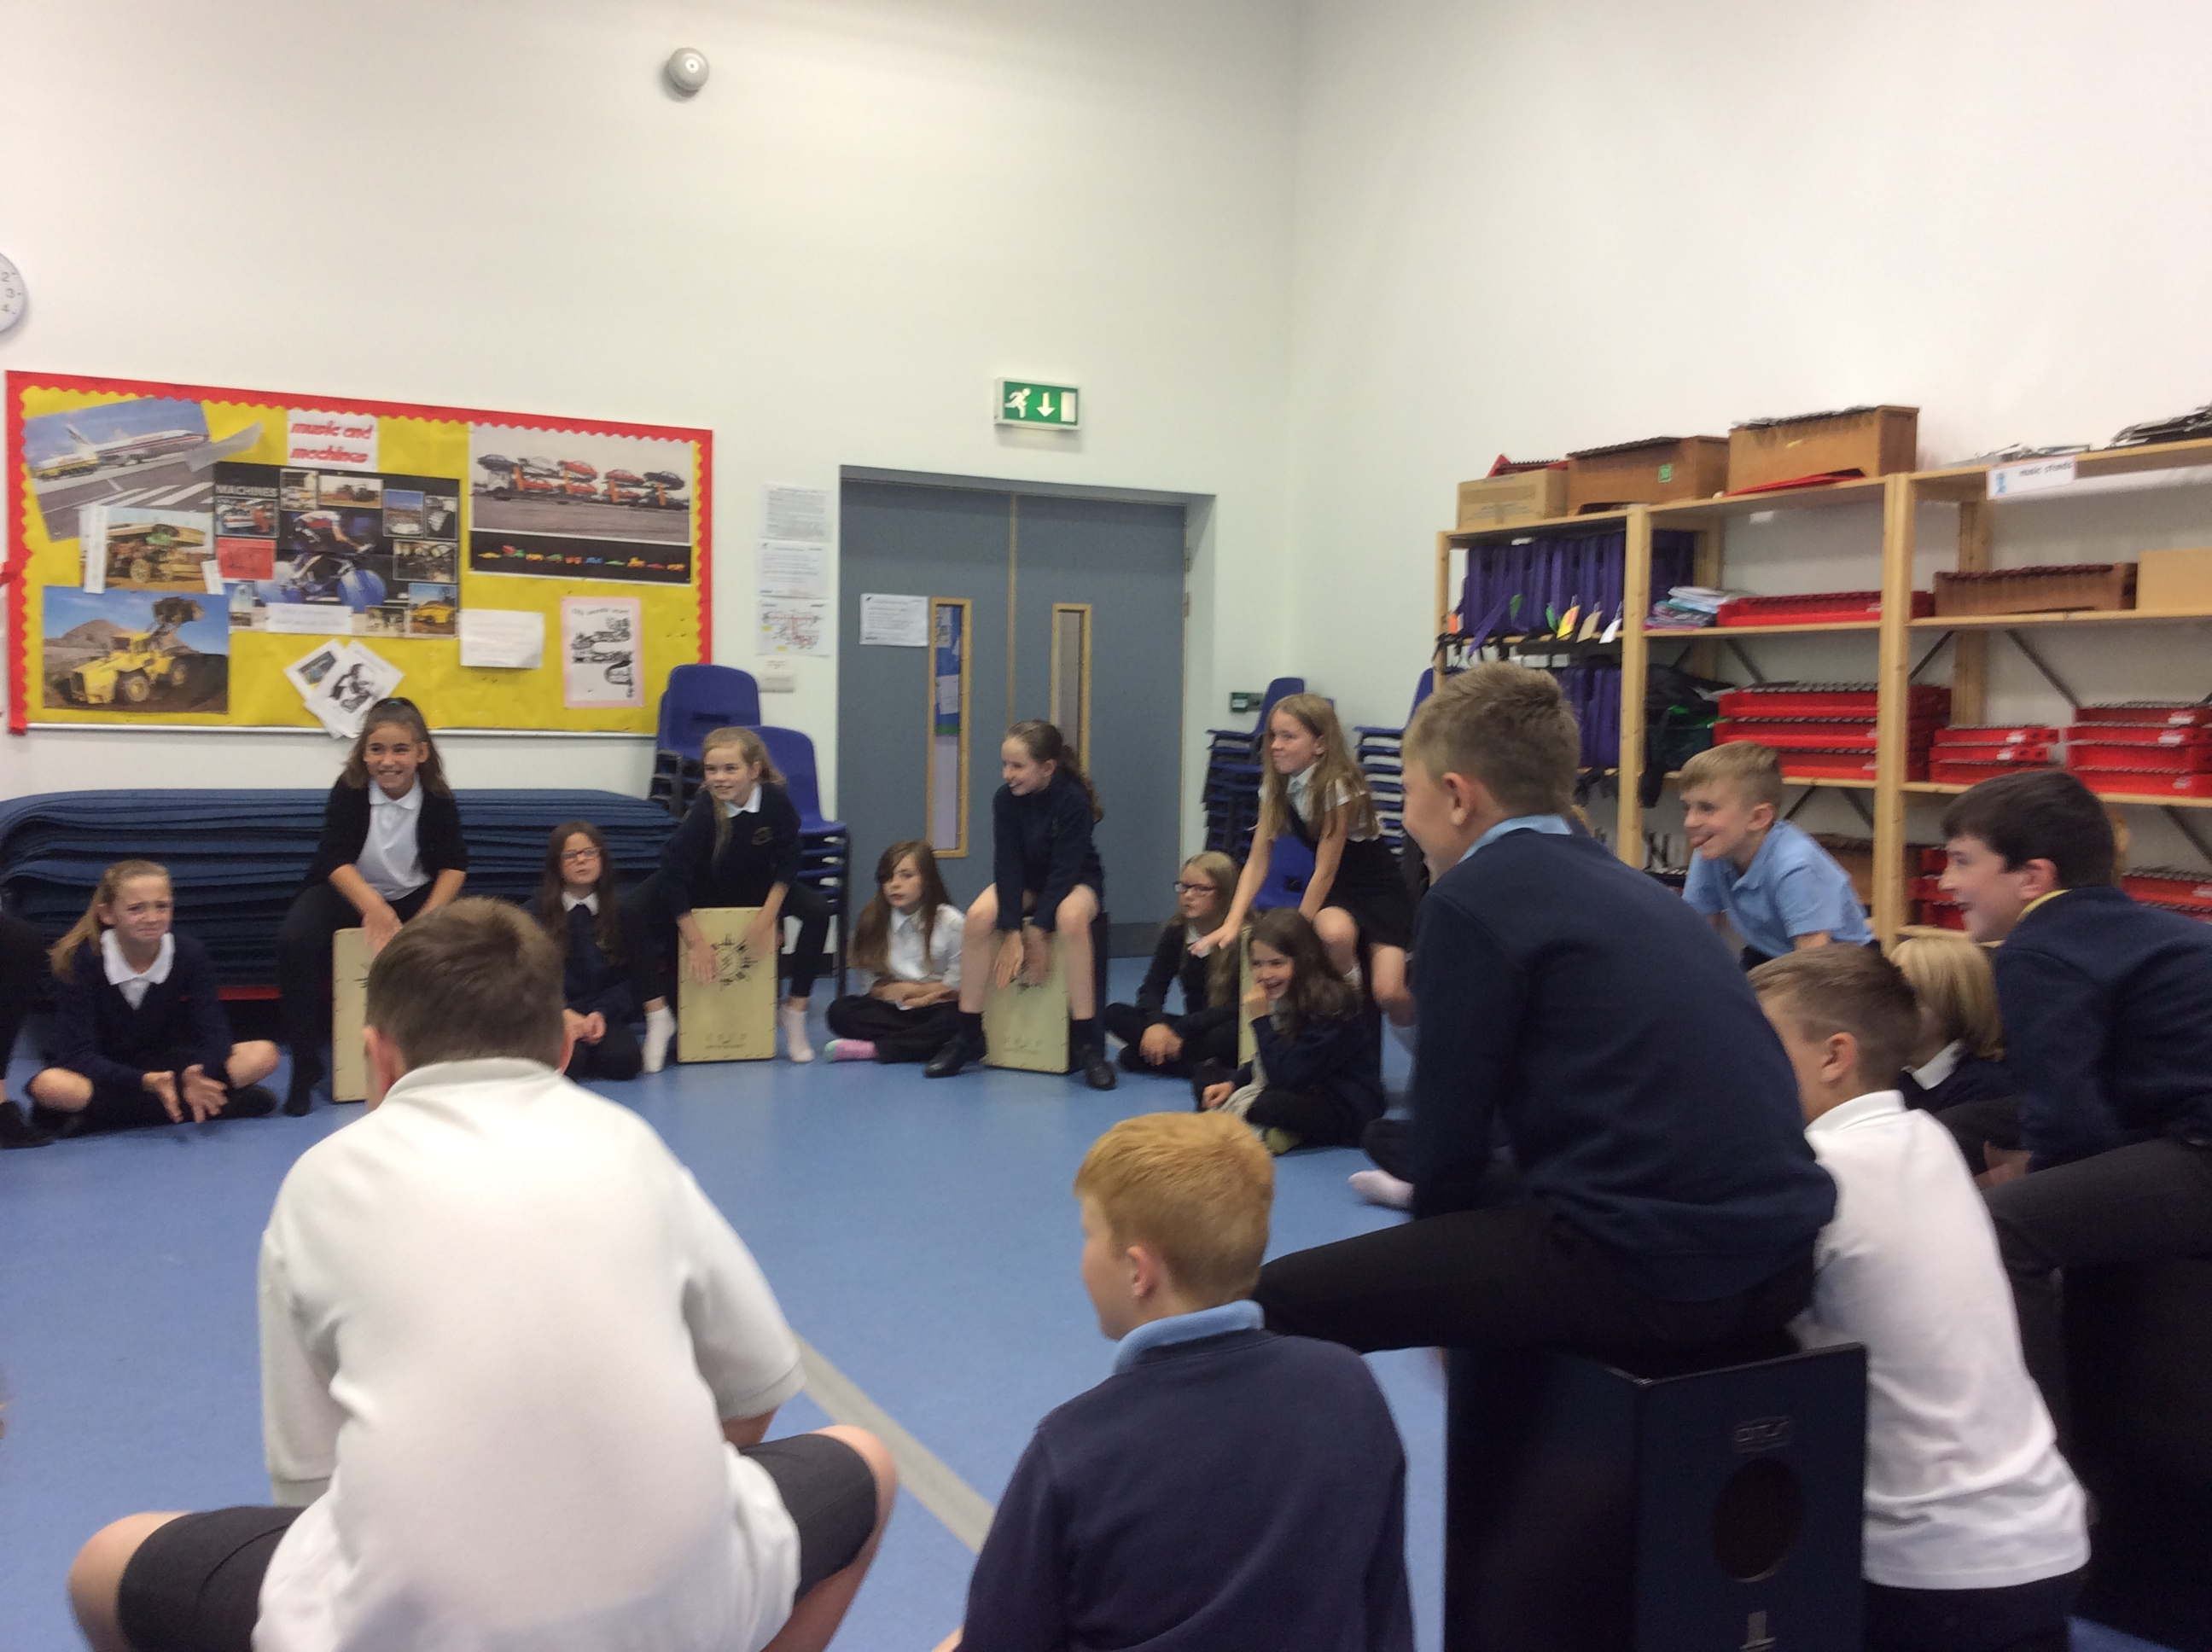
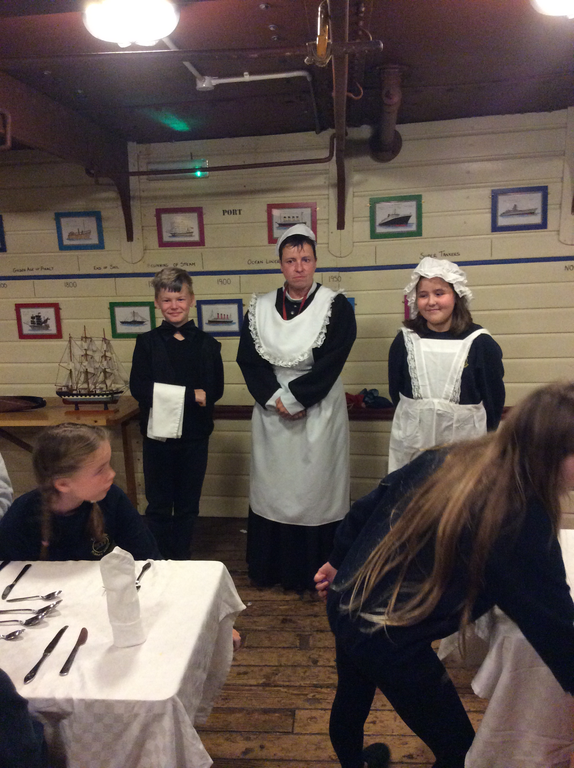 |  | 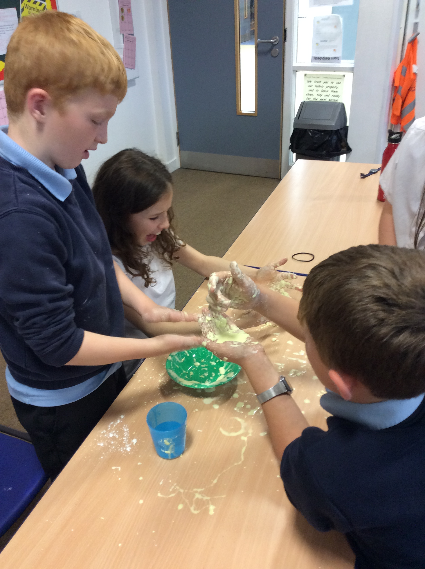 |  | P6 were given a taster session of Cajon Drumming at the start of the year. They learned different rhythms and played at different tempos. They were also able to try accompanying instruments to create a class piece.

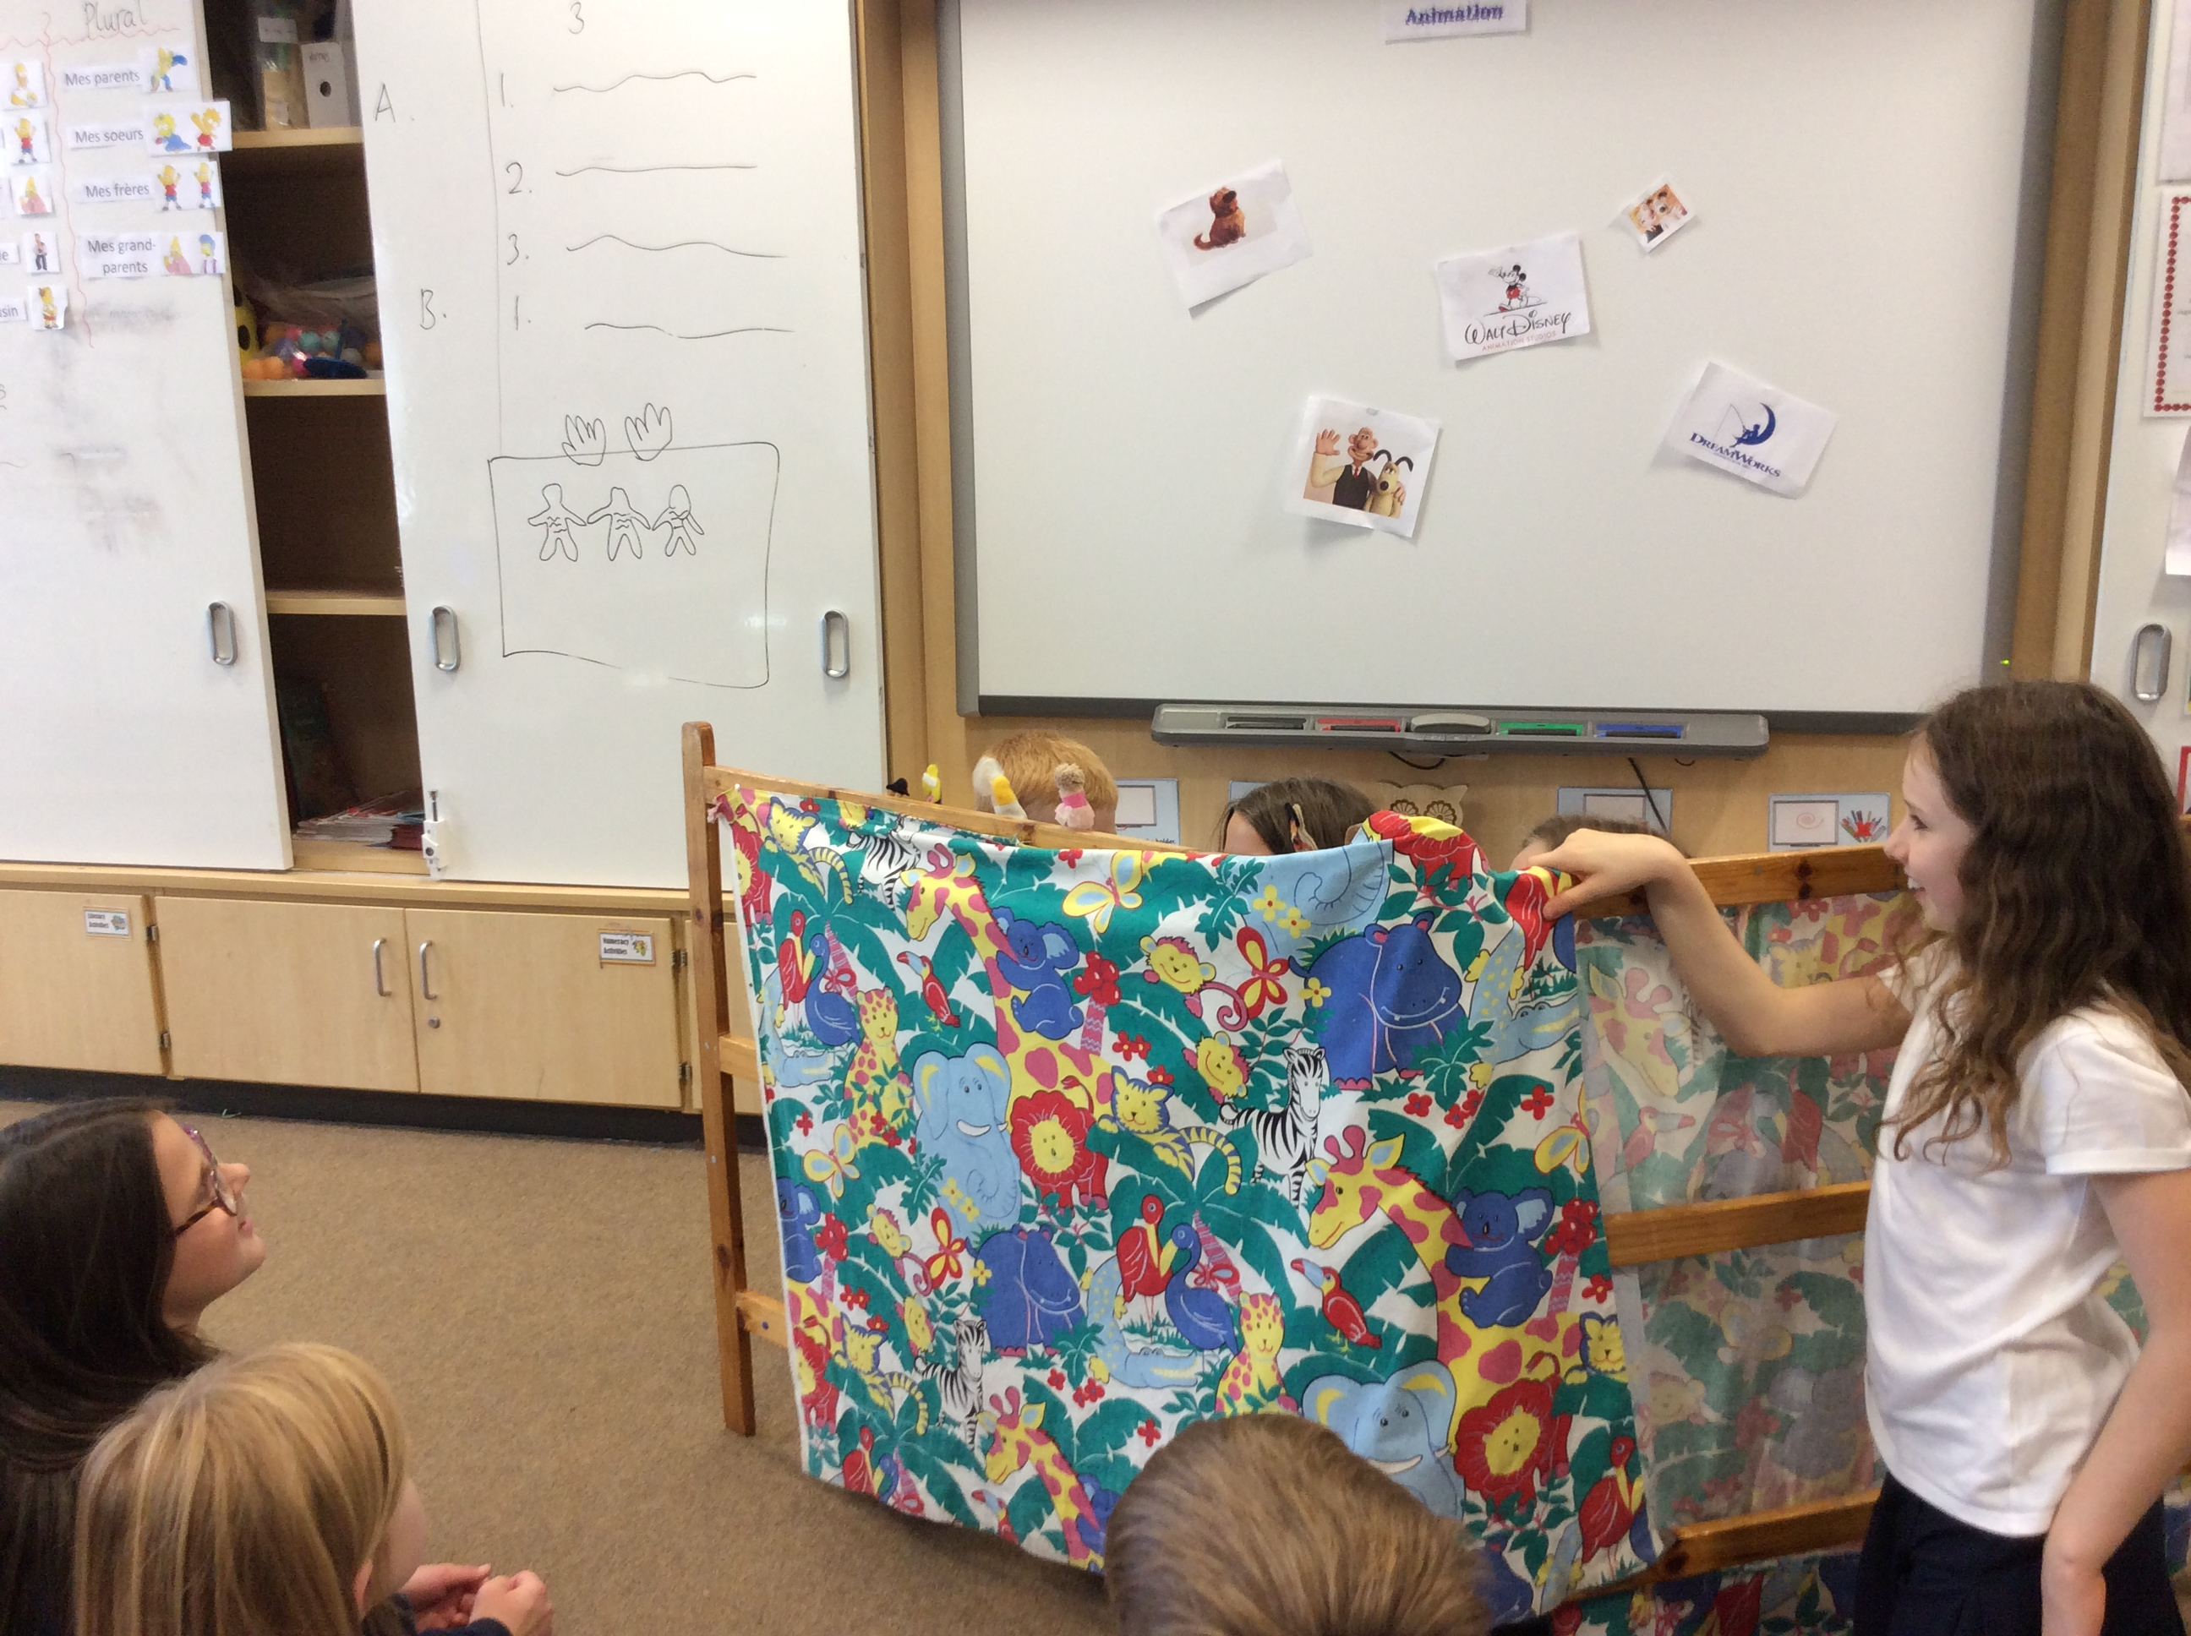  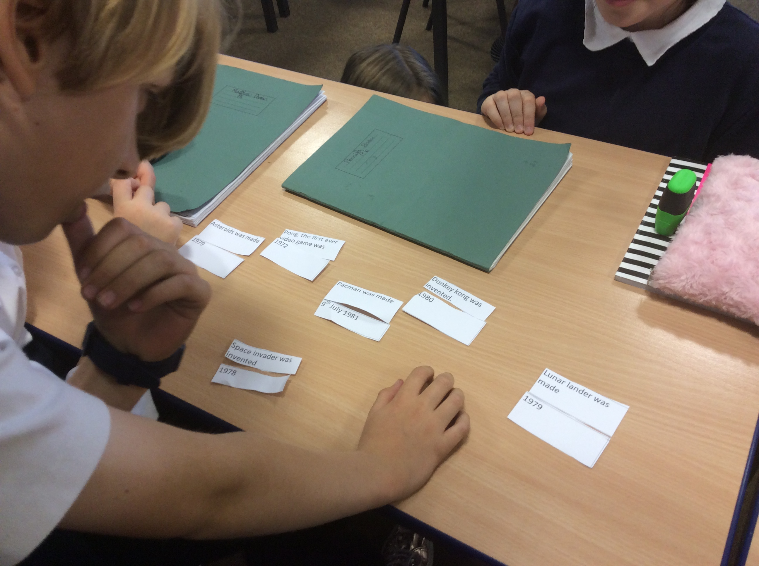 |  | 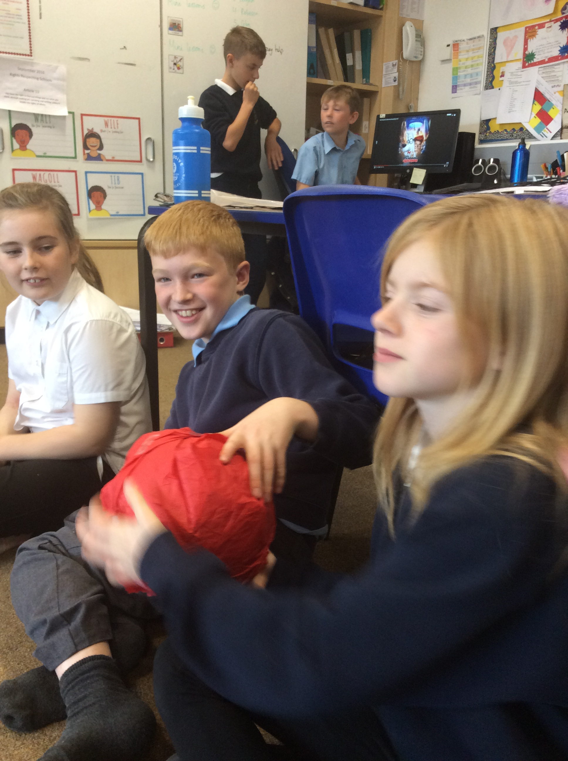 |  | 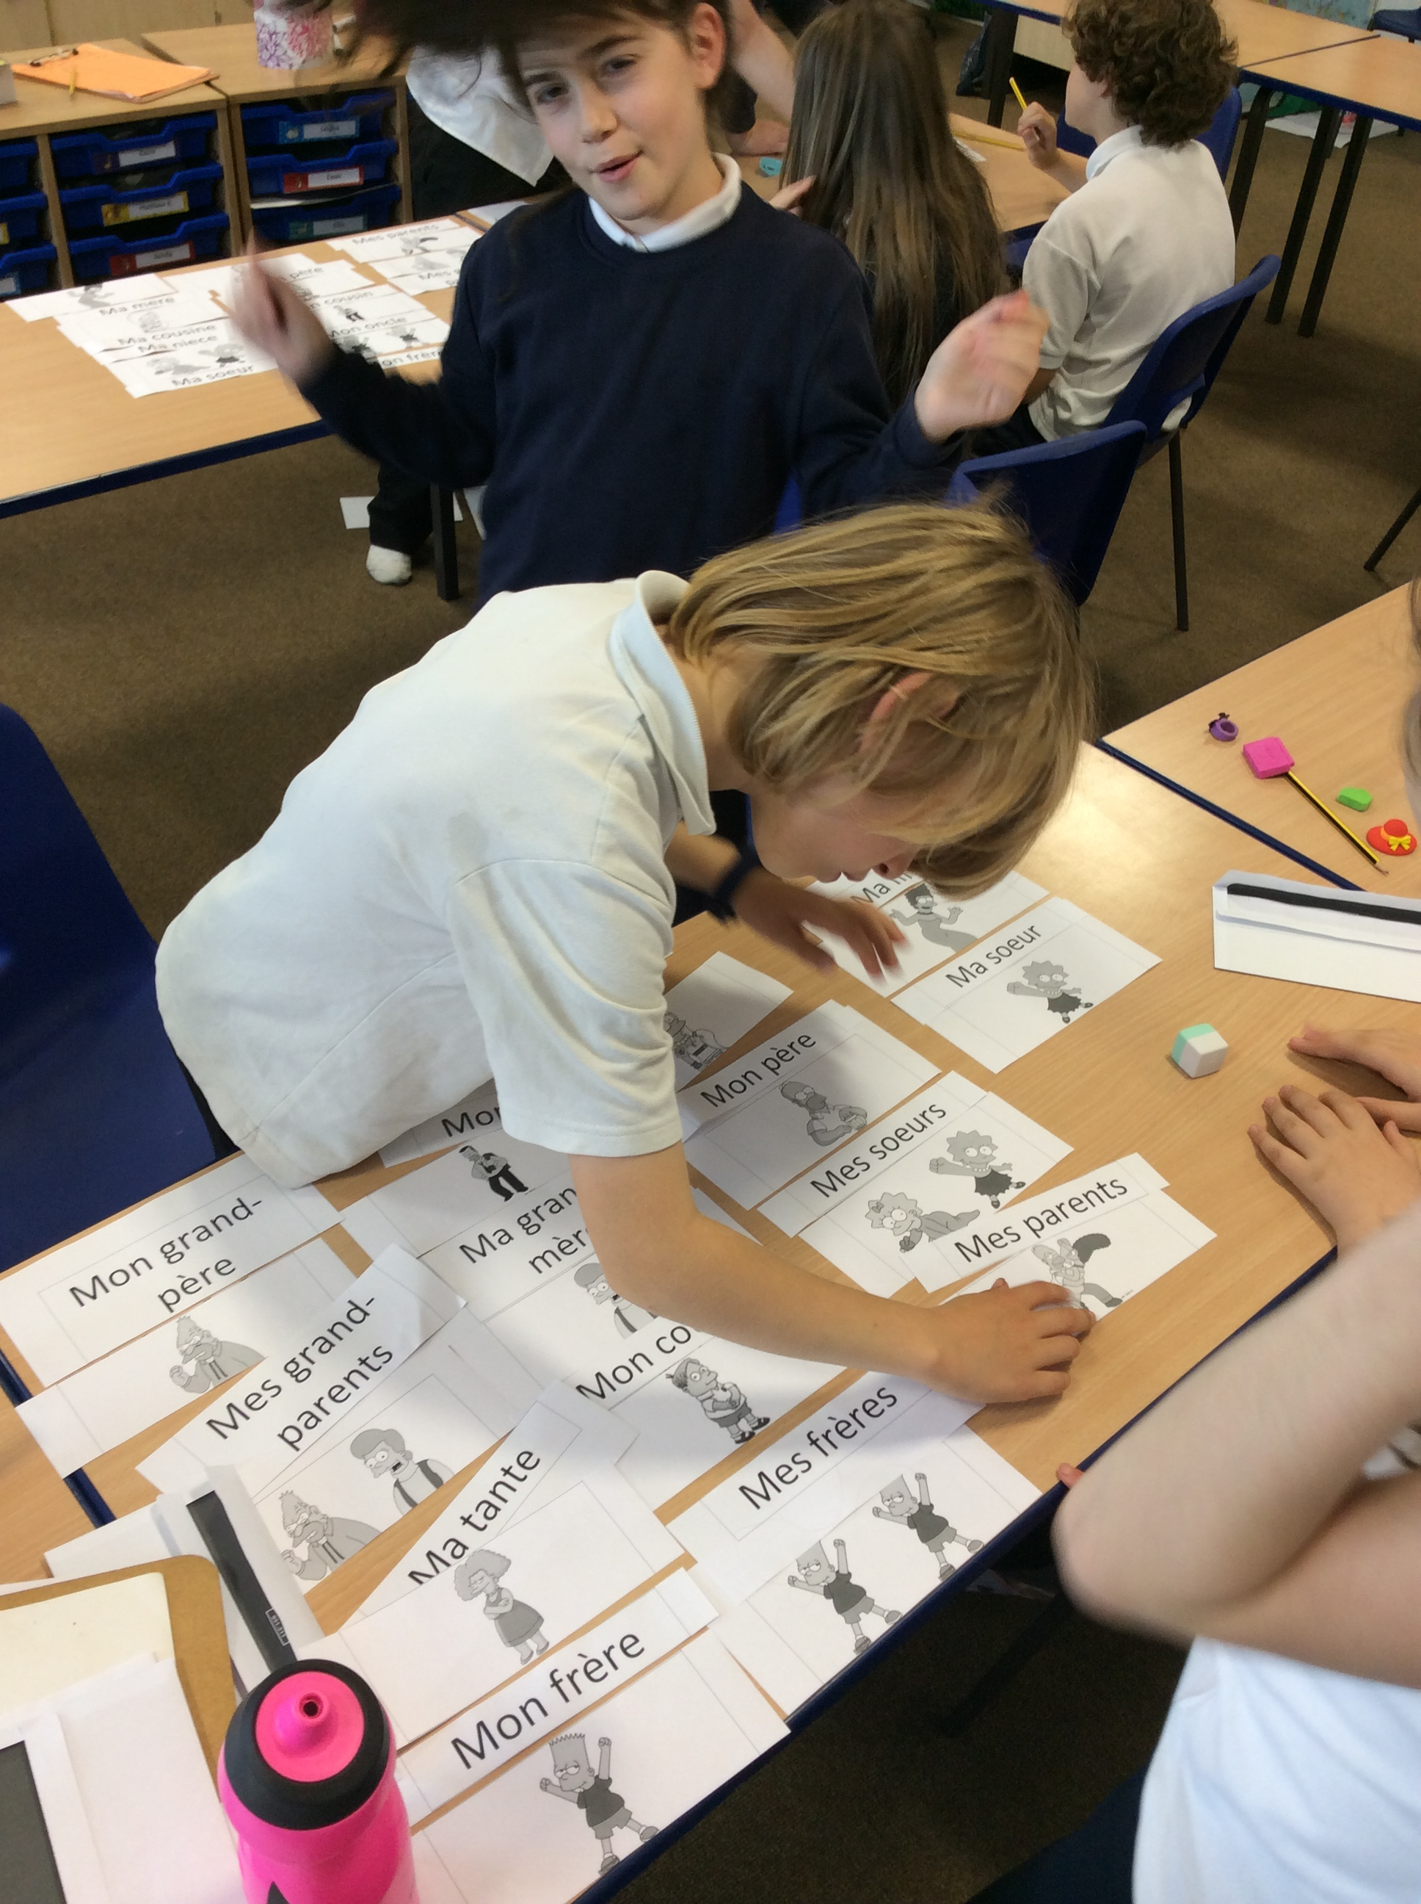
For World Teacher Day 2016 (5th October) Primary 6 were set the challenge of planning, organising and delivering a class lesson. They were given a week to think about what they wanted to teach and plan a fun and engaging lesson for the class, Miss McDonald included!  We were taught 4 excellent lessons on Animation, Transport, the film Mr Peabody and Sherman, Gaming and First Aid. The lessons were all well thought out and delivered, although I don’t think P6 realised how difficult it would be! |  | 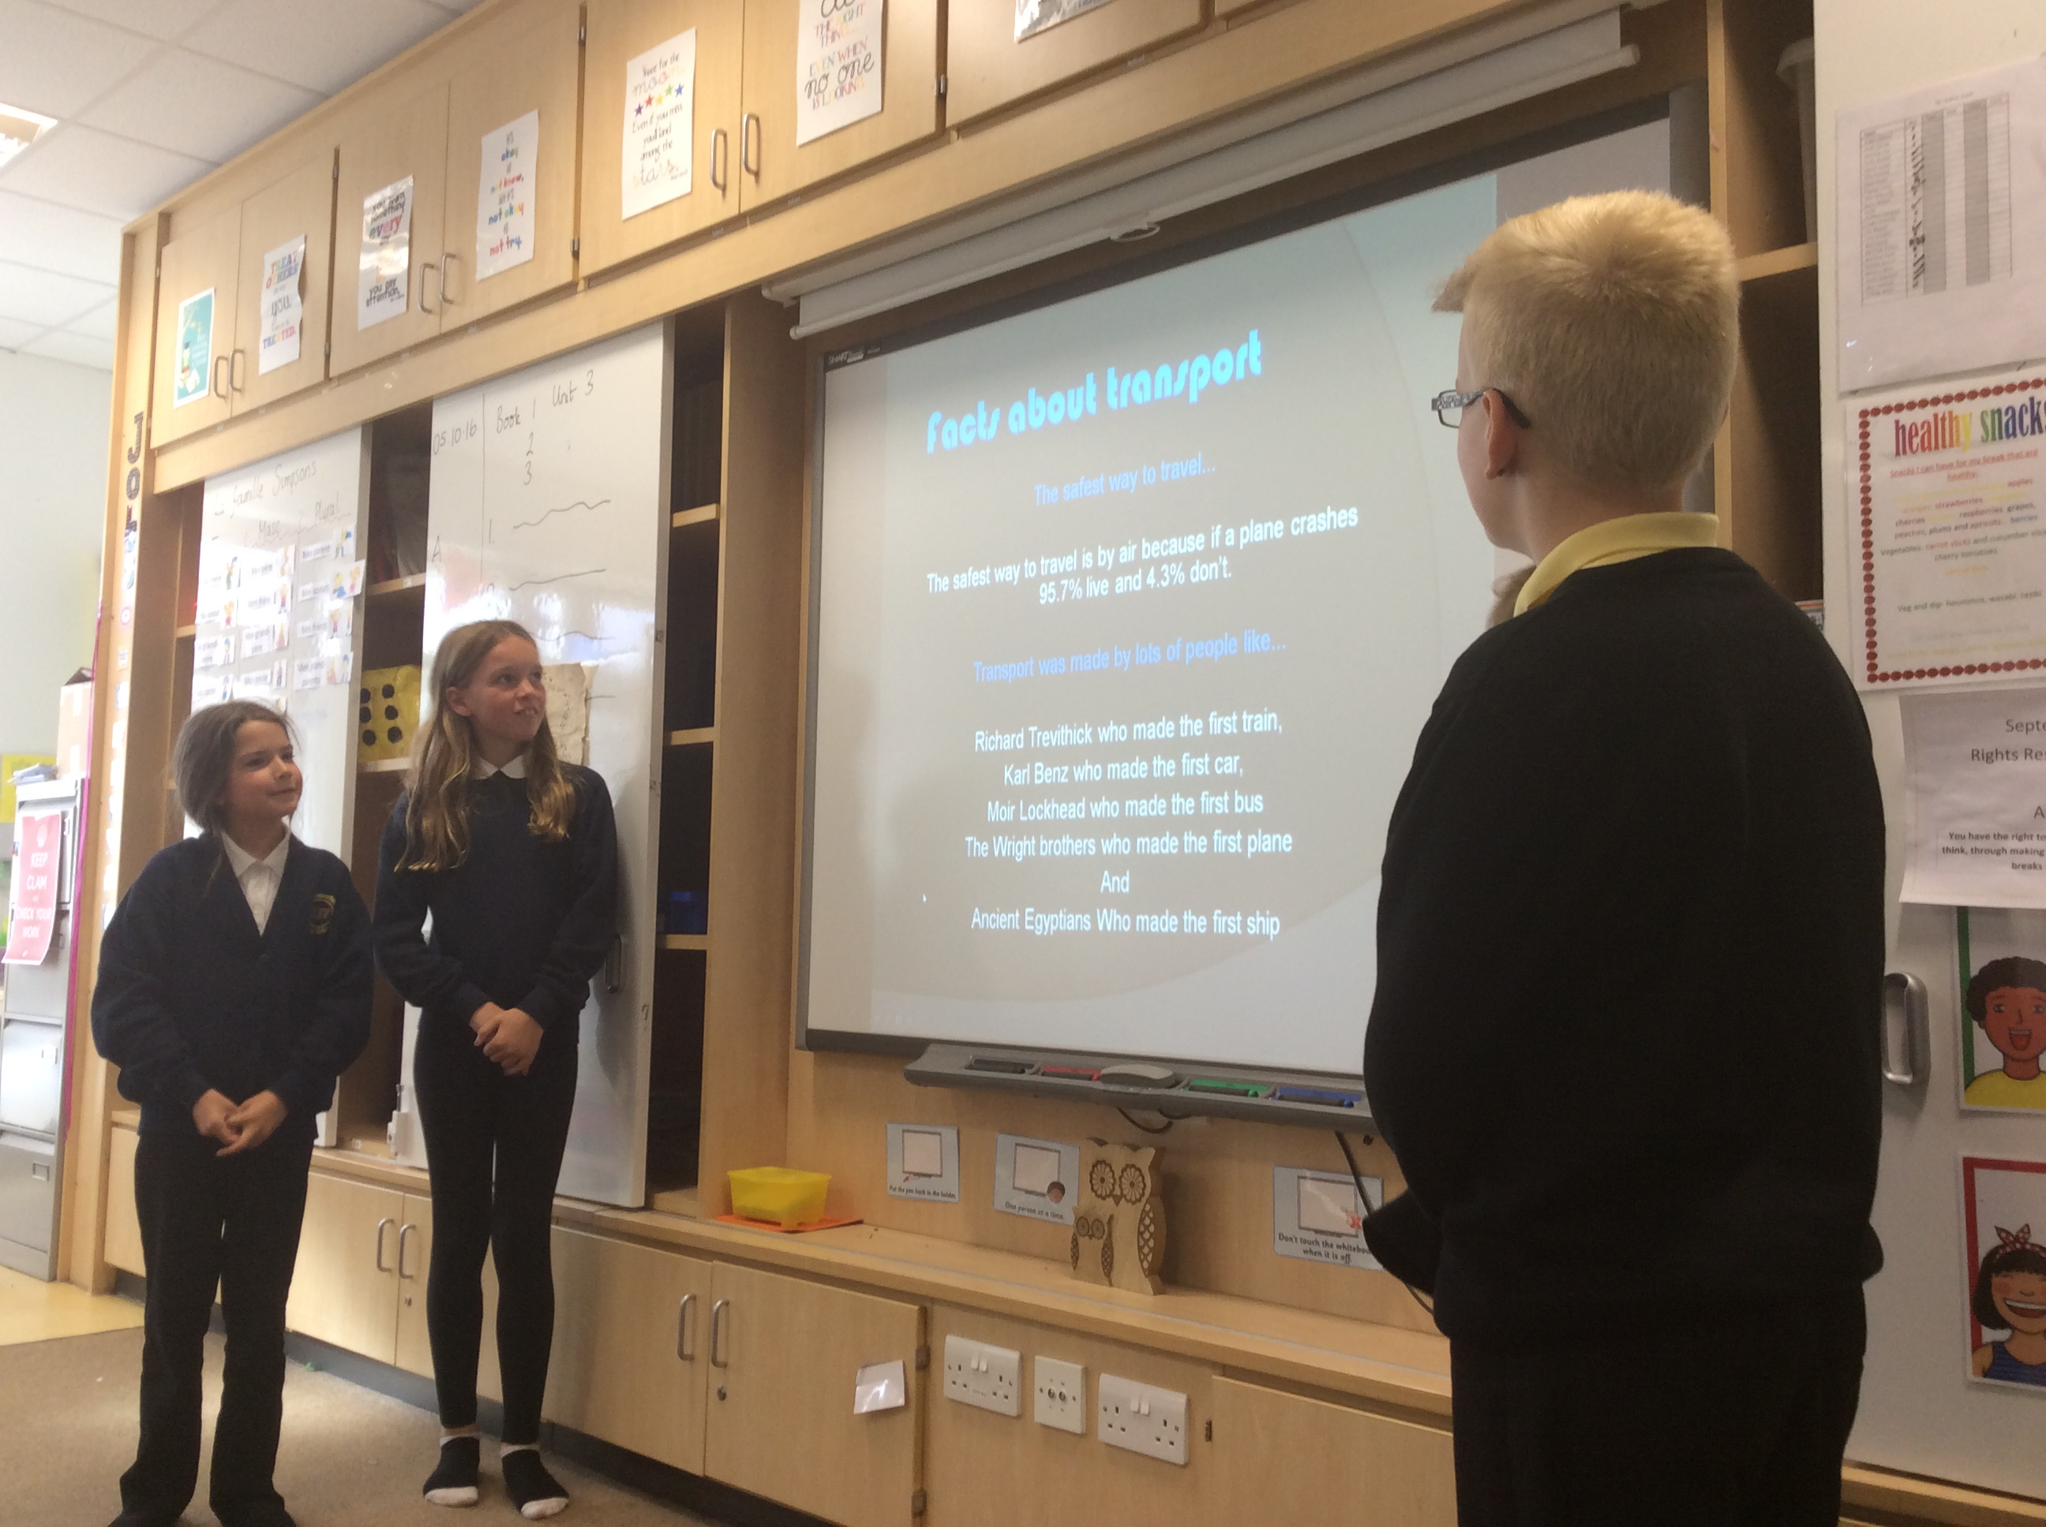 |  | P6 have been working with different teachers for their French lessons this term. They have been revising introductions and numbers. They have been learning how to say the weather and how to talk about their family.
 |  | 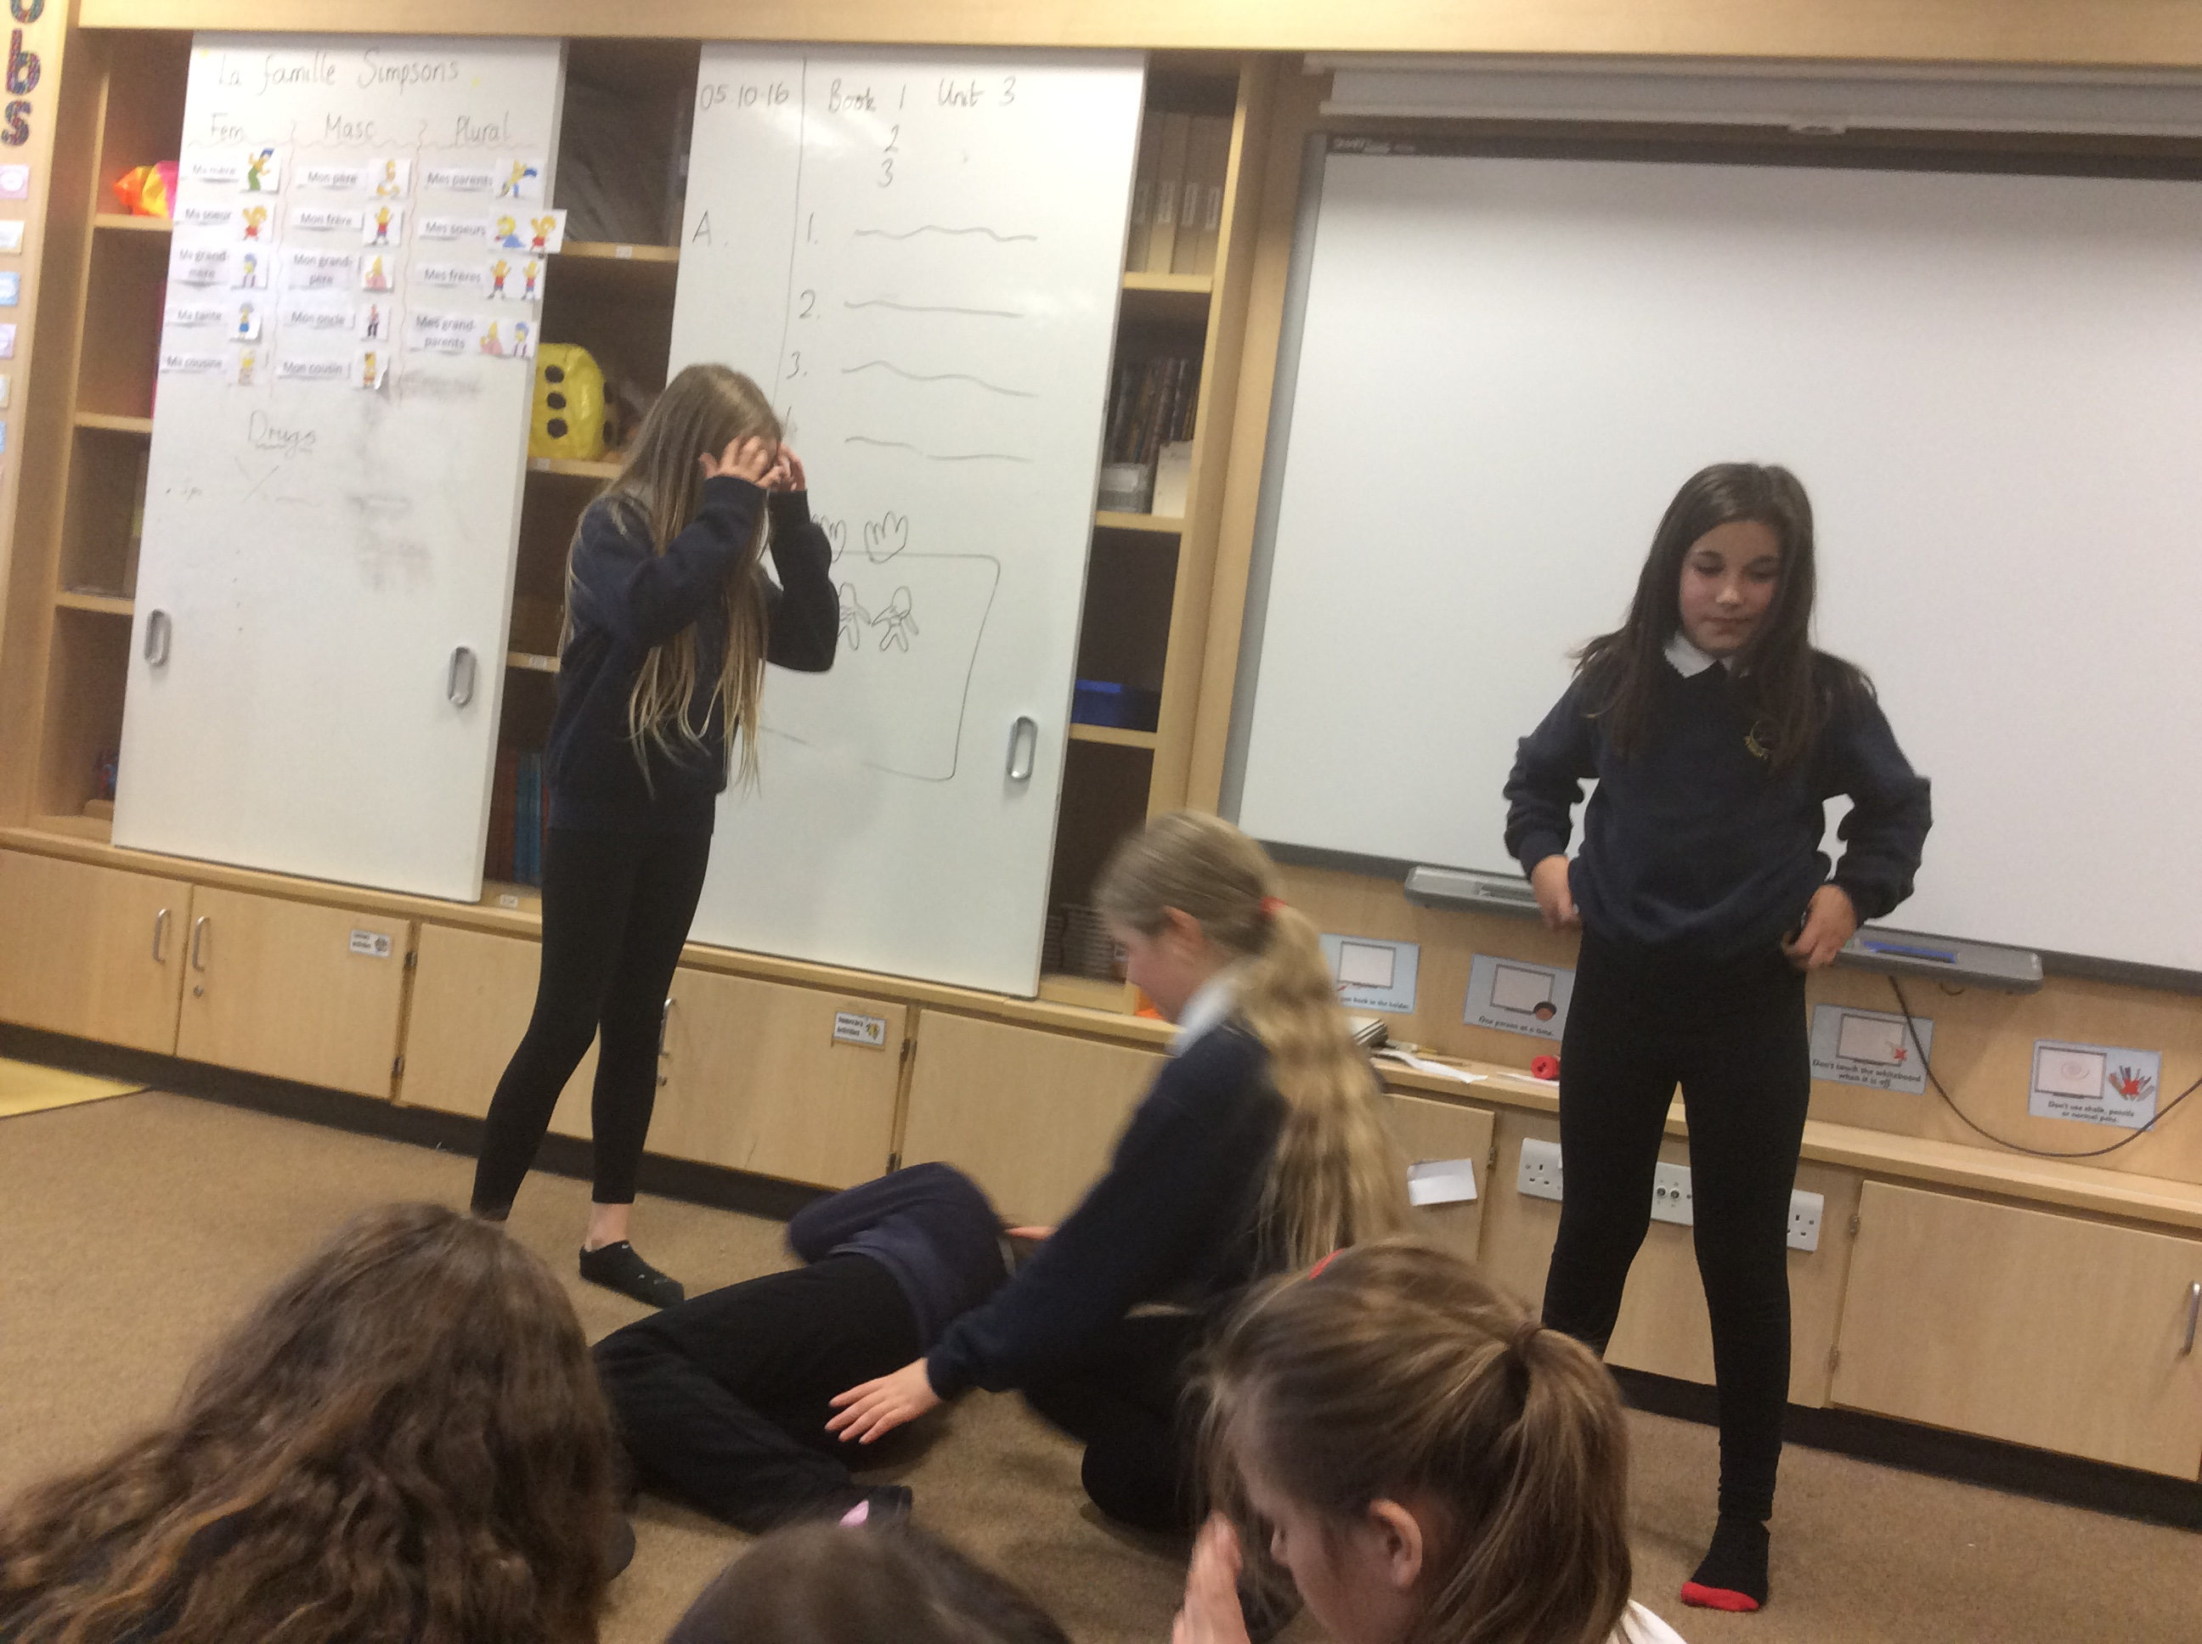 |  | 

