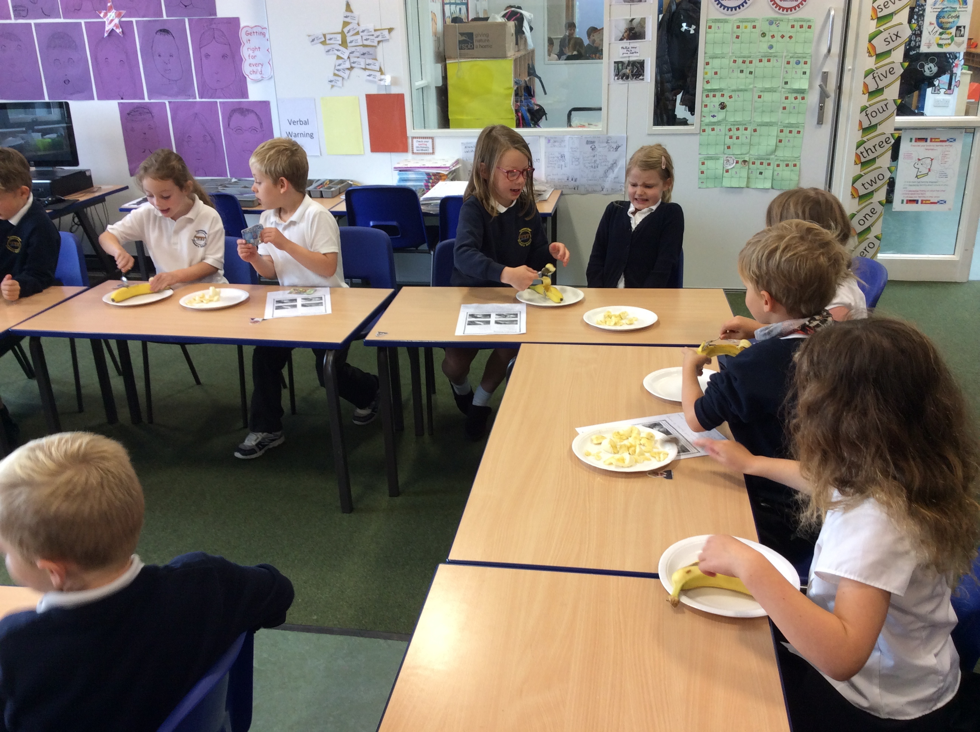 |  | We made posters about ourselves. We wrote:  - Our name and age  - What we will do when we grow up  - Hobbies and things we really like to do |  | 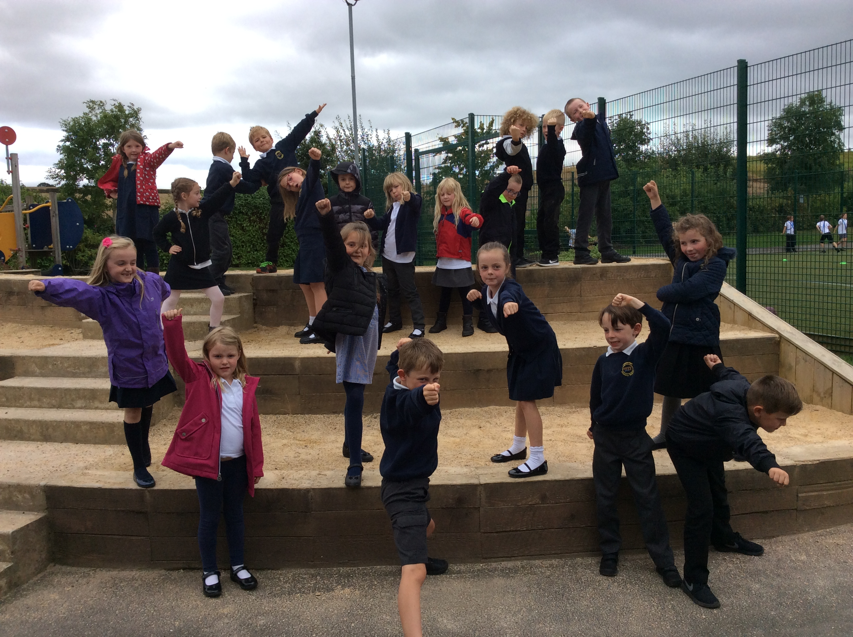
Egypt was our favourite topic with Mrs Dennis. We mummified some bananas, pretending they were pharaohs. We mixed salt, flour and water together and filled banana skins. Later we made banana loaf. We also went to the museum and saw ‘a real, life mummy’. It was fun. |  | 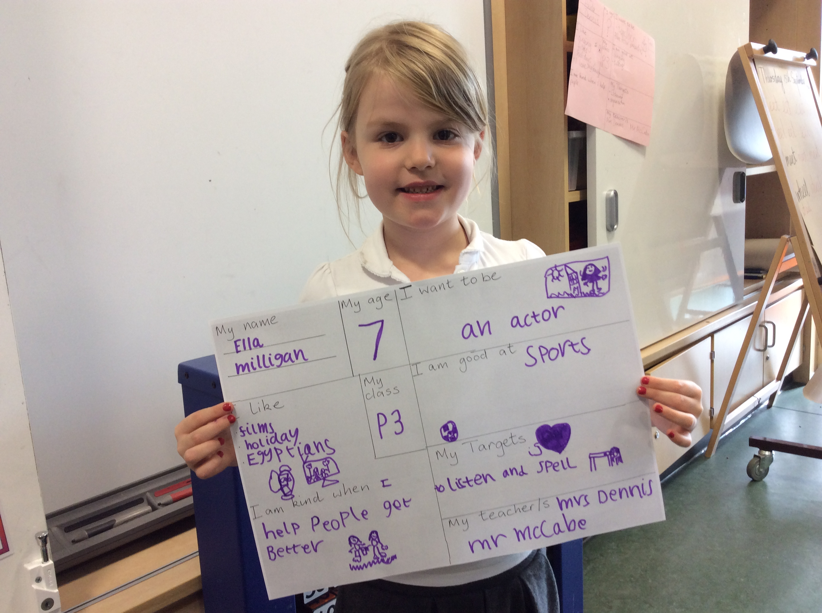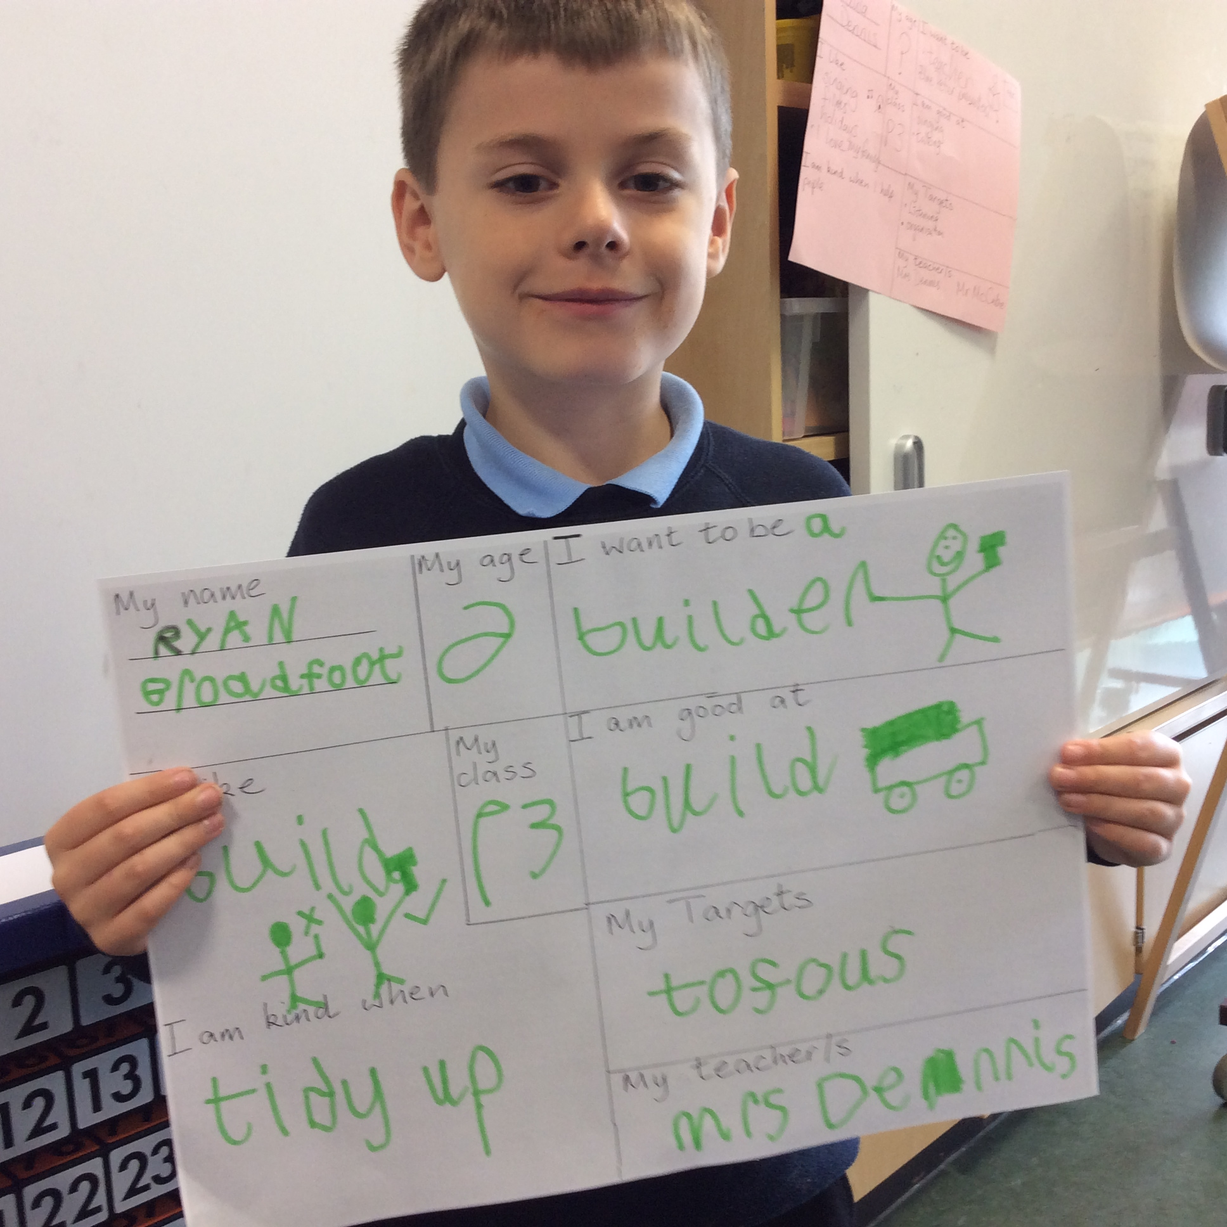 |  | We took lots of photos with Mrs Dennis. The top one is when we were outside looking at the raised beds. The bottom photo was of our reading groups. It was a special picture frame because it was not metal and could be folded up and put in a handbag.
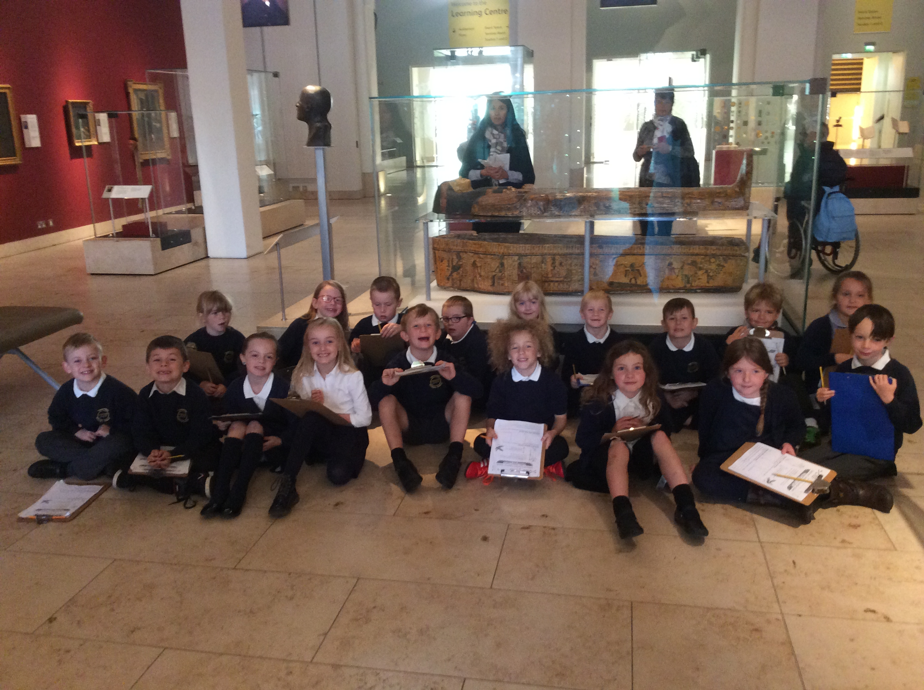 |  |  |  | 

