**Talking partners**

In class children have began

working with talking partners.

These partners will

change every week and will give

children the opportunity to work collaboratively with others as well as developing their listening and talking skills. The pair who work best together in their talking partners will get a prize at the end of the week!

**Language and Literacy**

**Reading** – Children will continue take home their reading books for homework each week. These books will be read and class and a comprehension task will be assigned on a Wednesday for children to complete in class to test their knowledge and understanding of the text.

**Writing** – Our writing focus this period will be Letter writing, where the children will learn how to layout and write a formal letter.

**Grammar** – This period we will be learning about nouns and how to recognise them in a piece of text.

**Spelling** – We will continue to work through the Jolly Grammar spelling book for spelling words.

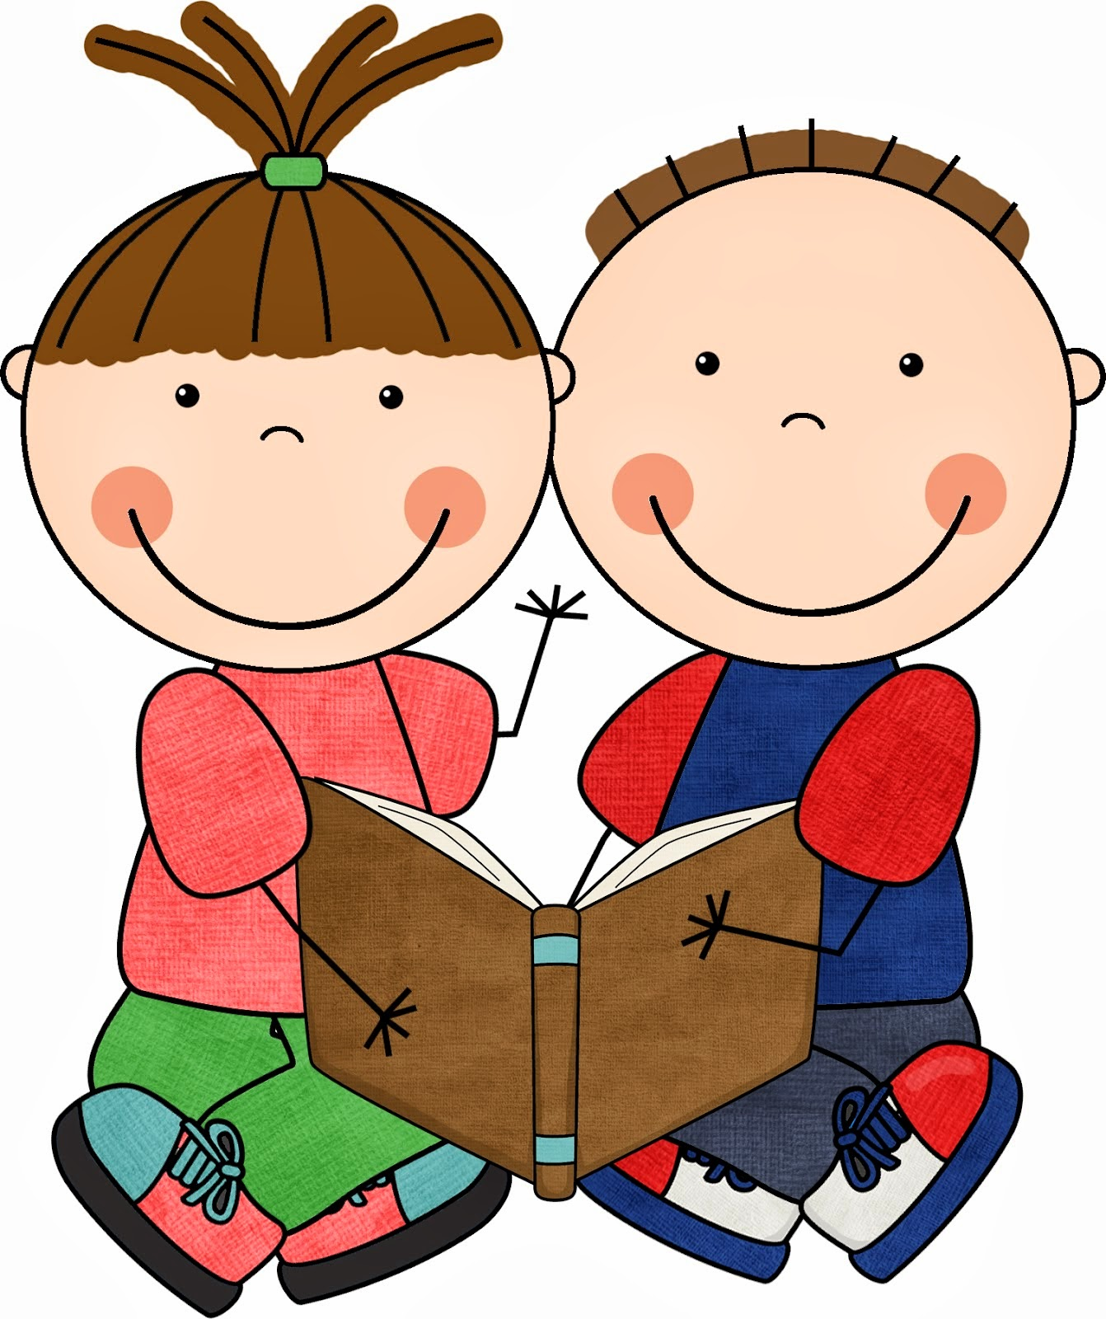[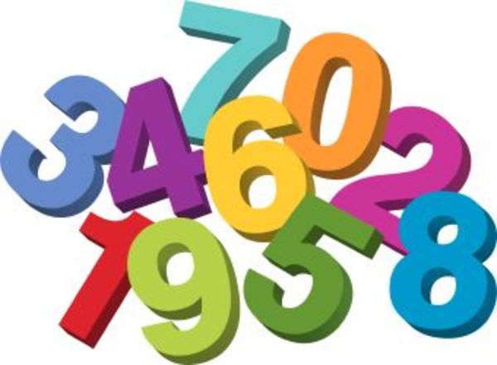](http://www.google.co.uk/url?sa=i&rct=j&q=&esrc=s&source=images&cd=&cad=rja&uact=8&ved=0ahUKEwjPiv75zv3OAhVLrRQKHaMRA6AQjRwIBw&url=http://www.clipartkid.com/biggest-maths-cliparts/&psig=AFQjCNGeX22kSWjYAyD4tuTVeAr_wVWgjQ&ust=1473350023909083)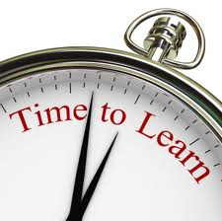[](http://www.google.co.uk/url?sa=i&rct=j&q=&esrc=s&source=images&cd=&cad=rja&uact=8&ved=0ahUKEwjDj8Kv0vjOAhVH7BQKHTChAsoQjRwIBw&url=http://www.clipartpanda.com/categories/skeleton-clip-art-free&psig=AFQjCNFwLixmLgoxVqLLTnJE2IoGrU92SA&ust=1473179209656624)

**Health and Wellbeing**

**PE**

Our focus for PE this period is hockey. The children will have the opportunity to work individually, in pairs or as a team to develop different skills for hockey such as: *Sending and receiving the ball, travel, control and attacking and defending.*

**Mathematics & Numeracy**

**Numeracy**

This period in Numeracy and Maths we will be focussing on:

* Sharing different objects into groups
* Skip counting forwards in 2s, 5s, 10s
* Using a different range of strategies to solve addition and subtraction problems
* We will also orally continue our work on counting forwards and backwards within 100.
* our Maths focus will be on time this period

**Topic**

**The Human Body**

For the first two week of Period 3 we will continue with our work on the Human Body. We will be learning all about bacteria and germs and how to prevent these from spreading. Children will also have the opportunity to create a poster based on the Human Body.

**Spain**

In Primary 2 we have been very fortunate to have Miss Moncusi from Spain in our class helping us learn! For the remaining two weeks of Period 3, Miss Moncusi will teach the children all about Spain. Miss Moncusi asked the children what they would like to learn about Spain and will plan accordingly to the responses of the children! Miss Moncusi will cover areas such as: Spanish language, food, weather and houses.