PE  Our focus for PE this period has been on fitness! We have been developing our skills in balance and coordination as well as focussing on stamina and speed! |  | 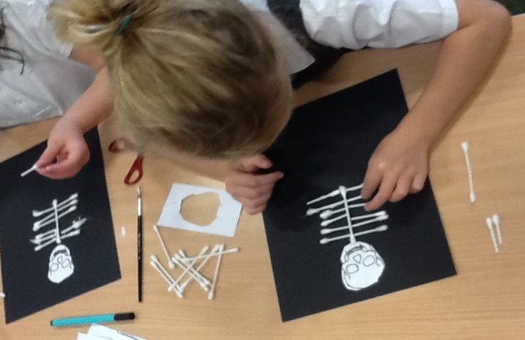 |  | Maths and Numeracy  In maths, we have been learning all about different 2D and 3D shapes. We have looked around our school environment to see what shapes we could find!  In numeracy we have been using different strategies and resources to help us work out addition sums.
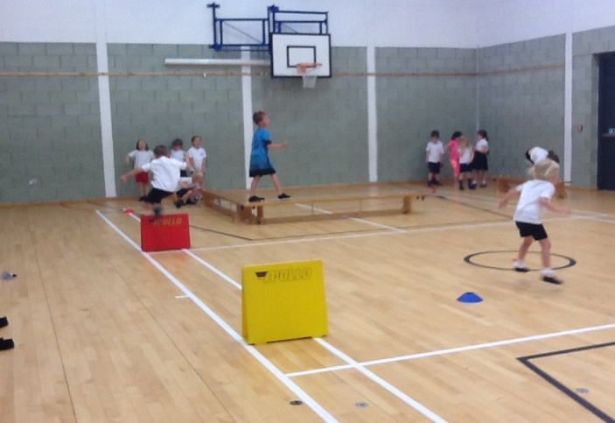 |  | Topic  We have been learning all about the Human Body for our topic! We have learned lots of interesting things about the skeleton, the 5 senses and about bacteria and germs! |  | 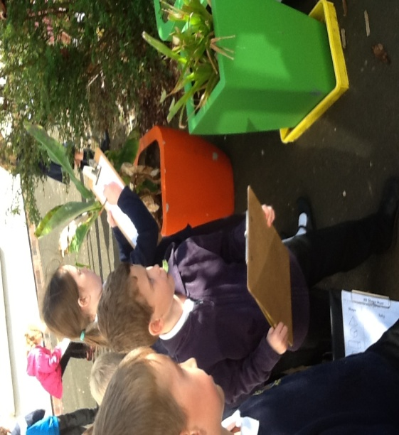
Literacy  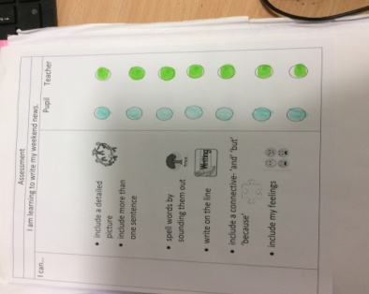  In Literacy we have been writing our Weekend News on a Monday! We are able to follow our Success Criteria and self-assess our own work. |  | 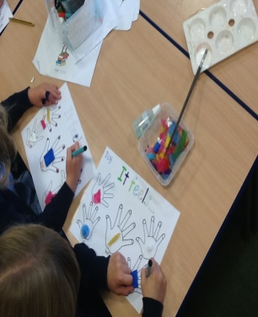  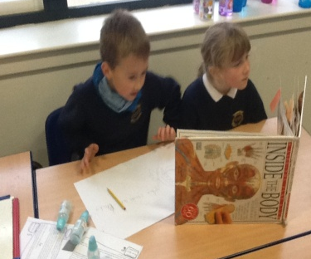 |  | 