

**Topic – Glasgow Study**

We have begun to investigate some basic facts about Glasgow, however we will not be fully launching into our topic work until we are back from our residential study visit. The planning for our topic will be done in collaboration with the children, and will be led by them, and their areas of interest, as the topic develops. We will carry out a range of say, write, make and do tasks. 

**Language and Literacy**

The children will be writing imaginative stories this term.

We will have discrete lessons on characterisation and setting before they let their imaginations run wild! We will also look at writing fact files in topic lessons.

We will focus on group novels for the last part of this session, with homework surrounding key elements of reading such as summarising, characterisation and questioning.

Each week we will follow a progressive handwriting programme, working on ascenders, descenders and joining letters correctly.

This term the class will require their P.E kit on a **Tuesday** & **Wednesday.**

Maths and Spelling homework will be issued on a **Monday** and due in on a **Friday**. Reading will be set pages for a specified date



**Mathematics and numeracy**

We will be continuing our maths rotation this term. We will

look at length, weight and capacity. We will begin to think about the links between fractions, decimals and percentages. We will also continue to revise multiplication, division addition and subtraction and number words and numerals. Each week we will undertake problem solving and enquiry.

**Health and Wellbeing**

In P.E our focus will be invasion games, and learning the skills and strategies which can be applied across a range of sports. We will be working in collaboration with P5 and P7.

With Mrs MacInnes, P6 will be looking at legal and illegal drugs and what effects these have on the body.

**Music**

While some of the class take part in Clarinet lessons, the rest of the class will work on a progressive music programme. We will look at rhythm and composition.

**Teaching Rotation**

P6 will be taught by myself, Ms Blyth and Mr Martindale in a weekly rotation each Tuesday afternoon. They will be learning Drama, ICT and RME in 45 minute sessions.

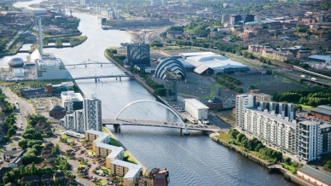

**Glasgow Study**

