**Language and Literacy**

**Reading** – Children will be given reading books as homework each week which will also be read in class. They will also have the opportunity to read for enjoyment and choice during our weekly visits to our school library.

**Writing** – In this term our focus for writing will be reflecting on our weekends through writing our ‘Weekend News’.

**Grammar** – We will be working our way through the ‘Jolly Grammar’ resource book, focussing on ***capital letters, alphabetical order, sentence structure and nouns.***

**Spelling** – Spelling words will be sent out each week to be completed at home. Once a week in class, children will engage with these words by completing different tasks using their spelling words.

**Expressive Arts**

**Music-** Primary 2 will complete a block in music where they will have the opportunity to work with a range of different instruments as they develop their skills and knowledge of ***rhythm*** and ***dynamics***.

[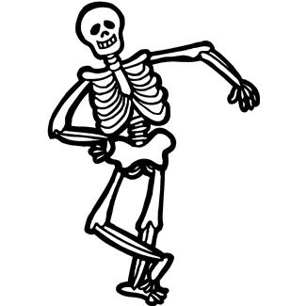](http://www.google.co.uk/url?sa=i&rct=j&q=&esrc=s&source=images&cd=&cad=rja&uact=8&ved=0ahUKEwjDj8Kv0vjOAhVH7BQKHTChAsoQjRwIBw&url=http://www.clipartpanda.com/categories/skeleton-clip-art-free&psig=AFQjCNFwLixmLgoxVqLLTnJE2IoGrU92SA&ust=1473179209656624)[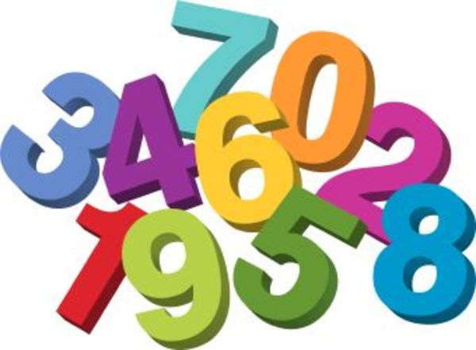](http://www.google.co.uk/url?sa=i&rct=j&q=&esrc=s&source=images&cd=&cad=rja&uact=8&ved=0ahUKEwjPiv75zv3OAhVLrRQKHaMRA6AQjRwIBw&url=http%3A%2F%2Fwww.clipartkid.com%2Fbiggest-maths-cliparts%2F&psig=AFQjCNGeX22kSWjYAyD4tuTVeAr_wVWgjQ&ust=1473350023909083)[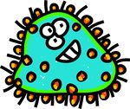](http://www.google.co.uk/url?sa=i&rct=j&q=&esrc=s&source=images&cd=&cad=rja&uact=8&ved=0ahUKEwjnu46J0_jOAhWGORoKHX0MAIIQjRwIBw&url=http://www.clipartpanda.com/clipart_images/germ-germ-clip-art-17667518&bvm=bv.131783435,d.ZGg&psig=AFQjCNFR9ANUDodCr477SRhpYQSLM1DFcg&ust=1473179398440982)[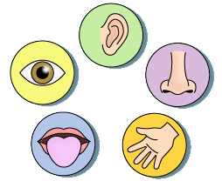](http://www.google.co.uk/url?sa=i&rct=j&q=&esrc=s&source=images&cd=&cad=rja&uact=8&ved=0ahUKEwiNg5Dc0vjOAhXL1hoKHWe-CgUQjRwIBw&url=http://7dd25.fhfy.net/e5f8d1da11f49590fc830994252ebc05&bvm=bv.131783435,d.ZGg&psig=AFQjCNFZDfDkcdU5VuGtHS2L8eBXpxYwEw&ust=1473179304225648)[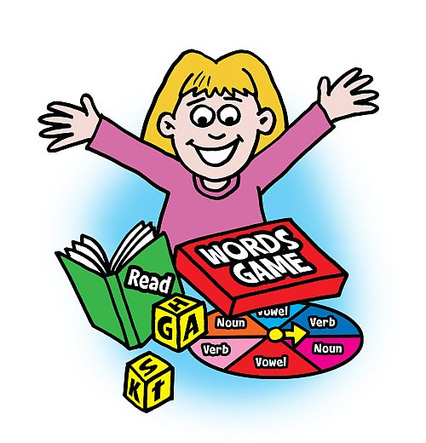](http://www.google.co.uk/url?sa=i&rct=j&q=&esrc=s&source=images&cd=&cad=rja&uact=8&ved=0ahUKEwjKws_2xf3OAhVD7RQKHY0GCQoQjRwIBw&url=http%3A%2F%2Fwww.clipartkid.com%2Fclip-art-reading-literacy-cliparts%2F&bvm=bv.131783435,d.ZGg&psig=AFQjCNFJbu5nPZQuZr5RkjAdrHkt5dZARw&ust=1473347646872654)[](http://www.google.co.uk/url?sa=i&rct=j&q=&esrc=s&source=images&cd=&cad=rja&uact=8&ved=0ahUKEwio8eTxmfvOAhVGUhQKHXWBCsQQjRwIBw&url=http://www.freeclipartnow.com/recreation/sports/fitness/&psig=AFQjCNEtBpn-b9fXgooh9aHc3hD0tSfctg&ust=1473267108349464)[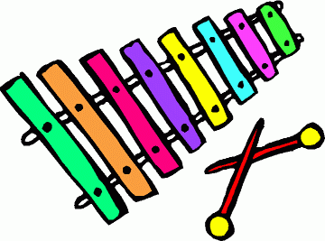](http://www.google.co.uk/url?sa=i&rct=j&q=&esrc=s&source=images&cd=&cad=rja&uact=8&ved=0ahUKEwjx6LOvm_vOAhXCJhoKHcU8CUgQjRwIBw&url=http://www.clipartpanda.com/categories/xylophone-clipart-black-and-white&bvm=bv.131783435,d.ZGg&psig=AFQjCNEOsCWNIeCfzjU3oOGRlAnk15tByw&ust=1473267524215270)

**Mathematics & Numeracy**

Children will be revising their knowledge of ***2D and 3D shapes*** this period. We will cover the properties of different shapes and will have the opportunity to create patterns with them.

In numeracy, we will work on recognising and counting up to ***100,*** ***addition*** and ***subtraction*** strategies and counting in ***sequences*** of 2s, 5s and 10s.

**Topic**

Our topic for term 2 will be a science based topic: **The Human Body**. Over the course of 6 weeks we will explore 3 different parts:

***Week 1 & 2***- The 5 senses: Exploring their purpose, reliability and limitations.

***Week 3 & 4***- Children will be learning about

the purpose and function of our skeleton and the different roles our vital organs have.

***Week 5 & 6***- Learning about the different symptoms of some common diseases caused by germs. Children will learn how germs are spread and discuss some prevention methods.

**Health and Wellbeing**

In PE we will be beginning a block on ***fitness*** where we will be developing many different skills including: ***balance, coordination, stamina and speed.***

**The Human Body**