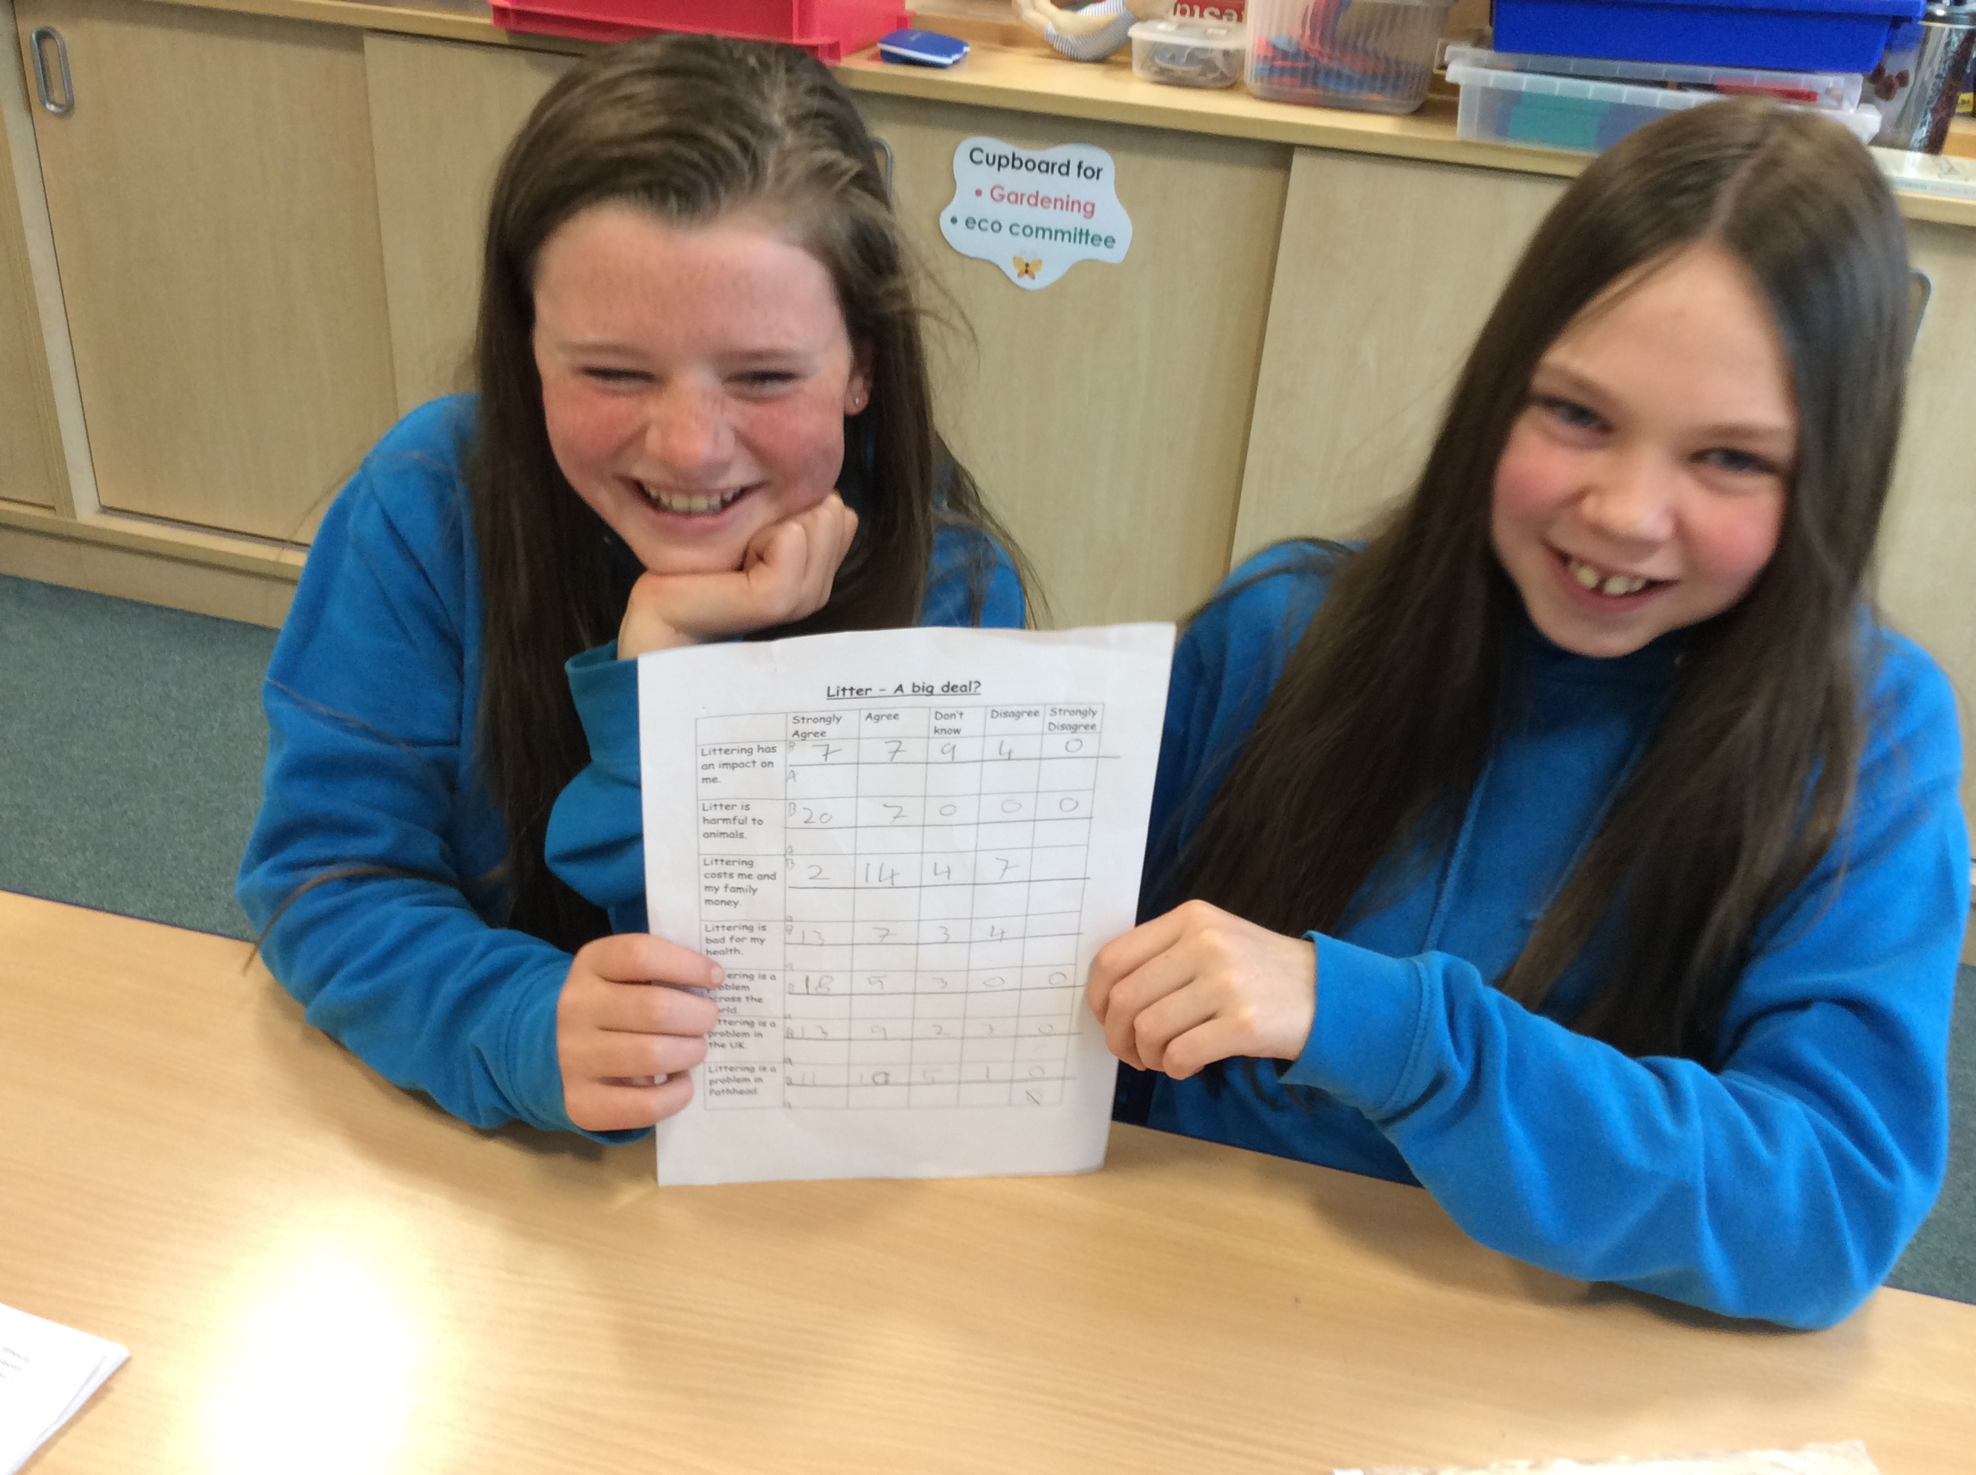 |  | The Eco School Topic in P5 is also Littering, with an emphasis on paper wastage. They are planning to:  - Ask the office staff to reuse envelopes by sticking a new label over the old address. |  | P2 and 3 Eco School Topic is ‘Biodiversity and the School Grounds.’ They have been looking at ways to improve the Sensory Garden. Ideas include a sandpit, a tree house and planting Xmas and fruit trees.
The Eco School Action Plans  P7’s Eco School Topic is looking at the problem of ‘Litter’. They have conducted a survey throughout the school with 7 pupils from each class, looking at attitudes about litter, littering and its impact. |  | 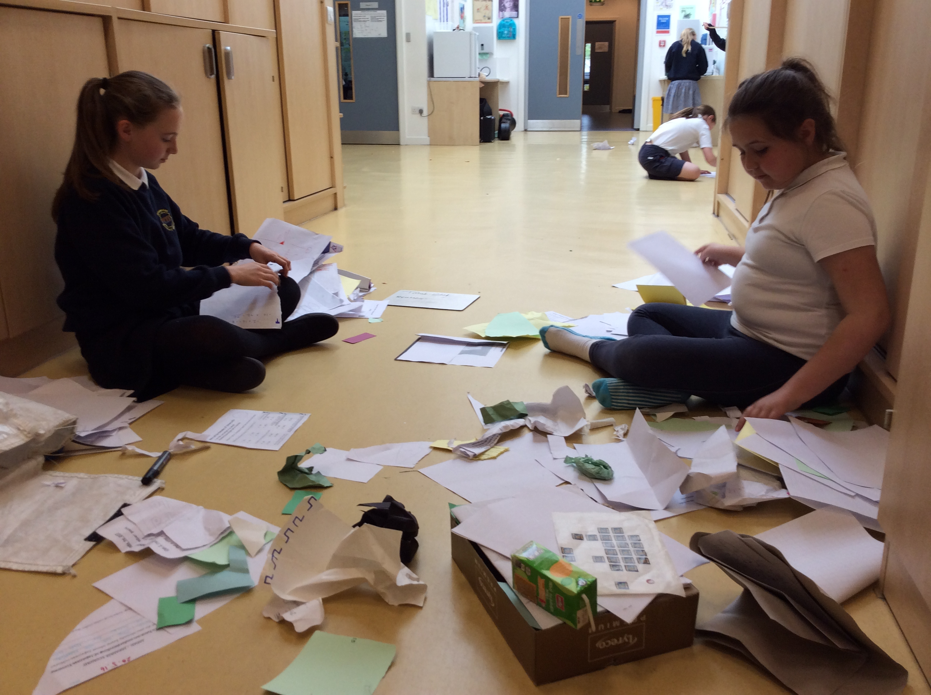 |  | They also want to attract more bees and butterflies to the garden. Shondra Riley has sourced free insect friendly plants for P2 and 3. These have been planted. A sun flower growing competition is underway.
These results are being collated to form a benchmark to work from. P7 intends to present an informative assembly about litter. They will then conduct another survey and use it to analyse and evaluate against the initial one. |  | - Give each class a scrap paper tray for reusable paper. Spot checks will be done on paper recycling bags.  - Make recycled paper doodle pads for teachers to use in place of post-it notes. |  | 

