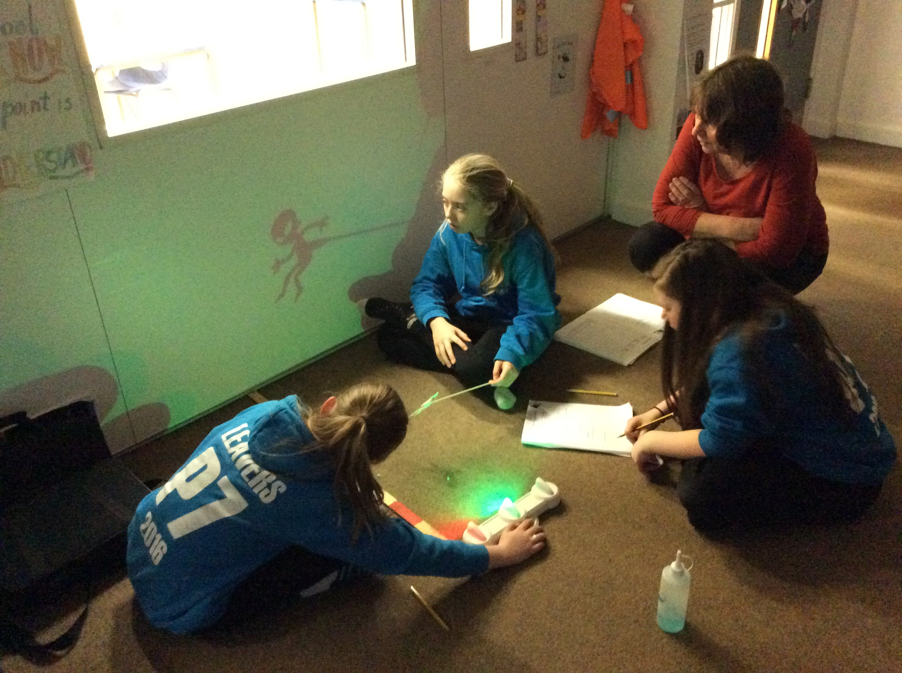  Shadows investigating |  | 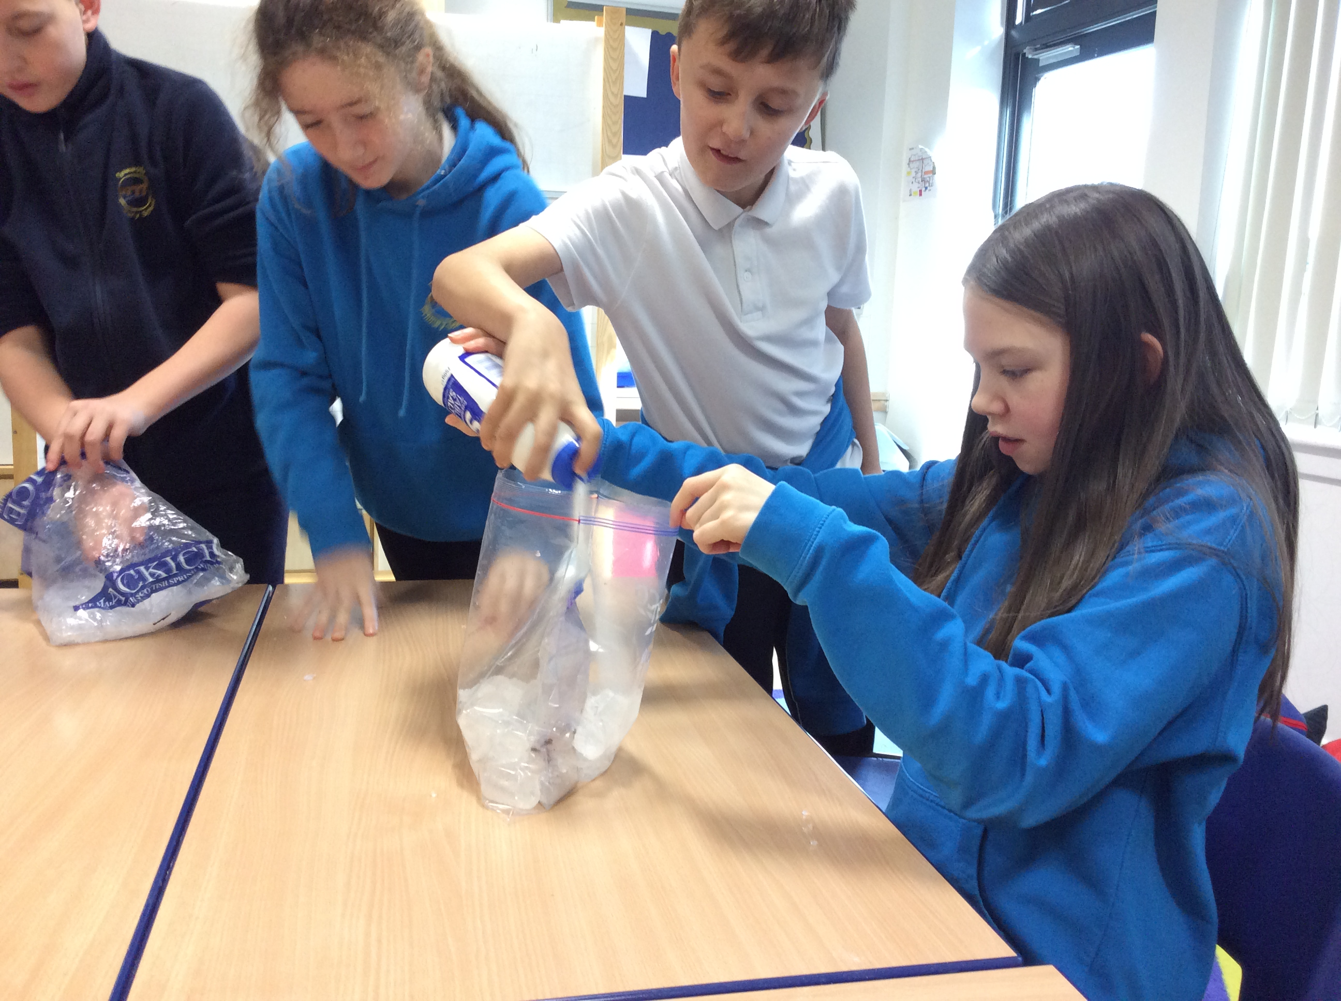  Instant Ice-cream |  | The nursery asked us why it gets darker. We did not know the answer so we did some research and the next day we did a presentation to them  Matteo
We used torches to measure the distance and height of shadows.  It was very fun and it had to be between 10cm and 1m.  We learned about |  | When we made the ice cream we had to put ice in a big bag then milk and vanilla essence in a small bag. Then we put the small bag in the big bag and shook it for 5 minutes. |  | 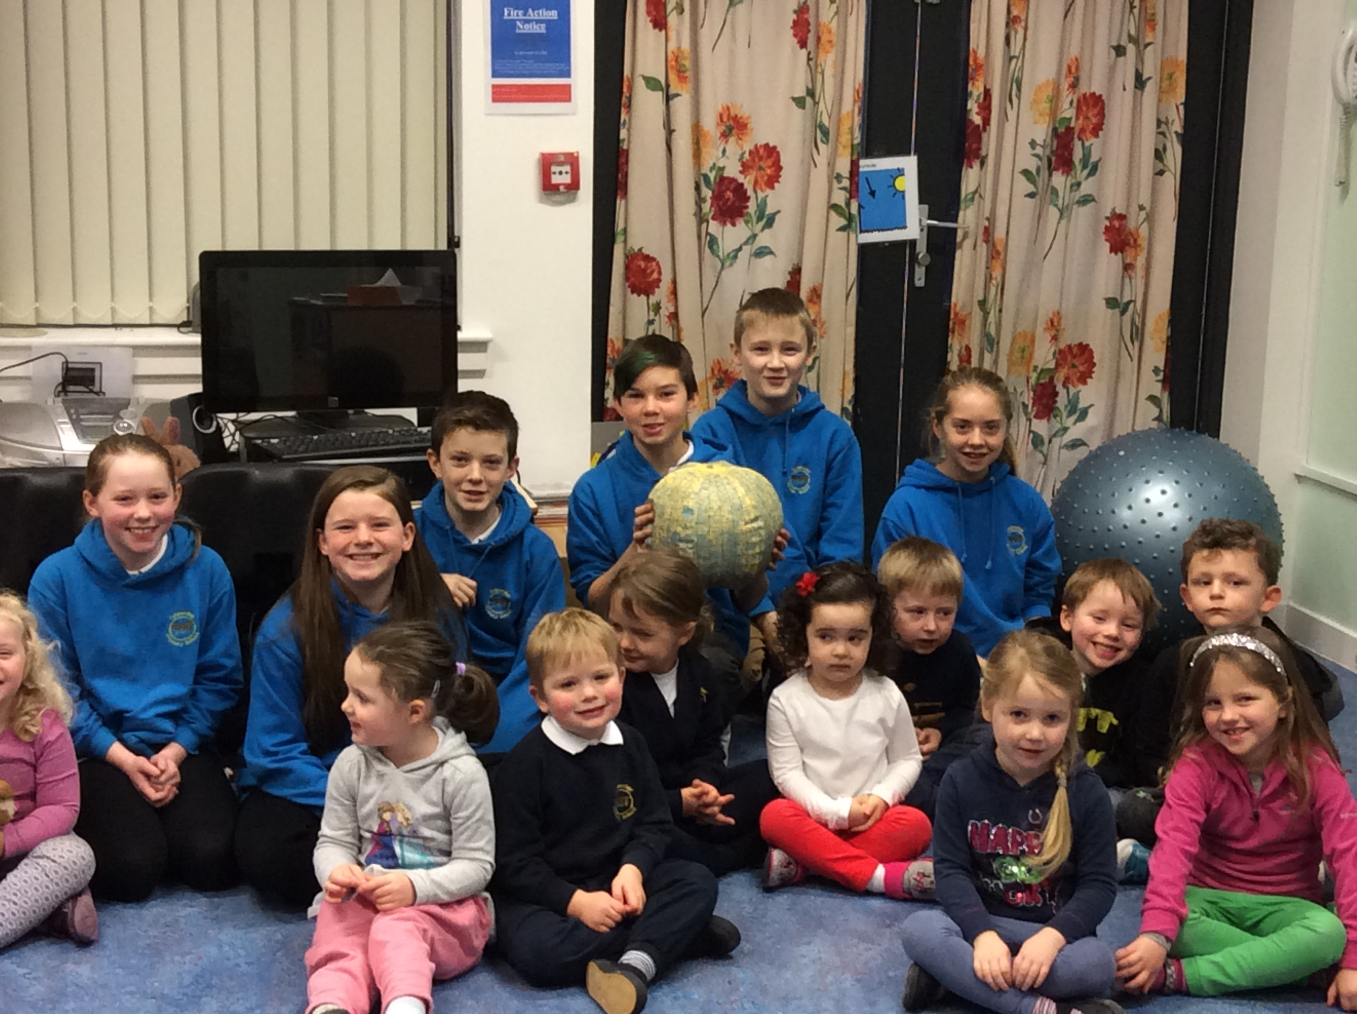  Nursery Presentation
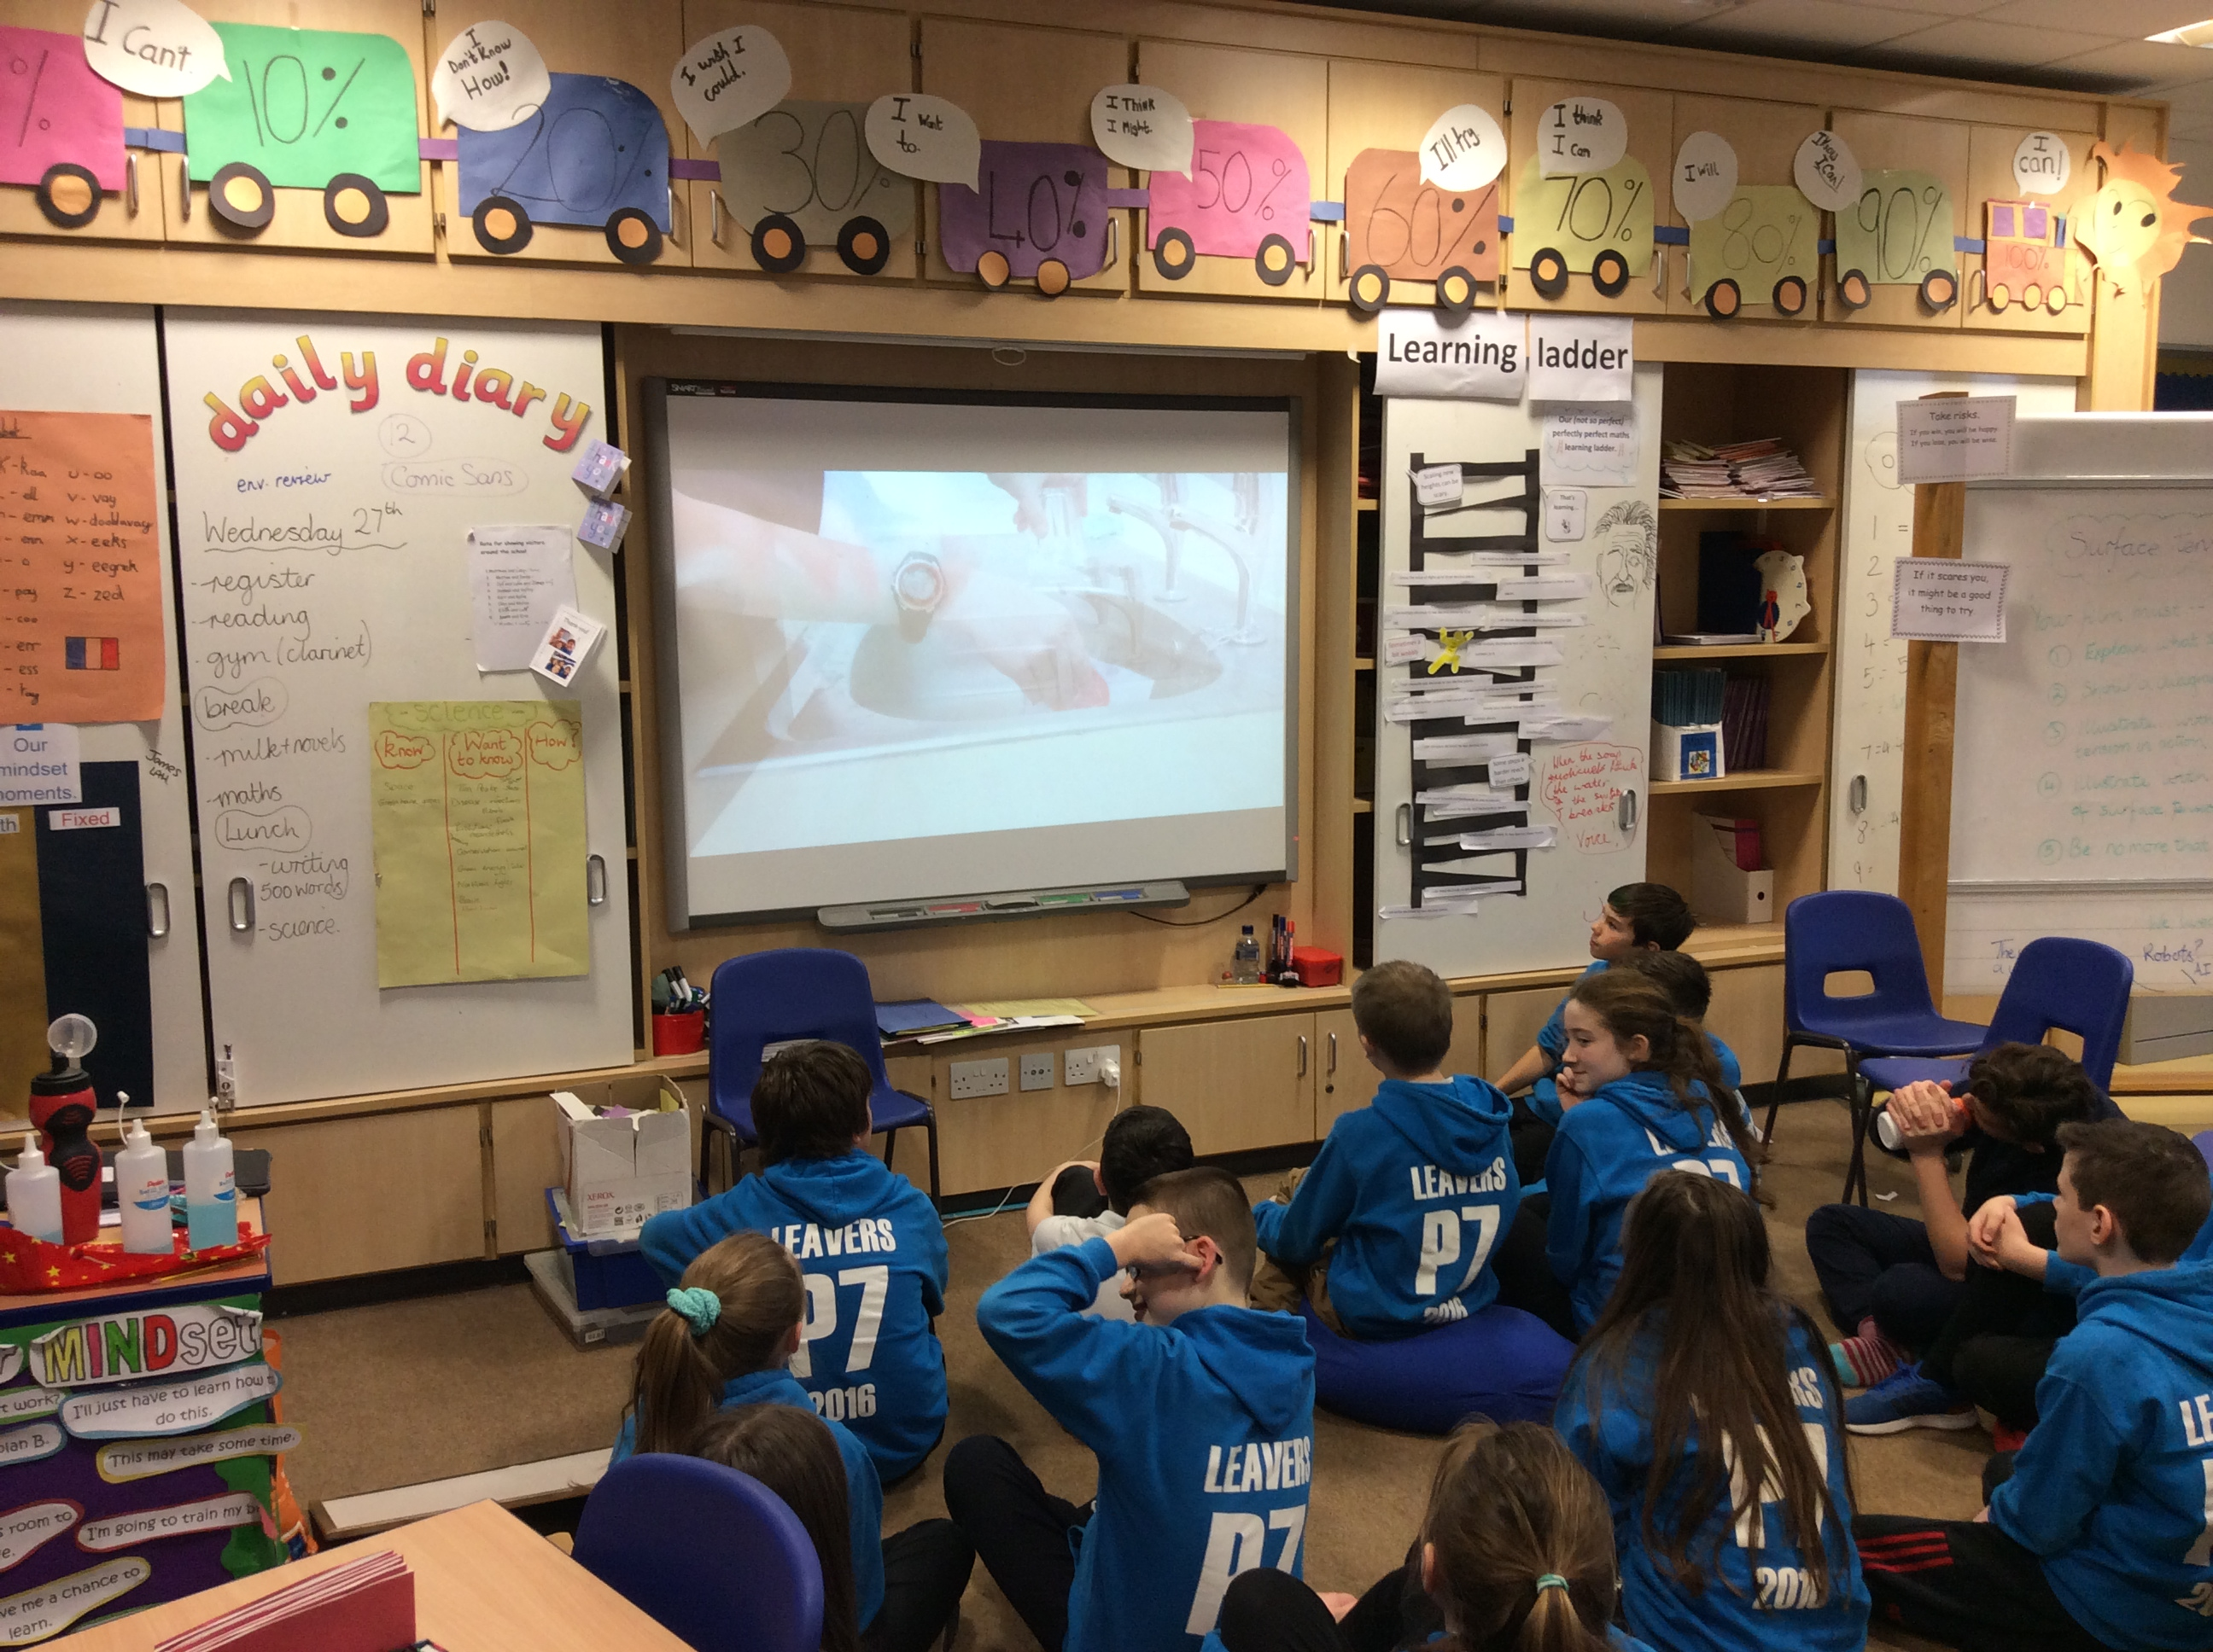  Film Making |  | In science we learnt how milk expands when dish soap was added.  samuel |  | 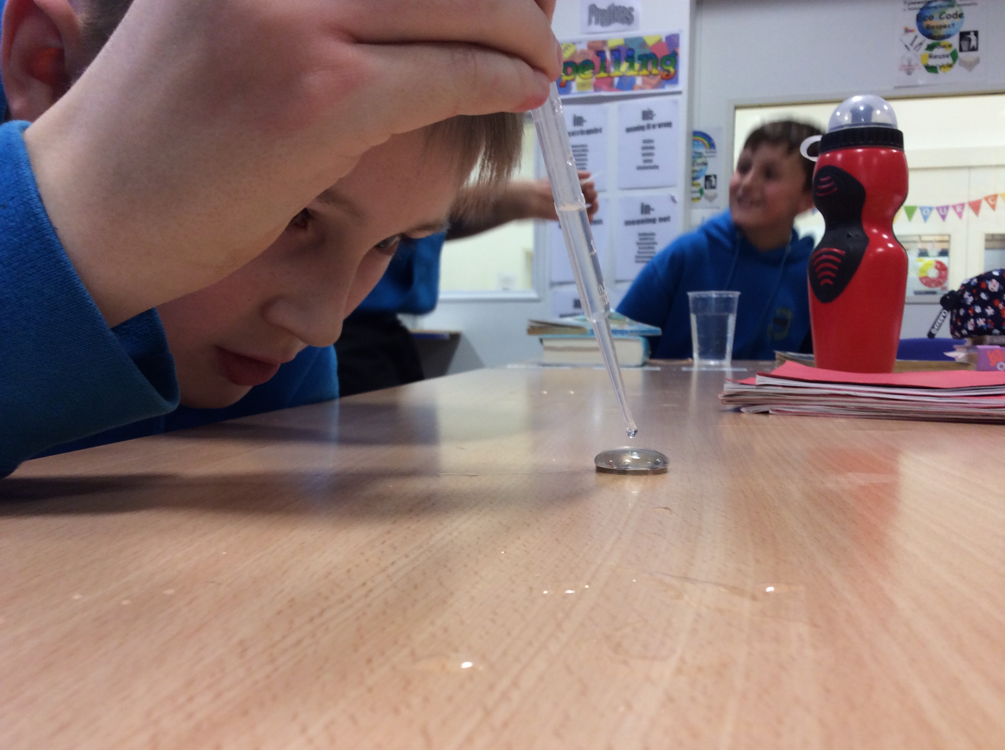  Surface Tension
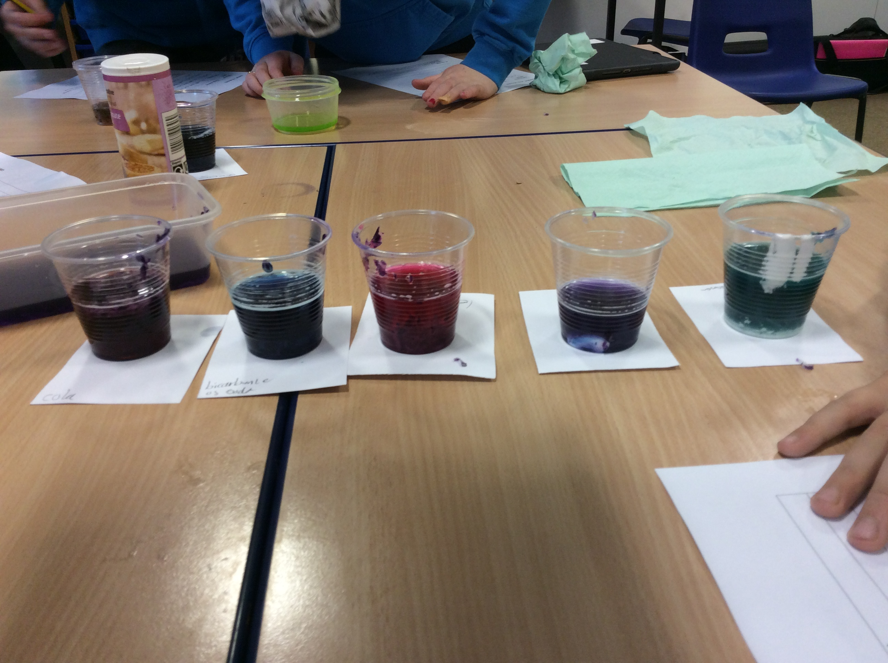  Acid or Alkali? |  | 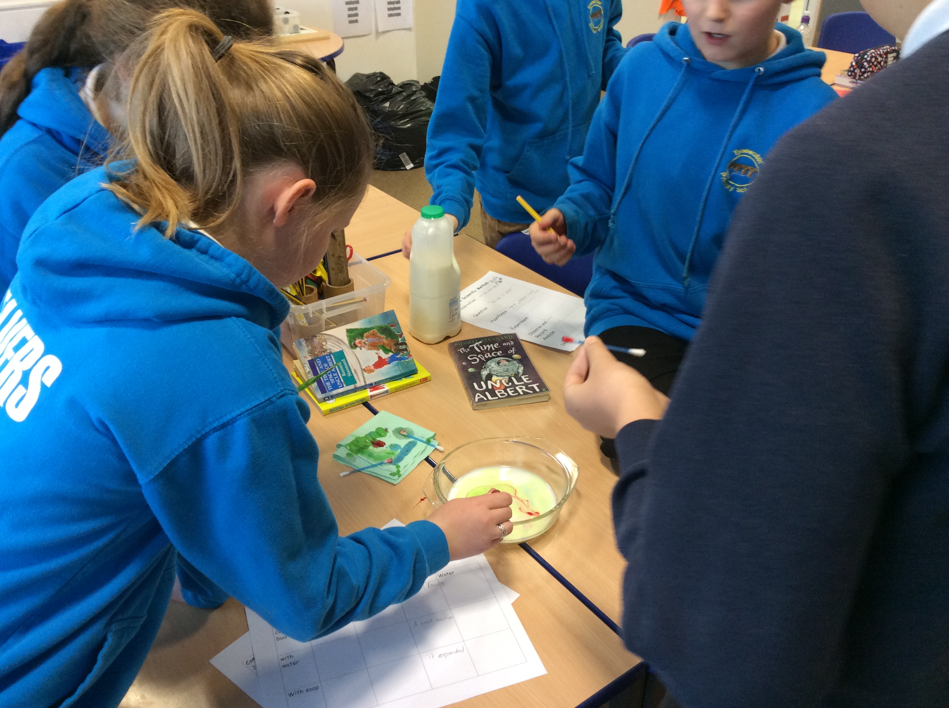  Chemical reactions |  | 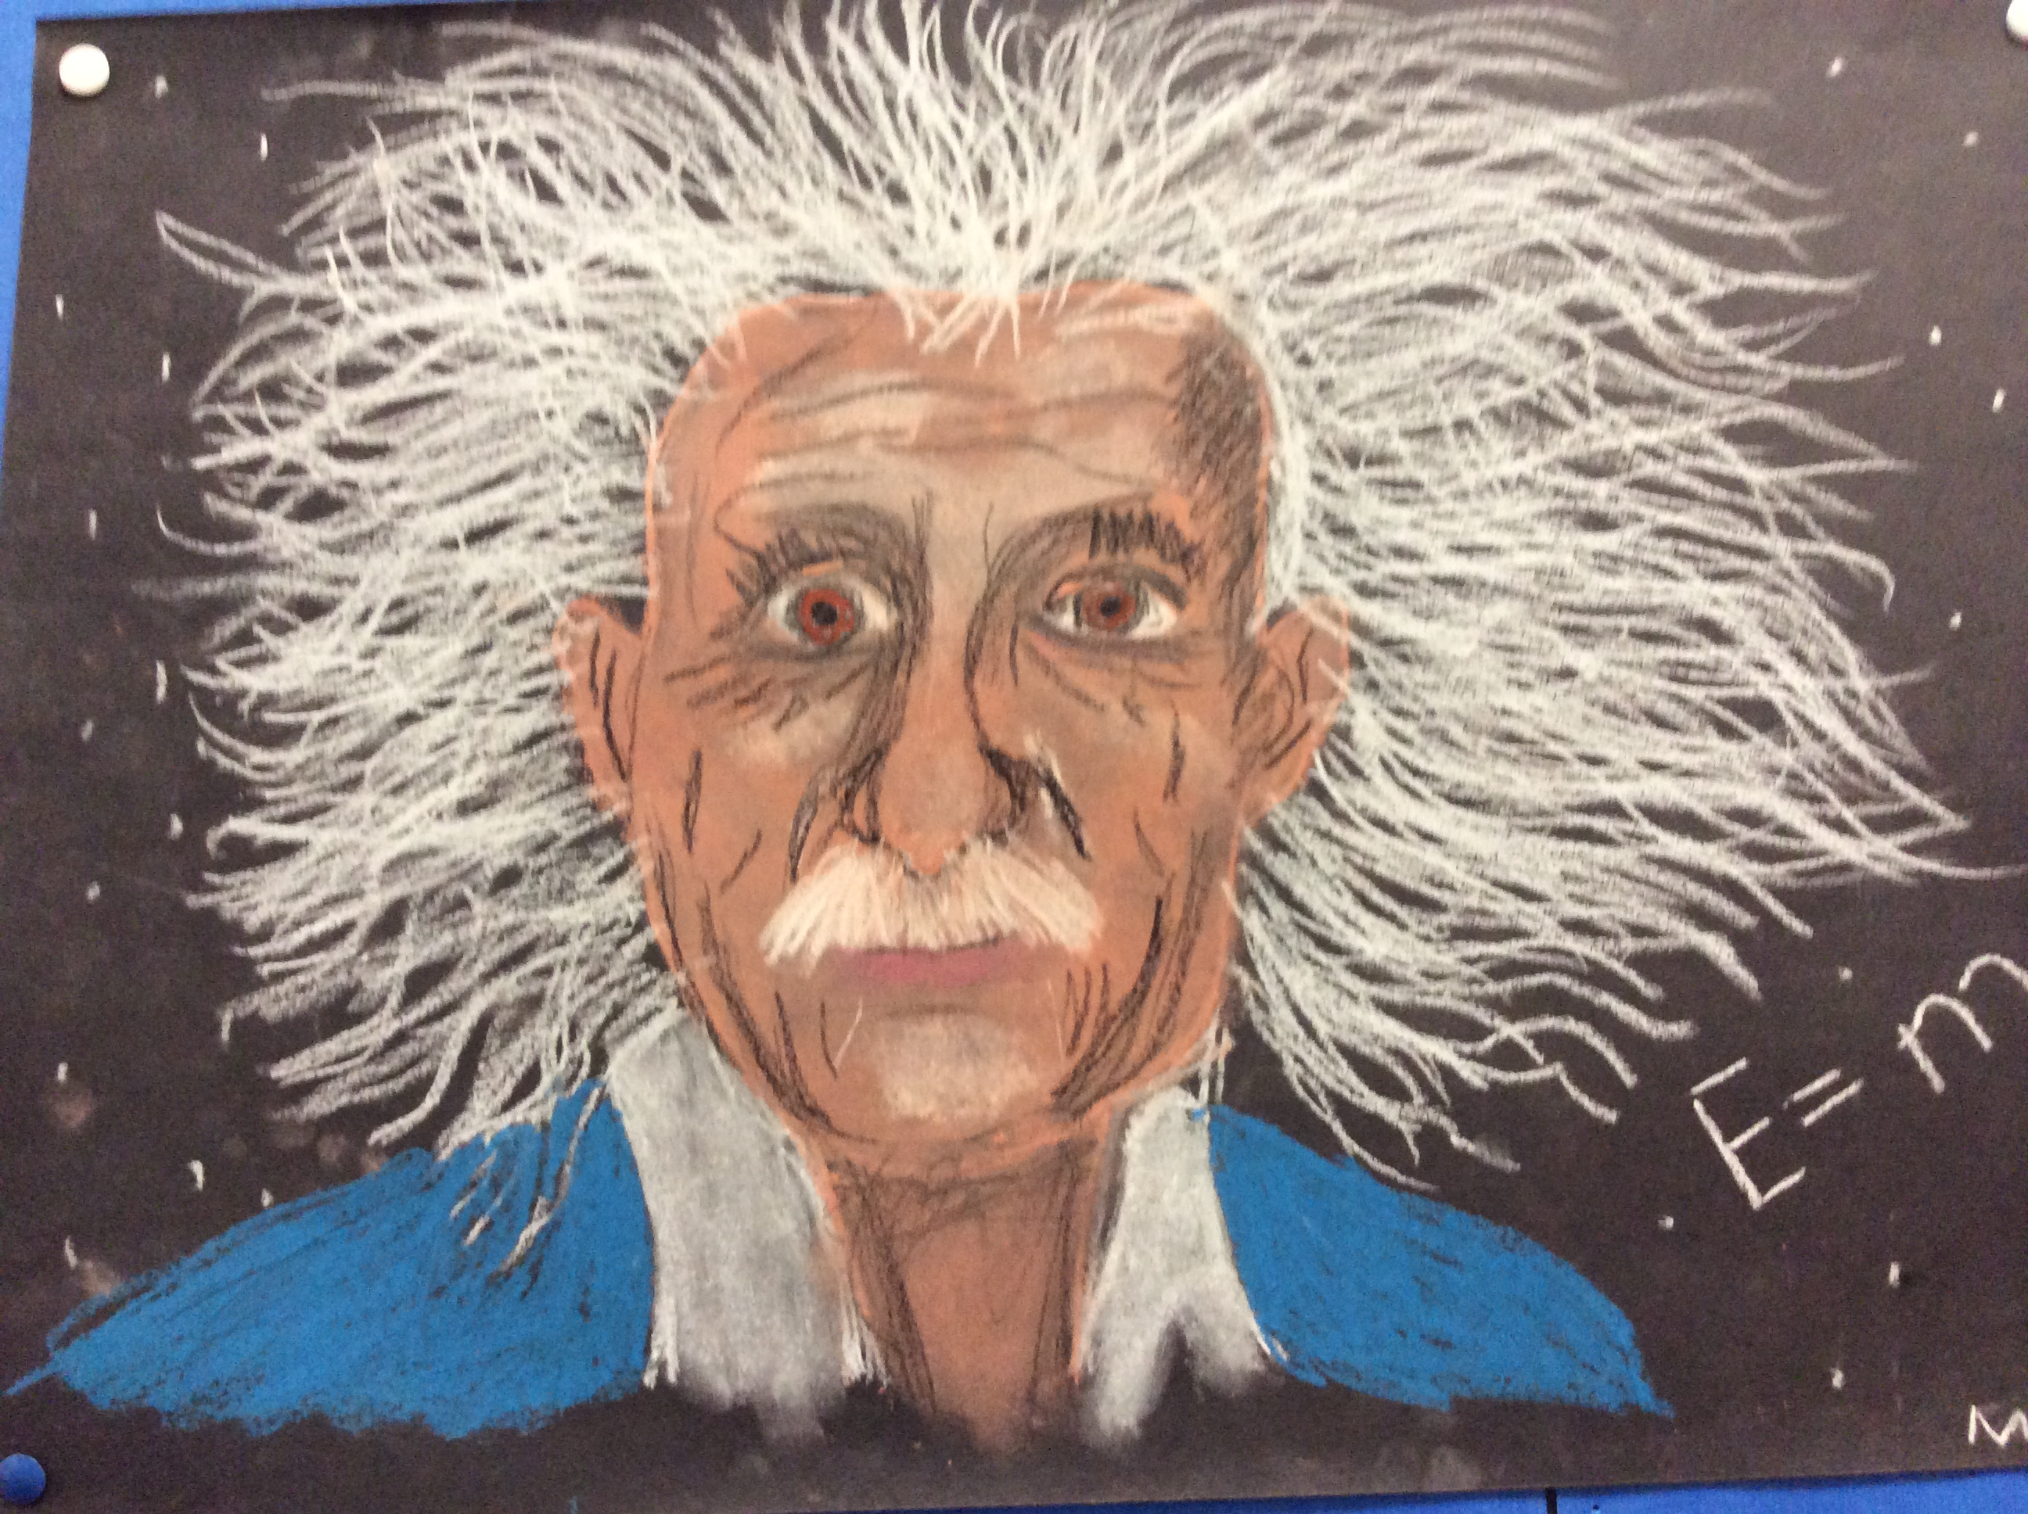  The Time and Space of Uncle Albert
We experimented with acids and alkali using cups of water mixed with red cabbage. We added things like lemon, vinegar, cola, soap, and other things. We concluded that acids left the mixture pinker, and alkali left it bluer. |  | This is an experiment where if you mix milk and food colouring together. Then you drip dish soap into it and watch the food colouring spread out. |  | We read The time and space of Uncle Albert which taught us a lot of interesting things about the theory of relativity. We all really enjoyed our learning.
Our new topic is robotics and we are in the process of building a Lego robot that reacts to voice commands and can move about on its own |  |  |  | 

