Burns Day  Both classes enjoyed learning about Scotland and listening to Scottish stories, our favourite was a book called `There was a wee lassie who swallowed a midgie`. |  | Looking After the Birds.  We have been watching the Birds that come into our garden each day so we decided that it would be nice to make bird feeders for our little friends. Everyone enjoyed getting messy to mix the food. |  | Literacy  We have all been keen to develop our letter recognition, we have used magnetic letters, laminated letter cards and typing on the computer. We even found letters hidden in the sand tray!
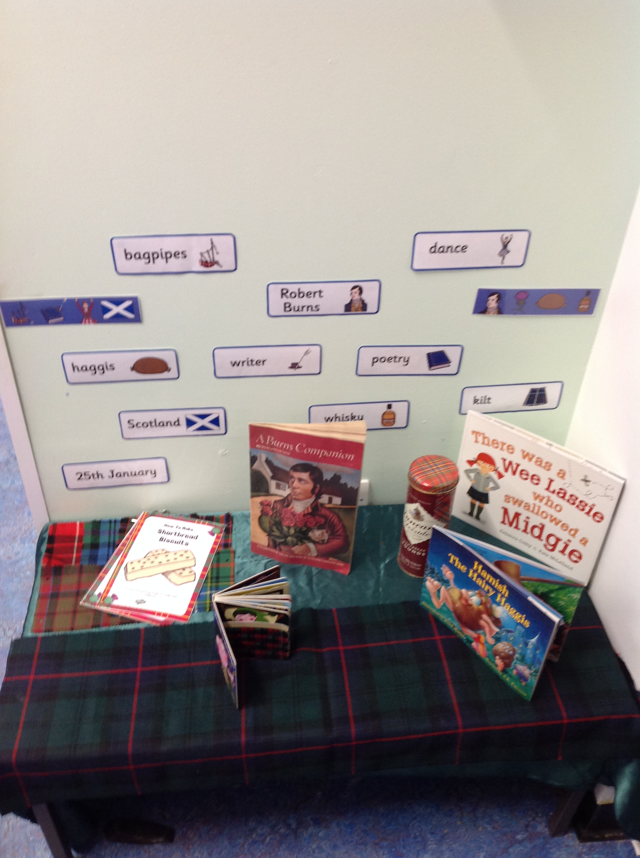 |  | 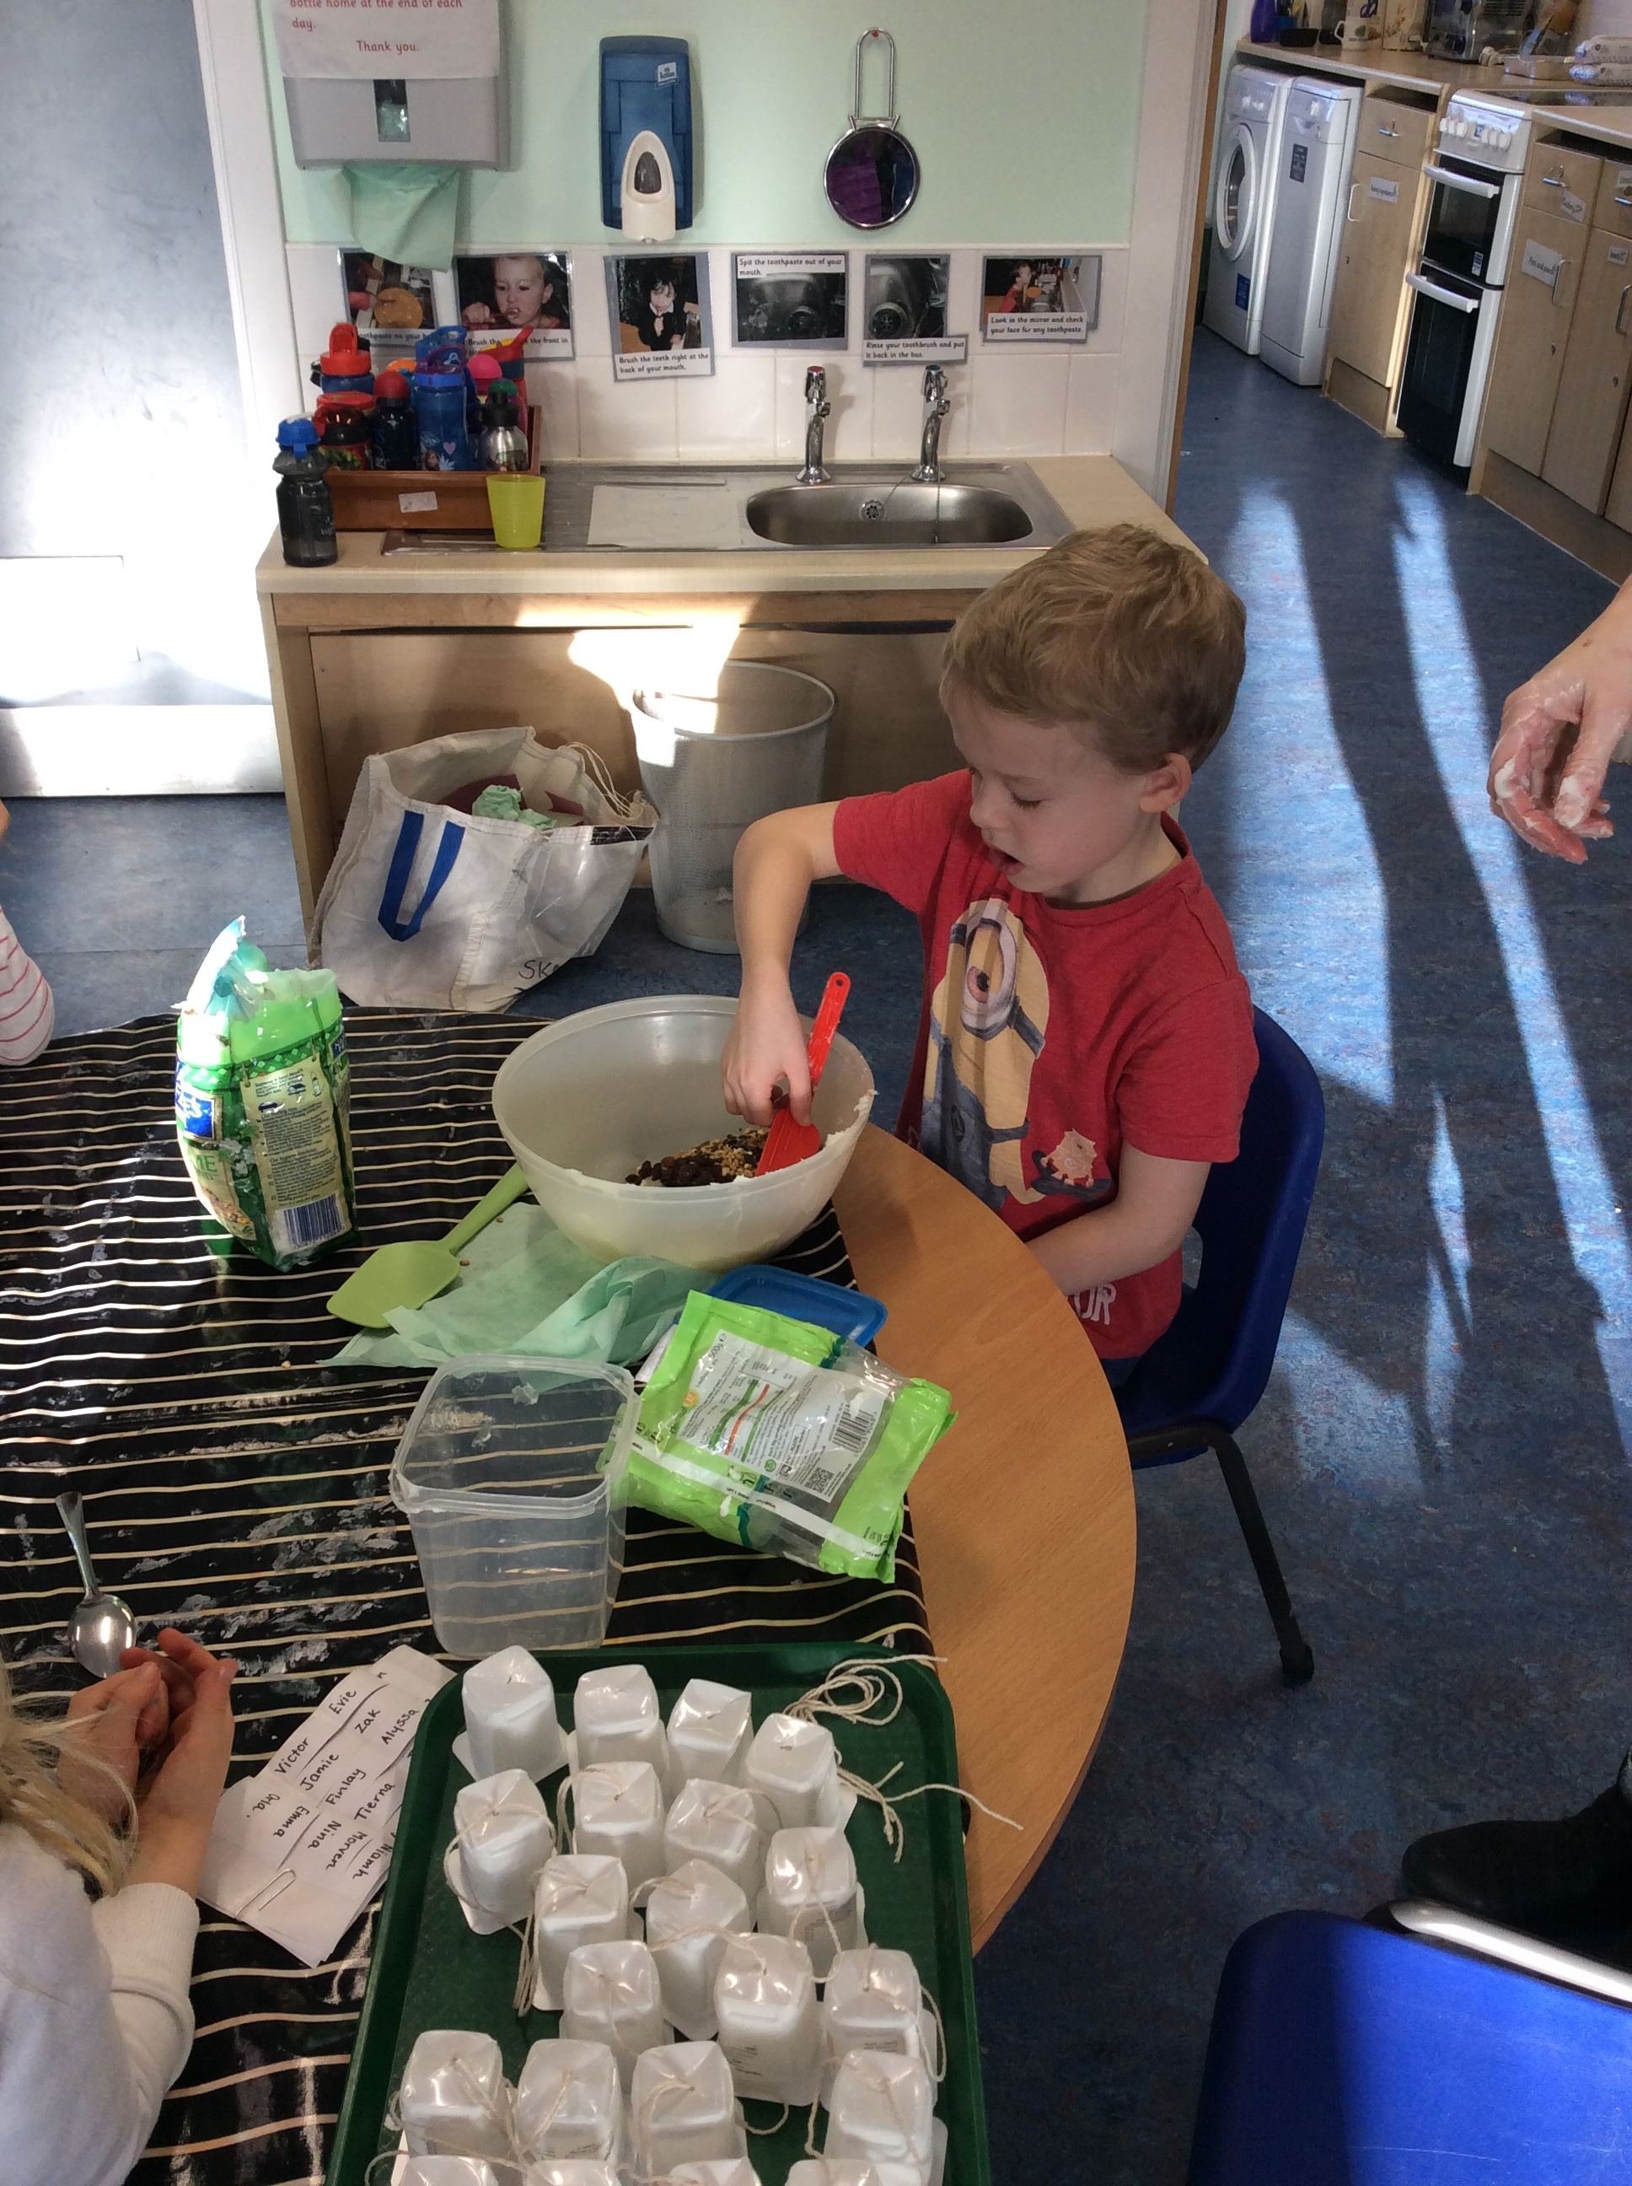 |  | 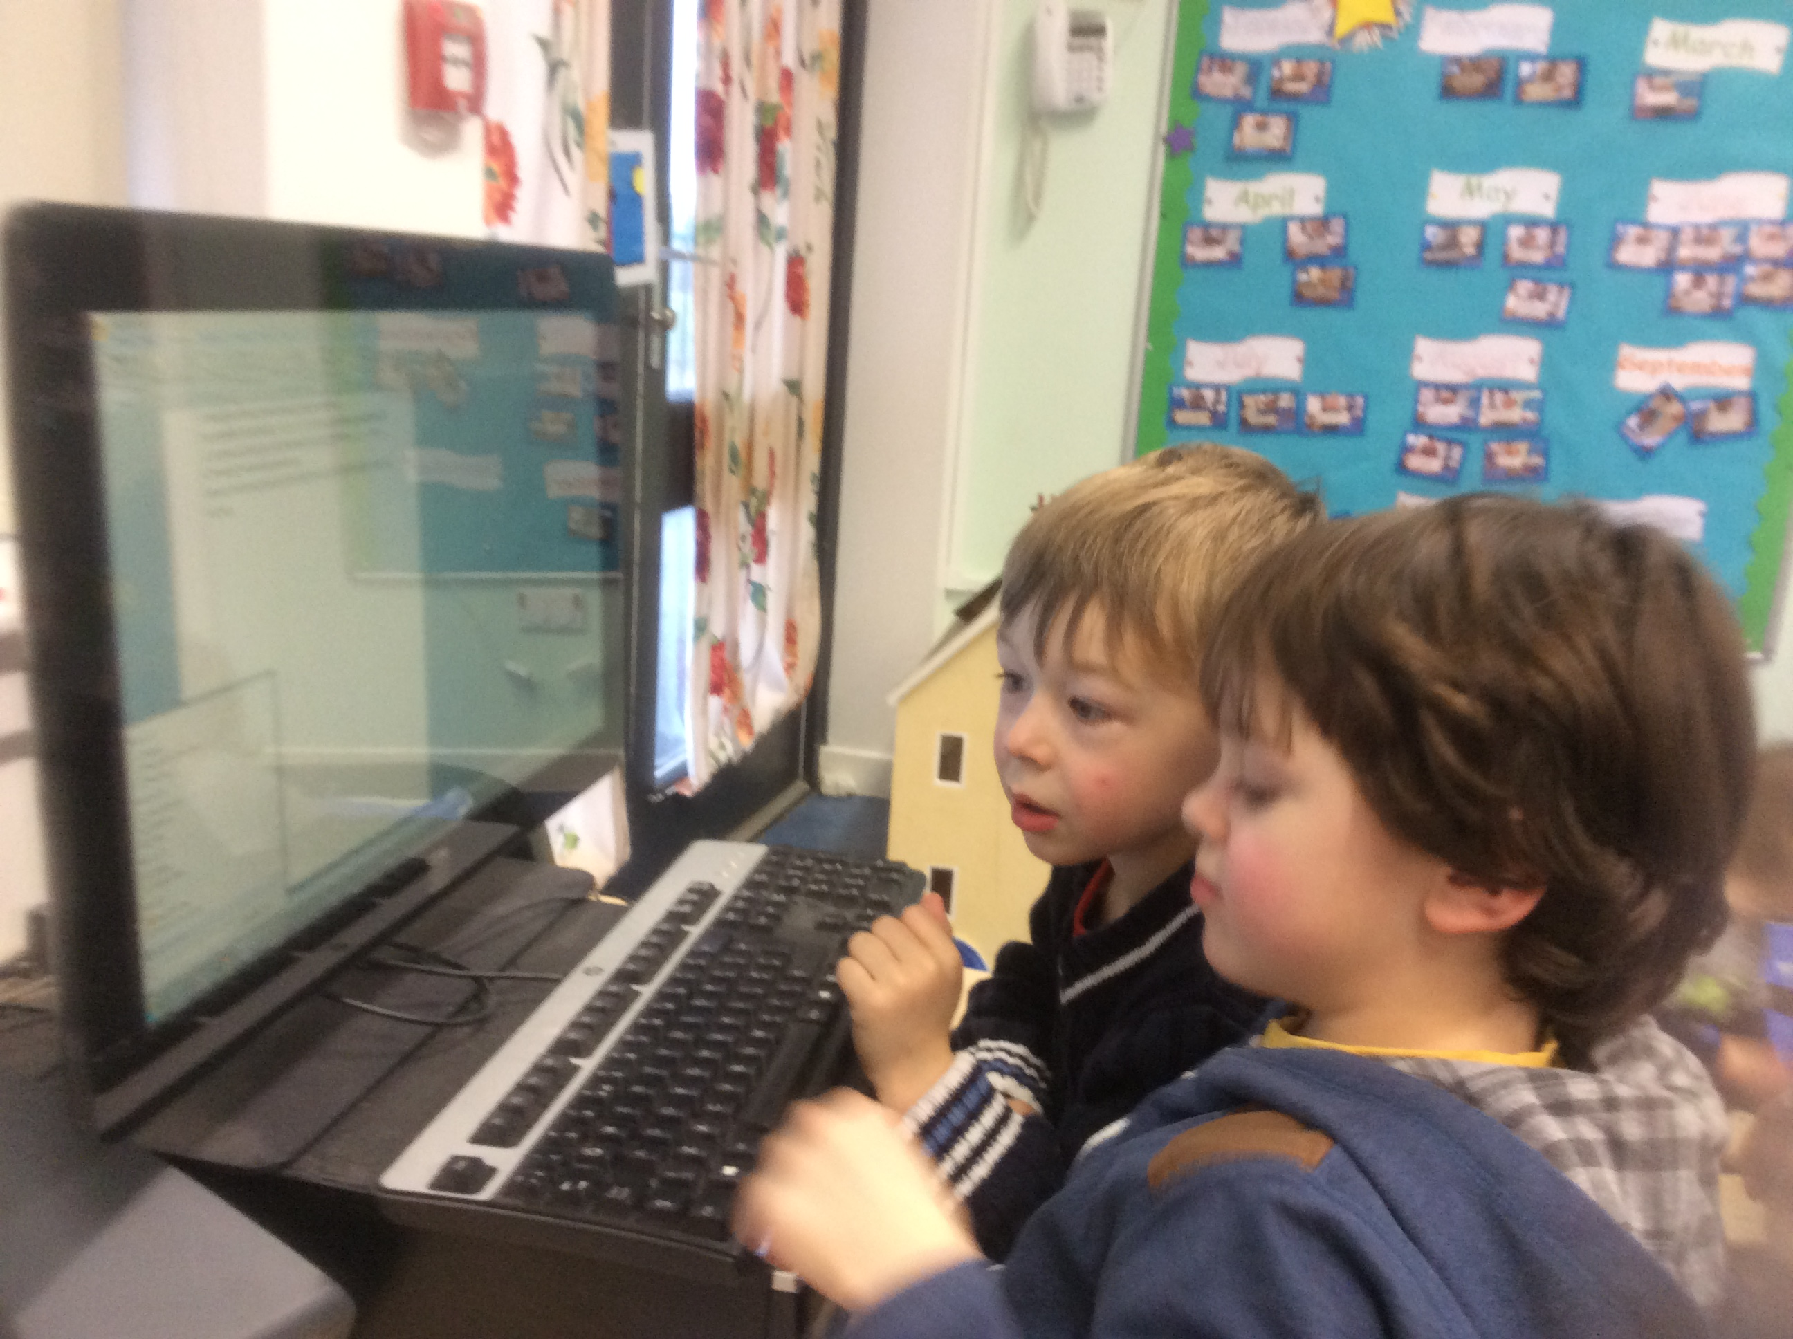
We really enjoyed having a Burns Ceilidh, we danced to Scottish music and dressed up in our kilts and wore tartan. After all that dancing we has a Scottish snack, we enjoyed the shortbread and even tried some Irn Bru! . |  | Each day we check that the birds have enough food to eat and that there is enough water in their bird bath.  we also need to remember to check our hedgehog house for little visitors. |  | 

