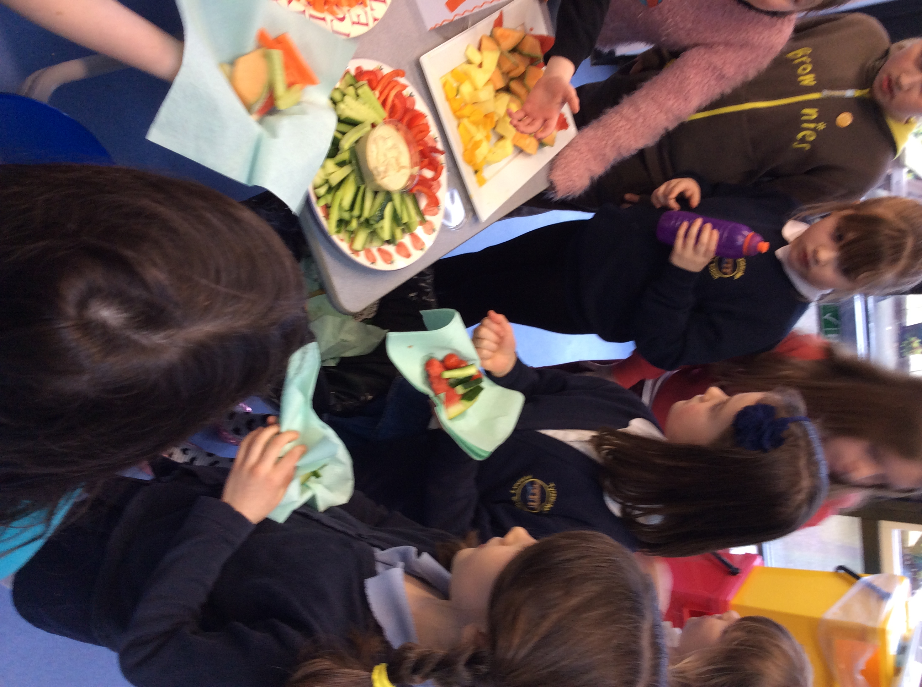 |  | 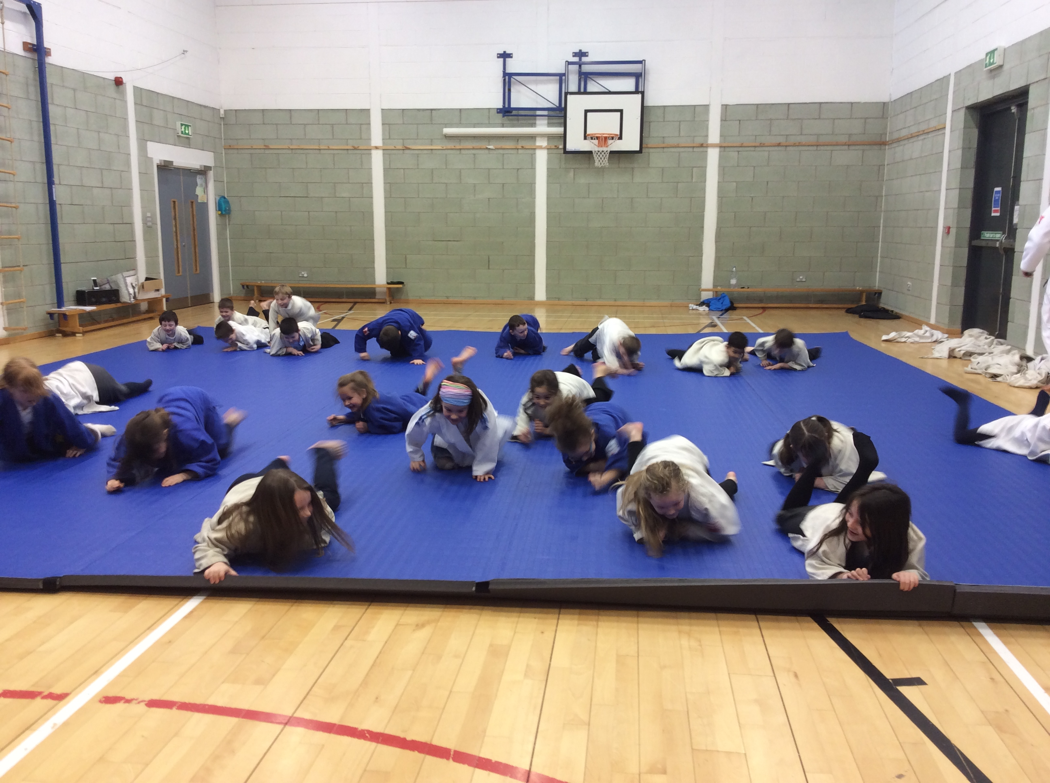 |  | 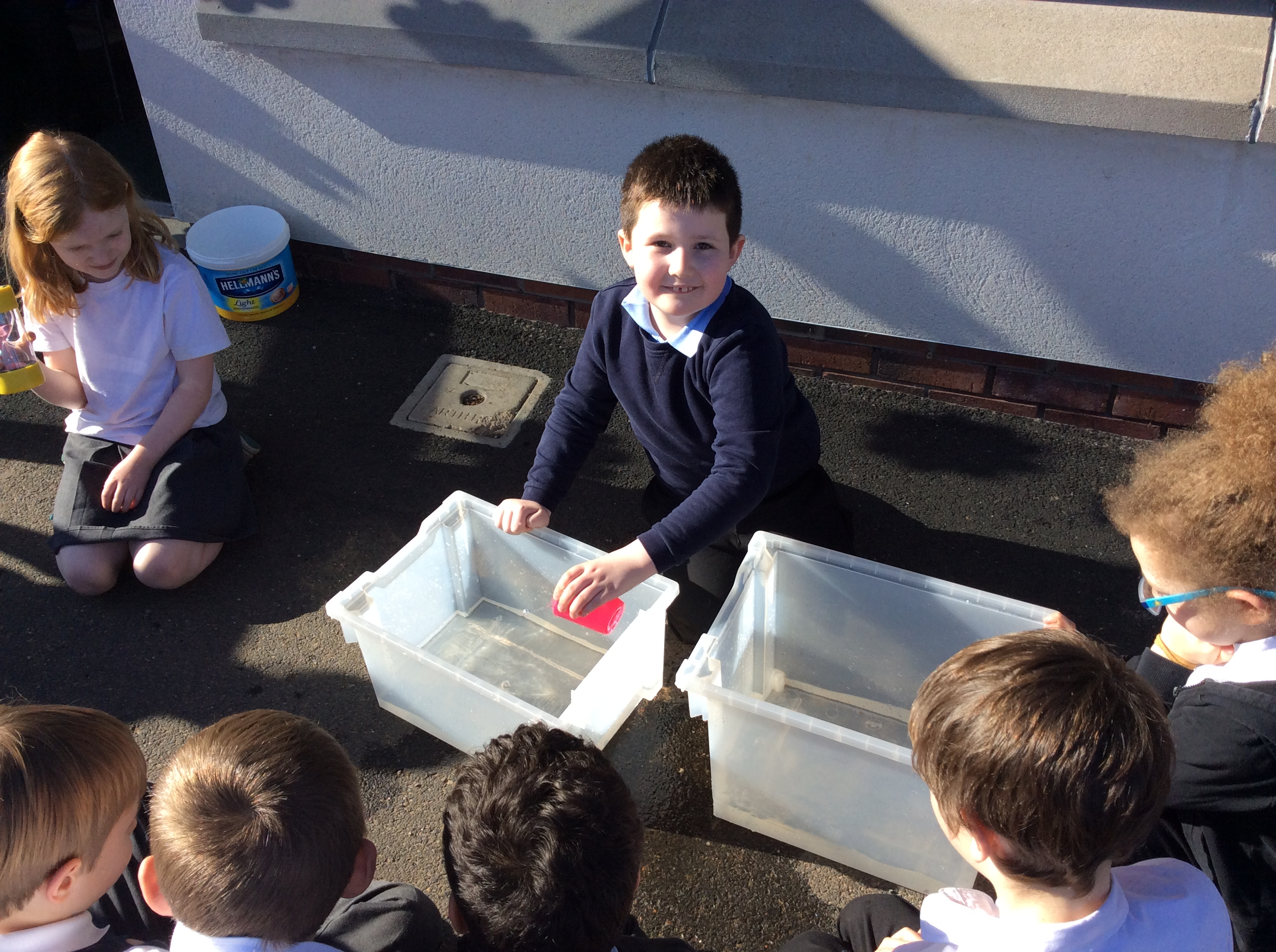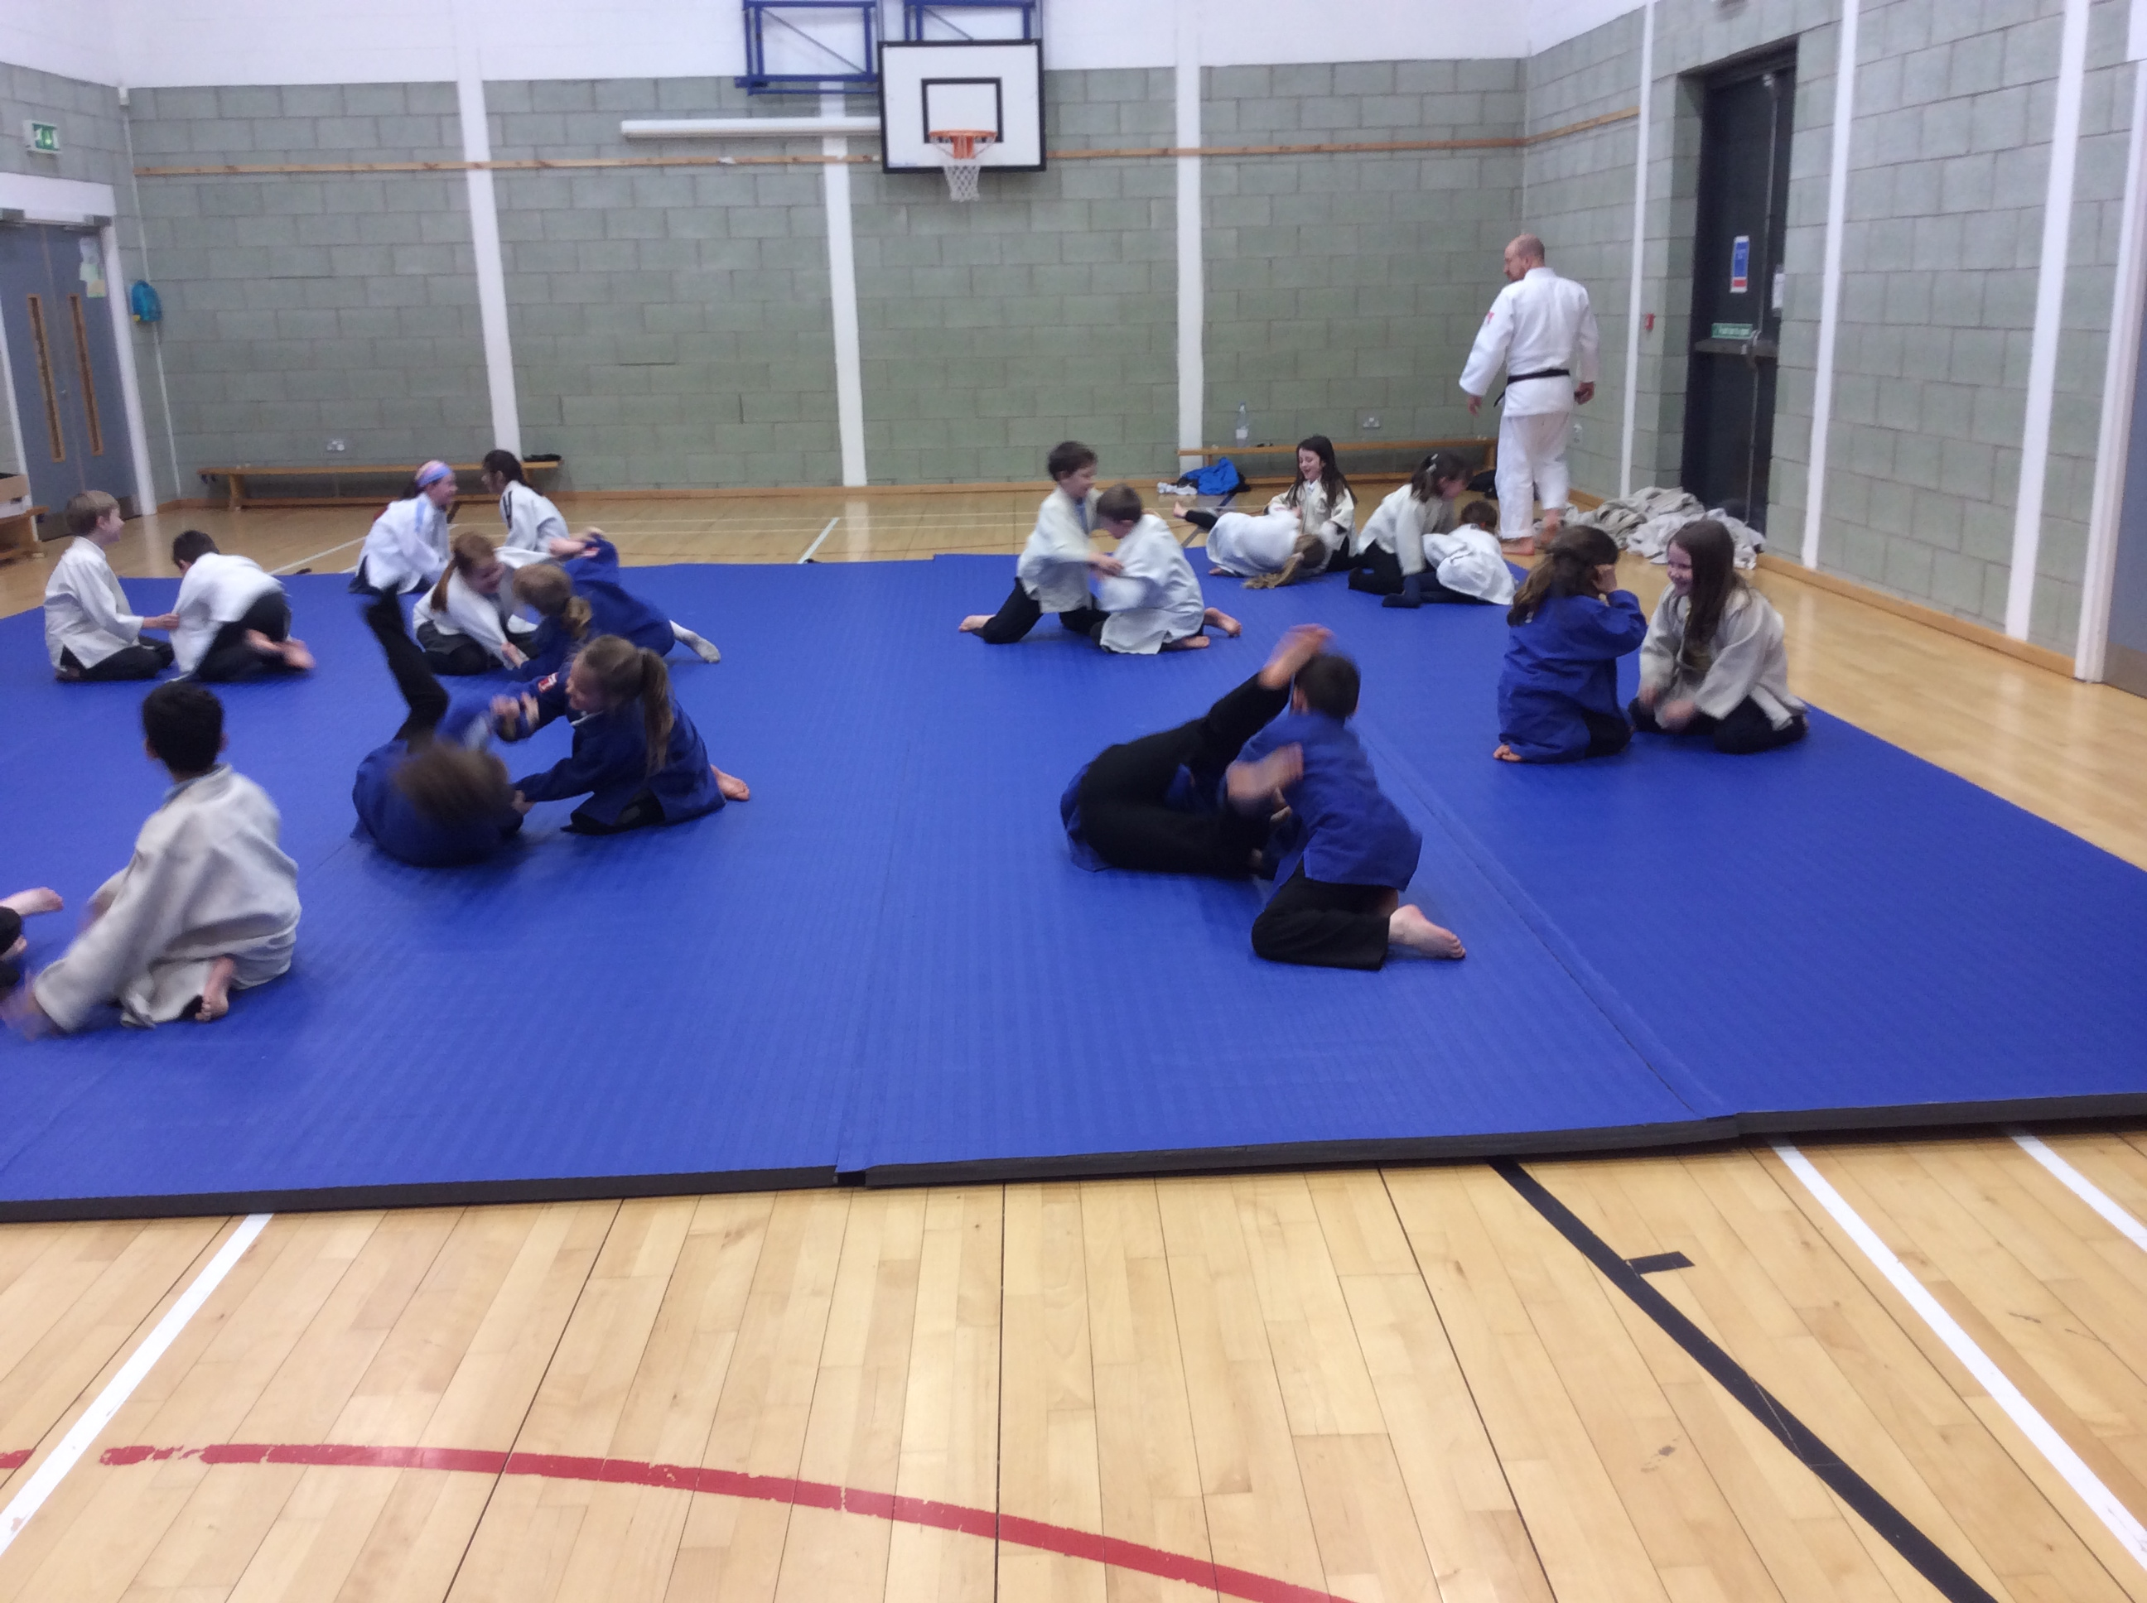
We enjoyed learning about different food that we can eat to stay healthy. We particularly enjoyed trying different fruits and vegetables. We are still aiming to get 100% for our healthy snack chart! |  | Our Healthy Bodies  Last term we learned about the human body and how to keep our bodies healthy.  These photos show us trying Judo! |  | We enjoyed learning about the heart. First we learned about how the heart works. We even conducted our own science experiment to see how much blood passes through the heart in 1 minute.
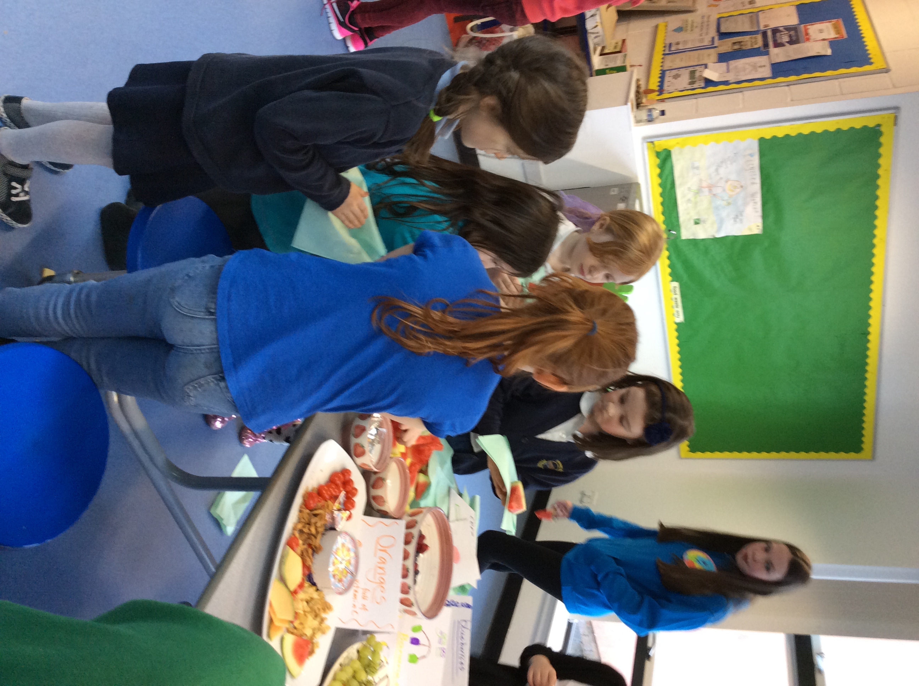  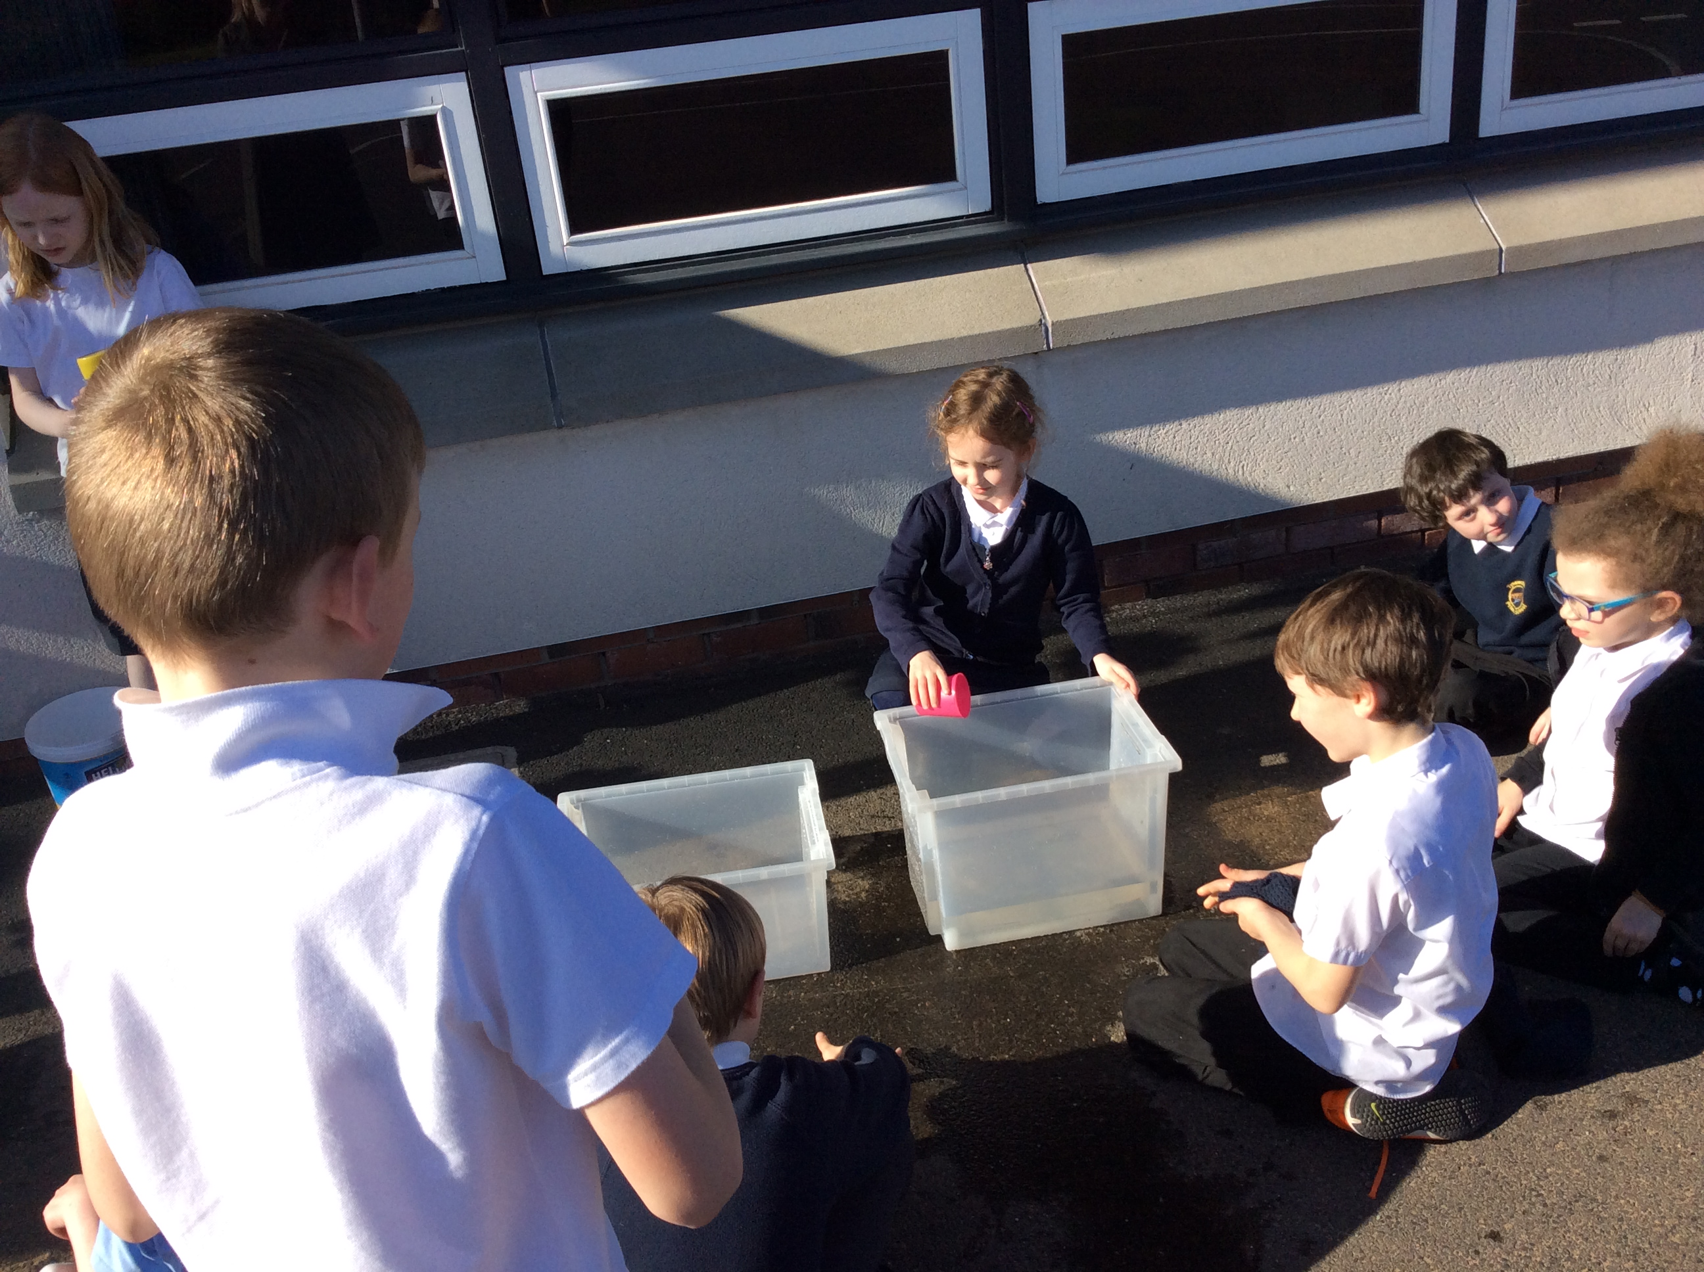 |  | 

