**Living Things**

During this topic we will discover and learn about:

* How living things depend on each other as we learn about food chains.
* Life cycles of plants and animals.
* What living things need to grow and survive.

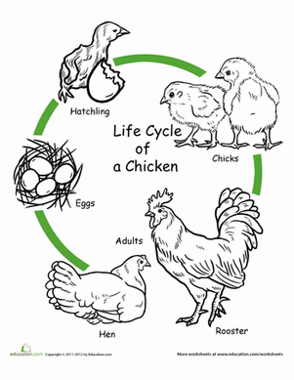

**Literacy**

We will continue to revise our sounds learnt so far and continue focussing on consonant blends.

We will also continue to develop our spelling skills and children will be given weekly spelling words to learn.

We will continue to develop our reading skills through Oxford Reading Tree as well as focussing on comprehension skills.

In addition to writing our weekly news, we will also be writing both fiction and non-fiction texts linked to our topic.

**Mathematics and Numeracy**

We will continue to work on our addition and subtraction skills including the strategies which we can use to help us. We will also be focussing on recognising numbers to 100.

In maths we will be focussing on measure.

**Health and Wellbeing**

In P.E. we will be learning the skills needed to play team games. We will focus on hockey, netball and basketball.

**Living Things**

