**Scotland**

During this topic we will discover and learn about:

* Scottish traditions including food and clothing
* Famous Scottish people
* Scots language and Scottish songs and stories
* How island life can differ to life in Pathhead (linked to Katie Morag)

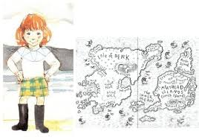

**Literacy**

We will continue to revise our sounds learnt so far as well as learning magic e and consonant blends.

We will also continue to develop our spelling skills and children will be given weekly spelling words to learn.

We will continue to develop our reading skills through Oxford Reading Tree and our key words.

In addition to writing our weekly news, we will be writing stories linked to our topic.

**Health and Wellbeing**

In P.E. we will be learning traditional Scottish dances as well as exploring dance through story telling. We will also be discussing the importance of making healthy choices.

**Mathematics and Numeracy**

We will continue to work on our addition skills, including counting on. Additionally we will focus on the concept of less/fewer as we work on our subtraction skills.

In maths we will be focussing on using directions and describing positions.

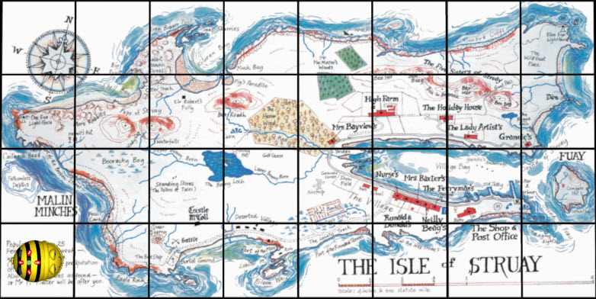

**Scotland**

