Skiing  Skiing was awesome! We passed a few more levels and we even got to use the jumps! We went all the way to the top.  Skiing was fun and exciting. Lucy  It was 100% fun and our coach was |  | Lyceum Theatre  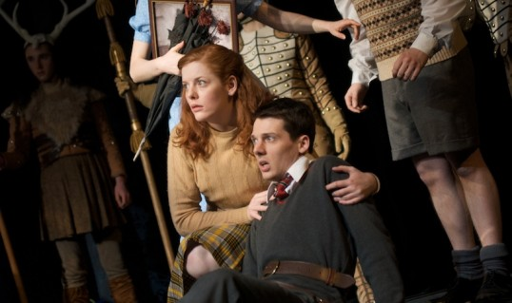 |  | London Filming  We made a complete film all about London. We made up a story about one of our classmates getting lost in London and we re-visited all the places we went during our trip. We still have to
really good. Eilidh  Skiing was good! Jon  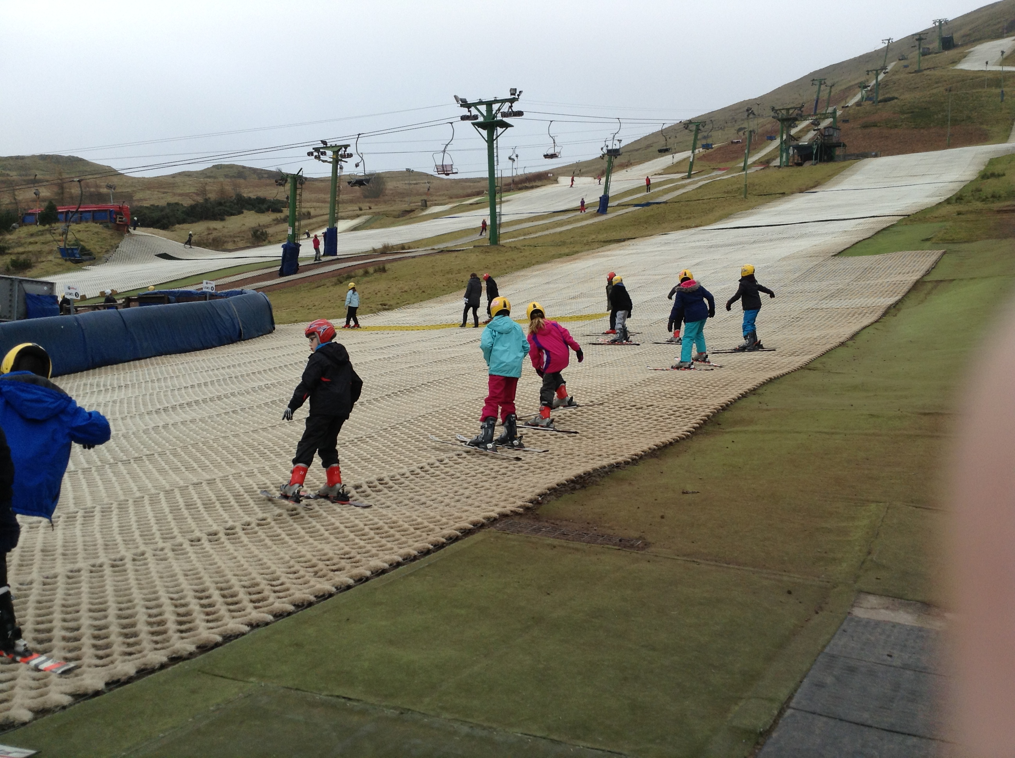 |  | We went to see the Lion, The Witch and The Wardrobe at the Lyceum theatre. I give it five stars out of five! Matteo. I think it was excellent and the costumes were very amusing. Daisy The set was very cool. Luis. |  | edit it but we think it’ll be funny!  I really liked the acting and the filming. Olav  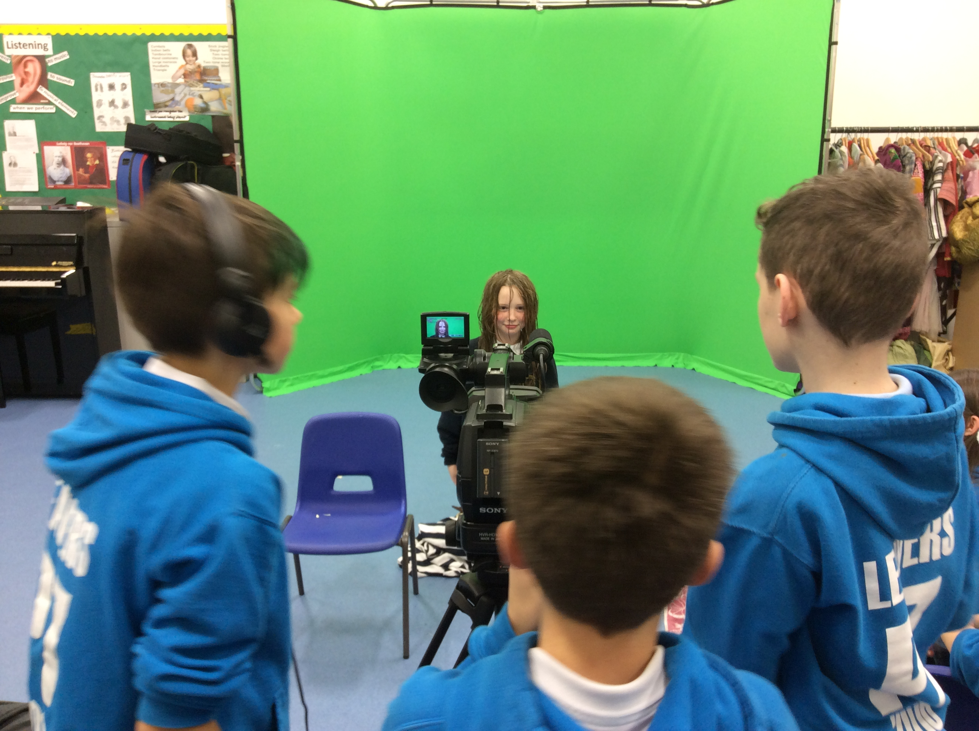
Christmas! This Christmas we did a Christmas assembly. We shared with the school the true essence of Christmas with our funny class assembly. It went well and it helped to build up our confidence to perform. |  | 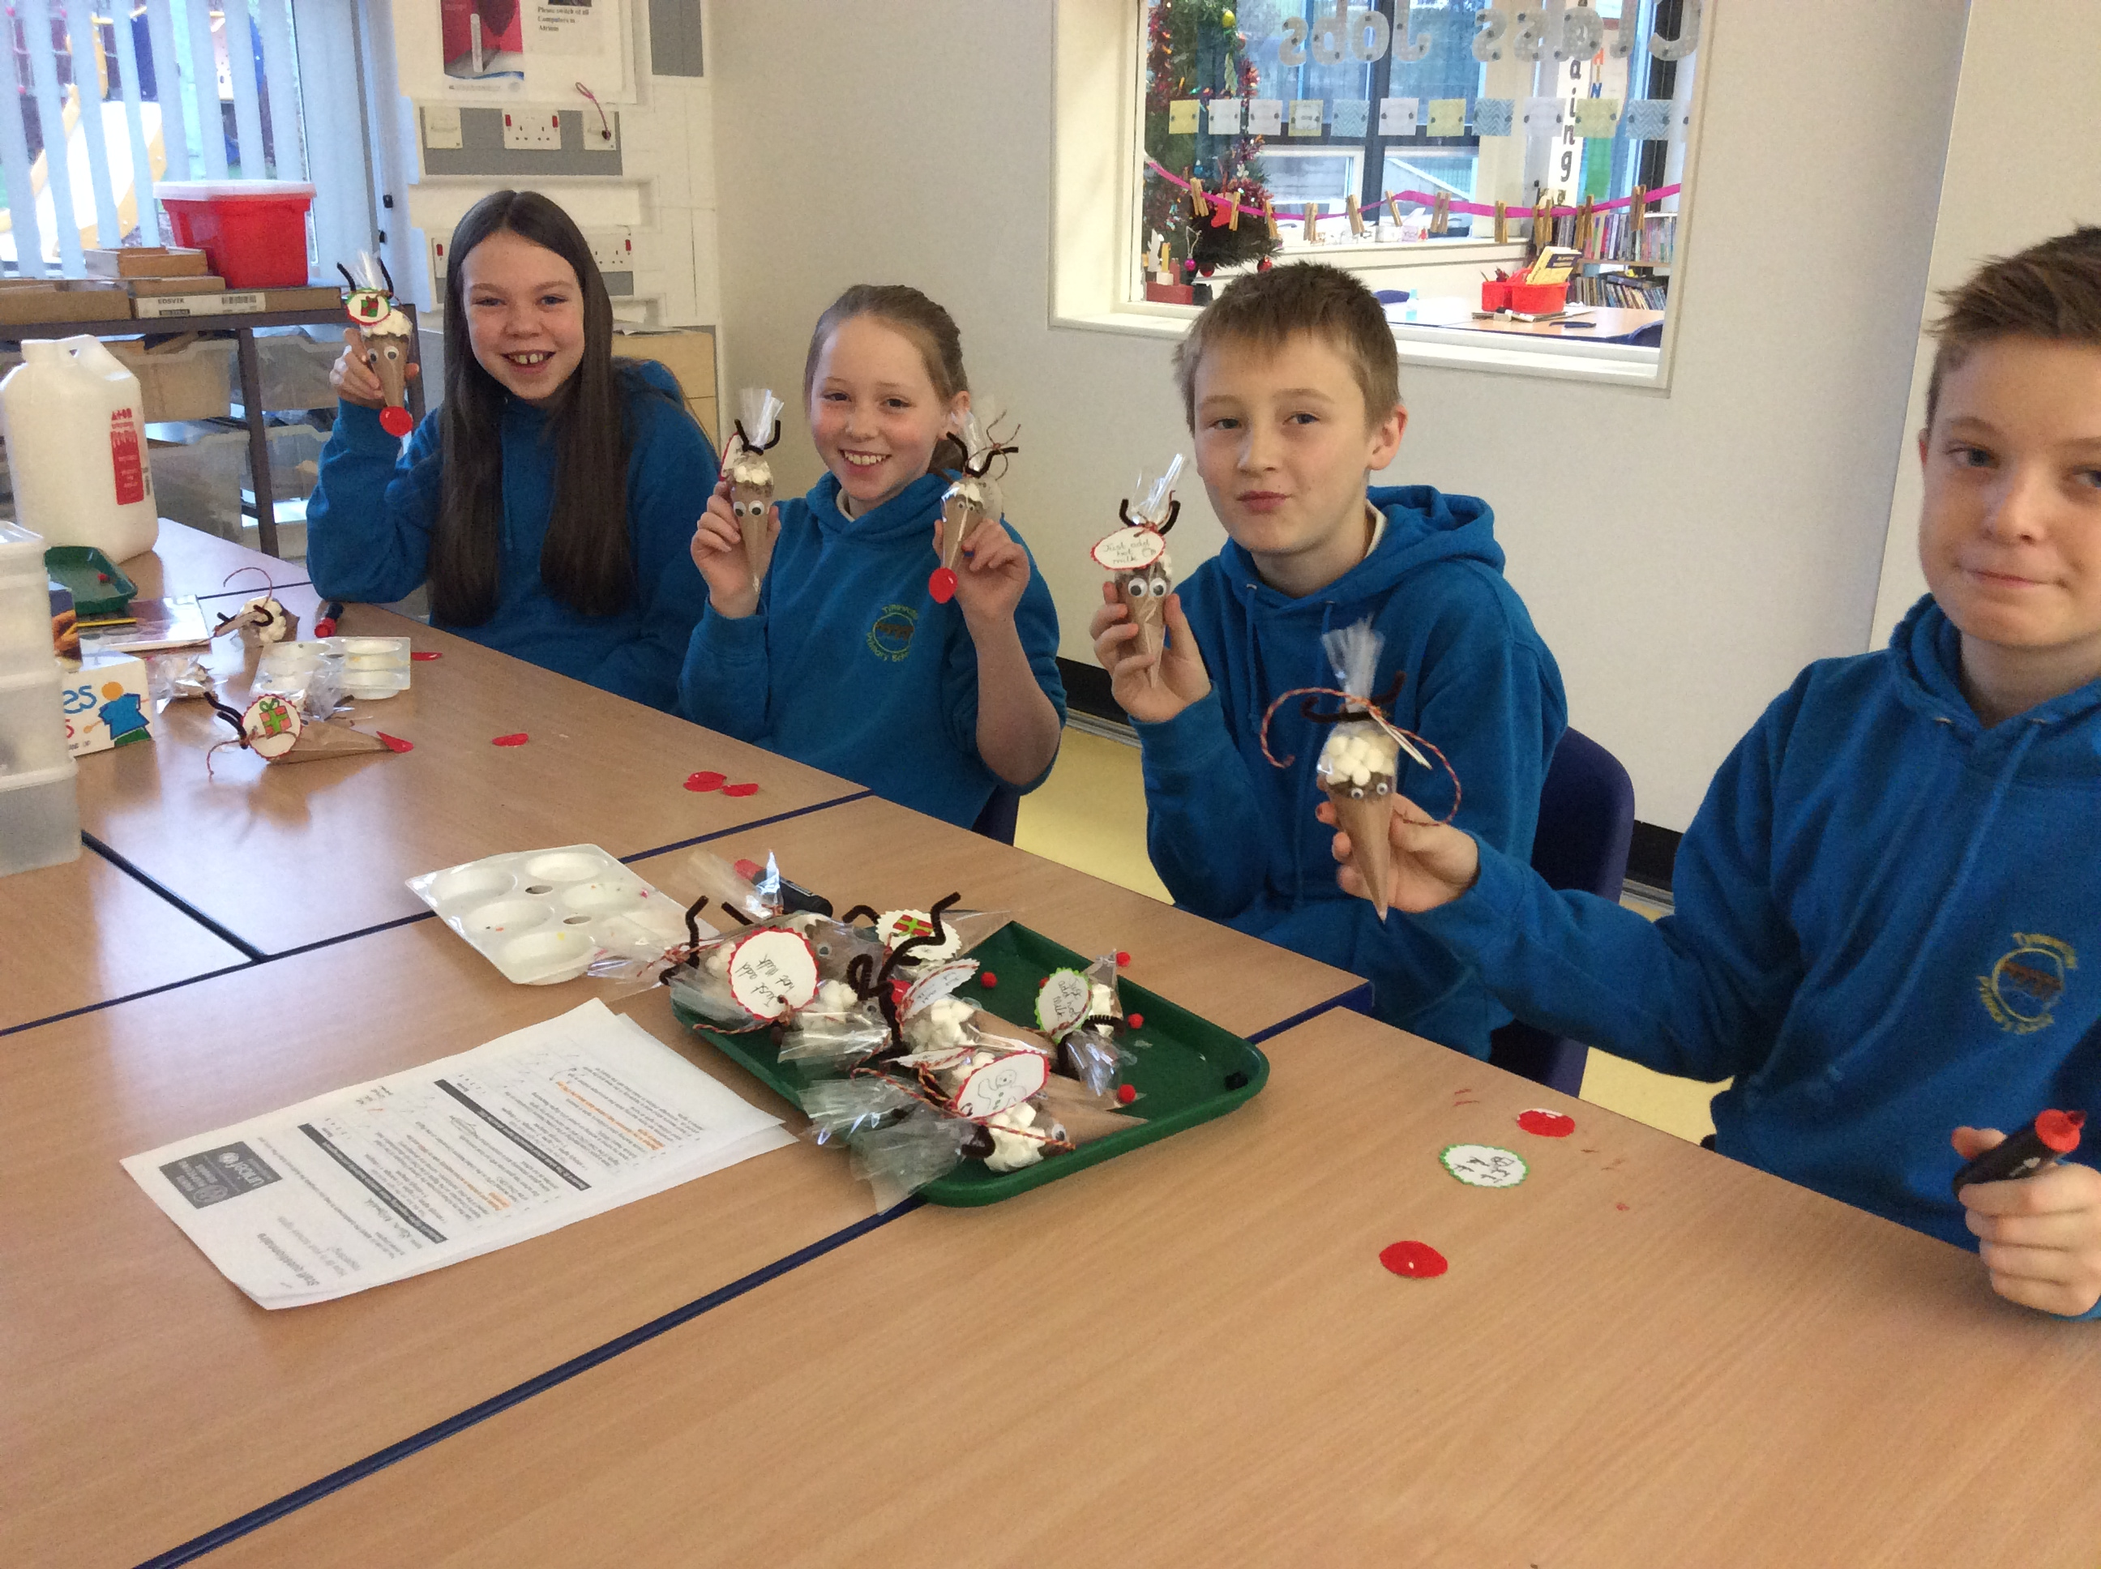 |  | Each class made a contribution to the Christmas Fair and we made Reindeer Hot chocolate gifts. They sold really well! We had a lot of fun at our Christmas party. We got sweeties if we were out of games too so it was great!

